These holistic assessment tasks have been created specifically for training purposes and are deliberately of varying quality.
Reflect on the key features of a holistic assessment task and discuss with colleagues which of these you feel are high quality examples, which clearly do not meet the standard of a good quality holistic assessment and those which ‘could be improved’. Traffic light these accordingly, recording reasons for each response, and make suggestions for improvements for those you have labelled as ‘amber’.

Experiences and Outcomes |  | Holistic Assessment Task
Reading | I regularly select and read, listen to or watch texts which I enjoy and find interesting, and I can explain why I prefer certain texts and authors.  LIT 1-11a / LIT 2-11a  I am learning to select and use strategies and resources before I read, and as I read,  to help make the meaning  of texts clear. LIT 1-13a  To show my understanding across different areas of learning, I can identify and consider the purpose and main ideas of a text. LIT 1-16a  I can share my thoughts about structure, characters and/or setting, recognise the writer’s message and relate it to my own experiences, and comment on the effective choice of words and other features.  ENG 1-19a  (Listening and Talking or Writing Es and Os depending on learner choice of presentation) | 1.) Roald Dahl Book Review  Now that we have read 3 of Roald Dahl’s books together, choose one to create a review about. You can present your review as a talk, a written review, a power point or a poster. Include:  - Front cover/blurb/illustrations  - Summary of the story – key events  - Characters, including your likes/dislikes  - Author’s use of language  Read your favourite section of the book aloud when you share your review with your group.  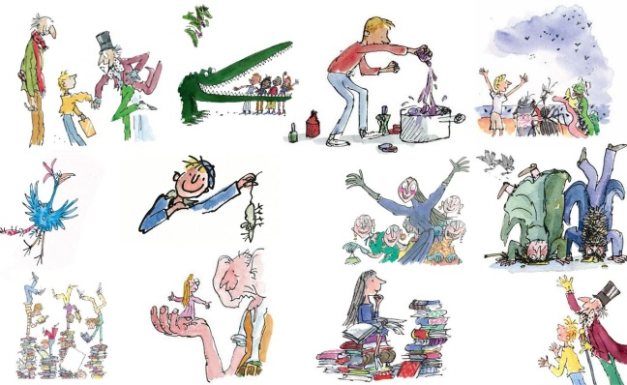

These holistic assessment tasks have been created specifically for training purposes and are deliberately of varying quality.
Reflect on the key features of a holistic assessment task and discuss with colleagues which of these you feel are high quality examples, which clearly do not meet the standard of a good quality holistic assessment and those which ‘could be improved’. Traffic light these accordingly, recording reasons for each response, and make suggestions for improvements for those you have labelled as ‘amber’.

Experiences and Outcomes |  | Holistic Assessment Task
Reading  Writing | I am learning to select and use strategies and resources before I read, and as I read, to help make the meaning of texts clear. LIT 1-13a  I can use my knowledge of sight vocabulary, phonics, context clues, punctuation and grammar to read with understanding and expression.  ENG 1-12a  Using what I know about  the features of different types of texts, I can find, select,  sort and use information  for a specific purpose. LIT 1-14a  To show my understanding across different areas of learning, I can identify and consider the purpose and main ideas of a text. LIT 1-16a  I can spell the most commonly-used words, using my knowledge of letter patterns and spelling rules and use resources to help me spell tricky or unfamiliar words. LIT 1-21a  I can write independently, use appropriate punctuation and order and link my sentences in a way that makes sense. LIT 1-22a  I am learning to use my notes and other types of writing to help me understand information and ideas, explore problems, generate and develop ideas or create new text.  LIT 1-25a | 2.) Egyptians  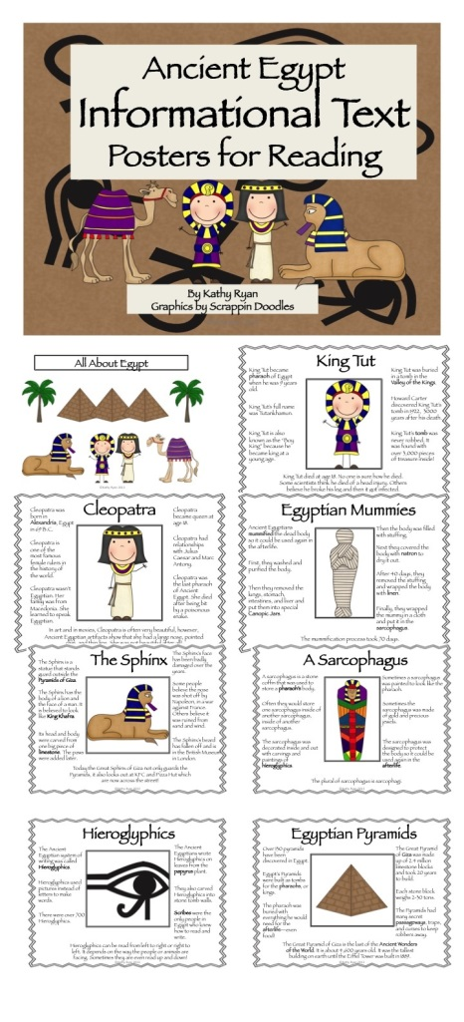  Read the poster about Ancient Egypt and list 5 facts.

These holistic assessment tasks have been created specifically for training purposes and are deliberately of varying quality.
Reflect on the key features of a holistic assessment task and discuss with colleagues which of these you feel are high quality examples, which clearly do not meet the standard of a good quality holistic assessment and those which ‘could be improved’. Traffic light these accordingly, recording reasons for each response, and make suggestions for improvements for those you have labelled as ‘amber’.

Experiences and Outcomes |  | Holistic Assessment Task
Reading  Writing | I am learning to select and use strategies and resources before I read, and as I read, to help make the meaning of texts clear.  LIT 1-13a  Using what I know about  the features of different types of texts, I can find, select, sort and use information  for a specific purpose. LIT 1-14a  I am learning to make notes under given headings and use them to understand information, explore ideas and problems and create new texts. LIT 1-15a  To show my understanding,  I can respond to different kinds of questions and other close reading tasks and I am learning to create some questions of my own.  ENG 1-17a  To help me develop  an informed view, I can recognise the difference between fact and opinion.  LIT 1-18a  I am learning to use my notes and other types of writing to help me understand information and ideas, explore problems, generate and develop ideas or create new text LIT 1-25a | 3.) Next week the ‘Wild about Scotland’ bus will be visiting our school. We will be learning more about Scotland’s native wildlife. In preparation for the visit:  - Use the information books and websites to research and find key information about Scotland’s wildlife  - Make notes under the headings:  - Animal name  - Habitat  - Diet  - Other interesting facts  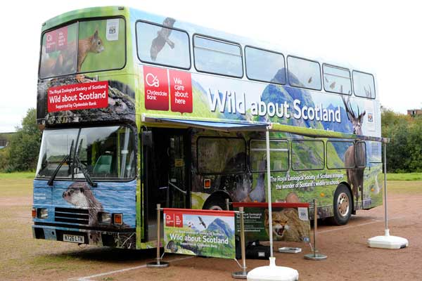  - Create 3 questions to ask the experts

These holistic assessment tasks have been created specifically for training purposes and are deliberately of varying quality.
Reflect on the key features of a holistic assessment task and discuss with colleagues which of these you feel are high quality examples, which clearly do not meet the standard of a good quality holistic assessment and those which ‘could be improved’. Traffic light these accordingly, recording reasons for each response, and make suggestions for improvements for those you have labelled as ‘amber’.

Experiences and Outcomes |  | Holistic Assessment Task
Reading | I can use my knowledge of sight vocabulary, phonics, context clues, punctuation and grammar to read with understanding and expression. ENG 1-12a  I am learning to select and use strategies and resources before I read, and as I read,  to help make the meaning  of texts clear. LIT 1-13a  Using what I know about  the features of different types of texts, I can find, select, sort and use information  for a specific purpose. LIT 1-14a  I am learning to make notes under given headings and use them to understand information, explore ideas and problems and create new texts. LIT 1-15a  I can share my thoughts about structure, characters and/or setting, recognise the writer’s message and relate it to my own experiences, and comment on the effective choice of words and other features.  ENG 1-19a | 4.) We have been focusing on character description using interesting and descriptive vocabulary to grasp the reader’s attention. Look at the extract from our class novel ‘Mr Gum’  Can you:  - Read the extract aloud  - Share 3 examples of interesting and descriptive vocabulary  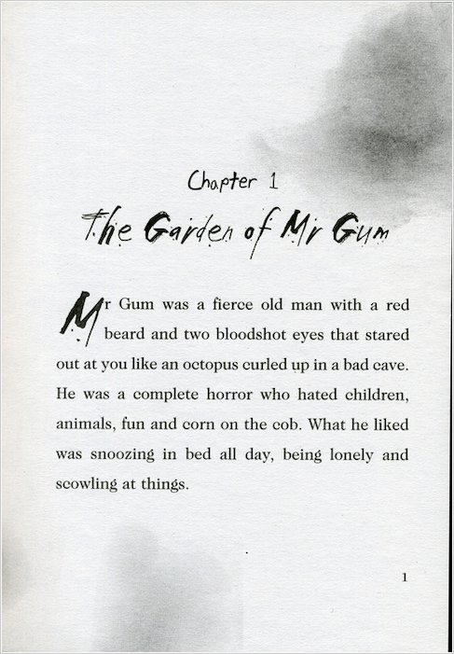  - Draw a picture of Mr Gum based on the description, labelling his likes and dislikes

These holistic assessment tasks have been created specifically for training purposes and are deliberately of varying quality.
Reflect on the key features of a holistic assessment task and discuss with colleagues which of these you feel are high quality examples, which clearly do not meet the standard of a good quality holistic assessment and those which ‘could be improved’. Traffic light these accordingly, recording reasons for each response, and make suggestions for improvements for those you have labelled as ‘amber’.
Experiences and Outcomes |  | Holistic Assessment Task
Reading | I can use my knowledge of sight vocabulary, phonics, context clues, punctuation and grammar to read with understanding and expression. ENG 1-12a  I am learning to select and use strategies and resources before I read, and as I read,  to help make the meaning  of texts clear. LIT 1-13a  To show my understanding across different areas of learning, I can identify and consider the purpose and main ideas of a text.  LIT 1-16a | 5.) The Christmas Story – Close procedure  Read the passage about the Christmas story and fill in the missing words using the word bank provided.  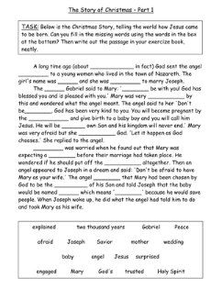

These holistic assessment tasks have been created specifically for training purposes and are deliberately of varying quality.
Reflect on the key features of a holistic assessment task and discuss with colleagues which of these you feel are high quality examples, which clearly do not meet the standard of a good quality holistic assessment and those which ‘could be improved’. Traffic light these accordingly, recording reasons for each response, and make suggestions for improvements for those you have labelled as ‘amber’.

Experiences and Outcomes |  | Holistic Assessment Task
Reading  Writing | I am learning to select and use strategies and resources before I read, and as I read,  to help make the meaning  of texts clear. LIT 1-13a  Using what I know about  the features of different types of texts, I can find, select, sort and use information for a specific purpose.  LIT 1-14a  I am learning to make notes under given headings and  use them to understand information, explore ideas and problems and create  new texts.  LIT 1-15a  To show my understanding across different areas of learning, I can identify and consider the purpose and main ideas of a text.  LIT 1-16a  I am learning to use my notes and other types of writing to help me understand information and ideas, explore problems, generate and develop ideas or create new text.  LIT 1-25a  I can convey information, describe events or processes, share my opinions or persuade my reader in different ways.  LIT 1-28a / LIT 1-29a | 6.) Vertebrates and Invertebrates  Read and look at the information about vertebrates and invertebrates. Make notes and organise your notes into sub-headings.  Use the information to create your own diagram showing examples of different types of vertebrates and invertebrates.  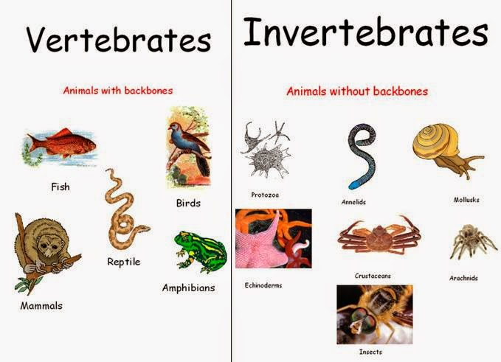
These holistic assessment tasks have been created specifically for training purposes and are deliberately of varying quality.
Reflect on the key features of a holistic assessment task and discuss with colleagues which of these you feel are high quality examples, which clearly do not meet the standard of a good quality holistic assessment and those which ‘could be improved’. Traffic light these accordingly, recording reasons for each response, and make suggestions for improvements for those you have labelled as ‘amber’.

Experiences and Outcomes |  | Holistic Assessment Task
Reading | I can use my knowledge of sight vocabulary, phonics, context clues, punctuation and grammar to read with understanding and expression.  ENG 1-12a  To help me develop an informed view, I can recognise the difference between fact and opinion.  LIT 1-18a | 7.) Christmas fact or opinion?  Read the statements on the cards. Decide with your partner whether they are fact or opinion. Display your cards in the two groups. Share your decisions with another pair. Did you agree?  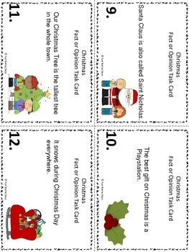  Create your own fact and opinion cards about a topic of your choice. Use these to write a short report about your topic together with your partner. Swap with another pair and read theirs. Use highlighter pens to highlight fact and opinions.

These holistic assessment tasks have been created specifically for training purposes and are deliberately of varying quality.
Reflect on the key features of a holistic assessment task and discuss with colleagues which of these you feel are high quality examples, which clearly do not meet the standard of a good quality holistic assessment and those which ‘could be improved’. Traffic light these accordingly, recording reasons for each response, and make suggestions for improvements for those you have labelled as ‘amber’.

Experiences and Outcomes |  | Holistic Assessment Task
Reading | I regularly select and read, listen to or watch texts which I enjoy and find interesting, and I can explain why I prefer certain texts and authors.  LIT 1-11a / LIT 2-11a  To show my understanding across different areas of learning, I can identify and consider the purpose and main ideas of a text.  LIT 1-16a  To show my understanding,  I can respond to different kinds of questions and other close reading tasks and I am learning to create some questions  of my own.  ENG 1-17a  I can share my thoughts about structure, characters and/or setting, recognise the writer’s message and relate it to my own experiences, and comment on the effective choice of words and other features.  ENG 1-19a | 8.) Author visit – World Book Day  ‘Quest for a cave’ by Judy Hayman.  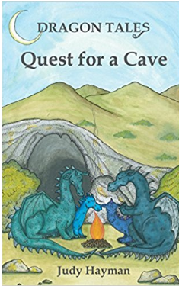  In preparation for our visit from Judy Hayman prepare a list of your thoughts and opinions about our recent class novel ‘Quest for a Cave’.  Prepare a list of questions to ask Judy about the story.

These holistic assessment tasks have been created specifically for training purposes and are deliberately of varying quality.
Reflect on the key features of a holistic assessment task and discuss with colleagues which of these you feel are high quality examples, which clearly do not meet the standard of a good quality holistic assessment and those which ‘could be improved’. Traffic light these accordingly, recording reasons for each response, and make suggestions for improvements for those you have labelled as ‘amber’.

Experiences and Outcomes |  | Holistic Assessment Task
Reading | I regularly select and read, listen to or watch texts which I enjoy and find interesting, and I can explain why I prefer certain texts and authors.  LIT 1-11a / LIT 2-11a  I can use my knowledge of sight vocabulary, phonics, context clues, punctuation and grammar to read with understanding and expression.  ENG 1-12a  I am learning to select and use strategies and resources before I read, and as I read,  to help make the meaning  of texts clear.  LIT 1-13a  To show my understanding,  I can respond to different kinds of questions and other close reading tasks and I am learning to create some questions  of my own.  ENG 1-17a | 9.) My favourite book  Bring in a favourite book from home to share with your reading group. Tell the group why you like the book and why you would recommend it to them. Read your favourite section of the book to the group and answer any questions they have.  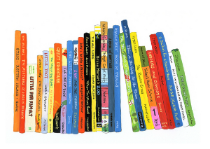

These holistic assessment tasks have been created specifically for training purposes and are deliberately of varying quality.
Reflect on the key features of a holistic assessment task and discuss with colleagues which of these you feel are high quality examples, which clearly do not meet the standard of a good quality holistic assessment and those which ‘could be improved’. Traffic light these accordingly, recording reasons for each response, and make suggestions for improvements for those you have labelled as ‘amber’.

Experiences and Outcomes |  | Holistic Assessment Task
Reading | I can use my knowledge of sight vocabulary, phonics, context clues, punctuation and grammar to read with understanding and expression.  ENG 1-12a  I am learning to select and use strategies and resources before I read, and as I read, to help make the meaning  of texts clear.  LIT 1-13a | 10.) Easter Sequencing  Read the sentences about the Easter story and put them in the correct sequence.  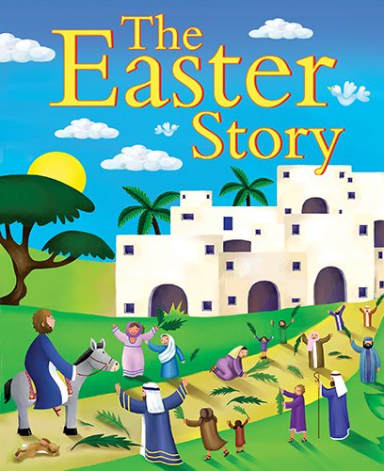

These holistic assessment tasks have been created specifically for training purposes and are deliberately of varying quality.
Reflect on the key features of a holistic assessment task and discuss with colleagues which of these you feel are high quality examples, which clearly do not meet the standard of a good quality holistic assessment and those which ‘could be improved’. Traffic light these accordingly, recording reasons for each response, and make suggestions for improvements for those you have labelled as ‘amber’.

Experiences and Outcomes |  | Holistic Assessment Task
Reading  Writing | I regularly select and read, listen to or watch texts which I enjoy and find interesting, and I can explain why I prefer certain texts and authors.  LIT 1-11a / LIT 2-11a  I can use my knowledge of sight vocabulary, phonics, context clues, punctuation and grammar to read with understanding and expression.  ENG 1-12a  I am learning to select and use strategies and resources before I read, and as I read,  to help make the meaning  of texts clear.  LIT 1-13a  To show my understanding across different areas of learning, I can identify and consider the purpose and main ideas of a text.  LIT 1-16a  I can share my thoughts about structure, characters and/or setting, recognise the writer’s message and relate it to my own experiences, and comment on the effective choice of words and other features.  ENG 1-19a  I enjoy creating texts of my choice and I regularly select subject, purpose, format and resources to suit the needs  of my audience.  LIT 1-20a / LIT 2-20a | 11.) Blurbs  Class Library visit – select a novel/fictional book based on the front cover, title and blurb. Share your choice with your reading group, explaining why you chose the book and what you think it might be about.  In reading for enjoyment time read your chosen book, taking notes about your likes/dislikes, favourite sections, characters etc.  Share your thoughts and opinions with your reading group.  Design a new front cover and write a new blurb for your chosen book after reading.  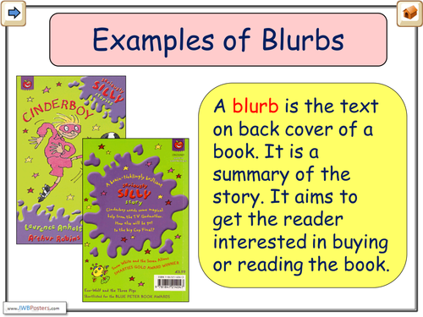

These holistic assessment tasks have been created specifically for training purposes and are deliberately of varying quality.
Reflect on the key features of a holistic assessment task and discuss with colleagues which of these you feel are high quality examples, which clearly do not meet the standard of a good quality holistic assessment and those which ‘could be improved’. Traffic light these accordingly, recording reasons for each response, and make suggestions for improvements for those you have labelled as ‘amber’.

Experiences and Outcomes |  | Holistic Assessment Task
Reading  Writing | I am learning to select and use strategies and resources before I read, and as I read,  to help make the meaning  of texts clear.  LIT 1-13a  Using what I know about the features of different types of texts, I can find, select, sort and use information for a specific purpose.  LIT 1-14a  I am learning to make notes under given headings and use them to understand information, explore ideas and problems and create new texts.  LIT 1-15a  To show my understanding across different areas of learning, I can identify and consider the purpose and main ideas of a text.  LIT 1-16a  I am learning to use my notes and other types of writing to help me understand information and ideas, explore problems, generate and develop ideas or create new text. LIT 1-25a  I can convey information, describe events or processes, share my opinions or persuade my reader in different ways.  LIT 1-28a / LIT 1-29a | 12.) Bridges  Read the information about the 3 bridges in Queensferry. Make notes about the bridge under the following headings:  - Type of bridge:  - When it was built:  - Another interesting fact:  Use your notes to create a poster about one of the bridges.  