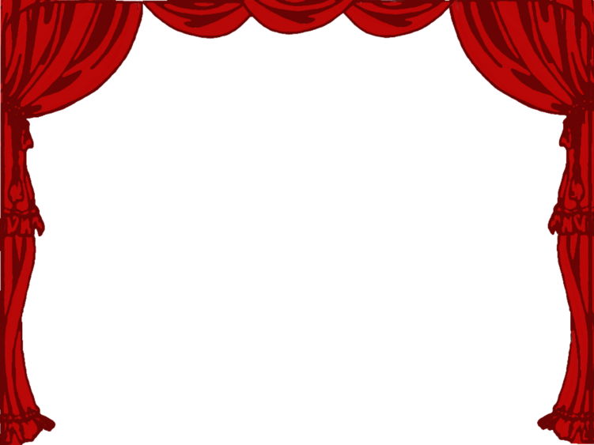

Snow White and The Seven Dwarves

The Junior School Show are putting on the pantomime of Snow White and The Seven Dwarves for one night only.

The main characters costumes cost the following prices to hire:

|  |  |
| --- | --- |
| Snow White | £30 |
| Prince Charming | £25 |
| Wicked Queen | £35 |
| Dwarf | £20 |

Task 1

How much does it cost to hire all the costumes needed?

The Talla Mhor costs £75 to hire for the night and seats 60 people. A local band will charge £100 to play music during the show.

Task 2

What is the total cost of putting on the panto?

Ticket prices have been set as follows:

|  |  |
| --- | --- |
| Adult | Child |
| £5 | £3 |

All the seats are sold for the show. There are 40 adults and 20 children.

Task 3

How much do all the tickets sell for?

Task 4

Does the show make money or lose money? Fully explain your answer.