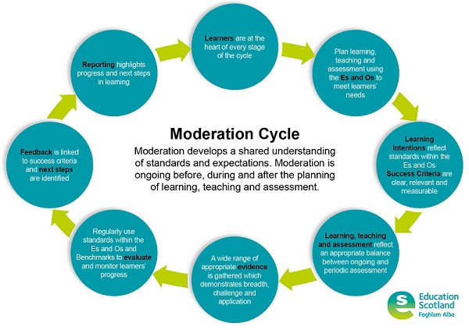
Cluster Moderation Timeline

General Key Messages
- Dedicate time – three years really to embed
- Needs to be in the Working Time Agreement – mix of long and short meetings, informal dialogue, etc.
- Needs to be school’s main priority
- About working together and establishing supportive, collegiate relationships
- Should lead to reduced workload over time
- Use what exists already
- Documentation on moderation itself not required – the “evidence” is the work (ie plans, LI, etc.) produced

Developing Project
- Pick a focus for project (something specific and contained)
  - a skill pupils struggle with?
  - one that isn’t explored as much as it could be?
  - consult with all staff to decide

- Pick relevant bundle of Es and Os
  - best to stick to a small number

- Have first meeting together to:
  - identify Learning Intentions
  - identify pre and post questionnaire questions to gauge pupil and teacher confidence
  - discuss ideas for pre and post assessment
  - pick context for learning – ideally wide so that schools can access it through topics best suited to learners

- Go back to learners to:
  - devise Success Criteria and discuss assessment ideas with pupils

- Have second meeting together to:
  - moderate LI, SC and assessment ideas
  - finalise pre and post assessments
  - agree evidence to be gathered

- Go back to learners to:
  - complete pre assessment task
  - afterwards, you may wish to share sample responses and identify areas to focus on

- Everyone works through project with pupils

- At end
- carry out post questionnaires and assessments with pupils to measure impact

- Have final meeting together to:
- moderate whole project, pupil evidence and feedback
- share some examples of highly successful learning

