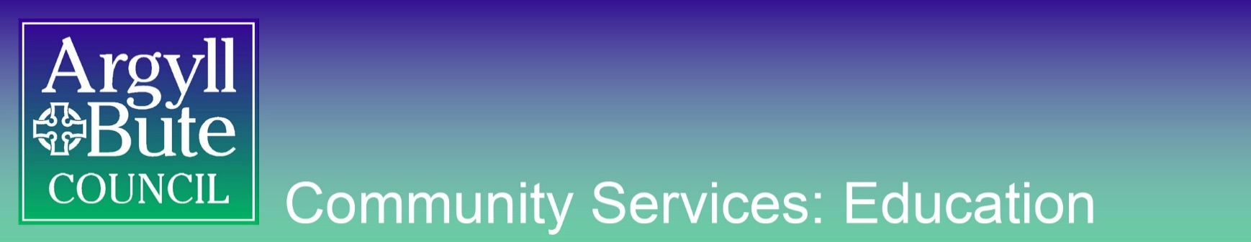

EDUCATION GUIDANCE

GUIDANCE on: Holistic Tasks

Produced: April 2019
Due for Review: April 2020
Owner: Various

A holistic assessment task should demonstrate the following:
- Breadth of learning - it should be based on a range of Experiences and Outcomes across different organisers (but not necessarily curricular areas);
- Challenge - it should ask pupils to use a range of higher order thinking skills such as analysis, creation, evaluation, problem solving, tackling multi step tasks, interpreting tasks;
- Application of learning in new and unfamiliar situations.

It will also come from one of the four contexts of learning:
- Life and ethos of the school as a community;
- Curriculum areas and subjects;
- Interdisciplinary learning;
- Opportunities for personal achievement.
To ensure best practice, the holistic task should be created at the same time as the planning is taking place, following the process laid out in the Moderation Cycle:
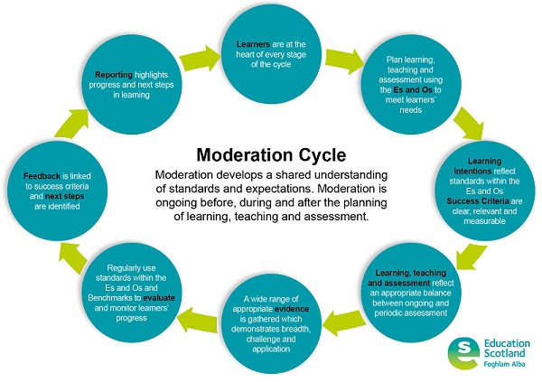
Using holistic assessment should also allow schools to tackle bureaucracy as it reduces the time for assessment by focusing on bundles of Experiences and Outcomes.

More advice, including a short Education Scotland video and examples of tasks, can be found here.
Practical Examples
Think about how existing practice can be adapted to include holistic tasks. You may already have tasks planned which could be tweaked slightly to ensure it’s a holistic task. For example…

- OLD TASK: a worksheet in which pupils have to label shapes.
- Vs.
- NEW TASK: pupils are asked to use a variety of shapes to create a picture and label them. Then they need to add up how many of each shape they used and say which one they used the most and which one they used the least.

The new task is holistic because it allows the learner to demonstrate:
- Breadth – comes from a range of organisers (shape, addition, number processes…)
- Challenge – requires learners to create
- Application – calls on skills (like addition) that they have learned previously to be used in a new context

Some practical examples of using Holistic Assessments could include:
- As a progress check before a summative assessment to find out whether any course content needs to be revisited
- As a means of assessing prior learning before a new topic
- When doing a task for a second time (ie. a second Critical Essay, a second painting in a similar style…)
- Based on real life events for pupils (ie. going on holiday, budgeting to buy something they like)
- Preparation for a school event, like a trip, show or open evening (ie. costing, planning, creating materials for it)
- Aftermath of a school event (ie. some form of writing task – challenge can be increased by varying the format of writing from the usual format, eg. a letter, a poster, a diary entry, a newspaper article, etc)
- Tasks which connect to groups in the school (eg. monitoring the weather for the Eco-Schools Group; a survey about a particular issue for the School Council)
- Tasks about issues raised in the community (ie. persuasive posters/letters/articles about littering, anti-social behaviour, etc)
- As a transition task (eg. budgeting for their first day/week)
- Written up interviews with individuals (ie. a new pupil, a new member of staff, a visitor to the school)
Education Scotland provide the following prompts for creating and moderating holistic tasks:
- Select a bundle of Es and Os which reflect the learning happening in the classroom.
- Create a holistic task which requires:-
  - the learner to draw on a range of learning
  - appropriate level of challenge
  - higher order thinking skills
  - application of learning in a new and unfamiliar situation
  - come from one of the four contexts of learning

Experiences and outcomes

Holistic Task

 | Prompt | Evaluative comments/suggested improvements
Experiences and Outcomes | Do the Es and Os link concepts appropriately and fit naturally?  Are they taken from a range of organisers?
Holistic Question | Is the task at the appropriate level?
 | Does the task enable the teacher to gather evidence of learning against the selected Es and Os?
 | Will this task require the learner to draw on a range of learning?
To what extent does the task promote higher order thinking skills?

Which skills will be most needed?

 | Are breadth, challenge and application evident?
This is an example of a first level holistic task for numeracy that was created by practitioners at a recent national QAMSO event. Moderate the example using the sets of questions provided by Education Scotland.
Holistic task – ETHOS OF SCHOOL AND CURRICULAR AREAS
Primary 4 are making Christmas crafts for their Christmas Fayre. They are making Snowmen Marshmallow Sticks.
Each snowman needs –
1 lollipop stick 12p each
3 marshmallows 15p each
9 smarties 6p each
1 spoonful of melted chocolate 2p a spoonful
How much does it cost to make one snowman?
By the day of the Fayre they have made 40 snowmen. Create a table that shows how much of each item has been used. What have they used the most of? What have they used the least of?
How much have they spent altogether to make the 40 snowmen?
The 1st customer buys 4 lollipops at £1.50 each. How much change do they get from £20?
Using the smallest number of coins, how would you give them their change?
Experiences and Outcomes
MNU 1-02a
MNU 1-03a
MNU 1-09a
MNU 1-09b
MNU 1-20b

This is an example of a second level holistic task for literacy that was created for practitioners at a recent national QAMSO event. Moderate the example using the sets of questions provided by Education Scotland.

Visit Scotland – Curricular Areas and Subjects
Research the tourist attractions Scotland has to offer through looking at leaflets and websites such as the Visit Scotland website. Take notes as you research and organise these under suitable headings.
Choose an appropriate format – eg advertisement, leaflet, poster, talk – through which to share your information and persuade tourists to come and visit Scotland.

Reading
I can select and use a range of strategies and resources before I read, and as I read, to make meaning clear and give reasons for my selection.
LIT 2-13a
Using what I know about the features of different types of texts, I can find, select and sort information from a variety of sources and use this for different purposes.
LIT 2-14a
I can make notes, organise them under suitable headings and use them to understand information, develop my thinking, explore problems and create new texts, using my own words as appropriate.
LIT 2-15a
To show my understanding across different areas of learning, I can identify and consider the purpose and main ideas of a text and
use supporting detail.
LIT 2-16a
Writing
I can use my notes and other types of writing to help me understand information and ideas, explore problems, make decisions, generate and develop ideas or create new text.
LIT 2-25a

Myth Busting
Holistic tasks are probably simpler than you think.
Myth – Holistic tasks are completely new.
Busted – Chances are, you will already be using some of the ethos of holistic tasks. As long as pupils are being given opportunities to apply previous learning in challenging activities which are not just assessing individual organisers then you are doing holistic assessment.

Myth – Every assessment needs to be a holistic task.
Busted – There is no need to only use holistic tasks. Some organisers will be better suited to holistic tasks than others. Aim to do two holistic tasks a session.

Myth – Holistic assessments should be high stakes tests.
Busted – The use of the word “assessment” can be a bit misleading. Remember that assessment should be ongoing and part of everyday learning – not all assessment needs to be a sit down test; it can be observations, jotter work, discussions, etc. Referring to them as holistic tasks or holistic questions may help this.

Myth – Holistic tasks should always take one hour to complete.
Busted – Some holistic tasks will be completed in a lesson; others may take a week of lessons to complete. It depends on the type of task and how many Es and Os are being assessed.

Myth – Holistic tasks are the same as holistic marking.
Busted – The repeated use of the word “holistic” is, again, a bit misleading. Marking holistically is taking an overview of an entire piece and making a judgement, based on criteria and exemplification (like marking writing pieces or art work).

Myth – We need to change all of our plans and assessments so that they include the term “holistic task”.
Busted – If you and your colleagues look at your pupils’ bodies of evidence and can identify pieces of work or other evidence which demonstrates breadth, challenge and application, then chances are you are already doing holistic tasks. Being aware of the terminology and being confident that pupils are being given opportunities to demonstrate breadth, challenge and application is what is important.

