Owl Facts - Feathers
- Owls can fly silently. Some people think that this is so that the prey doesn’t hear the owl approaching. It is actually so that tiny sounds made by the prey are not drowned out by the sound of the owl’s wings moving through the air.
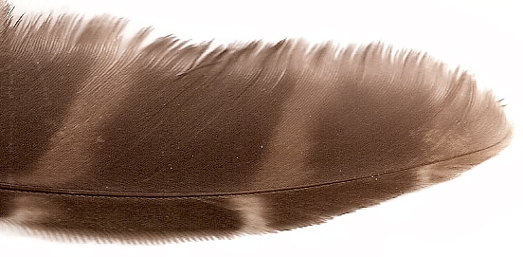
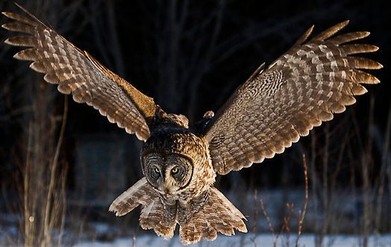
- The main reason owls can fly silently is the unique design of the primary feathers on the edge of the wings. When most birds fly, turbulence, created when air gushes over the surface of their wings, causes noise. In owls this noise is reduced because the edges of the feathers are ‘serrated’, like a comb. These soft edges allow air to pass through and the sound is muffled.

- Owls also have broad wings with large surface areas that help them to move through the air without flapping too much. Less flapping makes less noise.
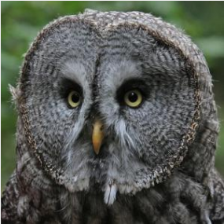

The arrangement of feathers on the face and around the eyes creates ‘facial discs’. The help to direct sound towards the owl’s ears – owls have excellent hearing.

