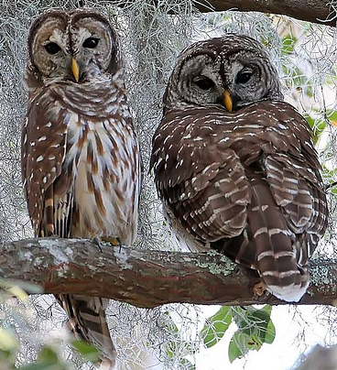
Owl Facts – Eyes
- Owls’ eyes are ‘fixed’. This means that an owl cannot move its eyes.
- Because it cannot move its eyes, an owl can move its head almost
all the way round. Extra vertebrae in its neck make this possible.

- Owls don’t see colours in detail. Their world is pale and almost colourless.

- The colour of the eyes tells us (in most cases) at what time of day the owl hunts:
Yellow, or white = diurnal (daytime hunters)
Orange = crepuscular (dawn / dusk hunters)
Black, or brown = nocturnal (night hunters)

