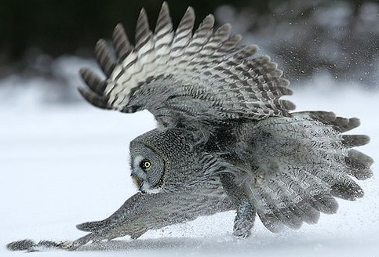
Owl Facts – Ears
- Hearing is the main sense used by an owl when it is hunting.
- The great grey owl has the best and most sensitive and accurate hearing of any animal that lives on dry land.
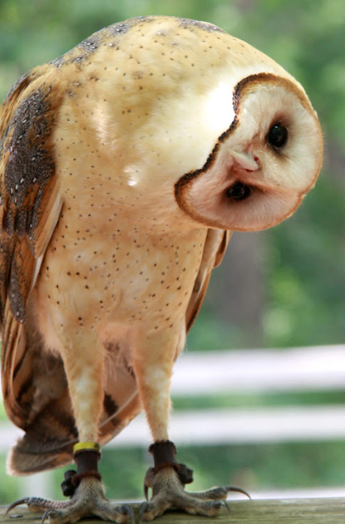
- The ears of an owl are just about level with the eyes, but one is slightly higher and further back than the other. This means that sound reaches each ear at a slightly different moment. The owl moves its head up and down and from side to side until the sound is coming into each ear at the same time. It has now pinpointed its prey....
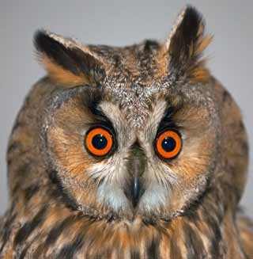
Ear tufts - these are not ears! Certain species of owl which roost in trees have ear tufts. The ear tufts break up the shadow of the owl against the leaves of the tree. So the ear tufts act as a kind of camouflage.

