Assessment and Moderation in the BGE – Support Pack
National Context
The National Improvement Framework for Scottish Education sets out the vision and priorities for continually improving Scottish education and closing the attainment gap, delivering both excellence and equity.

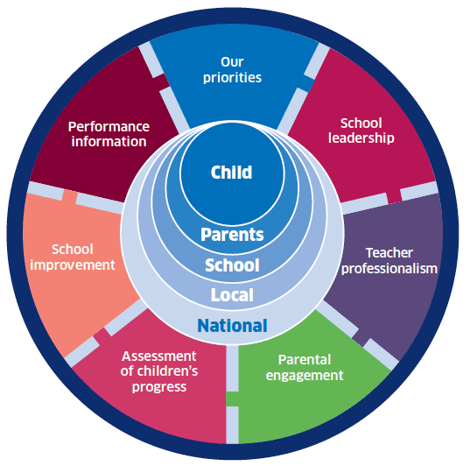
One of the key drivers within the National Improvement Framework is the assessment of children’s progress. This focuses on a range of evidence, demonstrating what children learn and achieve throughout their school career. This includes Curriculum for Excellence levels, skills, qualifications and other awards.

The Framework originally set out plans to collect teacher judgement data on achievement of CfE levels in literacy and numeracy, which have now been taken for three years. As this data becomes increasingly consistent and well moderated, we will be able to focus more accurately on the difference in attainment between the most and least disadvantaged children and take further action as a result. This data should be informed by a range of evidence, including standardised assessment, holistic assessment, summative and formative strategies and ongoing classwork. This data helps teachers to identify areas where good practice exists and which high-impact interventions should be shared. It also helps us to identify areas where, collectively, we need to do more. There is a need to use robust and consistent evidence to help us in raising attainment and closing the attainment gap.

By encouraging all teachers to take part in regular moderation activities, from the planning stages throughout, we are encouraging them to develop as enquiring professionals who are experts in teaching literacy, numeracy and health and well-being. This is critical to ensure the strongest possible progression in learning for all children. The methodology of moderating these responsibilities of all can then be applied to other curricular areas.

John Hattie (2009) argues that the greatest single issue facing the further enhancement of students is the need for teachers to have a common perception of progress. When a learner moves from one teacher to another, we must be able to guarantee that he or she will experience increasingly challenging tasks and similar expectations of progress. Teachers must have the knowledge and skills to help learners grow from where he or she is, as opposed to where they believe they should be at the start of the year. Moderation activities across and between schools are therefore essential, particularly at times of transition.
Local Priorities
In Argyll and Bute, our vision is clearly stated in Our Children, Their Future: together we will realise ambition, excellence and equality for all.
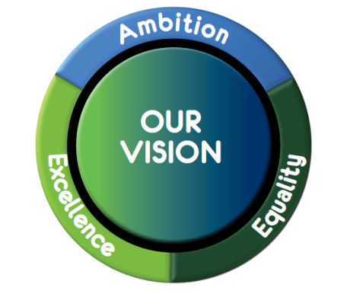
Schools with effective planning, assessment and moderation cycles in place have reported a number of key benefits that link directly to this vision and the six key objectives outlined in Our Children, their Future, including:
- Raised levels of attainment as practitioners build a better understanding of progression throughout the school, ensuring levels of pace and challenge remain high and avoiding dips in progress.
- Improved quality of learning experiences as learners better understand their learning and therefore become more motivated and engaged.
- Practitioners work together more effectively, building capacity and confidence in themselves and each other, particularly when making professional judgements.
- More effective assessment, tracking and monitoring systems are put in place to allow the monitoring of progress of all learners.
- Improved partnership working between early years’ practitioners and teachers, leading to more depth of understanding around planning for CfE and the developmental milestones in the early years.
- Development of leadership skills in staff as Head Teachers and Department Leaders are able to rely on the growing expertise of teachers, facilitated by Assessment and Moderation Facilitators.

More information relating to the national and local picture regarding Assessment and Moderation can be found in Appendix A - Assessment and Moderation - Setting the Context (PPT). This can be used for training purposes, led by AMFs.
The Moderation Cycle – Developing a Consistent Approach
For a number of years now, practitioners across Argyll and Bute have been encouraged to use either the NAR flowchart or the PAM Cycle for planning, assessment and moderation. These have both been replaced by the Moderation Cycle, developed by Education Scotland, which is very similar to the PAM Cycle and follows the same ethos of moderation being an ongoing process:

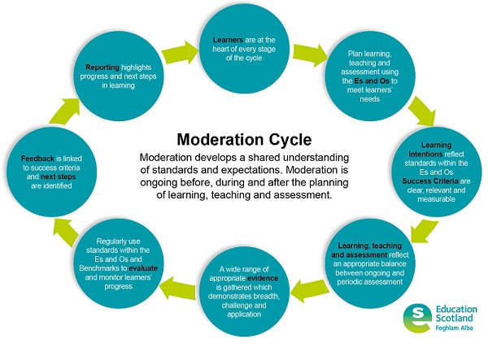

This should not be viewed as ‘something new’. The key messages remain the same as the PAM Cycle:
- This is a cyclical process – we do not reach ‘the end’. Rather, we reflect and evaluate against our understanding of the Moderation Cycle and BtC5 before deciding on how best to move forward.
- We must be looking for opportunities to bundle Es and Os, not only across curricular areas for IDL but also across organisers, particularly when planning for literacy and numeracy.
- The Learning Intentions directly inform the learning experiences, making it clear what pupils should know, be able to do or understand. These should provide breadth, depth, challenge and application based upon the planned learning.
- The Success Criteria are used for assessment purposes and feedback – children and teachers should be assessing progress against the agreed Success Criteria and it is essential that these are relevant and measureable.
- A range of evidence should be used for deciding whether pupils have achieved a level, though this evidence does not all need to be in one place.
- The Benchmarks are to be used for assessment purposes. These should inform professional dialogue and not be used as a checklist for planning.
- Recent guidance has been released from Education Scotland on reporting to parents and carers – ‘Reporting to Parents and Carers Guidance for schools and ELC settings’

Appendix B – The Moderation Cycle (PPT) can used to explain this process to staff.
It is the expectation that all teachers use this model for planning learning experiences within their classroom, and where possible, this model should be used for collaborative planning - particularly within literacy and numeracy.

Appendix C – Authority Guidance on Assessment is for Learning provides support in all aspects of Formative Assessment, including Learning Intentions, Success Criteria and Feedback. Associated PowerPoints will be available on SALi soon and can be used for training purposes.

We have also provided some examples of planners being used in schools and ELC settings on SALi that reflect this process and include each of the 7 key elements of effective planning, assessment and moderation:
- Bundled Experiences and Outcomes
- Learning Intentions
- Success Criteria
- Learning experiences
- Planned assessment approaches (including hinge questions and summative/holistic tasks)
- Feedback and next steps
- Evaluation

There is no expectation that each of these elements should be written and no set planning format has to be used. The emphasis should be on the quality of professional dialogue around these elements, rather than evidencing that they happened.

Achievement of a Level
Achievement of a Level data (NIF) should only be based on literacy and numeracy experiences and outcomes and not English and mathematics.
You should be able to evidence that learners have:
- Achieved a breadth of learning across each of the different organisers at their level.
- A depth of understanding across most aspects – but not necessarily all – and responded positively to the level of challenge set within the Es and Os.
- Applied their learning in new and unfamiliar contexts – holistic assessments provide strong evidence of this. In Secondary, evidence would be taken from a range of subject areas.
- Pupils have moved towards working at the next level for some aspects.

Benchmarks and the Argyll and Bute Numeracy Progression Framework should be used to support professional dialogue when making judgements.

Robust procedures for recording, tracking and monitoring are essential in providing efficient and effective systems for tracking progress throughout a level and should allow schools to draw on a wide range of evidence for each learner with ease.

Moderation judgements should be made following moderation discussions, considering a range of evidence. Two authority training days in March – one for Early and First Levels, and one for Second and Third Levels – are also planned to allow practitioners to moderate pupil evidence across the authority. Furthermore, a number of our QAMSOs are currently undertaking a professional learning opportunity with Education Scotland which will involve the organisation of cluster moderation events and the development of banks of moderated pupil evidence.

Support
We recognise that different establishments are at very different places within their assessment and moderation journey and would like to offer a loose guide/breakdown of activities that might support you in moving forward. This is not a definitive list but may provide you with some ideas for taking the next step (e.g. some schools may be starting on number 1, others may be ready to start at number 5)
- Self-evaluation – where are you now in terms of assessment and moderation? Education Scotland’s “Improving moderation through effective self-evaluation” (Appendix E) may be a useful resource for this.
- Revisiting BtC5 and linking this to The NIF and Our Children, Their Future – setting the context training can be very important for all practitioners to understand why we are on this journey and the impact that it can have on our learners.
- Training on the Moderation Cycle – ensuring practitioners are familiar with the cycle and that planning across your school reflects the key elements; materials (including an introductory video) can be found on the Moderation Hub to support this process.
- Looking specifically at Learning Intentions and Success Criteria – what is the difference? What makes good Learning Intentions/Success Criteria? This has been highlighted at national moderation events as an area of concern – is it worth revisiting in your setting? The AifL Guidance and associated PowerPoints on SALi can be used for this.
- Providing effective feedback for children – this is vital in raising attainment and closing the gap. It may be worth exploring the benefits of written/verbal feedback and considering the language used in this. Appendix E, a PowerPoint related to this and some exemplar feedback to moderate, can be used for this.
- Choosing an aspect of literacy/numeracy to plan for collaboratively (or revisiting an area of your BGE) – work through the Moderation Cycle and build up an idea of what progression in that area looks like within your school/between schools/across your department. Bundle Es and Os appropriately to get the most from your project – what links exist across organisers? How might you plan for these collectively?
- Embed practices of moderation – do you have a termly focus across the school/between schools? Have you revisited your BGE course and ensured that it reflects the Moderation Cycle? ((Appendix G – “Rolling this out in different settings” provide examples of good practice from primary and secondary schools that may provide support at this stage.)
- Creating holistic assessment tasks – ensure all staff understand what holistic assessment means, using training materials available. Staff should then ‘have a go’ at creating a holistic assessment task as part of the Moderation Cycle – these can be planned for collaboratively and should provide breadth, challenge and application (Appendix H – Creating Effective Holistic Assessment Tasks PPT, available here, can support this as well as additional resources provided on SALi). These can then be moderated across or between schools and feedback given.
- Achievement of a Level – exploring as a staff what ‘Achievement of a Level’ looks like and what the body of evidence created for each pupil might look like, while ensuring that staff are aware of the need for a range of evidence. Moderation of the evidence at each level in and across schools/departments/clusters. Appendix I – “A Range of Evidence Contributing Achievement of a Level” handout – can be used as a reminder for staff.
- Tracking and monitoring: could your AMF lead a session with school staff reviewing the tracking and monitoring systems within the school – is there a good balance of summative and formative assessment? Is there regular professional dialogue regarding pace, challenge and progress? Are interventions put in place and monitored?
A range of resources will soon be uploaded onto SALi, including all of the training documents referred to within this overview.
Appendix J - People Who Can Help provides a list of names and contact details for members of the central team who can offer you support as well as the names and email addresses of all QAMSOs. We are very keen to encourage networking between AMFs and QAMSOs – AMFs have been split into groups and “assigned” to each QAMSO, so that following national moderation events, QAMSOs can share the key messages of their training with their AMFs, who can then share them with their schools. We have recommended that QAMSOs make contact with their AMFs to organise a meeting to share good practice and consider how to move moderation forward in their cluster; at the upcoming AMF Recall Day, we also plan to allow time for AMFs and QAMSOs to gather in their cluster groups.

Conclusion
Effective assessment and moderation practices align a large number of local and national priorities in education, simultaneously raising attainment levels and allowing us to accurately focus on the gaps in learning and address these effectively. They improve learning and teaching experiences for children and ensure that all staff have a deep understanding of their learners’ progress and how this relates to national standards and expectations.
The schools that have reported the most success in driving forward their assessment and moderation practices have ensured that time has been given over to this in their Working Time Agreements and we therefore urge schools to consider this carefully when planning the collegiate calendar for their upcoming session.

Appendix
Appendix A - Assessment and Moderation - Setting the Context (PPT).
Appendix B – The Moderation Cycle (PPT)
Appendix C – Authority Guidance on Assessment is for Learning
Appendix D – Planning exemplar for primary
Appendix D(ii) – Planning exemplar for secondary
Appendix E – Moderating Feedback PowerPoint
Appendix E(ii) – Exemplar Feedback to Moderate
Appendix F – Education Scotland’s “Improving moderation through effective self-evaluation”
Appendix G – “Rolling this out in different settings - primary” (PPT)
Appendix G(ii) – “Rolling this out in different settings – secondary” (PPT)
Appendix H – Creating Effective Holistic Assessment Tasks (PPT)
Appendix I – A Range of Evidence Contributing to Achievement of a Level
Appendix J - People Who Can Help

Helpful Resources/Links
Reporting to Parents and Carers Guidance for schools and ELC settings
The Assessment and Moderation page on SALi
Argyll and Bute Numeracy Progression Framework
Building the Curriculum 5 and a potted version
The National Improvement Framework
Our Children, Their Future policy document
The Moderation Hub
Holistic Assessment video explanation

