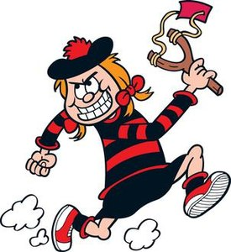
Minnie Minx
Word Bank Translation
Is mise….. I am called….
Tha mi…… I am….
Tha mi a’ fuireach ann am ….. I live in……….
Chan eil mi….. I am not…….
Tha……..orm It is on me (clothes, hair)
Tha….agam I have………….
‘S toigh leam………. I like…………

- __ ____ Minnie.
- ___ __ deich.
- ___ __ _ ________ ann am Baile Beano.
- ____ ___ __ modhail.
- ___ ad ___.
- ___ geansaidh le striopan dearg agus dubh ___.
- ___ sgiort dubh ___.
- ___ falt ruadh ___.
- __ ____ ____ iasg agus sliseagan.
- ___ cat ____.

