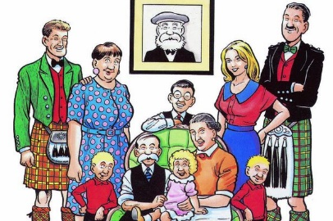
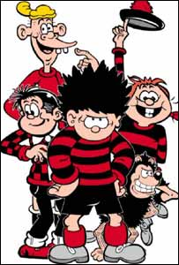
Argyll and Bute Gaelic Comic Book P7/S1 Transition Project

Aim: All P7 pupils to create their own Gaelic comic strips which can be displayed at their local secondary school during transition.
Activities linked to this project can be part of the Gaelic teaching which takes place when P7 pupils are on transition visits or during their first term at secondary school.
This project is designed for whole clusters or across clusters within the authority.
Scottish comic books have been chosen as the overarching theme with a particular focus on the Beano and Broons series of comic books.
The comic book format is inclusive as learners can achieve success through writing very simple sentences. This encourages reluctant writers to participate while allowing confident writers the opportunity to create more complex story lines.

Resource Pack
A resource pack has been developed by Argyll & Bute Council specifically for this project and is designed to support practitioners in the delivery of the project.
The principal resources for the project are sound enabled Powerpoints which can be found at
https://blogs.glowscotland.org.uk/ab/sali/12-languages/transition-projects/
These PPTs present characters from two popular Scottish comics- The Broons and the Beano . All characters present themselves simply, in the first person e.g. Is mise Dennis. Tha mi deich.
You may wish to use all the characters or select a few. This can be discussed as a cluster. For example, some clusters, with predominately multi-composite classes, have selected specific characters in order to focus on different characters the following year.
The language within the PowerPoint can also be edited if you wish to only focus on a few key phrases.
The Gaelic language activities in the resource pack focus on constructing simple sentences to talk about yourself e.g. Is mise…., Tha mi……. This learning is then used by pupils to describe comic book characters in the first person e.g. Is mise Minnie, Tha mi a’ fuireach ann am Baile Beano etc. Using this framework, learners then invent their own characters and create simple comic strips in Gaelic containing first person description. The comic strips produced will be of varying lengths depending on the ability of the learners.

Contents of Resource Pack

Writing activities:
These activities are designed to develop learners’ confidence in writing simple sentences containing first person description. This will then allow them to create their own comic strips with minimal use of a dictionary or google translate.

All about me booklet
This booklet is a good starting point for the project as it focuses on simple sentence structures which allow learners to write about themselves. This booklet can then be used as a stimulus for the learners to create their own characters, using the sentence structures as a framework and then adapting these.

Matching and Gap fill activities for each of the comic book characters. These help with the comprehension and production of descriptive sentences and allow pupils to consolidate their learning.

My Character writing frame

Comic strip templates

Colour Character descriptions for display

Once learners have completed these activities they will have developed their confidence in creating first person descriptive sentences. They can then use the All about Me booklet or My Character writing frame to create sentences about their own comic character. The resource pack also contains comic strip templates to help pupils create their own comic strips.

For learners who are not confident with their drawing skills there is the option of using digital tools:
Website for making comic strips: http://www.makebeliefscomix.com/ you do not need to create an account and the comic strips can also be printed. (Guide to finding accents on a keyboard included in resource pack)

Book Creator Chrome on laptops.
This resource has a comic book format so learners can create their own e-comic books. This resource is free but you need to create a class account. The e-books are fully interactive and can even speak in Gaelic if you download the Ceitidh Voice from Call Scotland on to the laptops (To obtain this software please log a call with the IT service desk and an IT technician will install this software remotely).

All the printable resources in this pack are also available in digital form at https://blogs.glowscotland.org.uk/ab/sali/12-languages/transition-projects/

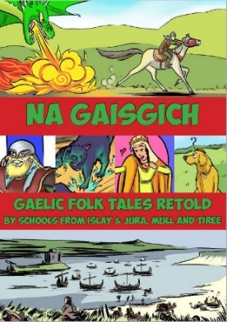
Links for Gaelic Comic book project

The Argyll and Bute Gaelic Comic Book created by all the schools on Islay, Jura, Mull & Tiree is an excellent resource to inspire the learners to create their individual Gaelic comic strips.

www.argyll-bute.gov.uk/sites/default/files/gaelic_comic_2018_screen_res.pdf

The Beano has a great website for learners to explore: https://www.beano.com/
Within this website there are some really useful drawing tutorials which will help learners to draw various characters from the Beano. Here are some direct links.
Drawing characters:
https://www.beano.com/categories/quick-draw
https://www.beano.com/posts/how-to-quick-draw-dennis
https://www.beano.com/posts/dennis-gnasher-unleashed-how-to-draw-dennis
https://www.beano.com/posts/how-to-draw-minnie-the-minx
https://www.beano.com/posts/how-to-quick-draw-gnasher
https://www.beano.com/posts/dennis-gnasher-unleashed-how-to-draw-gnasher
https://www.beano.com/posts/how-to-quick-draw-walter
https://www.beano.com/posts/how-to-quick-draw-mrs-creecher
https://www.beano.com/posts/how-to-quick-draw-5-more-mythical-creatures

The Story of the Beano
Some articles on the history and evolution of the Beano through time.

1974 Minnie the Minx: https://www.beano.com/posts/on-this-day-in-beano-history-28th-september-1974
https://www.scottishfield.co.uk/culture/whatson/a-special-event-to-mark-80-years-of-the-beano/
https://www.scotsman.com/lifestyle/culture/books/scottish-fact-of-the-week-the-beano-1-3048606
https://theculturetrip.com/europe/united-kingdom/scotland/articles/a-brief-history-of-the-beano-scotlands-beloved-comic/
https://www.list.co.uk/article/14523-the-beano/
https://www.bbc.co.uk/news/uk-scotland-tayside-central-44951622 (+video)

Smathsin is an online Gaelic comic which could be used as a learning resource for this project https://smathsin.co.uk

Developing and Extending the Project

Practitioners may wish to develop this project to incorporate more IDL opportunities or extend the Gaelic language learning.

Links to literacy: Learners can read comic books in English.
Perhaps explore other genres such as Japanese Manga or French comics like Asterix and Tintin. These comics also have Gaelic translations which could be explored. Although the Gaelic versions would be too difficult to read independently, learners could be word detectives in order to identify familiar words on a page.

Cultural links: In many cultures comic books are as popular with adults as children. This is the case in France.
Links to pages about the culture of comic reading in France: https://www.understandfrance.org/French/Cartoons.html
http://news.bbc.co.uk/1/hi/programmes/from_our_own_correspondent/7246634.stm

The learning could be extended to describing characters in the third person or secondary colleagues could focus on this aspect of learning. Several clusters have chosen this option for the French Comic book transition project, with the modern languages department continuing the comic book theme during the first term of S1 in order to develop third person description.

