Gnasher
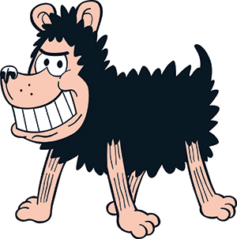
Word Bank Translation
Is mise…..
Tha mi…….
Tha mi a’ fuireach ann am …..
Chan eil mi….. I am not…….
Tha……..orm It is on me (clothes & hair)
Tha….agam I have………….
Is toil leam………. I like…………

- __ ____ Gnasher.
- ___ __ trì.
- Tha mi a’ fuireach ___ __ Baile Beano.
- ____ ___ mi modhail.
- ___ bian dubh ___.
- __ ___ ____ a bhith a’ cluich le Dennis.
- __ ____ ____ a bhith a’ ruith.

