

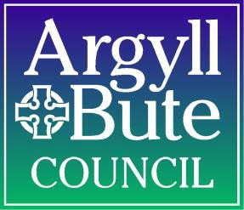**Argyll and Bute: Education**

**Annual Plan**

**2017/18**

**Our Children, Their Future**

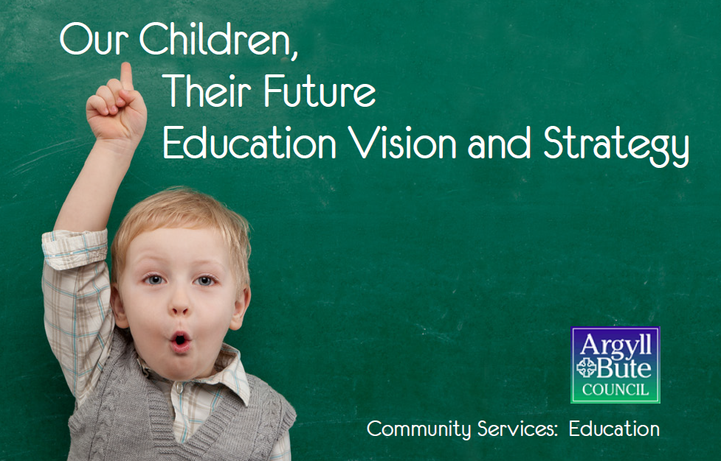

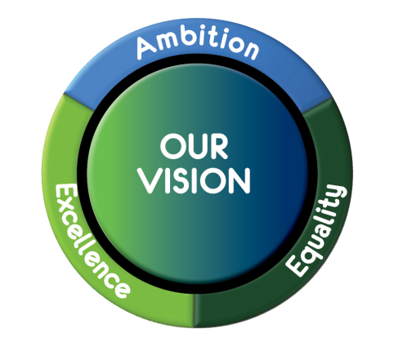

|  |  |  |
| --- | --- | --- |
| **Section** | **Content** | **Page** |
| Section 1: | **Foreword and Introduction**   * 1. Councillor Yvonne McNeilly   Policy Lead for Education and Lifelong Learning   * 1. Ann Marie Knowles   Executive Director, Community Services (Acting) |  |
| Section 2: | **The Purpose and Use of the Annual Plan** |  |
| Section 3: | **The Policy Context for Education Services**  3.1 The Standards in Scotland’s School etc. Act. 2000, as revised in 2016  3.2 Key Priorities of Argyll and Bute Council: Education Service |  |
| Section 4: | **The Context for the Annual Education Plan**  4.1 The Argyll and Bute Education Vision: Our Children, Their Future  4.2 Our Children and Young People  4.3 The Population and Demographic Profile of Argyll and Bute  4.4 Multiple Deprivation in Argyll and Bute  4.5 Supporting all of our Children and Young People  4.6 Resourcing our Plan: The Education Budget |  |
| Section 5: | **Continuity and Progression with Previous Plans**  5.1 Analysis of Performance Information  5.2 Inspection and Scrutiny Outcomes  5.3 Reducing Inequalities in Educational Outcomes as a result of Socio – Economic Disadvantage |  |
| Section 6: | **Addressing the National Improvement Priorities in Argyll and Bute**  6.1 The Four National Priorities for Education in Argyll and Bute  6.2 Addressing The Four National Priorities for Education in Argyll and Bute   * School leadership * Staff professionalism * Parental engagement * Assessment of children’s progress * School improvement * Performance information   6.3 Pupil Equity Funding  6.4 Addressing the Six National Improvement Drivers for Education in Argyll and Bute  Education Services organisational Chart |  |
| Section 7: | **Bibliography and references** |  |

**SECTION ONE: FOREWORD AND INTRODUCTION**

**Councillor Yvonne McNeilly, Policy Lead for Education and Lifelong Learning**

I am delighted to provide you with the first Annual Education Plan for our schools and services in Education in Argyll and Bute for 2017/2018. This plan has been prepared in response to the requirements of the Standards in Scotland’s Schools etc. Act 2000 which brings new statutory duties for the Local Authority into force.

Our plan draws together a range of information of the work of the Education Service for pupils, staff, parents and carers and our communities. It is aimed at ensuring that all of our children and young people are provided with the best possible educational experience and are fully supported to achieve their full potential.

I am pleased that this new annual plan helps us to recognise and celebrate a wide range of the work of the Service, to celebrate both our young people and our staff. We have a great deal to be proud of in Argyll and Bute and this plan illustrates a number of the successes and achievements of our children and young people, of our staff, as well as those of our schools and services. It is right to be proud of these achievements, but equally important to acknowledge that further improvements are still needed. Improvements which are being taken forward by the Service as part of our ambitious change programme. A programme which is aimed at responding to a period of significant National change, challenge and development for Scottish Education.

This plan sends an important message about the importance that Argyll and Bute Council places on the delivery of Education. The new Education Vision and Strategy: *Our Children, Their Future*, published earlier this year contains six key objectives. We have continued their use in this plan as our key drivers for raising educational attainment and achievement for all children and young people in Argyll and Bute.

Finally, my thanks to all of our children, young people, staff, families and communities for their continuing support at this important time.

Kind regards,



Yvonne

**Ann Marie Knowles, Acting Executive Director, Community Services**

Our Vision is to ensure that together we will realise **ambition**, **excellence** and **equality** for all. For Education Services this means delivering services of the highest quality that inspire all learners, transform and improve learning experiences and strengthen our communities to continually improve our service for everyone who use them.

The preparation and publication of this Annual Plan prescribed under the new legal framework arising from the Standards in Scotland’s etc. Act. 2000, as revised in 2016 places an increased focus on improvement planning and, importantly, performance reporting for Education in Argyll and Bute, and the context for this new Annual plan takes full account of a number of significant National, Council and local expectations and developments.

Section 6 of the plan highlights the key objectives and actions to be addressed by the Service and by schools and establishments as an integral aspect of their improvement planning processes for session 2017/2018.

I hope you find the Annual Plan both informative and useful. The commitment of all of our staff who are part of Education Services enable us to continue to take forward our very high aspirations. Our continued focus is to ensure that we provide the best possible learning experiences for all of our children, young peoples and adults. Experiences which support and endorse our commitment to ambition, excellence and equality.

My sincere thanks to everyone for their contributions to the development of the Education Vison and Strategy, ***Our Children, Their Future*** and to the revision of Schools, Service and Establishment Improvement planning for session 2017/2018, essential features of this new Annual Education Plan.

A copy of this plan will now be sent to Scottish Ministers, as required within the legislation. Argyll and Bute welcomes this step, allowing us to develop and foster increasing and deeper knowledge of the successes and challenges facing Scottish Education, to engage with and share good practice and further our commitment to improving the lives of all children and young people in Argyll and Bute.

I would welcome any comments or suggestions you may have which will help Education Services make the most of the impact of the plan for our children, young people and communities.

Best wishes

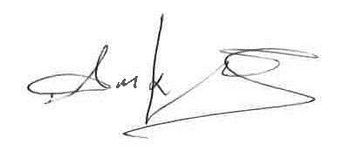

Ann Marie

**SECTION TWO: THE PURPOSE AND USE OF THE ANNUAL PLAN**

The Education Services Annual Plan for 2017/2018 has been prepared in compliance with the statutory guidance set out within the “*Standards in Scotland’s Schools etc. Act 2000”,* Published by Scottish Government in March 2017. It brings together a range of information from each of the areas of the Education Service in Argyll and Bute, reaffirming our shared vision for Education Services of **ambition,** **excellence** and **equality** for all.

The plan is aimed at providing schools, services and staff with the necessary information to support them to:

* Make increasing use of the key objectives contained within the Education Vision and Strategy: “*Our children, Their Future”* when developing andimplementing individual service, team and school improvement plans for session 2017/2018, and in doing so to ensure effective consultation with parents and carers, children and young people, staff, partners and communities is central to these processes;
* In doing so to have due regard to:

1. Improving educational outcomes for children and young people from socio-economic disadvantage;
2. Securing improvement in attainment, particularly in literacy and numeracy;
3. Closing the attainment gap between the most and least disadvantaged children and young people in Argyll and Bute;
4. Improvement in the health and well-being of children and young people in Argyll and Bute, and
5. Improvement in employability skills and sustained, positive school-leaver destinations for all young people in Argyll and Bute.

* Make effective use of this plan and the associated improvement framework to implement our shared key objectives through the delivery of effective learners journeys between classes, and stages of curriculum for excellence and between and across schools, establishments and with our education partners;
* Use the objectives and improvement priorities to support and engage in professional discussions with children and young people, parents and carers, staff, partners and communities aimed at improving outcomes for learners;
* Take steps to identify, celebrate and share effective practice across Education Services;
* Take effective action in ensuring that both school and service/team plans complement and re-inforce the work being taken forward both by schools and services to deliver improving outcomes for children and young people;
* Ensure the use of an increasing range of relevant and appropriate performance data to inform decision making and secure improvement for all children and young people, and
* Continue their effective use of the National Improvement Framework Drivers for Improvement.

**SECTION THREE: THE NATIONAL AND LOCAL POLICY CONTEXT**

This is a time of significant change for Education Services. The pace of change, the drive to improve services and the financial context combine to place increasing demands on the delivery of education. Despite these challenges, it is important that we remain ambitious to ensure the best outcomes for our children and young people.

**3.1 The Standards in Scotland’s Schools etc. Act 2000 and the National Improvement Framework for Scottish Education**

The 2017 document “The National Improvement Framework for Scottish Education: Achieving Excellence and Equity”, published in December 2016 set out four National Priorities for Education. They are:

* Improvement in attainment, particularly in literacy and numeracy;
* Closing the attainment gap between the most and least disadvantages children;
* Improvement in children and young people’s health and well-being, and
* Improvement in employability skills and sustained, positive school-leaver destinations for all young people.

The improvement framework documentation notes further that:

*“Everyone working in Scottish Education should be clear about how they can contribute to addressing these priorities. Local authority and school improvement plans should reflect these priorities and ensure the clear line of sight between local and national expectations. There may be further improvement priorities at school level based on local needs and self-evaluation.”*

*Source: Page 2: 2017 National Improvement Framework for Scottish Education: Achieving Excellence and Equity.*

These four priorities are set in the context of seven “*drivers for improvement*” summarised in the following diagram:

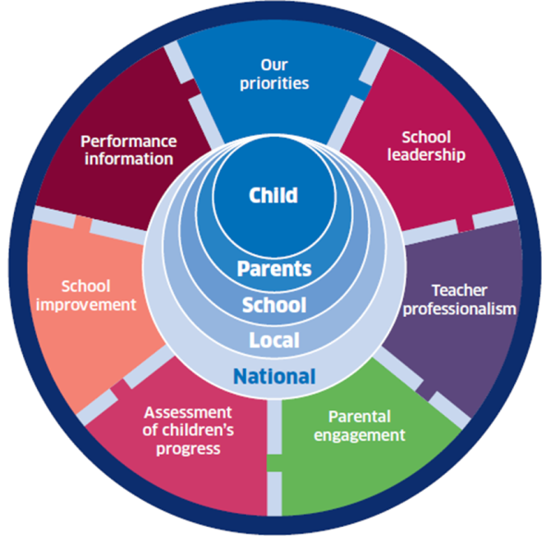

In addition to the National Improvement Framework, statutory guidance issued following the changes to the Standard’s in Scotland’s Schools etc. Act 2000, stressed a number of other important elements which should be included within their annual improvement plan. These include a requirement for:

“Education Authorities, in carrying out their school education functions, must have due regard to the need to reduce inequalities of educational outcome experienced by pupils as a result of socio-economic disadvantage, where:

* An education authority is making a decision of a strategic nature about the carrying out of its functions relating to school education, and
* An education authority is considering what steps to take to implement such a decision”.

The Authority must also seek and have “due regard” to the views of the following groups in relation to the Authority’s strategic decisions and steps to take to implement such decisions:

1. The Head Teacher of such schools managed by the Authority as the Authority thinks appropriate;
2. Such pupils as the Authority thinks appropriate;
3. The parents of such pupils as the Authority thinks appropriate;
4. The representatives of a trade union which appears to the authority to be representative of the teaching staff at such schools managed by the Authority as the Authority thinks appropriate;
5. Such voluntary organisations as the Authority thinks appropriate, and
6. Any other persons the Authority thinks appropriate.

The National Outcomes for Scotland include:

* Our children have the best start in life and are ready to succeed;
* Young people are equipped through their education to become successful learners, confident individuals, effective contributors and responsible citizens;
* We have tackled the significant inequalities in Scottish society, and
* We have improved the life chances for children, young people and families at risk.

Further legislation and policy are in place which require to be taken account of when delivering Education Services. This includes:

* The Education Additional Support for Learning (Scotland) Acts 2004 and 2009;
* The Children and Young People (Scotland) Act;
* The Scottish Schools (Parental Involvement) Act 2006;
* Teaching Scotland’s Future: Report of a Review of Teacher Education (2010);
* Getting It Right For every Child;
* Curriculum for Excellence;
* The Scottish Attainment Challenge;
* The National Improvement Framework;
* Raising Attainment For All;
* A Blueprint for 2020: The Expansion of ELC in Scotland;
* The Early Years Framework, and
* Developing Scotland’s Young Workforce.

These are inarguably the driving forces behind the work of Education Services reflecting national strategies such as the National Improvement Framework for Scottish Education as well as local strategies for the delivery of services in Argyll and Bute.

**3.2 KEY PRIORITIES OF ARGYLL AND BUTE COUNCIL: EDUCATION SERVICE**

Our aspiration is to ensure that Argyll and Bute is the best place in Scotland for our children to grow up. Our vision is that **together we will realise ambition, excellence and equality for all.** Our vision sends a signal about the importance we attach to education, is simple in message and is recognised by everyone.

Our vision is being delivered for all our children and young people through the following 6 key objectives. To:

* Raise educational attainment and achievement for all;
* Use performance information to secure improvement for children and young people;
* Ensure children have the best start in life and are ready to succeed
* Equip young people to secure and sustain positive destinations and achieve success in life;
* Ensure high quality partnership working and community engagement, and
* Strengthen leadership at all levels.

Our strategy for realising this vision is best explained by showing how our six objectives link to each of the national drivers and improvement priorities.

|  |  |  |
| --- | --- | --- |
| **Our Children Their Future (OCTF)**  **Priority Actions** | **National Improvement Framework (NIF)**  **Key Drivers for Improvement** | **National Improvement Framework (NIF)**  **Key Priorities** |
| Strengthen leadership at all levels | School Leadership |  |
| Teacher Professionalism |  |
| Ensure high quality partnership working and community engagement. | Parental Engagement |  |
| Ensure children have the best start in life and are ready to succeed. | Assessment of Children’s Progress | Improvement in children and young people’s health and wellbeing. |
| Equip young people to secure and sustain positive destinations and achieve success in life. | Improvement in employability skills and sustained, positive school-leaver destinations for all young people. |
| Raise educational attainment and achievement for all. | School Improvement | Improvement in attainment, particularly in literacy and numeracy |
| Use performance information to secure improvement for children and young people. | Performance Information | Closing the attainment gap between the most and least disadvantaged |

**SECTION FOUR: THE CONTEXT FOR THE ANNUAL EDUCATION PLAN**

**4.1 The Argyll and Bute Education Vision: Our Children, Their Future**

Our aspiration is to ensure that Argyll and Bute is the best place in Scotland for our children to grow up. Our vision is that together we will realise **ambition**, **excellence** and **equality** for all**.** Our vision sends a signal about the importance we attach to education is simple in message and is recognised by everyone. This is best captured as:

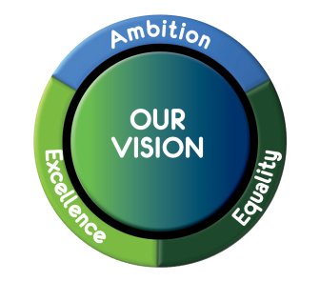

The Education vision is underpinned by our values: **respect,** **openness** and **fairness**.

This vision is being delivered for all our children through the following 6 key objectives.

We will:

* Raise educational attainment and achievement for all;
* Use performance information to secure improvement for children and young people;
* Ensure children have the best start in life and are ready to succeed;
* Equip young people to secure and sustain positive destinations and achieve success in life;
* Ensure high quality partnership working and community engagement, and
* Strengthen leadership at all levels.

We acknowledge and value the involvement of all stakeholders in supporting the delivery of these key objectives. To date stakeholder engagement has been progressed in a variety of ways including:

* Initial consultation with a reference group;
* Committee papers to elected members;
* Education Service Team meetings;
* In-service session for teaching staff;
* Meetings with groups of children and young people at school and authority level;
* Parent Council meetings, and
* Community meetings and planning groups.

Further engagement will be achieved through improvement planning in schools, establishments and services, ensuring our values are reflected in the work of all areas of the Service.

**4.2 Our Children and Young People**

Argyll and Bute, the second largest local authority by area covers approximately 9% of the total land area of Scotland. Argyll and Bute has the third sparsest population density (0.13 persons per hectare). The population of 87,660(NRS 2014 MYE) is scattered across an area of just under 2,700 square miles. It is approximately 100 miles long from the Isle of Coll in the north to Southend in Kintyre, and 90 miles wide from Bridge of Orchy in the east to the Isle of Tiree in the west.

More than half of Argyll and Bute's population live in rural areas, as classified by the Scottish Government's Urban-Rural Classification (2013-2014). A further 32% per cent live in communities with populations between 3,000 and 10,000 people designated as small towns. Less than a fifth of the population live in an urban area with a population of over 10,000 people.

Argyll and Bute is an area of outstanding natural beauty with mountains, sea lochs, and 23 inhabited islands. The geography provides challenges for service delivery, particularly in communications and transport.

**4.3 The Population and Demographic Profile of Argyll and Bute**

The total population of Argyll and Bute is 88,166 based on the 2011 census. This compares to a total population for the area of 91,306 in the 2001 census, a reduction of 3.4%. We were one of only 4 Local Authority areas to show a decrease in population. Future population projections suggest a reduction in our total population of 7.2% from 2010 to 2035.

The change in population from 2001 to 2011 is different across the 4 areas of Argyll and Bute as shown below.

Helensburgh and Lomond – 7.5%

Bute and Cowal – 4.8%

Mid Argyll, Kintyre and Islay – 3.6%

Oban, Lorn and the Isles + 4.3%

The decline in population experienced to date and that projected in the future presents a significant challenge to the overall viability of the area. This challenge is made more difficult by the variation in population changes over the areas within our Local Authority area.

In addition to the changes in total population, the demographic balance is also changing. The table below shows the change in population over age cohorts projected for 2010 and 2035 and also the changes in demographics between 2001 and 2011.

|  |  |  |
| --- | --- | --- |
| **Age** | **Change**  (2001 to 2011) | **Projections**  (2010 to 2035) |
| Under 15 | - 16.6% | - 8.7% |
| 15 – 64 | - 5.2% | - 14.4% |
| 65 and over | + 5% | + 39.7% |

More people living longer is a real success. However, demographic changes do create a number of challenges for us in Argyll and Bute. These challenges range from:

* Changes to service delivery requirements for Community Planning Partnership partners;
* The availability of people to join the overall workforce;
* A smaller pool of people creating wealth, and
* How to enhance the economic or community contribution made by people.

One in five of the population of Argyll and Bute (20.4%) is aged between 0 and 19 years (NRS 2011-based Mid-Year Estimates)

|  |  |  |
| --- | --- | --- |
| **Age group** | **Number** | **Percentage of total population** |
| Under 5 | 4,065 | 4.5% |
| 5-15 | 10,063 | 11.2% |
| 16-19 | 4,196 | 4.7% |
| 20-29 | 9,488 | 10.6% |
| 30-44 | 14,775 | 16.5% |
| 45-64 | 27,314 | 30.5% |
| 65 and over | 19,689 | 22.0% |
| Total population | 89,590 | 100% |

*Table 1: Argyll and Bute’s Population (NRS 2011-based Mid-Year Estimates)*

**4.4 Multiple Deprivation in Argyll and Bute**

The Scottish Index of Multiple Deprivation (SIMD) has been used to identify pockets of overall deprivation within Argyll and Bute. Based on the SIMD 2016, 10 out of the Council area’s 125 data zones were identified as being amongst the 15% most overall deprived data zones in Scotland. All of these data zones are located in the area’s towns. However, deprivation can, and does, occur elsewhere. Because the SIMD identifies concentrations of deprivation, smaller pockets and instances of individual deprivation are not picked up by the index.

The results for Argyll and Bute from the SIMD 2016 show

* 10 datazones in Argyll and Bute in the 15% most overall deprived datazones;
* 9 datazones are in the 15% most income deprived datazones;
* 10 datazones are in the 15% most employment deprived datazones;
* 7 datazones are in the 15% most health deprived datazones;
* 35,090 people live in the 47 datazones (37.6%) that are amongst the 15% most access deprived datazones, and
* 39 of Argyll and Bute’s datazones – more than 31% – are in the 1% most access deprived datazones.

Overall according to the SIMD 2016 data Argyll and Bute has had no change in deprivation since the 2012 SIMD was published. Patterns of deprivation vary by domain.

Argyll and Bute Council’s Vision ‘Realising our Potential Together’ is underpinned by 4 key values:

* We involve and listen to our customers and communities;
* We take pride in delivering best value services;
* We are open, honest, fair and inclusive, and
* We respect and value everyone.

Community Services is the largest of the Services within Argyll and Bute and accounts for approximately 56% of the total expenditure of the Council. The Council offices are located in Lochgilphead with three education offices based in Dunoon, Oban and Helensburgh.

Within Community Services, Education is statutorily, required as prescribed in the ‘Standards in Scotland’s Schools etc. Act 2000’ to provide school education for every child of school age to support the development of the personality, talents and mental and physical abilities of the child to his or her fullest potential.

**4.5 Supporting all of our Children and Young People**

The Education Service is currently responsible for:

* Seventy two primary schools;
* Four 3-18 schools;
* Five secondary schools;
* One joint campus;
* One school for pupils with complex additional needs, and
* Two Early Learning and Childcare Centres.

56% of Argyll and Bute primary schools have a FTE (full time equivalent) of 3 or less teachers covering the 5 to 12 age group.

All schools, with the exception of one very small primary school, have a Parent Council as anticipated and defined within the Scottish Schools (Parental Involvement) Act 2006.

**Pupil Roll in Argyll and Bute**

The total school pupil roll stands at 10,316 (December 2016 Census), comprising 5,789 primary pupils, 4,500 secondary pupils and 27 pupils in the school for pupils with complex additional needs. This compares with previous sessions, shown below:

|  |  |
| --- | --- |
| **Session** | **Total Pupil Roll** |
| 2015/16 | 10,445 |
| 2014/15 | 10,565 |
| 2013/14 | 10,675 |

Five years earlier this was 10,758 in 2011/12. In addition there are 1,742 pre-school children in two Council Nursery Centres, fifty one Early Learning and Childcare classes and three Early Learning and Childcare Gaelic classes.

**Early Learning and Childcare Provision**

767 children are catered for in twenty two voluntary, privately and independently managed Early Learning and Childcare establishments. 101 are receiving Early Learning and Childcare as a 2 year old under the Children and Young People Act criteria (70 with partner providers, 19 with local authority, 12 with childminders). Approximately 108 children share their Early Learning and Childcare hours across more than one nursery.

In 2016/17 our children and young people were supported in their learning by:

* 837.98 Full Time Equivalent (FTE) Teachers;
* 75.01 FTE Classroom Assistants;
* 179.85 FTE ASN Assistants;
* 14.29 FTE Pupil Support Assistants;
* 101.67 FTE Clerical Assistants;
* 30.02 FTE Technicians, and
* 94.14 FTE Childcare and Education Workers.

Early Learning and Childcare is also available within fifty four Services provided in schools. These fifty four Services are managed by Head Teachers. The largest services are supported by four Lead Childcare and Education Workers. The two stand-alone nurseries are managed by Heads of Centre, supported by a senior within each provision.

**Youth Services Provision**

Youth Services work with young people in schools and the wider learning community to improve their life chances through learning, personal development and active citizenship. Youth Services is made up of a FTE Youth Service’s Manager, 1 FTE Admin Officer, 9.5 FTE Community Learning and Development Youth Workers (including a Youth Participation Worker, Opportunities for All Worker and a Duke of Edinburgh’s Award Development Worker), and 4.4 FTE Youth Work Assistant’s posts. The team delivers a range of range of informal and curriculum based learning opportunities across Argyll and Bute.

**Support for Children and Young People with Severe and Complex Needs**

A range of provisions to support the needs of children and young people, identified as having severe and complex needs, as described in the Additional Support for Learning (ASL) Act are available across a number of schools within the Authority.

The majority of children and young people with additional support needs, including those with complex needs, access their education provision in their local pre-school centre or mainstream school. The Pupil Support Service and Educational Psychology Service provide advice, guidance and training to staff on meeting additional support needs in mainstream settings, as well as offering guidance on the implementation of effective universal early intervention approaches. In addition, these services work along with others, following the Getting it Right for Every Child (GIRFEC) practice model, to provide direct support to pupils and families, as required.

**Autism Strategy**

In 2014, it was agreed that developing an Argyll and Bute wide Autism Strategy would be the best way to establish a more coordinated approach and make best use of resources to support people with autism. The Argyll and Bute Autism Strategy is built around consultation with local people with autism and their carers, and in line with the priorities set out in the Scottish Strategy for Autism. Our vision for supporting people with autism in Argyll and Bute is:

**“All people with autism are respected and accepted for who they are, are valued for what they contribute to our communities, and are able to live the life they choose.”**

We fully recognise the valuable role that people with autism play in our communities in Argyll and Bute. We believe that people with autism should be treated with dignity and respect, and receive the support they require to continue to live full lives in their community. We believe that everyone is unique and entitled to a fulfilling life.

Delivery of the priorities set out in the strategy developed in 2014 are being led and coordinated by the Argyll and Bute Health and Social Care Partnership (ABHSCP), alongside third and independent sector organisations.

**Gaelic Medium Education**

The Gaelic Language (Scotland) Act 2005 (the Act), passed by the Scottish Parliament, seeks to secure the status of Gaelic as an official language of Scotland commanding equal respect to the English language. As such, the National Plan has legal status and is more than a list of corporate priorities. The Act requires a revised Plan to be submitted every five years.

The Plan includes proposals for the promotion of strategies for increasing the number able to speak Gaelic, encouraging its use and facilitating access to Gaelic language and culture.  It includes priorities that other bodies and authorities should have regard to in respect of Gaelic matters and the preparation of Gaelic Language Plans.

The Gaelic Specific grant funding is allocated to local authorities directly from the Scottish Government and requires to be applied for on an annual basis. The main purpose of the grant is to assist in meeting the targets as set by Bòrd na Gàidhlig’s National Gaelic Language Plan and Argyll and Bute’s Gaelic Language Plan, which was approved by Bòrd na Gàidhlig in April 2014 and is valid until 2018. Bòrd na Gàidhlig have assessed Argyll and Bute’s progress in meeting the targets within our plan as ‘moderate’. The Gaelic gathering and Gaelic education were commended.

Gaelic Medium Education is available in six pre-school and primary establishments at Bowmore, Rockfield, Salen, Sandbank, Strath of Appin and Tiree with continuity and progression of language skills in the five associated secondary establishments. Five secondary schools provide Gaelic Education for fluent speakers with four also providing Gaelic Learner Education. In August 2017 further primary GME provision will be offered in Bunessan, Ross of Mull and in 2018 further pre-school provision will be offered in Sandbank, Dunoon.

**4.6 Resourcing Our Plan: The Education Budget**

The budget for Community Services, Education is £71,722,957 as per Service Outcome.

|  |  |
| --- | --- |
| **Service Outcome** | **Annual Budget 2017-18** |
| ED01 - Primary School Education | £26,374,357 |
| ED02 - Secondary School Education | £25,753,402 |
| ED03 - Central/Management Team | £4,273,951 |
| ED04 - Additional Support Needs | £8,451,958 |
| ED05 - Opportunities for All | £655,338 |
| ED06 - Leadership and Professional Learning | £17,364 |
| ED07 - Early Years | £6,196,587 |
| **Education** | **£71,722,957** |

Further funding has been provided by Scottish Attainment Challenge Funding and Pupil Equity Funding (PEF) and further detail on the allocation and use of this specific funding can be found in **Section 6.3** of the plan.

**SECTION FIVE: CONTINUITY AND PROGRESSION WITH PREVIOUS PLANS**

The preparation of the Annual Plan takes full account of the range of previous plans used by Education Services to inform our annual objectives and associated improvement priorities. In addition to the review and assessment of formal plans information from a range of other important reports and publications have been used to formulate this plan. These include:

* The Education Services Plan for 2016/2017;
* The Standards and Quality report published December 2016;
* School Improvement Plans;
* The Educational Psychological Services Plan;
* A range of Education performance reports presented for approval by Community Services Committee during 2015 – 2017;
* Education Scotland’s report on the Strategic Inspection of the Education Functions of Argyll and Bute Council, 23 March 2017;
* Early Learning and Childcare 1140 Hours Delivery Plan, and
* Early Years Service Priorities 2016 – 17.

Having taken due regard of the information contained within each of these important publications this Annual Plan draws together a range of information on the performance of Education Services. The consistent review and analysis of a wide range of performance information allows us to deliver services effectively, demonstrating continual improvement in outcomes for children and young people. We use this performance information to intervene to secure improvement for both individual children and groups.

**5.1 Analysis of Performance Information**

A broad range of relevant and appropriate quality and performance information is available at both service and school levels. This is evaluated and refined routinely to meet expectations at National, Council and Service levels. A range of quantitative and qualitative measures are included within Pyramid. On a quarterly basis, this information is reported to EMT and DMT, as well as one to one discussions with the Head of Service, Executive Director and Chief Executive.

Regular progress reports are submitted to Community Services Committee and the Performance and Scrutiny Review Committee. This allows consideration of performance within and across outcomes in key areas linked to the SOA. In addition, performance information routinely used to support improvement includes:

* Early Years Developmental milestones data;
* Baseline reading assessment at P1;
* CfE levels at P1, P4, P7 and S3;
* Suffolk Reading test analysis at P4 and P7;
* A range of attainment data from INSIGHT;
* SQA Analysis;
* Achievement information including Duke of Edinburgh and Saltire Awards;
* School Leaver Destinations;
* A range of SEEMIS information including key information pertaining to vulnerable groups;
* Analysis of scrutiny information;
* Child’s Plan audits and analysis;
* Autism Strategy Plan;
* Audit of Child Protection information;
* School visit feedback;
* PRISM (CLD Management Information System);
* Internal Audits;
* Consultation on policy and guidance;
* Complaints analysis;
* Attendance rates;
* Absence rates, and
* Exclusions from school.

**Outcomes for Pupils**

**Pupil Attainment in External Examinations**

The following table illustrates the overall authority performance in the National

Qualifications Framework in sessions 2014/15 and 2015/16. A full analysis of the examination results for individual schools within the authority is available within the published committee reports on the council website.

Examination results for session 2016/17, due to be published in August 2017 were

not available at the time of preparation of this plan.

***Table 1: presents the overall performance of Argyll and Bute across all course levels*.**

|  |  |  |  |  |  |  |
| --- | --- | --- | --- | --- | --- | --- |
| **Course** | **A and B**  **Average**  **% A-C Awards** | **National**  **Average**  **% A-C Awards** | **Difference** | **A and B**  **Average**  **% A-C Awards** | **National**  **Average**  **% A-C Awards** | **Difference** |
| **Year** | **2014/2015** | | | **2015/2016** | | |
| **National 4** | **94.70%** | **93.30%** | **+1.4%** | **96.17%** | **93.20%** | **+2.97%** |
| **National 5** | **74.80%** | **79.80%** | **-5.0%** | **76.23%** | **79.40%** | **-3.17%** |
| **Higher** | **76.80%** | **79.2%** | **-2.4%** | **78.29%** | **77.20%** | **+1.09%** |
| **Advanced**  **Higher** | **83.60%** | **80.90%** | **+2.7%** | **75.6%** | **81.70%** | **-6.10%** |

**2015/2016 Summary:**

Overall, the results for pupils across National 4 are higher than the national average and demonstrate an increasing trend. The results for pupils across National 5 are below the national average. However, there was an improvement in the Higher results of 1.09% for Argyll and Bute schools when compared with their 2014/15 results. Advanced Higher results were higher than the national average in 2015 however decreased in 2016.

It is important to note that % pass rate data needs to be interpreted very carefully as schools tend to have presentation policies that are designed to encourage pupils to achieve success at the highest level of qualification that they can. For some pupils this may mean that they receive a D grade which is an award. It is also the policy in Argyll and Bute, as with other local authorities, that pupils and parents are given a strong voice when it comes to deciding to continue with a course or whether to sit an external exam. Some pupils are supported to attempt a level that they may find challenging to pass as it may be their last opportunity to do so. For example in S6. Schools will again offer these pupils the opportunity to sit the exam to improve their positive destination chances e.g. access to Higher or Further Education.

**Key Dashboard Measures from Insight**

Secondary schools are increasingly presenting this type of data at their annual meetings with elected members as part of their Performance Reports. The data presented here is a sample covering some of the main measures in the benchmarking tool:

* Literacy and Numeracy;
* Improving attainment for all, and
* Attainment versus Deprivation.

School leaders, teachers and education officers analyse the attainment in these areas for particular groups or cohorts including Looked After Children (LAC), gender, additional support needs and SIMD level for improvement. Insight also shows which subject departments are producing very good or outstanding results allowing good practice to be identified and shared. Similarly, departments that are performing less well are identified and support is put in place to secure improvement.

**Literacy and numeracy (for S6 pupils based on the S4 roll)**

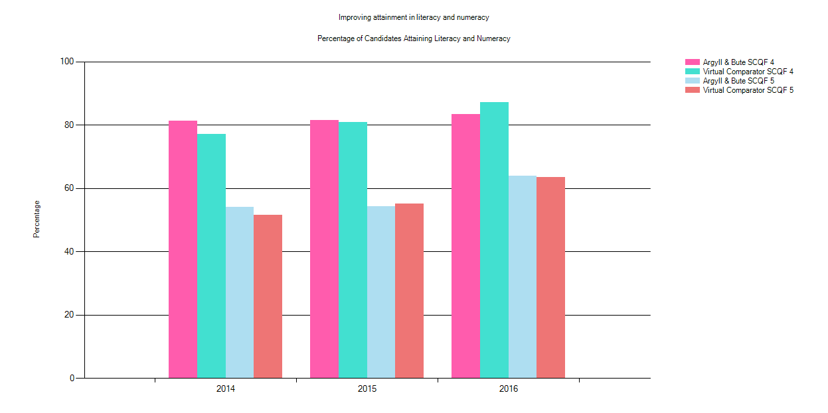

Level 4 Literacy: despite maintaining the positive level of performance trend in Argyll and Bute, the performance of Argyll and Bute pupils in 2016 remained below the virtual comparator. This is an area for continuing improvement within the authority.

Level 5 Literacy: the data demonstrates improvement in 2016 for Level 5 literacy and numeracy. This is broadly in line with performance improvement by the virtual comparator.

Table illustrates both the annual percentage and number of pupils in each cohort achieving level 4 or level 5 literacy and numeracy in Sessions 2014 -2016.

|  |  |  |  |  |
| --- | --- | --- | --- | --- |
|  | Year | % Level 4 Literacy and Numeracy | % Level 5 Literacy and Numeracy | Number in Cohort |
| Argyll & Bute | 2014 | 81.23 | 54.12 | 959 |
| Virtual Comparator | 2014 | 77.16 | 51.65 | 9590 |
| National | 2014 | 76.41 | 51.33 | 56029 |
| Argyll & Bute | 2015 | 81.42 | 54.18 | 958 |
| Virtual Comparator | 2015 | 80.95 | 55.19 | 9580 |
| National | 2015 | 78.58 | 53.57 | 55673 |
| Argyll & Bute | 2016 | 83.33 | 63.92 | 948 |
| Virtual Comparator | 2016 | 87.22 | 63.43 | 9480 |
| National | 2016 | 84.76 | 61.21 | 54632 |

**Improving attainment for all (S6 pupils based on the S4 roll)**

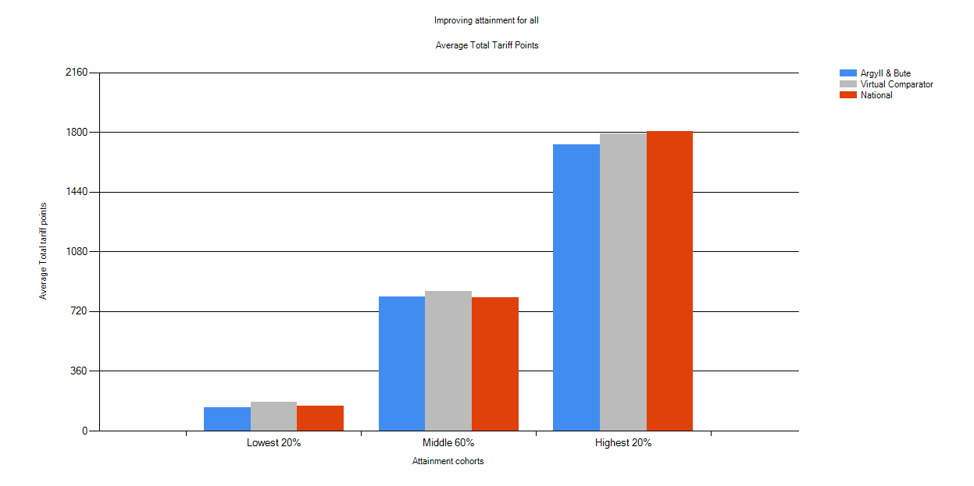

The data above illustrates the **total tariff points** achieved by pupils in each of three attainment groups in 2016.

The following table provides information on total tariff points for pupils across the three years from 2014 – 2016. This is important performance information is reviewed by both the service and schools on a regular basis to inform decisions on improving outcomes for learners.

|  |  |  |  |  |  |
| --- | --- | --- | --- | --- | --- |
|  | Year | Lowest 20% | Middle 60% | Highest 20% | Number in Cohort |
| Argyll & Bute | 2014 | 177 | 817 | 1758 | 959 |
| Virtual Comparator | 2014 | 143 | 738 | 1765 | 9590 |
| National | 2014 | 138 | 739 | 1784 | 56029 |
| Argyll & Bute | 2015 | 173 | 784 | 1773 | 958 |
| Virtual Comparator | 2015 | 167 | 796 | 1803 | 9580 |
| National | 2015 | 149 | 778 | 1815 | 55673 |
| Argyll & Bute | 2016 | 141 | 809 | 1726 | 948 |
| Virtual Comparator | 2016 | 174 | 840 | 1794 | 9480 |
| National | 2016 | 151 | 805 | 1805 | 54632 |

It is also useful to consider the **complementary tariff points** as they offer a fairer ‘like for like’ comparison across different authorities and schools with a range of curricular models.

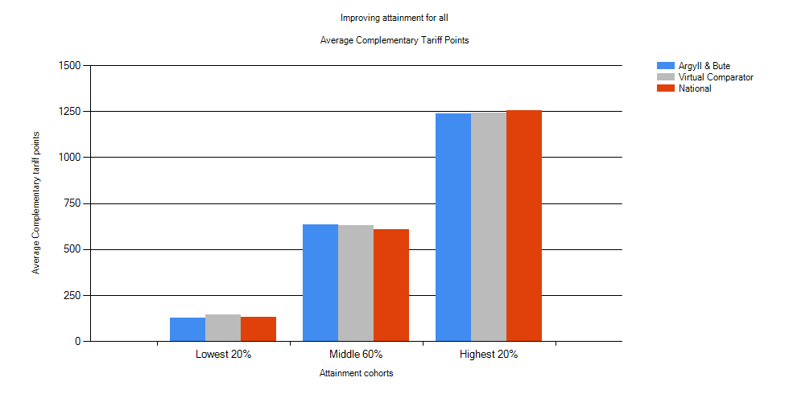

|  |  |  |  |  |  |
| --- | --- | --- | --- | --- | --- |
|  | Year | Lowest 20% | Middle 60% | Highest 20% | Number in Cohort |
| Argyll & Bute | 2014 | 145 | 604 | 1233 | 959 |
| Virtual Comparator | 2014 | 119 | 546 | 1211 | 9590 |
| National | 2014 | 115 | 549 | 1227 | 56029 |
| Argyll & Bute | 2015 | 138 | 579 | 1240 | 958 |
| Virtual Comparator | 2015 | 133 | 585 | 1237 | 9580 |
| National | 2015 | 122 | 572 | 1243 | 55673 |
| Argyll & Bute | 2016 | 127 | 634 | 1236 | 948 |
| Virtual Comparator | 2016 | 146 | 630 | 1241 | 9480 |
| National | 2016 | 130 | 607 | 1256 | 54632 |

As reference 5 grade A’s at Higher is 1020 points compared with 5 grade C’s which is 800 points, 6 grade A’s at National 5 is 504 points, 4 units at National 4 and 2 units at National 5 is 154 points. It is important to note that schools offer some course options that do not attract tariff points but positively impact on life chances for example Duke of Edinburgh Award.

**Attainment versus deprivation (S6 pupils based on the S4 roll)**

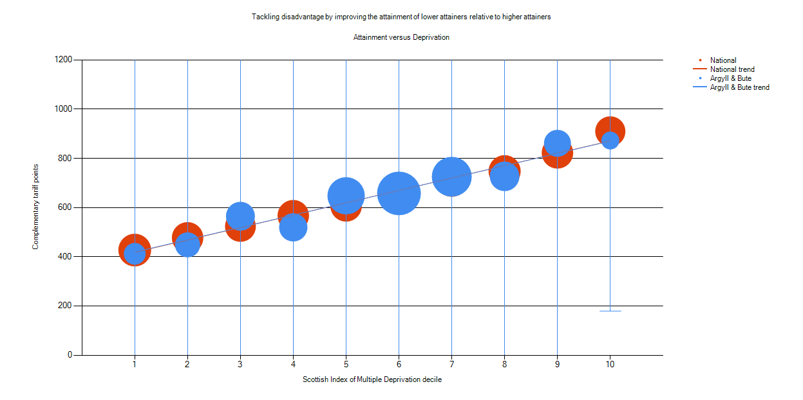

The 2016 data in the graph above shows the average **complementary tariff** points achieved by pupils in each of the 10 Scottish index of multiple deprivation (SIMD) cohorts in Argyll and Bute compared with the national data. Overall there are no significant differences in the data apart from SIMD 4.

Below the Argyll and Bute figure is shown alongside the virtual comparator. Insight commentary does not pick out any statistically significant gaps although SIMD 2, 4, 6 and 8 are slightly lower than the VC.

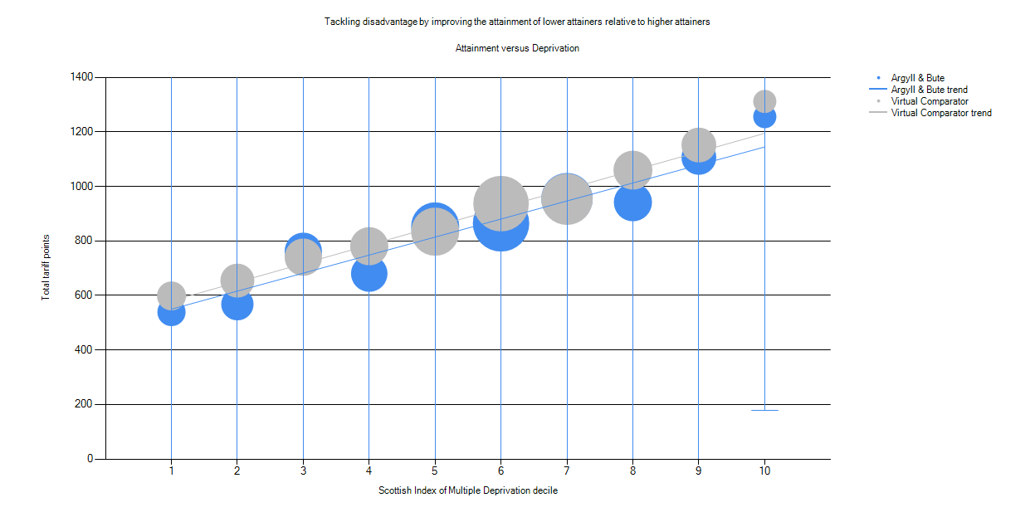

The 2016 data in the graph below shows the average **total tariff** points achieved by pupils in each of the 10 Scottish index of multiple deprivation (SIMD) cohorts in Argyll and Bute compared with the national data. In SIMD 2, 4 and 8 performance is lower than the national data.

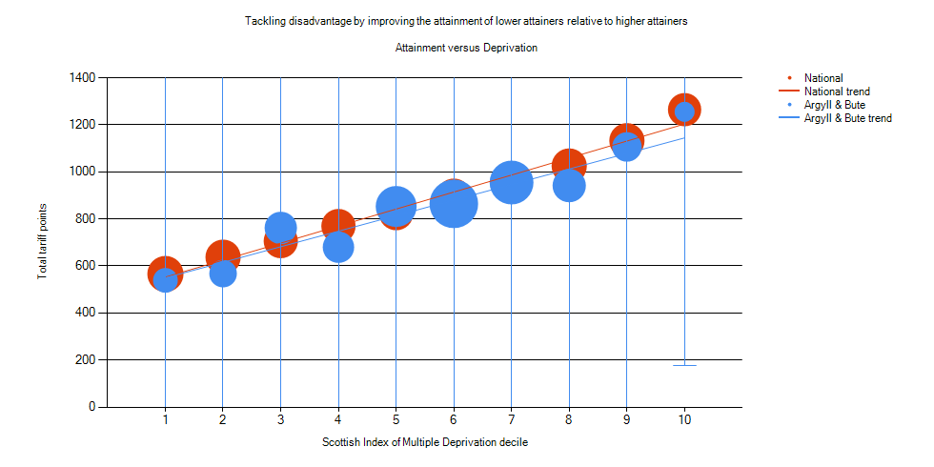

Argyll and Bute Council works closely with key partner agencies, including Skills Development Scotland (SDS). Each secondary school has attached SDS member(s) of staff to support the delivery of careers information, advice and guidance predominately to senior phase pupils, although early intervention is available for pupils at risk of moving into a negative destination post school.

The Scottish Government have been working with Skills Development Scotland and key partners involved in Opportunities for All to develop a Participation Measure that provides a more comprehensive and detailed understanding of the activities young people are taking part in between 16 and 19 years of age. The Participation Measure is the primary means of monitoring the impact of the Opportunities for All pledge which aims to ensure all young people are supported in their path to sustainable employment.

Traditionally there has only been detailed information published concerning the destinations of school leavers – the School Leaver Destination Return (SLDR) – this group accounts for only a quarter of the 16-19 year old population. The Participation Measure shows the proportion of 16-19 year olds participating in education, training or employment, including those who are in the senior phase of their secondary education.

The Participation Measure for the period 1st April 2015 to 31st March 2016 for Scotland was published on 31st August. The Argyll and Bute Participation Measure showed 94.2% of our young people engaged in education, employment or training against the Scottish average of 90.4%. The Argyll and Bute data shows a participation rate of 94.2% (3,429) from a cohort of 3,642 young people; 3.1% (113) not participating and 2.7% (100) unconfirmed.

This can be compared to the Scottish figures of 90.4% participating, 4.0% not participating and 5.6% unconfirmed. Argyll and Bute is one of 18 local authorities to report a higher rate than the national figure and we are currently in fifth position behind Western Isles, Shetland, East Renfrewshire and East Dunbartonshire.

**Skills for Work and Wider Achievement Partnership Awards**

Skills for Work (S4W) courses focus on the skills and knowledge required within a broad vocational area and provide an understanding of the workplace.  These SQA accredited courses offer opportunities for learners to acquire employability skills through a variety of practical experiences that are linked to a particular vocational area such as Automotive Engineering, Construction, Engineering, Health & Social Care, Hospitality, Rural and Maritime.  For session 16/17 we introduced the Foundation Apprenticeship award in Engineering to reflect local labour market opportunities available in Cowal.

In the 2016/17 academic session, there were 31 different skills for work courses delivered in partnership with Argyll College UHI, West College Scotland, local employers and local secondary schools. There were 65 classes on offer across the 10 secondary schools allowing a total of 501 young people to participate.  The majority of classes (58) were delivered by Argyll College UHI with 5 delivered by the school/employer model and 3 through West College Scotland.

A further 2,137 pupils across S1 to S6 accessed 120 different wider achievement qualifications through courses such as Duke of Edinburgh Award, John Muir Award, Sports Leader Awards. All of these courses provide young people with an opportunity to spend time in a different learning environment, meet new people and face new challenges.

A total of 2,638 young people enhanced their curriculum through accessing these wider achievement partnership awards during session 2016/17. Young people further developed their skills for learning, life and work supporting their progress into positive and sustained destinations after leaving school.

**SCHOOL/COLLEGE PARNERSHIP QUALIFICATIONS**

|  |  |  |
| --- | --- | --- |
| **COURSE** | **LEVEL** | **NOS** |
| Engineering | Foundation App | 4 |
| Administration and IT | Higher | 5 |
| Art | Higher | 4 |
| Beauty | Higher | 3 |
| Early Education and Childcare | Higher | 21 |
| Health and Social Care | Higher | 6 |
| Psychology | Higher | 30 |
| Cosmetology | NPA Level 4 | 31 |
| Automotive Engineering | National 4 | 10 |
| Creative Digital Media | National 4 | 14 |
| Construction | National 4 | 9 |
| Early Education and Childcare | National 4 | 35 |
| Engineering | National 4 | 24 |
| Financial Services | National 4 + 1 unit Nat 5 | 18 |
| Hairdressing | National 4 | 10 |
| Hospitality | National 4 | 16 |
| Maritime Studies | National 4 | 20 |
| Rural Skills | National 4 | 31 |
| Sport and Recreation | National 4 | 14 |
| Art | National 5 | 5 |
| Construction | National 5 | 28 |
| Early Education and Childcare | National 5 | 36 |
| Energy | National 5 | 8 |
| Engineering | National 5 | 25 |
| Hairdressing | National 5 | 26 |
| Hospitality | National 5 | 19 |
| Practical Cookery | National 5 | 5 |
| Rural Skills | National 5 | 13 |
| Child Development | Non Certificate | 10 |
| Person Presentation | Non Certificate | 12 |
| Practical Experiences - Construction/Engineering | Non Certificate | 9 |
| **TOTAL** |  | **501** |

**Wider Achievement Partnership**

**The awards offered during 2016/17 included:**

|  |  |  |  |
| --- | --- | --- | --- |
| Organisation | SCQF LEVEL | LEVEL/GRADE | TOTAL |
| ASDAN | Preparatory | Towards Independence: Animal Care | 2 |
| ASDAN | 4 | Certificate of Personal Effectiveness | 6 |
| ASDAN | 3rd/4th | Personal Development | 5 |
| BSC |  | Basic Food Hygiene | 73 |
| BSC |  | Health and Safety at Work | 16 |
| BSC |  | Lifting and Handling | 15 |
| CARITAS |  | Caritas Award | 2 |
| Duke of Edinburgh |  | Bronze + HIS | 92 |
| Duke of Edinburgh |  | Silver | 48 |
| Duke of Edinburgh |  | Gold | 4 |
| FAB |  | Friends Against Bullying | 6 |
| Dynamic Youth Award |  | Award | 87 |
| Heartstart |  | Heartstart | 98 |
| John Muir |  | Explorer | 32 |
| John Muir |  | Discovery | 41 |
| Polish |  | A level | 1 |
| Princes Trust | 3 | XL Personal Development | 41 |
| Professional |  | Introduction to stage make-up | 1 |
| Professional |  | Cyber Security | 1 |
| Professional |  | Estate Agency | 1 |
| Royal Yachting Association |  | Level 2 Dinghy Sailing | 12 |
| Saltire |  | SALTIRE Awards Scheme + HIS | 471 |
| Scottish Football Association |  | Football - Early Touches | 32 |
| SFA |  | Football Ref | 10 |
| Sports Leader |  | Day Leader Award | 93 |
| Sports Leader |  | Positive Coaching Scotland | 77 |
| Sports Leader |  | Sports First Aid | 75 |
| Sports Leaders |  | Sports Leader | 77 |
| SQA | 5 | Customer Services | 90 |
| SQA | 5 | Computer Games Design | 13 |
| SQA | 5 | Digital Photography | 46 |
| SQA | 6 | Eng Science | 12 |
| SQA | 5 | Eng Science | 21 |
| SQA | 4 | Food Hygiene for the Hospitality Industry | 12 |
| SQA | 4 | Hospitality NAT 4 | 33 |
| SQA | 5 | Hospitality NAT 5 | 51 |
| SQA | 4 | Kitchen Skills an introduction | 12 |
| SQA | 4 | Languages for life and work | 120 |
| SQA | 5 | Leadership | 39 |
| SQA | 6 | Leadership | 12 |
| SQA | 4 | Personal Development Award – Nat 4 | 3 |
| SQA | 5 | Personal Development Award | 4 |
| SQA | 5 | Religion, Belief and Values | 15 |
| SQA | 4 | Religion, Belief and Values | 1 |
| SQA | 4 | Safe road user | 17 |
| SQA | 5 | Scottish Studies | 11 |
| SQA | 6 | Scottish Studies | 10 |
| SQA |  | Scots Language | 2 |
| SQA | 5 | Volunteering | 6 |
| SQA | 5 | Wellbeing | 25 |
| SQA | 5 | Woodwork skills  NAT 5 | 8 |
| SQA | 4 | Woodwork Skills NAT 4 | 1 |
| SQA | 4 | Work Experience -  Nat 4 | 29 |
| SRU |  | SRU Rugby Ready | 38 |
| Youth Achievement Award | 4 | Bronze | 10 |
| Youth Achievement Award | 5 | Silver | 48 |
| Youth Achievement Award | 5 | Youth Coaching Course | 5 |
| West College Scotland | 4 | Introduction to Construction | 3 |
| West College Scotland | 4 | eSafety | 1 |
| West College Scotland | 3 | Introduction to Photography | 2 |
| West College Scotland | 4 | Introduction to information Technology | 2 |
| West College Scotland | 4 | Introduction to Retail | 1 |
|  |  | TOTAL NUMBER OF PUPILS | 2122 |

In addition a number of sixth year students accessed qualifications at national 7 level offered by the Open University Young Applicants Scotland Scheme (YASS), the International Baccalaureate award and degree level modules.  Further information is shown in the table below:

|  |  |  |
| --- | --- | --- |
| YASS | Engineering the Future | 1 |
| YASS | Galaxies, Stars, Planets | 1 |
| YASS | Law in Contemporary Scotland | 2 |
| YASS | Molecules - Medicines and Drugs | 1 |
| YASS | Retail Management & Marketing | 2 |
| YASS | Understanding the Autism Spectrum | 1 |
| YASS | English For academic purposes online | 1 |
| YASS | Statistics | 1 |
| International Baccalaureate | Social Science | 2 |
| International Baccalaureate | Science | 2 |
| West College Scotland | Human Body Structure and Functions | 1 |
|  |  | 15 |

**5.2 Inspection and Scrutiny Outcomes**

**Strategic Inspection of the Education Functions of the Council**

An evaluation of the effectiveness of the Education functions of the Council was conducted by Education Scotland in September 2016. The inspection was based on a framework of quality indicators (published in Quality Management in Education 2), which embody the Government's policy on Best Value. The framework is based on six high level questions which can be answered by evaluating the quality of education across ten key areas.

The inspection set out to answer the following questions:

* What key outcomes has the education authority achieved?
* How well are the needs of stakeholders being met?
* How well does the Education Authority deliver and improve the quality of its education services?
* How good is the quality of strategic leadership and direction?, and
* What is the Education Authority’s capacity for improvement?

A number of selected updated quality indicators were evaluated against the six-point scale. As a core part of the inspection the Authority submitted their self-evaluation against these five quality indicators.

The following table illustrates the evaluations made by the Authority, compared with the Education Scotland evaluations.

|  |  |  |  |
| --- | --- | --- | --- |
| **Quality Indicator** | | **Argyll and**  **Bute**  **Evaluation** | **Education**  **Scotland**  **Evaluation** |
| QI 1.1 | Improvements in performance | Satisfactory | Weak |
| QI 2.1 | Impact on children, young people, adult learners and families | Satisfactory | Satisfactory |
| QI 5.1 | Delivering and improving the quality of services | Satisfactory | Weak |
| QI 9.2 | Leadership and direction | Satisfactory | Weak |
| QI 9.4 | Leadership of change and improvement | Satisfactory | Weak |

Education Scotland published its Report on 21 March 2017. The main findings of the inspection included an assessment of the key strengths and main points for action for the Authority arising from the inspection. The key strengths are identified as:

* The proportion of young people who move on from school to a positive destination;
* The contributions of the Early Years Team and the Educational Psychology Service in delivering a strong foundation and support for children’s learning, and
* The positive and wide range of partnerships which help staff to meet learners’ needs, particularly those of MOD families and refugees.

The published report also confirms a range of good or effective practice across areas of the Education Service including:

* The achievement of children and young people across Argyll and Bute reflects a broad range of national awards and award bearing wider achievement qualifications;
* Over 1500 young people last session achieved across a broad range of awards including the Duke of Edinburgh’s Award, John Muir, Saltire and Youth Achievement Awards;
* In almost all early learning and childcare (ELC) settings, most children achieve their expected developmental milestones;
* The number of young people securing a positive destination on leaving school has increased over the period 2011-2016;
* Argyll and Bute has implemented all aspects of the Getting it Right for Every Child (GIRFEC) practice model and is continuing to develop and improve it. The Education Service plays a key role on leading the development of GIRFEC across Argyll and Bute and through its contribution to the national *Well-Being Application working* group;
* A significant amount of work has been carried out to support Looked After Children;
* There are good examples of the Early Years Strategy policy being embedded in practice;
* Important changes have been made across the Education Service to engage head teachers and senior staff in improvement activities. This includes the Secondary Performance Reporting group (now called the Achievement and Attainment Group), and
* A number of internal forums and working groups have been set up to support the implementation of Curriculum for Excellence.

The main points for action identified a need for the Authority to:

* Significantly improve young people’s attainment across the authority;
* Improve the use of data, ensuring greater rigour;
* Continue to improve the quality of educational provision with consistently higher levels of support and challenge from central officers and elected members;
* Improve relationships and communication, promoting a more positive ethos amongst all stakeholders; and
* Improve the quality of strategic leadership and direction at all levels within the Education Authority.

The priority for the Education Service will be to retain our focus on delivering high quality services that improve outcomes for all of our children and young people. The Education Vision and Strategy: “Our Children, Their Future” is a key part of this. We note and welcome that the main points for action recommended in the Education Scotland report is in line with the aims of the new Education Vision and Strategy.

Since the inspection visit in September 2016 a number of improvements actions have been taken forward by Education Services through a detailed action plan. These include:

* The significant work of the Service in preparing and publishing the revised Education Vision and Strategy: Our Children, Their Future, with a clear focus on ambition, excellence and equality reflecting local and national priorities;
* A conclusion of the “tackling bureaucracy workload review” undertaken by Education Scotland in August 2016 identified the “Impact of assessment and moderation facilitators” as a key strength of the Authority;
* The role of centrally employed officers has been revised to provide increased support for schools and early years settings. This includes advice in curriculum areas such as literacy, numeracy and science, technology, engineering and mathematics (STEM);
* The appointment of two additional Principal Teachers, to support the development and improvement of Literacy and Numeracy of pupils across all schools in the Authority;
* A Head Teacher Advisory Group has been introduced with the main purpose of improving communication and engagement between schools and the Authority;
* Further improvements have been made to communication with schools and services through the publication of regular education bulletins;
* Curriculum guidance materials have been updated and made accessible to all staff through the Sharing Argyll Learning (SAL) site. These are designed to support staff in taking forward learning and teaching;
* A new approach to reviewing school examination results was introduced in September 2016. This is focused on increasing the use data to improve outcomes for learners;
* Following feedback from ELC practitioners, the Argyll and Bute Learning and Development Framework was issued to all ELC settings and childminders in Argyll and Bute. Locality based twilight training sessions delivered between March and June supported implementation
* Improvement planning materials for use by schools in session 17/18 were revised in consultation with Head Teachers, and
* Further development of collaborative working arrangements with other Local Authorities which focus on improvement and sharing of practice to support the raising of standards across services and schools.

In June 2017 a return visit was made by Education Scotland to assess the progress of the Authority in responding to the improvement priorities arising from the inspection report. They met with a variety of stakeholders reflecting on the following 3 questions:

1. What actions have Argyll and Bute Council taken to address the main points for action outlined in the Strategic Inspection Report of the Education Functions of the Council published on 21 March 2017?
2. What steps has Argyll and Bute Council taken to improve strategic leadership and direction across the education functions of the Council?
3. What progress has Argyll and Bute Council made in improving the levels of communication, support and challenge to its schools?

A letter will be provided by Education Scotland in August 2017 detailing their findings from this visit.

Education Scotland will conduct a further inspection in September 2017 to evaluate improvement against the main points for action detailed in the Inspection Report published in March 2017.

Further details of strategic interventions being undertaken by Education for 2017/2018 to improve outcomes for children and young people in Argyll and Bute are contained in **Section 6** of the plan.

**School Inspection Outcomes**

Within schools in Argyll and Bute there is strong commitment from our leadership teams and staff to improve outcomes for all children and young people and in ensuring that all of our children and young people are experiencing consistently high-quality learning experiences.

From January 2017 onwards, evidence from 5 school inspections following the revised Education Scotland Inspection Model indicated that:

* the majority of schools (60%) were evaluated as satisfactory or better and less than half (40%) were evaluated as weak for *Leadership of Change* (QI 1.3);
* all schools (100%) were evaluated as satisfactory or better and less than half of schools (40%) were evaluated as good or better for *Learning, Teaching and Assessment* (QI 2.3);
* all schools (100%) were evaluated as satisfactory or better and the majority (60%) of schools were evaluated as good or better for *Ensuring Wellbeing, Equality and Inclusion* (QI 3.1);
* all schools (100%) were evaluated as satisfactory or better and less than half of schools (40%) were evaluated as good or better for *Raising Attainment and Achievement* (QI 3.2), and
* all (100%) ELC settings inspected by Education Scotland were evaluated as satisfactory or better. This included 4 nursery classes within school settings and one partner provider.

From August 2013 - June 2016, evidence from 16 school inspections indicated that:

* all schools (100%) were evaluated as satisfactory or better and most schools (75%) were evaluated as good or better for *Learners’ Experiences* (QI 2.1);
* almost all schools (94%) were evaluated as satisfactory or better, and a majority of schools (56%) were evaluated as good or better for *Improvements in Performance* (QI 1.1);
* almost all schools (94%) were evaluated as satisfactory or better, and a majority of schools (63%) were evaluated as good or better for *Meeting Learning Needs* (QI 5.3);
* the majority of schools (69%) were evaluated as satisfactory or better and less than half of schools (44%) were evaluated as good or better for the *Curriculum* (QI 5.1);
* most schools (88%) were evaluated as satisfactory or better and less than half of schools (25%) were evaluated as good or better for *Improvement through Self-evaluation* (QI 5.9), and
* most (87%) ELC settings inspected by Education Scotland were evaluated as satisfactory or better. This included 10 nursery classes within school settings and 5 partner providers.

**5.3 Reducing Inequalities in Educational Outcomes as a result of Socio – Economic Disadvantage**

A key driver of the National Improvement Framework is to reduce inequalities in educational outcomes as a result of socio-economic disadvantage**.** Education Services, in responding to National expectations have taken a number of steps to respond to this requirement. The Education Vision and Strategy “Our Children, Their Future” places the needs of all children and young people at the heart of our vision. Together we will realise **ambition**, **excellence** and **equality** for all**.** Our vision sends a signal about the importance we attach to education

Notably the recent Education Scotland Inspection Report highlighted the following service approaches which make an effective contribution to this important area of National policy:

* Argyll and Bute Council has implemented all aspects of the GIRFEC national practice model and is continuing to develop and improve it. At school and council-wide level there are well-developed and embedded systems for supporting children and young people. GIRFEC approaches are understood and there are positive examples of effective practice outlined in the Care Inspectorate Services for Children and Young People Inspection Report September 2013.
* Opportunities for staff continue to develop their own professional skills are readily accessible on the council website. Staff working in the ELC sector values the access which they have to e-learning. These opportunities are also impacting positively on the confidence of primary school staff to deliver the national practice model for GIRFEC and in improving their planning for the individual child and young person. The Education Service plays a key role in leading the development of GIRFEC across Argyll and Bute and through its contribution to the national *Well-Being Application* working group. Staff and young people have also worked well with partners, including health agencies and *Choose Life*, to develop guidance to support young people at risk of suicide and self-harm.
* Current arrangements for allocating Additional Support Needs (ASN) staffing and resources have been drawn up following considerable consultation with various stakeholders, including the ASN Review Group which includes Head Teachers, ASN specialists and teaching (and other) unions. The role of the area principal teacher of ASN in allocating resources to support ASN in schools is leading to greater fairness and equity.

**Outcomes for Children and Young People who are Looked After**

Community Services: Education has developed a range of effective measures to support the educational needs of looked after children in schools. In line with legislation, support to looked after children is needs based, through appropriate assessment being carried out with evidence based interventions then implemented. The GIRFEC practice model is the principal vehicle to assess needs and devise appropriate outcomes. There are procedures in place to ensure that looked after children have:

* An identified named person;
* A designated senior manager with whole school responsibility for looked after children;
* Screening using the Wellbeing indicators to identify whether the child or young person has additional support needs;
* Procedures in place to ensure that the individual educational needs will be known to their respective teachers ;
* A support plan or Child’s Plan, if required, with appropriate educational outcomes;
* Regular progress reviews with support plans updated accordingly, and
* Their looked after status recorded appropriately in SEEMIS.

Children and young people who are looked after are at an increased risk of experiencing mental health difficulties. The sustained focus on increasing the awareness and skills of staff and young people themselves, to ensure early intervention aimed at enhancing the mental health and wellbeing of all our children and young people, will have a particular impact on those who are, or have been, looked after.

**Attainment of Looked After Young People at the secondary school stage**

**S4 pupils - performance in Literacy and Numeracy for the last three years**

At SCQF level 4 the performance of Looked after at home pupils in Argyll and Bute was close to the national average in 2014 and 2015 and significantly higher in 2016. Looked after away from home pupils performed much better in 2014 than those at home but then fell below the national average in 2015 and well below in 2016.

At SCQF Level 5 the performance of looked after at home pupils in Argyll and Bute was much higher than the national average in 2016 but a little lower than the virtual comparator. In 2016 the performance of looked after away from home pupils was much lower than those looked after at home and below the national average.

***S5 pupils - performance in Literacy and Numeracy for the last three years***

At level 4 and 5 over the last three years the performance of pupils in Argyll and Bute for both looked after away from home and at home has declined and was lower than the national average and significantly lower than virtual comparator at SCQF in 2016.

**IMPORTANT NOTE 1**: It is very important to note the very small numbers of pupils as this can lead to large fluctuations in percentage figures.

**IMPORTANT NOTE 2**: When they looked after filters are used within the insight tool the virtual comparator is not one of the variables that determine pupil selection so the pupils who are looked after in Argyll and Bute are not being compared with other looked after children across Scotland in the VC data.

**General Educational Attainment June 2015 for looked after leavers**

Overall the performance of pupils looked after away from home in Argyll and Bute is significantly lower than the pupils who are looked after at home whose performance is broadly in line with the virtual comparator.

|  |  |  |
| --- | --- | --- |
|  | Argyll & Bute (2015)  LA LAAC | Virtual comp (2015)  LA LAAC |
| 1 or more qualification at SCQF Level 3 or better | 87%(of 8) 100% (of 9) | 94.12% 89% (of 90) |
| 1 or more qualification at SCQF Level 4 or better | 87.5% 78% | 91.76% 84% |
| 1 or more qualification at SCQF Level 5 or better | 75% 33% | 73.53% 64% |
| 1 or more qualification at SCQF Level 6 or better | 37.5% 11% | 37.65% 29% |
| 1 or more qualification at SCQF Level 7 or better | 12.5% 0% | 8.82% 6% |

The only comparator data is age, gender, ASN and SIMD rank. Therefore it is much fairer to look at the national data as this is only composed of pupils who are looked after and therefore does offer a like for like comparison.

**General Educational Attainment June 2016 for Looked After Leavers**

|  |  |  |
| --- | --- | --- |
|  | Argyll & Bute (2016)  LA LAAC | Virtual Comparator (2016)  LA LAAC |
| 1 or more qualification at SCQF Level 3 or better | 78%(of 9) 75% (of 8) | 93% (of 90) 91% (of 80) |
| 1 or more qualification at SCQF Level 4 or better | 78% 75% | 90% 85% |
| 1 or more qualification at SCQF Level 5 or better | 56% 50% | 62% 61% |
| 1 or more qualification at SCQF Level 6 or better | 22% 25% | 38% 32% |
| 1 or more qualification at SCQF Level 7 or better | 0% 0% | 13% 6% |

**Positive Destinations for Looked After Children**

The Education Service endorses the principles of the Care Leavers Covenant and is committed to working for real change in the lives of care experienced young people to improve their support, opportunities and outcomes.

Argyll and Bute Council offers all S4 – S6 Looked After and Accommodated Children (LAAC) the opportunity to gain that first taste of employment through a summer internship placement with the Council.  The LAAC young people attend the summer placement for four days a week over a five week period and completed an identified project on behalf of a council department.  During the placement the young person is paid the national minimum wage.

Our Looked after Young People in Argyll and Bute leaving school are increasingly entering positive destinations from their 2014 outcomes (education, employment or training). In 2014, **68.4% (cohort 19)** of looked after young people who left school entered a positive destination. In 2015 the figure was **88.24% (cohort 17).** In 2016 the figure was **76.47% (cohort 17).**

In August of each year, Education Officers have initial discussions with senior leadership teams in secondary schools regarding the outcome of the most recent certificate examinations. The SQA results for looked after children is a specific item on the agenda for this discussion, to be considered alongside their other achievements and the individual narrative for each young person.

**Attendance, Absence and** **Exclusions**

**Primary**

Overall attendance for primary aged pupils in Argyll and Bute and nationally is increasing slightly. The average total absence from school for all primary age children is 4.48% and for looked after children are 4.92%. No primary age looked after children were excluded from an Argyll and Bute primary school last session.

**Secondary**

The average total absence from school for all secondary age children is 8.20% and for looked after children are 14.52%. Further analysis demonstrates that this average figure is inflated by a smaller number of young people who have a significant difficulty with school attendance. Exclusions openings account for 0.07% of the absences for looked after children, with the overall secondary school population figure for exclusion being 0.04%. There requires to be a continued focus on ensuring children and young people at the secondary stage are meaningfully engaged with the life of the school and sustain positive attendance.

For the past two full school sessions looked after pupils account for between 9-10% of the total number of pupils excluded. The cohort of 202 looked after pupils in session 2015-2016 forms just 2% of the overall school population of 10,445.

For looked after pupils the number of days absent due to exclusion reduced by over 40% from session 2014-2015 to 2015-2016. This compares to a 33% reduction for the whole school population. The number of looked after pupils being excluded reduced by 21% compared to a 30% reduction for the whole school population.

There is a downward trend for all pupils over the past two full school sessions with Exclusion Incidents per 1000 pupils reducing from 20.53 to 15.08 is session 2015-2016. This is below the national average which was reported as 27.2 in session 2014-2015.

*Source: Summary Statistics for Schools No.6 2015 Edition.*

**Achievement**

The achievement of children and young people across Argyll and Bute Council reflects a broad range of national and award bearing wider achievement qualifications. Schools have worked well to develop a wide range of learning pathways for young people which enables them to achieve a broad range of skills. Over two thousand young people enhanced their achievement portfolio last session and this has contributed well to securing positive, sustained destinations for young people when they leave school.

The Council has secured a number of key partners to enhance the achievement of young people across all four administrative areas. There are strong examples of young people accessing courses to meet specific local needs, for example Maritime Skills. A large number of Skills for Work qualifications are available across the authority in key skills which have the potential to grow the local economy and enhance services, for example, in early education and childcare, hospitality, engineering and rural skills.

The 2015/2016 Council Standards and Quality report documents clearly the range of wider achievement courses and awards gained by young people. Over 1500 young people last session achieved across a broad range of awards including the Duke of Edinburgh’s Award, John Muir, Saltire and Youth Achievement Awards. This is helping them to extend their personal achievements and to enhance their skills for learning, life and work. Schools are regular, successful contributors to the National Mod. The Council’s Modern Apprenticeship programme has provided 23 young people with relevant placements and a few schools have been successful in offering senior phase learners Foundation Apprenticeships in both engineering and health and social care.

Education Digital Learning modern apprentice Steven Simpson completed his HND this session ahead of schedule and for the second year has been nominated as Apprentice of the Year. Steven has secured a permanent post as a Desktop Technician with the council IT service and will be undertaking a graduate level apprenticeship as part of this post.

The Early Years team carried out ‘Learning and Development’ self-evaluation visits to 65% of ELC settings between January and June 2016. Managers, head teachers and ELC teams welcomed these visits, leading to positive impact within each setting’s self-evaluation and the process being taken forward during session 2016-17. 97% of ELC settings in Argyll and Bute submitted their data on developmental milestone progress to the Early Years Service by the end of June 2016. This enabled data to be shared with receiving schools and also showed that 74% of children had achieved their expected developmental milestones by the time they started Primary One in August 2016. Four members of the Early Years Team were accepted to participate in the ‘Improvement Science in Action’ programme delivered by the Scottish Government’s ‘Children and Young People Improvement Collaborative’. This is a year-long programme which has supported practitioners to develop their skills in using the Model for Improvement within their work. The Early Years team have been applying their new skills to an early literacy project – to ensure all children entering their last year of ELC know at least 3 nursery rhymes. Following a consultation with parents and carers, three Local Authority pre5 units provided flexible ELC during term time in addition to Commissioned Providers of Day-care of Children and Partner Childminders throughout session 2015-16. The Service will continue to develop the quality, accessibility and flexibility of provision in preparation for 1140 hours of funded ELC in Argyll and Bute by 2020.

Wellbeing Application (WBA) training started in earnest on 8th May and continued to 20th June on various dates. Training was held in 9 different locations including Mull, Bute, Islay and Tiree. During this time 89 staff members with responsibility either as a Named Person or a Named Person Support were trained on the WBA. An overview training session was provided to the central team before the end of the 2106-2017 session.

Further training is planned for 2017-2018 session with 3 dates in August having been agreed and a refresher training date set for Campbeltown in November. A total of 27 primary schools still need to have a member of staff trained on the Wellbeing Application, although some of these are shared headships. Most secondary schools have trained the majority of their guidance staff with all secondary schools having at least 1 member of staff being trained.

Continued training opportunities will be arranged for the GIRFEC Advisors throughout session 2017/2018.

**SECTION SIX: THE NATIONAL IMPROVEMENT FRAMEWORK**

In response to the drive to deliver excellence and equity for every child in education in Scotland and to deliver the four national priorities, the Scottish Government provided support to schools and local authorities through the Scottish Attainment Challenge Funding (SACF) and Pupil Equity Funding (PEF).

**6.1 Scottish Attainment Challenge Funding**

The First Minister launched the Scottish Attainment Challenge in February 2015 to prioritise improving outcomes for children and young people, with a specific focus on raising attainment and closing the poverty gap.  The Attainment Challenge is underpinned by the National Improvement Framework, Curriculum for Excellence and Getting it Right for Every Child. Argyll and Bute Council was not identified as a Challenge Authority through the Scottish Attainment Challenge initiative and did not benefit from additional funding. However one of our schools, Rosneath Primary School, was identified through the Scottish Attainment Scotland Fund Schools Programme to receive targeted support to close the poverty related attainment gap and received funding of £19,500 in Session 2015/2016 and £19,944 in Session 2016/2017.

All targeted pupils reading showed an increase in both their reading levels and reading ages. Most children have improved by 1 year or more over a 3 month period. There has also been an improvement in their confidence, enjoyment and motivation to read.

Measures demonstrate that the interventions made have raised the attainment of the targeted group of learners and in particular the most disadvantaged children have achieved success.

A further £63,279 grant funding was received from the Scottish Attainment Challenge Innovation Fund to support the Health and Wellbeing of children across a range of schools through Better Movers and Thinkers (BMT). BMT is an approach used in the learning and teaching of physical education designed to develop the ability of all children and young people to move and think in a more cohesive way developing, enhancing and fostering skills within the learning process.

Through the Scottish Attainment Challenge Funding all local Authorities have direct access to a named Scottish Government Attainment Advisor who works collaboratively alongside local authority staff on agreed priorities which support the Scottish Attainment Challenge. The Attainment Advisor for Argyll and Bute has also worked with central education staff to build capacity within the team to advice and support schools in responding to the NIF priority of raising attainment and reducing the poverty gap.

**6.2 Addressing the Four National Priorities for Education in Argyll and Bute**

**Progress for Education in Argyll and Bute for 2016/17**

In 2016, Education Services implemented the following approaches aimed at securing educational improvement for all children and young people within Argyll and Bute.

* In June 2016, Education Service participated in the Teacher Judgement Survey where the achievement of Curriculum for Excellence levels were gathered nationally for Reading, Writing, Listening and Talking and Numeracy at the stages of P1, P4, P7 and S3. The 2016 Evidence Report details the national picture of the percentage of P1, P4, P7 and S3 pupils who are achieving the expected CfE Level relevant for their stage in Literacy and Numeracy (Appendix C).
* Within Argyll and Bute, the percentage of P1, P4, P7 and S3 pupils who are achieving the expected CfE Level relevant for their stage in Literacy and Numeracy as outlined in the CFE Experimental Statistics published by the Scottish Government is summarised below:

|  |  |  |  |  |  |  |
| --- | --- | --- | --- | --- | --- | --- |
| CfE Levels | 2015/2016 | P1 | P4 | P7 | S3 | S3 |
| Early Level | First Level | Second Level | Third Level | Fourth Level |
| Reading | Argyll & Bute | 82% | 72% | 75% | 89% | 32% |
| Scotland | 81% | 75% | 72% | 86% | 39% |
| Writing | Argyll & Bute | 80% | 64% | 70% | 88% | 34% |
| Scotland | 78% | 69% | 65% | 84% | 37% |
| Listening and Talking | Argyll & Bute | 86% | 75% | 80% | 91% | 43% |
| Scotland | 85% | 81% | 77% | 87% | 41% |
| Numeracy | Argyll & Bute | 85% | 68% | 65% | 89% | 62% |
| Scotland | 84% | 73% | 68% | 86% | 49% |

This data has been derived from the first year of collection and is classed as experimental. Further development is planned by the Service in working with all schools during session 2017/18 and following the publication of the national data later in 2017.

The Attainment Advisor assigned to Argyll and Bute has provided support and challenge to the Head Teacher and staff at Rosneath Primary School to increase capacity within the school and identify strategies to raise attainment in literacy. A range of learning and teaching approaches have been put in place and data has been generated to evidence improvement. Following analysis and evaluation of information gathered successes will be shared with schools across the authority in order to inform best practice. Support initiatives have also begun with other schools in the Helensburgh area, John Logie Baird, Garelochhead, St Joseph and Colgrain. In addition, the Attainment Advisor has also worked with central education staff to building capacity within the team to advise and support schools in responding to the NIF priority of raising attainment and reducing the poverty gap.

In addition, the Education Service have recruited a team of Quality Assurance and Moderation Support Officers (QAMSOs) from within the central team and education establishments. These officers are released from the Authority to attend National Improvement Framework workshops in Glasgow and Edinburgh on sharing standards of attainment. The knowledge gained at these meetings by QAMSOs is used to inform the Education Service’s strategy in raising attainment in literacy and numeracy and to ensure standards of attainment are in line with national expectations.

The Education Service is currently rolling out a training programme that aims to have a dedicated Assessment Facilitator in every establishment. Assessment Facilitators build capacity in their establishments in order that teachers are confident in planning for improved attainment and making quality professional judgements on achieving Curriculum for Excellence levels (CfE). Facilitators are increasingly working collaboratively to bring cluster school staff together to share their understanding of standards expected in order that there is consistency across establishments.

**6.3 Pupil Equity Funding (PEF)**

Pupil Equity Funding (PEF) is being provided by the Scottish Government for 2017/18 to continually improve Scottish Education through the provision of £120 million funding, allocated directly to schools and targeted at closing the poverty related attainment gap. Publicly funded primary, secondary and special schools receive £1,200 in 2017/18 for each child in Primary 1 to S3, or equivalent, who are eligible and registered for free school meals. This grant is ring-fenced and is to be allocated directly to each qualifying school. National guidance explicitly notes that schools should use the funding for the purpose of delivering focused activities and interventions that lead to improvements in literacy, numeracy and health and wellbeing for identified pupils.

Argyll and Bute received PEF Funding of £1,304,400 for 2017/18, with 84% of schools receiving varying amounts of funding ranging from £1,200 to £76,800. All schools have submitted a PEF plan to the authority outlining how they will spend their funding to deliver interventions that will close the poverty related attainment gap. Education Officers will discuss progress on interventions with Head Teachers during calendared quality improvement visits during Session 2017/18.

**6.4 Addressing the Six National Improvement Framework Drivers for Education in Argyll and Bute for 2017/2018**

**The National Improvement Framework Drivers for Education are:**

* School Leadership;
* Staff Professionalism;
* Parental Engagement;
* Assessment of Children’s Progress;
* School Improvement, and
* Performance Information.

Education Services will deliver the National Improvement Framework Drivers for 2017/2018 through our **6 key objectives** for Education in Argyll and Bute which are to:

* Raise educational attainment and achievement for all;
* Use performance information to secure improvement for children and young people;
* Ensure children have the best start in life and are ready to succeed;
* Equip young people to secure and sustain positive destinations and achieve success in life;
* Strengthen high quality partnership working and community engagement, and
* Strengthen Leadership at all Levels.

The following section of the plan illustrates examples of the programmes of work being taken forward by staff across Education Services to deliver these expectations.

|  |  |
| --- | --- |
| **key OBJective 1:** | **raise educational attainment and achievement FOR ALL** |

What is this?

The quality of education offered by each school in Argyll and Bute and how effective they are in raising educational attainment and achievement for all children and young people.

Why is this important?

The curriculum includes a broad range of experiences which are planned for children and young people through their education, to help every child and young person to develop knowledge, skills and attributes for success in learning, life and work. Research and evidence consistently demonstrates the direct link between poverty and deprivation and lower attainment and achievement.

Within Argyll and Bute Education Service we will raise educational attainment and achievement for all through the following agreed **priority actions**:

* Improve the overall quality of learning experiences;
* Tackle disadvantage and deprivation to close the attainment gap;
* Improve literacy, numeracy and health and wellbeing outcomes for children and young people, and
* Continually improve curriculum design and development.

**In session 2017-2018 we will:**

* Take further steps to increase the overall proportion of children and young people who achieve in line with the national expectation in Literacy and Numeracy;
* Take further steps to increase the overall proportion of children and young people who achieve in line with national expectation in Gaelic Medium Education;
* Re-engage schools with National guidance on curriculum principles, entitlements and expectations to ensure effective delivery of a quality curriculum at a local level. Prepare, in consultation with schools, a curriculum principle, entitlement and expectation paper for use by all schools ensuring the opportunity for all children and young people to experience relevant and wider achievement within the curriculum;
* Implement revised approaches to ensure overall improvement in levels of attainment for Senior Phase pupils across all SQA examination levels;
* Revise approaches to quality assurance and moderation in all schools;
* Further improve the effectiveness of school support visits by Central Officers ensuring greater consistency and challenge to all schools, and ensure the needs of all pupils are being effectively met;
* enhance and further develop opportunities for digital learning and creativity in all of our establishments;
* Revise and implement a comprehensive programme of educational establishment reviews (early years, primary, secondary, youth services and education services) ensuring effective support and challenge to deliver continuous improvement;
* Provide a range of support to all Authority schools in taking forward assessment and moderation approaches;
* Continue to second a Literacy and Numeracy co-ordinator to support all Authority schools in raising attainment in literacy and numeracy;
* Deliver a programme of professional learning events aimed at raising attainment in literacy and numeracy;
* Improve the number of young people securing a positive destination for each secondary school in line with individual virtual comparators;
* Further develop support and engagement with Secondary schools to ensure increased positive, post school destinations for all Argyll and Bute leavers (Participation measures);
* Ensure that all secondary establishment work in collaboration with partners to support the development of skills for the world of work;
* Improve the pace and challenge of learning and development within ELC and create greater consistency across settings within literacy, numeracy and developmental milestones;
* Continue to ensure adequate provision of resources and equipment to meet the needs of children and young people with additional support needs, and
* Support the capacity and confidence of Head Teachers to meet the requirements of all Child’s Plans.

|  |  |
| --- | --- |
| **key objective 2:** | **use Performance Information to secure improvement for children and young people** |

What is this?

All of the information and data we need to get a full picture of how well education for our children and young people is improving. As no single measure provides a full picture of performance, we will gather together and analyse a broad range of data collected from each of the other key objectives of our children their future to assist us to provide a comprehensive overview of the progress being made by all children and young people.

Why is this important?

Education Services gather, analyse and report on a wide range of performance information that allow us to deliver services effectively and demonstrate that we are continually improving outcomes for children and young people. For example, we use information about the progress of our children and young people to inform the approaches to learning and teaching in the classroom. It is everyone’s responsibility to gather and use performance information to intervene to secure improvement for both individual children and groups. We will actively engage parents and young people in this process.

Within Argyll and Bute Education Service we will use performance information to secure improvement for children and young people through our priority **actions**:

* Effectively assess, track and monitor the progress of our children and young people;
* Implement strong self-evaluation, quality assurance and improvement planning, and
* Clearly report outcomes.

**In session 2017-2018 we will:**

* Refine further steps taken to improve approaches to self-evaluation and planning for improvement and changes;
* Further refine the Authority approach to Standards and Quality Reporting and Improvement planning across establishments;
* Revise current arrangements to reporting of performance information at all levels to support elected members to effectively undertake their scrutiny role;
* Provide increasingly effective support to schools in the use of data to benchmark progress for learners and secure further improvement in achievement and attainment for all children and young people with effective interventions;
* Continue to work with the Attainment Advisor assigned to Argyll and Bute to provided support and challenge to the central team and schools in their use of performance information to secure improvement;
* Continue to monitor curriculum models across each of the ten secondary schools to ensure the average tariff scores for all Argyll and Bute young people are increased, as appropriate;
* Improve the attainment and progress of children in literacy and numeracy in P4 and P7 in line with national expectations;
* create greater ownership of data within ELC settings and to build confidence and capacity around analysis of data;
* Early Years Team to make more effective use of authority wide data within the self -evaluation of the Service, and
* Build capacity within each Argyll and Bute Family Pathway locality to analyse data and see how small changes can impact on local and national priorities.

|  |  |
| --- | --- |
| **KEY OBJECTIVE 3:** | **ENSURE CHILDREN HAVE** THE BEST START IN LIFE AND ARE READY TO SUCCEED |

What is this?

In Argyll and Bute, we work together to ensure children and young people experience a positive start that supports and nurtures all children and builds firm foundations for later life.

Why is this important?

We know that children develop faster in the first few years of life than at any other time so, to make an impact and ensure we tackle potential disadvantage, this is a priority area for us.

**In session 2017-2018 we will:**

* As part of Argyll and Bute’s Children, audit existing parenting provision and resources for each point on the parenting pathway from pre-birth to school leaver age;
* All Early Learning and Childcare (ELC) settings to share developmental milestone progress for all children entering primary education;
* As part of Argyll and Bute’s Children, develop and implement a parenting strategy to support parenting from pre-birth to school leaving age;
* Plan and implement the necessary steps to ensure the delivery of 1140 hours of early learning and child care by 2020;
* Ensure greater consistency in expectations of children’s progress in ELC literacy, numeracy and developmental milestones through effective support and challenge from the Early Years Team, and
* As part of the 1140 Hours Delivery Plan, develop an ‘ELC Quality Action Plan’ to ensure provision is of the highest quality for children in Argyll and Bute accessing 1140 hours of ELC by 2020.

|  |  |
| --- | --- |
| **KEY OBJECTIVE 4:** | **EQUIP YOUNG PEOPLE TO SECURE POSITIVE DESTINATIONS AND ACHIEVE SUCCESS IN LIFE** |

What is this?

This is the progress our young people make in securing sustained positive destinations in employment training or further/ higher education when they leave formal education.

Why is this important?

For our population in Argyll and Bute to grow through economic development our industries need a workforce with the right skills, attitudes and capacities. Positive destinations information will tell us about how successful young people in Argyll and Bute are when they leave school. This will also tell us about the choices young people make and the difference in positive destinations between those from the most and least disadvantaged backgrounds.

Within Argyll and Bute Education Service we will equip young people to secure and sustain positive destinations and achieve success in life through our priority **actions**:

* Equip children and young people with skills for learning, life and work.
* Promote enterprise and entrepreneurship.
* Support lifelong learning.

**In session 2017-2018 we will:**

* Increase positive destinations for looked after children in Argyll and Bute;
* Increase the number of Duke of Edinburgh (D of E) participants from the most deprived SIMD (Scottish Index of Multiple Deprivation) areas in Argyll and Bute;
* Increase the number of young people on Activity Agreements (AA) progressing into positive destinations;
* Increase the number of young people on Flexible Learning plans reengaging with school or progressing into positive destinations;
* Enhance and further develop opportunities for digital learning and creativity in all of our establishments;
* Reduce the number of young people recorded as unconfirmed on the Participation Measure for Argyll and Bute;
* Ensure that All secondary establishments have a minimum of 3 DYW (Developing Young Workforce) partnership agreements for school employer collaboration in supporting knowledge and understanding of world-of-work and applicable skills, and
* Increase the number of Youth Achievement and Dynamic Youth Awards achieved.

|  |  |
| --- | --- |
| **KEY OBJECTIVE 5:** | **ENSURE HIGH QUALITY PARTNERSHIP WORKING AND COMMUNITY ENGAGEMENT** |

What is this?

Partnership working and community engagement focuses on ways in which parents and carers, families and professionals work together to support children and young people’s learning.

Why is this important?

We recognise that most of a child’s development takes place outwith our schools and ELC settings therefore the role of families and carers is critical to ensuring our children and young people succeed. We will empower parents and carers to be part of the decisions that are taken in respect of their children’s education and development, and to work along with the staff in each school on improvement planning. We will engage parents and carers in dialogue around the new duties on education authorities, new approaches to learning and ultimately their role in their children’s education. We will ensure that strong partnerships are created and maintained with local bodies including businesses, third sector organisations and community groups. This will broaden and deepen the curricular experiences offered to children and young people by our educational establishments.

Within Argyll and Bute Education Service we will strengthen parental and community engagement through our **priority actions**:

* Develop and strengthen parental engagement and participation;
* Improve the curriculum links between schools and colleges;
* Develop and strengthen partnerships with business and the community, and
* Work together to secure improvement.

**In session 2017-2018 we will:**

* Review and update further the Authority Parental Involvement Strategy to ensure greater engagement and communication with parents and carers;
* Identify a range of approaches to ensure that all young people are encouraged in making an effective contribution to decision making, self-evaluation and performance improvement processes at both school and Authority levels;
* Further develop the remit and focus of the Head Teacher Advisory Group to support improved communication, engagement and relationships between the Authority and Schools;
* Ensure the ongoing provision of a range of information is routinely issued to staff and parents to improve communication;
* Hold authority wide capacity building courses for young people to encourage involvement in local and national decision making;
* Ensure that Local Youth Forums attend at least one Community Planning Partnership (CPP) Area Planning Group meeting per annum;
* Further improve relationships and communication through consultation with all ELC stakeholders in preparation for 1140 hours of funded ELC, and
* Provide 1-1 support to each ELC provider around how they can improve family learning and engagement through effective use of their own community and local assets.

|  |  |
| --- | --- |
| KEY OBJECTIVE 6: | STRENGTHEN LEADERSHIP AT ALL LEVELS |

What is this?

School leadership improves the quality and impact of leadership roles within schools at all levels. Teacher professionalism improves the overall quality of the teaching workforce and the impact of their professional learning on children’s progress and achievement. In Argyll and Bute we have provided professional learning opportunities at all levels from pre career entry through to Head Teacher development and beyond; whilst ensuring staff in Argyll and Bute have quality experiences and development opportunities. During a period of difficulty in teacher recruitment both in Argyll and Bute and nationally it has been essential to ensure there is opportunity to enhance the profession by providing opportunities to “Grow Our Own” teacher leaders. We also seek to retain our highly trained teacher workforce by providing professional development opportunities, to ensure that there are enough teachers and leaders with the requisite skills to ensure our schools thrive within their local communities. Pupil leadership is important within the learning context and all schools encourage pupil voice.

Why is this important?

Strong leadership within our schools helps ensure that all children achieve the best possible outcomes through the highest quality of learning and teaching. In Scotland we have a highly professional, graduate teaching workforce with high professional standards, which are set by the General Teaching Council for Scotland (GTCS). Within Argyll and Bute, we want to continue to improve the professionalism of our teachers and the quality and impact of their professional learning on improving children’s learning and the outcomes they achieve.

Within Argyll and Bute Education Service we will strengthen leadership at all levels through our **priority actions**:

* Focus on effective educational leadership;
* Promote career long professional development for all staff;
* Provide professional learning opportunities for front line services, and
* Maximise the use of resources.

**In session 2017-2018 we will:**

* Continue to promote the revised Education Vision and Strategy: Our Children, Their Future, with a clear focus on ambition, excellence and equality reflecting local and national priorities;
* Take steps to develop and strengthen strategic leadership across Education Services engaging all Senior Officers;
* Further develop the Education Authority Leadership Programmes at all levels;
* Provide an ongoing programme of professional development for centrally deployed officers to further extend their skills, knowledge and capacity in undertaking support and challenge activities with schools;
* Progress the review and realignment of central officer functions and responsibilities to ensure increased rigour and consistency in levels of support and challenge across all Authority schools in line with the Governance Review;
* Improve strategic direction in a number of areas including learning and teaching and curriculum development;
* Audit and analyse the continuing professional development (CPD) needs of all primary and secondary teaching staff in relation to the NIF (National Improvement Framework). Plan and implement CPD programme as identified in the needs audit;
* Strengthen approaches to professional review processes for all Head Teachers;
* Undertake further reviews of Head Teacher appointment processes;
* Review further recruitment challenges faced by the Authority: identify potential approaches to minimise the impact of the national teacher recruitment difficulties;
* Provide leadership training for Lead Childcare and Education Workers, and
* Provide induction training for all new Childcare and Education Workers and new ELC Managers / Head Teachers.

**Conclusion:**

The planning and reporting processes at school, service and Education Authority levels are designed to produce robust, consistent and transparent data of the work of the Education Authority, to improve our understanding of what works and, ultimately, drive forward improvements that will improve outcomes for the children and young people of Argyll and Bute.

A key requirement of these processes is that the Scottish Ministers must publish a National Improvement Framework setting out the four key priorities which all partners in the education system should be working to address. The first NIF was published in January 2016. The first statutory NIF under the 2000 Act was published on 31 December 2016.

This Education Plan has been prepared in compliance with the requirements set out

in the Statutory Guidance accompanying the Standards in Scotland’s Schools etc.

Act 2000 taking full account of the requirement to:

* Implement local plans and priorities for the 2017/2018 school year as set out
* in *Our Children, Their Future*;
* Responded to the requirements of the National Improvement Framework for
* Scottish Education (NIF);
* Introduced revised approaches to School Improvement Planning for school year 2017/2018;
* Publish the Annual Education Plan for 2017/2018 covering the period 1 September 2017 to 31 August 2018;
* Ensure the implementation of the Annual Education Plan during the period September 2017 to June 2018;
* Put in place the necessary arrangements to analyse the outcomes of the 2017/2018 Annual Education Plan and prepare and publish the Annual report of progress as soon as possible after 31 August 2018, and
* In addition takes full account of the main points for action contained within the inspection report on the education functions of the authority published by Education Scotland in March 2017.

**Community Services: Education Organisation Chart**

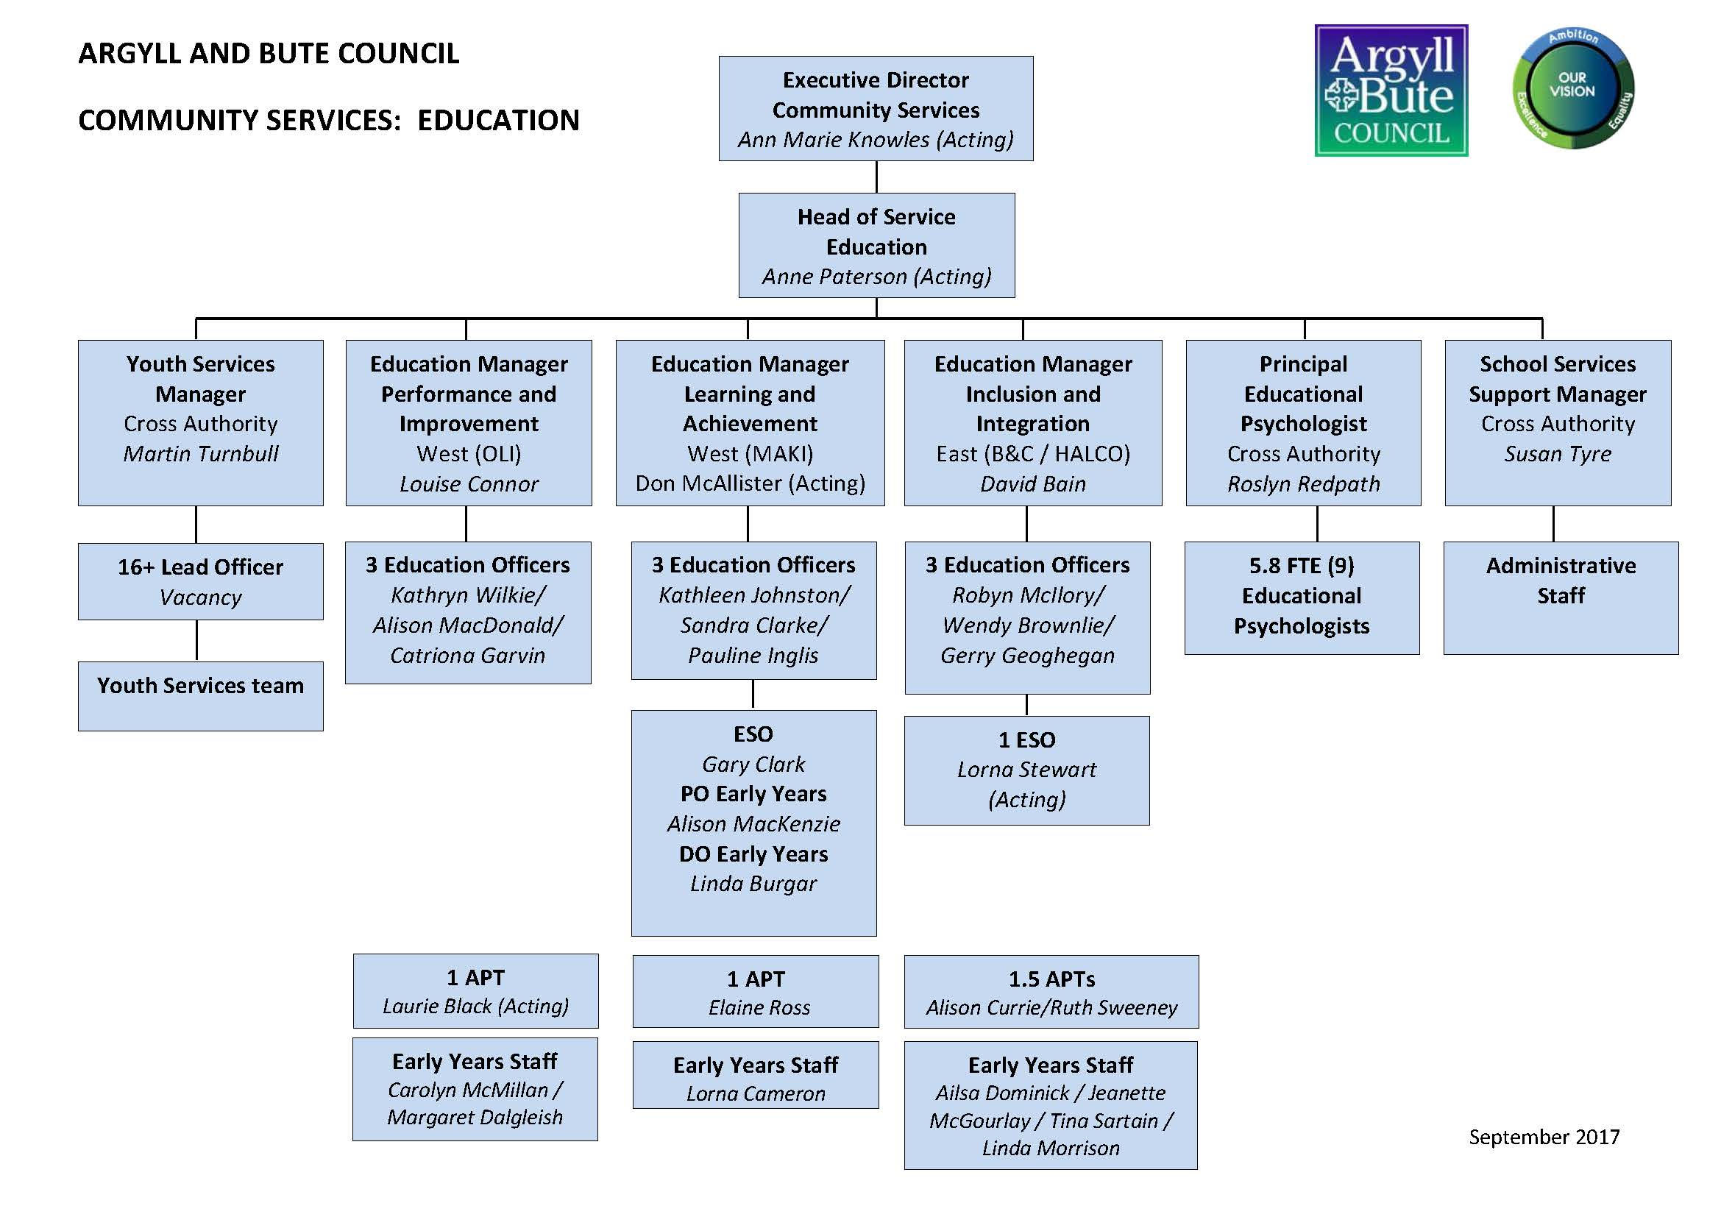

|  |  |
| --- | --- |
| APT | Assistant Principal Teacher |
| ESO | Education Support Officer |
| PO | Principal Officer |
| DO | Development Officer |
| The role of Chief Education Officer is undertaken by Head of Service Education | |

**Glossary of terms**

|  |  |
| --- | --- |
| ASL | Additional Support for Learning |
| ASN | Additional Support Needs |
| AFA | Area Finance Assistant |
| Aifl | Assessment is for Learning |
| BGE | Broad General Education |
| BWG | Education Service Budget Working Group |
| CfE | Curriculum for Excellence |
| CIRF | Capital Items Replacement Fund |
| CLD | Community Learning and Development |
| CPD | Continued Professional Development |
| COSLA | Convention of Scottish Local Authorities |
| DHT | Deputy Head Teacher |
| DSM | Devolved School Management |
| EIS | Educational Institute of Scotland |
| ELCC | Early Learning and Childcare Centres |
| ESOL | English for Speakers of Other Languages |
| FE | Further Education |
| FTE | Full Time Equivalent |
| GIRFEC | Getting It Right For Every Child |
| GTCS | General Teaching Council (for Scotland) |
| HE | Higher Education |
| HGIOS4 | How good is our School 4 |
| HGIOELC | How Good Is Our Early Learning and Childcare |
| HMIE | Her Majesty’s Inspectorate of Education |
| JSC | Joint Service Committee for Teaching Staff |
| LAC | Looked After Children and Young People |
| LNCT | Local Negotiation Committees for Teachers |
| MCMC | More Choices, More Chances |
| NAR | National Assessment Resource |
| NIF | The National Improvement Framework |
| NPF | National Performance Framework |
| PAThS | Promoting Alternative Thinking Strategies |
| PSD | Personal and Social Development |
| PSE | Personal and Social Education |
| QMIE2 | Quality Management In Education 2 |
| RMPS | Religious, Moral and Philosophical Studies |
| SCEL | Scottish College for Educational Leadership |
| SCQF | Scottish Credit Qualifications Framework |
| SCRA | Scottish Children’s Reporter Administration |
| SEN | Special Education needs |
| SIMD | Scottish Index of Multiple Deprivation |
| SQA | Scottish Qualifications Authority |
| SRA | Shared Risk Assessment |
| SSLN | Scottish Survey of Literacy and Numeracy |
| SSSC | Scottish Social Services Council |
| SSTA | Scottish Secondary Teacher’s Association |
| SVQ | Scottish Vocational Qualification |
| UCAS | Universities and Colleges Admissions Service |
| VLE | Virtual Learning Environment |
| VSE | Validated Self Evaluation |

**Bibliography**

**A range of information contained within National publications, Service Plans, Committee reports and policy documents have been used to support the preparation and publication of this annual plan. These include:**

1: Achievement of Curriculum for Excellence (CfE) Levels return

<http://www.gov.scot/stats/bulletins/01253>

2: Association of Directors of Education in Scotland (ADES) report on Headteacher Recruitment, March 2016

<http://www.gov.scot/Resource/0050/00505011.pdf>

3: Child Health 27-30 Month Review Statistics , December 2015

http://www.isdscotland.org/Health-Topics/Child-Health/Publications/2015-12-15/201512

4: Education Outcomes for Looked After Children 2014/15

<http://www.gov.scot/Publications/2016/06/7455>

5: Evaluation of the Impact of the Implementation of Teaching Scotland’s Future, March 2016

6: Initial Destinations of Senior Phase School Leavers, No 1: 2017 Edition, Scottish Government 2017

7: National Improvement Framework For Scottish Education 2016 Evidence Report,

Scottish Government, December 2016, ISBN: 978-1-78652-612-0

8: Our Children, Their Future: Education Vision and Strategy, Argyll and Bute Education Service

9: Participation Measure for 16 – 19 year olds in Scotland

(Experimental Statistics - data being developed), Skills Development Scotland, 2015,

<https://www.skillsdevelopmentscotland.co.uk/news-events/2015/august/new-measure-to-> help-scotlands-young-people/

10: Programme for International Student Assessment (PISA) 2015: Highlights from Scotland’s Results

<http://www.gov.scot/Resource/0051/00511095.pdf>

11: Scottish Government Summary Statistics in Schools in Scotland (December 2016)

<http://www.gov.scot/stats/bulletins/01255>

12: Scottish Schools Adolescent Lifestyle and Substance Use Survey (SALSUS)

<http://www.gov.scot/Topics/Research/by-topic/health-community-care/social-research/> SALSUS

13: Scottish Survey of Literacy and Numeracy (SSLN)

<http://www.gov.scot/Topics/Statistics/Browse/School-Education/SSLN>

14: Skills Development Scotland Participation Measure for 16-19 year olds in Scotland

[https://www.skillsdevelopmentscotland.co.uk/media/38957/participation_measure_ final_publication.pdf](https://www.skillsdevelopmentscotland.co.uk/media/38957/participation_measure_%20%09final_publication.pdf)

15: Summary Statistics for Schools in Scotland, No. 7: 2016 Edition 13 December 2016,

ISBN 978-1-78652-665-6 (web only)

16: Teacher Census, Supplementary Data <http://www.gov.scot/Topics/Statistics/Browse/School-Education/teachcenssuppdata>

17: Standards in Scotland’s Schools etc. Act 2000: Statutory Guidance, Scottish Government, March 2017

18: 2017 National Improvement Framework and Improvement Plan for Scottish Education: Achieving Excellence and Equity, Scottish Government, December 2016

19: Delivering Excellence and Equity in Scottish Education: A Delivery Plan for Scotland, June 2016 <http://www.gov.scot/Publications/2016/06/3853>

20: Getting it Right for Every Child, <http://www.gov.scot/Topics/People/Young>People/gettingitright

21: National Improvement Framework for Scottish Education – Achieving Excellence and Equity <http://www.gov.scot/Publications/2016/01/8314>

22: Teaching Scotland’s future: Report of a Review of Teacher Education in Scotland, December 2015

<http://www.gov.scot/resource/doc/337626/0110852>