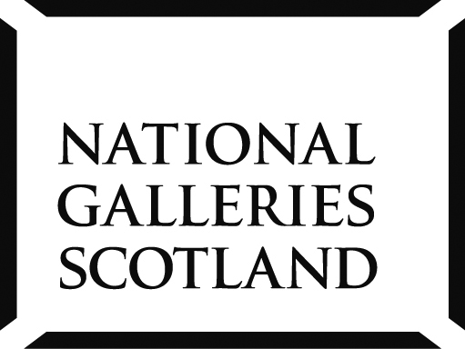

CPD Workshops for Teachers 2014
We offer inspiring practical workshops, led by artists with expert knowledge and experience. You can be creative yourself while learning how to adapt art activities in a practical way to the needs of your class.

Sessions cost £50 per person and includes all materials, refreshments and entry to any paying exhibitions.

Life Drawing Inspired by Titian
Saturday 6 September 2014, 10am-4.30pm. £50 per person. Limited places. Clore Education Centre, Scottish National Gallery.
Inspired by Titian's dynamic figure poses and loose handling of paint, this course will look at approaches to drawing the figure in an energetic and expressive way. Drawing materials will be combined in layers to achieve some of the effects that Titian sought and that Degas emulated in his own pastel paintings. Charcoal, ink and chalk pastels will be used on a variety of surfaces. Led by artist Damian Callan.
http://www.nationalgalleries.org/whatson/exhibitions/titian-and-the-golden-age-of-venetian-art/

GENERATION: 25 Years of Contemporary Art in Scotland
Friday 26 September 2014, 1.30–4.30pm & Saturday 27 September 2014, 10am-4.30pm. £50 per person. Limited places. Clore Education Centre, Scottish National Gallery.
This short intensive CPD course for Teachers will begin with an examination and discussion of the GENERATION exhibition at the Scottish National Gallery - exploring ideas, materials and processes.

Thereafter, we will work in the Clore studio from our own creative ideas and those inspired by the exhibition. A variety of conventional and unconventional materials will be available to engage and experiment with, helping us to consider how choice of media, technique and form communicate meaning.
Whilst the main focus of the workshop is to allow participants personal creative exploration time, we will discuss how the ideas and materials introduced in the workshop could be used successfully in the classroom. Led by artist Audrey Grant.
http://www.nationalgalleries.org/whatson/exhibitions/generation-25-years-of-contemporary-art-in-scotland-national/

PLEASE BOOK YOUR PLACE BY THURSDAY 28 AUGUST 2014

To book a place of any of these sessions, please contact Sarah Mackinnon, Education Bookings Coordinator on 0131 624 6410 or email education@nationalgalleries.org

Further CPD sessions to be announced shortly.

Private Views for Teachers 2014-2015

The Art of Golf: The Story of Scotland’s National Sport
Wednesday 10 September 2014, 5.15 – 7pm
Scottish National Gallery

American Impressionism: A New Vision
Wednesday 24 September 2014, 5.15 – 7pm
Scottish National Gallery of Modern Art Two

Remembering the Great War
Wednesday 1 October 2014, 5.15 – 7pm
Scottish National Portrait Gallery

GENERATION: 25 Years of Contemporary Art in Scotland
Wednesday 22 October 2014, 5.15 – 7pm
Scottish National Gallery of Modern Art Two

BP Portrait Award 2014
Wednesday 3 December 2014, 5.15 – 7pm
Scottish National Portrait Gallery

The Two Roberts: Colquhoun & MacBryde
Wednesday 21 January 2015, 5.15 – 7pm
Scottish National Gallery of Modern Art Two

To book your place, email education@nationalgalleries.org

Download the latest Programme for Schools here:
http://www.nationalgalleries.org/media/_file/education/ngs-schools-programme-2014-2015.pdf

