
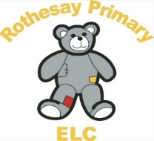
Rothesay Primary Pre-5

Toilet Learning Policy

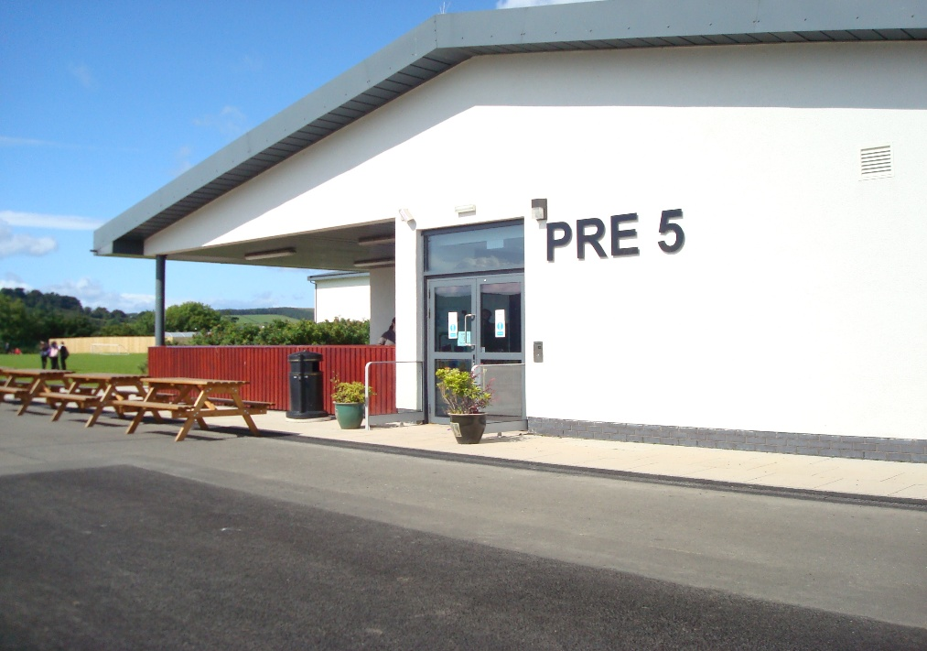

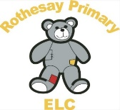
Toilet Learning Policy 

Articles of the UNCRC (the UN Convention on the Rights of the Child)
Article 3: The best interests of the child must be a top priority in all decisions and actions that affect children.
Article 5: (parental guidance and a child’s evolving capacities) Governments must respect the rights and responsibilities of parents and carers to provide guidance and direction to their child as they grow up, so that they fully enjoy their rights. This must be done in a way that recognises the child’s increasing capacity to make their own choices
Article 12: (respect for the views of the child) Every child has the right to express their views, feelings and wishes in all matters affecting them, and to have their views considered and taken seriously.
Article 24: You have a right to the best health possible and to medical care and to information that will help you to stay well.

Health and Social Care Standards: My support, my life (Health and Social Care Standards - My support, my life.)
1.0 | I experience high quality care and support that is right for me.
1.1 | I am accepted and valued whatever my needs, ability, gender, age, faith, mental health status, race, background or sexual orientation.
1.4 | If I require intimate personal care, this is carried out in a dignified way, with my privacy and personal preferences respected.
4.11 | I experience high quality care and support based on relevant evidence, guidance and best practice
5.4 | If I require intimate personal care, there is a suitable area for this, including a sink if needed.
1.15 | My personal plan (sometimes referred to as a care plan) is right for me because it sets out how my needs will be met, as well as my wishes and choices

Statement of purpose.
At Rothesay Primary Pre-5, we are committed to providing a nurturing, inclusive and responsive approach to toilet learning, toileting and intimate care. We recognise that toileting is a significant developmental milestone and an important part of children’s health, wellbeing and early learning.
We ensure all children are supported with dignity, privacy and respect, and that their individual needs are met through warm, respectful and responsive interactions.
Our practice reflects:
- Getting it Right for Every Child (GIRFEC)
- Health and Social Care Standards (2017)
- Realising the Ambition: Being Me (2020)
- UNCRC (United Nations Convention on the Rights of the Child)

Rothesay Primary Pre-5 recognise the importance of working with families to support children’s health, wellbeing and development through effective toilet learning. With reference to ERIC, The Children’s Bowel and Bladder Charitie’s 3 step ‘Let’s Go Potty’ approach https://eric.org.uk/potty-training-policy/
Using the toilet independently and stopping wearing nappies/pull-ups is a big milestone for the child and their family. There are lots of new and exciting skills to learn. It is normal to have lots of accidents at the beginning, and this is an important part of the learning process. Rothesay Primary Pre-5 will demonstrate patience and positive encouragement to all children.
We will……
· Ensure the family and child’s individual needs are identified and met.
· Ensure all cultural preferences are taken into account
· Ensure a positive experience is created, supporting both children and families throughout.

ERIC, The Children’s Bowel and Bladder Charity, has helpful information and resources on toilet learning in early years settings.
Their 3 step ‘Let’s Go Potty’ approach is broken down into stages:
1. Preparation
2. Practice
3. Stop using nappies
All policies and procedures that are implemented throughout Rothesay Primary
Pre-5 must continue to be implemented.

Collaboration.
Rothesay Primary Pre-5 will work in partnership with parents and carers by:
· Using a consistent approach, based on the 3 step ‘Let’s Go Potty Approach’.
· Sharing this policy with parents and carers.
· Ensuring the child’s individual needs are met including those with additional needs and/or cultural preferences.
· Provide a safe, suitable and welcoming environment for intimate care, nappy changing and toileting – please see Nappy Changing and Intimate Care policy.
· All staff involved in these procedures will have a full disclosure check as part of the Protection of Vulnerable Groups (PVG) scheme.
Rothesay Primary Pre-5 will ask parents/carers to:
· Provide nappies/pull ups and changing resources such as wipes while the child is still using them.
· Dress the child appropriately when taking part in toilet learning, i.e. in clothing that is easy for the child to remove.
· Follow the agreed approach at home to ensure consistency and reduce potential confusion for the child.
· Communicate with staff any issues or concerns regarding their child’s toilet learning/ development.
The Lead practitioner/Manager will inform and support practitioners to access any additional training resources to support their professional development.
At Rothesay Primary Pre-5 we are following ‘Let’s go potty: Let’s go together’! This is the 3 step evidence based approach adopted by ERIC, for children learning how to use the toilet independently and stopping wearing nappies/pullups.
The foundation of this approach is that children are born ready to learn new skills. Research shares it is better for children’s bladder and bowl health to stop using nappies/pull between 18 and 30 months. Rothesay Primary Pre-5 will share www.eric.org.uk for information and advice.
Brief Summary of the 3 step ‘Let’s Go Potty’ approach:
STEP 1
PREPERATION
Spending time preparing the children for toilet learning is the best way to help them start the process.
Help prepare them by:
· Making sure there is no underlying constipation, and they are having plenty of water based drinks (6-8 full cups a day) – keeping the bladder and bowl healthy will help with toilet learning.
· Rothesay Primary Pre-5 and parent/carers should monitor wee and poo – refer to ERIC wee and poo checker – (Appendix 1 & 2).
· Involving them in the nappy changing process, encouraging discussions about using the toilet to help them understand where wee and poo goes, and the language we use for the toilet and how our body feels.
STEP 2
PRACTICE
Learning how to use the toilet and feel comfortable around wee and poo is a great way to introduce the next step. Research shares from the time a child can safely sit up unaided, they can be introduced to the toilet with the help of an adult.
Opportunities to sit on a toilet include:
· Shortly after they wake up
· After mealtimes
· Anytime you know the child needs to go, (for example when you observe the child straining for a poo or dancing for a wee).
It is important to use play to teach children what to expect, for example the use of stories, characters and toys to encourage and motivate them.
STEP 3
STOPPING USING NAPPIES/PULL-UPS
Now the child has been preparing and has had the opportunity to practice, they will have gained new skills and confidence.
The final steps are to stop wearing nappies/pull-ups. Tips to make this easier include:
· The families and Rothesay Primary Pre-5 will agree a good time to begin. It is best to avoid doing it at a time when there are any big changes to the child’s or family’s routine.
· For the child to be as independent as possible, they should wear clothing that is easy for them to get on and off Rothesay Primary Pre-5 will support/advise where required.
· Encourage all children regardless of gender to sit on the toilet for wees and poos – especially in the beginning. This helps to empty the bladder better and helps to prevent constipation.
We will work in partnership with families to ensure consistency in the approach to no longer using nappies/pull-ups.
Most children can learn to be clean and dry. Children with Additional Support Needs including delayed development and physical disabilities may take longer and need more support, however the process you need to follow is the same.
Rothesay Primary Pre-5 are committed to supporting all children and families during toilet learning, working in partnership to develop children’s individual care plans that reflect and are responsive to their needs.
Institute of Health Visiting Potty Training Guide

Monitoring of this Policy
It will be the responsibility of Rothesay Primary Pre-5 Lead practitioners/Manager to ensure that all staff, including new or temporary staff, are familiar with this policy and to monitor that it is being implemented. This will be reviewed through both formal and informal observation of staff practice.

Appendix 1

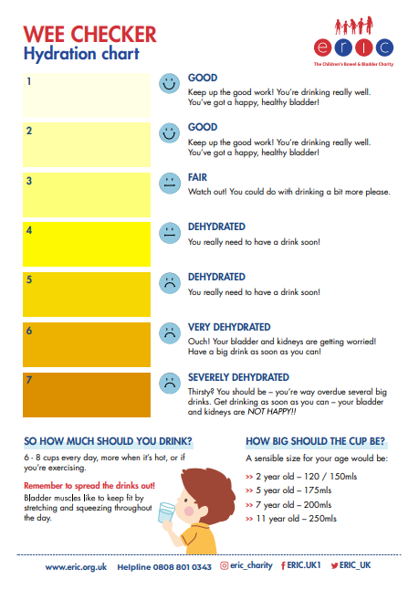

Appendix 2

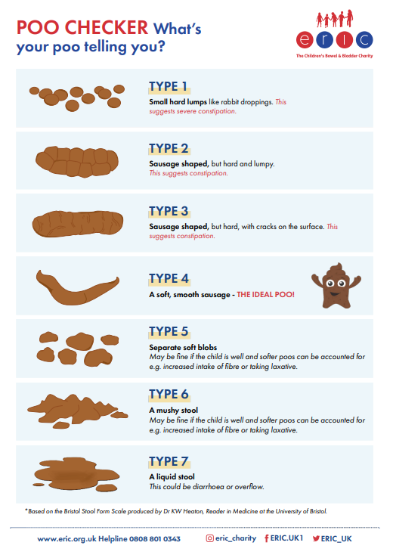

Appendix 3

Toilet Learning Policy
I have read and understood this policy.
Staff Name - Print and Sign | Date Reviewed

