
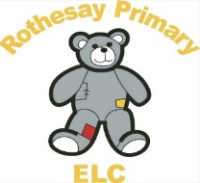
Rothesay Primary Pre-5

Nappy Changing and intimate care Policy and Procedures

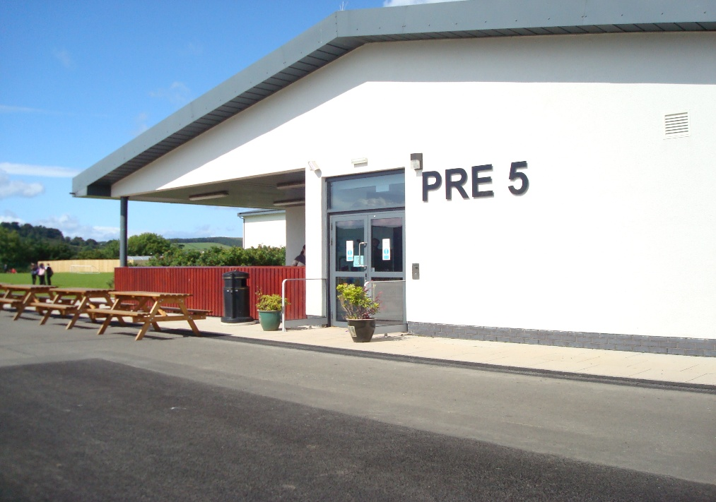

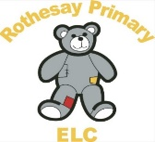
Nappy Changing and Intimate Care 
Policy and Procedures
Articles of the UNCRC (the UN Convention on the Rights of the Child)
Article 3: The best interests of the child must be a top priority in all decisions and actions that affect children.
Article 5: (parental guidance and a child’s evolving capacities) Governments must respect the rights and responsibilities of parents and carers to provide guidance and direction to their child as they grow up, so that they fully enjoy their rights. This must be done in a way that recognises the child’s increasing capacity to make their own choices
Article 24: You have a right to the best health possible and to medical care and to information that will help you to stay well.

Article 34: You have the right to be protected from sexual abuse.

Article 36: You have the right to protection from of any other kind of exploitation

Health and Social Care Standards: My support, my life (Health and Social Care Standards - My support, my life.)
1.0 | I experience high quality care and support that is right for me.
1.1 | I am accepted and valued whatever my needs, ability, gender, age, faith, mental health status, race, background or sexual orientation.
1.4 | If I require intimate personal care, this is carried out in a dignified way, with my privacy and personal preferences respected.
4.11 | I experience high quality care and support based on relevant evidence, guidance and best practice
5.4 | If I require intimate personal care, there is a suitable area for this, including a sink if needed.
1.15 | My personal plan (sometimes referred to as a care plan) is right for me because it sets out how my needs will be met, as well as my wishes and choices

Statement of Purpose

We recognise that every child reaches developmental milestones at varying chronological ages. Therefore, all children will be welcomed to Rothesay Primary Pre-5 regardless of their progress towards toilet learning.

The following policy outlines procedures and considerations for nappy changing and for intimate care, when changing a child who is learning to use the toilet. Toilet learning is viewed as a self-care skill that children have the opportunity to learn with the full support and non-judgemental concern of staff. Children’s privacy, dignity and where appropriate independence will be respected and always promoted at Rothesay Primary Pre-5.

It is important that all members of staff have a clear understanding of their role in preventing the spread of infection and are familiar with the guidance, policies and procedures that are in place to prevent and control infection in childcare settings. Good hand hygiene and hygienic nappy changing practice and effective decontamination of equipment and the environment is vital to reduce the risks of transmitting infection to children and staff.

This guidance is also relevant when attending to a child who requires a change of clothing.

Responsibilities

Staff should ensure children feel safe and secure throughout the activity and that they are respected and valued as individuals. Children have a right to privacy and dignity when their needs are being met and staff should ensure this is maintained at all times. The quality of a child's experience during this time is paramount. Nappy changing/intimate care should be a nurturing experience and can play an important part of the process of building a positive relationship between the adult and child.
Staff should make eye contact with the child, communicate with the child and offer praise and encouragement throughout the experience.
Staff should ensure that nappies are changed regularly throughout the day and promptly after soiling.
The child's key person and classroom assistants will be responsible to ensure routine nappy changing/intimate care, but all staff have a responsibility to respond when a child is soiled in order to ensure prompt attention. If a staff member notices that a child needs changed, then this must be alerted in a sensitive manner with the child and the keyworker if available.

A record will be kept by the staff members of changing times and any observations such as nappy rash or loose movements etc. This information should be shared with parents/carers when the child is collected in a sensitive and respectful way, (appendix2).

All staff involved in these procedures will have a full disclosure check as part of the Protection of Vulnerable Groups (PVG) scheme.

Equipment and Procedures

Children will be changed in a warm, well ventilated, designated changing area which allows privacy for the child and has handwashing facilities for both children and adults, The changing area will only be used for the nappy changing and intimate care and will only contain equipment to support this. The surfaces will be easily wiped down and disinfected. The changing area should be separate from the play areas and away from food preparation areas, serving areas and laundry areas. Nappy changing and intimate care areas should be designated for that use only.

The safety of children is paramount, and no child will be left unsupervised on a changing unit. Any potential risks associated with nappy changing and intimate care will be suitably assessed and actions taken to reduce these to the lowest practical level.

A nappy changing unit which conforms to BSI 8, will be used when changing babies and very young children. The changing unit will have steps up to the unit depending on the age of the child, which will be retracted when not in use. Rothesay Primary Pre-5 will ensure toilet lids within the changing area will be closed before any flushing to reduce the risk of spray coming back into the room and cross contamination. The changing area has adequate space to support safe movement for child and adult.

Staff involved in nappy changing/intimate care will wash and dry their hands thoroughly, using the designated sink for hand washing only, before starting changing procedures and they will wear disposable gloves and apron which will be changed between attending to each child.

When changing a child, disposable wipes or cotton wool will be used. The child will always be cleaned wiping from front to back. All nappies, wipes and barrier creams must be provided from home and only used by one child. (see Appendix 1)

Any child requiring the application of barrier cream must have prior written parental permission.

All children will be encouraged to wash their hands to help establish good hygiene habits. After changing the child will be dressed and returned to the playroom.

Children should become familiar with the toileting area to develop confidence and familiarity with the environment. Children will have the opportunity to use the toilet independently or be given assistance as required. All children will be encouraged to adopt good personal hygiene habits.

Rothesay Primary Pre-5 do not have the necessary facilities to ensure the safe use, storage and cleaning of potties as outlined within Preventing and controlling infections - GOV.UK. Toilet facilities within the setting are appropriate to the age and stage of development. (lower than standard household sanitation).

Storage and Disposal

It is best practice to take all nappy changing products directly to the nappy changing facility for each child on each occasion. If a child’s personal belonging need to be stored withing the changing area, (nappies, wipes and other items) will be clearly labelled and stored in cupboards with doors/drawers, sealed plastic containers or bags that can be cleaned easily and clearly labelled with the child’s name.

Used disposable nappies will be securely sealed in a nappy sack and placed in a lidded bin designated

Rothesay Primary Pre-5 will keep contaminated clothing in a sealed plastic container for the minimum time necessary. If a child's clothes have been contaminated with bodily fluids, any solid waste will be flushed down the toilet. Items will be double bagged and labelled before storing in a sealed waterproof container within the changing area and a laundry label put on child’s peg to advise parent/carer to collect.(Appendix 3)

We will sensitively return clothing to parents/carers, being respectful of the child’s dignity.

Rothesay Primary Pre-5 staff will ensure PPE, such as gloves and aprons are worn at all times when handling soiled linen or clothing.

Staff will ensure that areas around the changing unit and any touched surfaces, including the splash zone around the sink and toilet are left clean and disinfected with non-antibacterial surface cleaner in line with standard infection prevention control procedures (SICP’s) before and after use.

Finally, both gloves and apron will be removed, disposing of them appropriately then wash and dry hands thoroughly once more.

This process will be repeated for each child who requires to be changed.

Application of Nappy Creams

Parents will complete a medication form to enable staff to apply nappy cream supplied from home. Staff will liaise with parents daily when their child has had nappy cream applied. Parents who supply nappy cream that has been supplied with a medication label will complete a medication sheet. This will then be completed to monitor usage and date the cream. Nappy cream should be applied by parents in the first instance to monitor and ensure there are no allergic reactions before supplying this to the nursery.

Monitoring of this Policy

It will be the responsibility of the Lead Practitioners and Manager to ensure that all staff, including new and temporary are familiar with these procedures and to monitor that they are being implemented by all staff. This will be achieved by regularly inspecting the changing area for cleanliness and supplies and this will be evidenced in our daily cleaning schedule. Appropriate records are being maintained and parents kept informed. This will aid the consistent implementation of this policy, the nappy changing/intimate care procedure will be laminated and displayed within the changing area and within this policy for parents/carers information.

See also:
Infection Control Policy
Child Protection Policy
Health and Safety Policy

Find out more:

https://www.gov.scot/Resource/0042/00423979.pdf

http://www.gov.scot/Topics/People/Young-People/gettingitright/lead-professional

https://hub.careinspectorate.com/media/5638/nappy-changing-guidance-2024.pdf

https://publichealthscotland.scot/publications/health-protection-in-children-and-young-people-settings-including-education/health-protection-in-children-and-young-people-settings-including-education-version-1/#section-1

https://hub.careinspectorate.com/media/1623/space-to-grow.pdf

https://www.gov.scot/binaries/content/documents/govscot/publications/advice-and-guidance/2017/06/health-social-care-standards-support-life/documents/health-social-care-standards-support-life/health-social-care-standards-support-life/govscot%3Adocument/health-social-care-standards-support-life.pdf

Lead Practitioner:
Leanne Costello Date of next review: October 2026

Appendix 1

Guidance: Space to Grow - Section 02 - Nappy Changing Guidance

- Spray the changing unit with non-antibacterial surface cleaner in line with standard infection prevention control procedures (SICP’s) and wipe clean, then wash your hands once completed.
- Ensure the change area is clean and tidy before you begin and that you have enough hand soap, gloves, antibacterial spray, nappy sacks, paper towels and aprons
- Before you begin, take everything you need out of the child’s bag/box and lay it out.
- Keep the child’s belongings close by in case you need anything extra
- It is important to chat to children while you change them, reassuring them if they are upset. It is a good opportunity for developing communication skills and build positive relationships between staff and child.
- Once a child is on the changing unit you must not leave the child unattended at any time during change time
- Put on gloves and a clean apron once the child is lying down
- Undress or pull down lower items of clothing, un popping vests and pulling up above nappy
- Remove dirty/wet nappy and place into a nappy sack
- Clean the child thoroughly with their own wipes or cotton wool and apply creams as directed by the parent/carer.
- Remove gloves and dispose of them.
- Put on fresh gloves to apply child’s own barrier creams
- Put on fresh nappy, ensuring tapes are not stuck too tight. You should be able to comfortably place your fingers between nappy and skin
- Re-dress the child, ensuring that vest/clothes are clean and suitable
- Babies/children should wash their own hands after nappy changing, smaller babies can be helped by staff
- If you have changed an item of clothing this should be double bagged with two nappy sacks, labelled with child’s name and placed in the closed tub within the changing room and a laundry label put on child’s peg to advise parent/carer to collect.
- Tie the nappy sacks and place in the bin
- Spray the changing unit and wipe clean
- Remove gloves and apron and place into the bin
- Wash hands following guidelines displayed
- Take child to wash their hands
- Take child back to play
- Record the change on the nappy sheet and record on the daily care sheet to be sent home with parents/carers.

Appendix 2

Rothesay Primary Pre-5 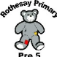
Nappy Changing/Toilet Learning Record
Prescribed barrier cream, parents/carers must complete: Parent/carer permission form: Administration of medication.

Child’s name:
Key: W-Wet S-Soiled X – No change needed
Date | Time | Key | Observation/Comment | Barrier  Cream- with permission | Wet through Play | Tried Toilet | Staff  Sign

Appendix 3

************************************************************************
To reflect current Care Inspectorate guidance and UK Health Security Agency guidance, ”all contaminated items must be sent home with the child, with information on how to launder provided to the parent or carer” – (Care Inspectorate, Nappy changing for early learning and childcare settings (excluding childminders) 2025).
Rothesay Primary Pre-5 would like to advise all parents/carers to wash any contaminated clothing separately in a washing machine, using a pre-wash cycle, on the hottest temperature that the clothes will tolerate. – With thanks.
*************************************************************************
*************************************************************************
To reflect current Care Inspectorate guidance and UK Health Security Agency guidance, ”all contaminated items must be sent home with the child, with information on how to launder provided to the parent or carer” – (Care Inspectorate, Nappy changing for early learning and childcare settings (excluding childminders) 2025).
Rothesay Primary Pre-5 would like to advise all parents/carers to wash any contaminated clothing separately in a washing machine, using a pre-wash cycle, on the hottest temperature that the clothes will tolerate. – With thanks
*************************************************************************
*************************************************************************
To reflect current Care Inspectorate guidance and UK Health Security Agency guidance, ”all contaminated items must be sent home with the child, with information on how to launder provided to the parent or carer” – (Care Inspectorate, Nappy changing for early learning and childcare settings (excluding childminders) 2025).
Rothesay Primary Pre-5 would like to advise all parents/carers to wash any contaminated clothing separately in a washing machine, using a pre-wash cycle, on the hottest temperature that the clothes will tolerate. – With thanks

