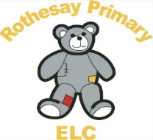


Rothesay Primary School Pre5

Infection, Prevention and Control Policy
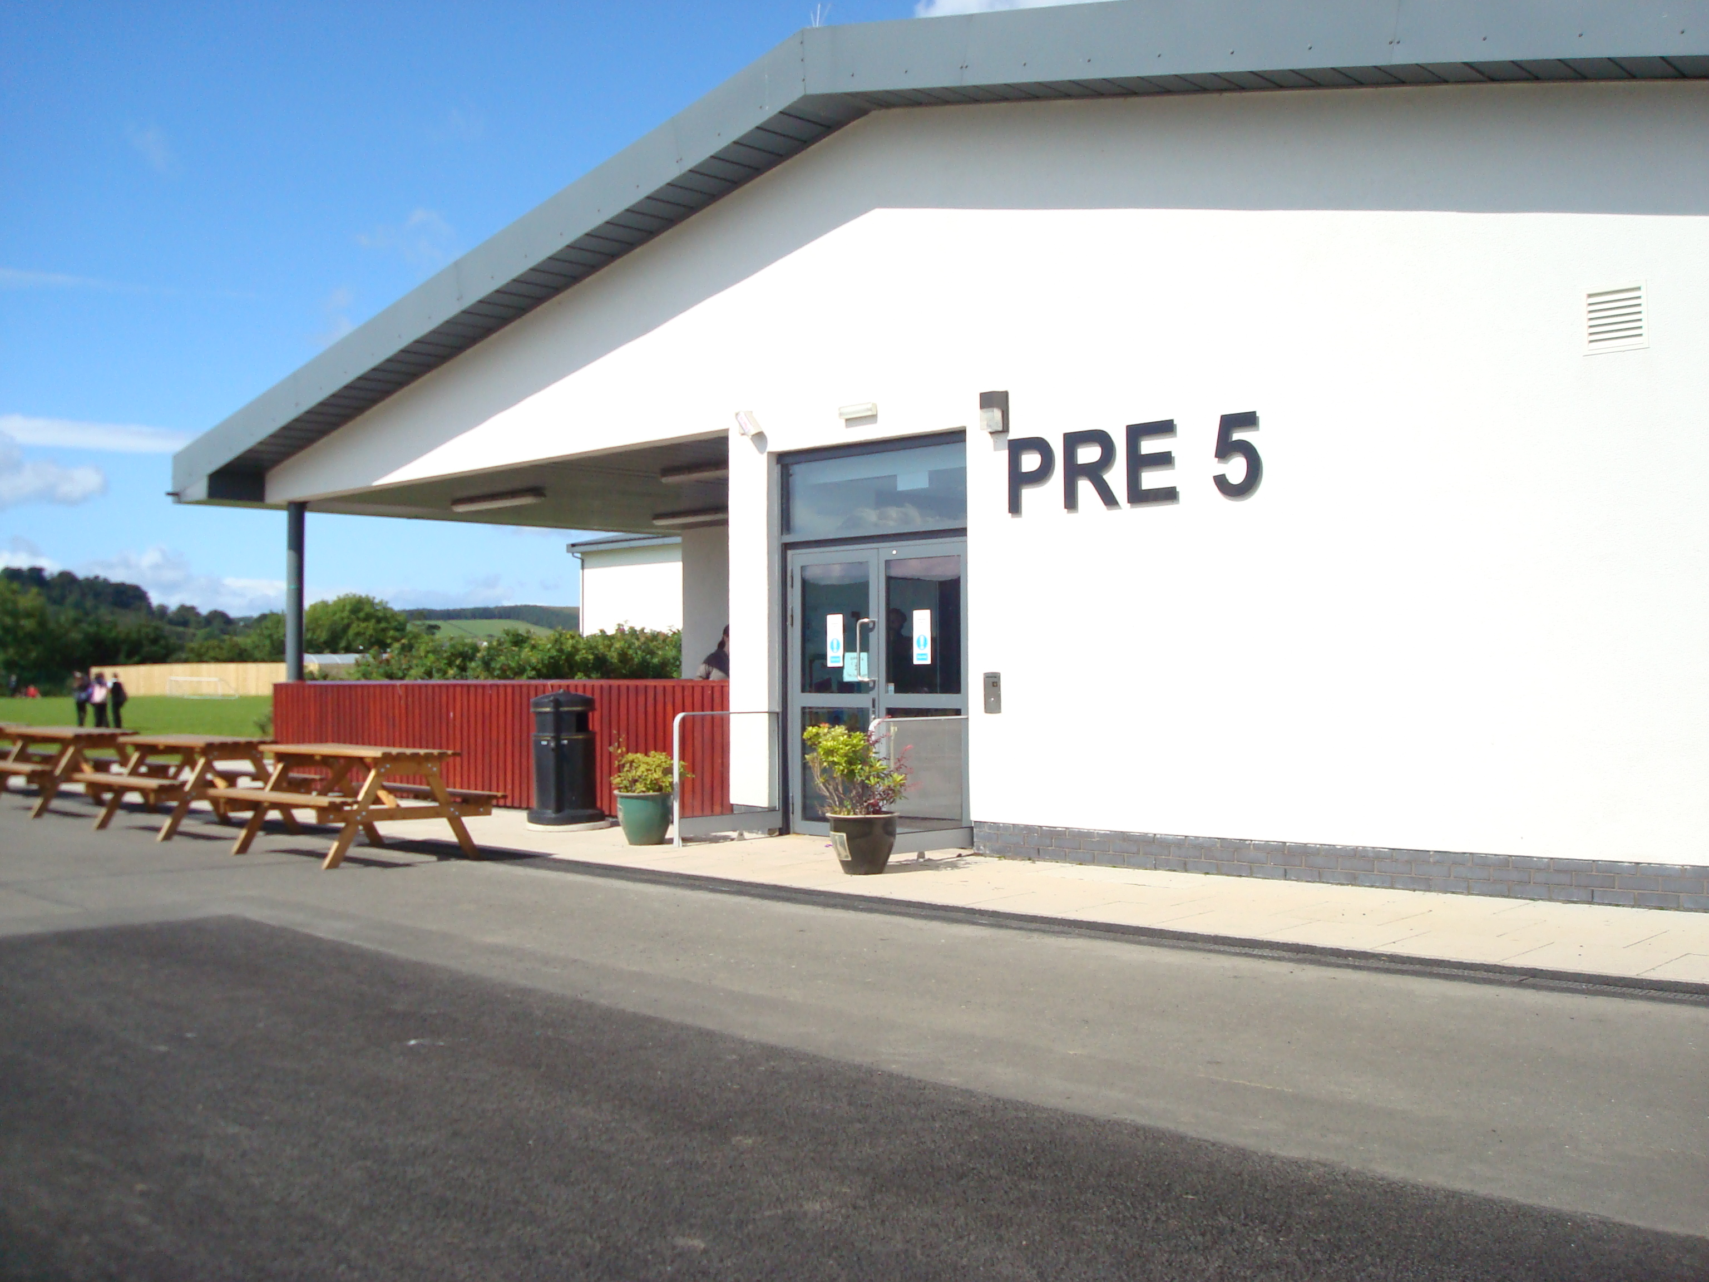

This policy was adopted at a meeting of ELC.

On: 11th March 2026 Review Date: 31st October 2026

Signed
Designation: Acting Head of Centre

This policy is underpinned by the UNCRC and Health and Social care Standards as reflected below.
Articles of the UNCRC (the UN Convention on the Rights of the Child)
Article 3 | The best interests of the child must be a top priority in all decisions and actions that affect children.
Article 24 | (health and health services) Every child has the right to the best possible health. Governments must provide good quality health care, clean water, nutritious food, and a clean environment and education on health and well-being so that children can stay healthy. Richer countries must help poorer countries achieve this

Health and Social Care Standards: My support, my life (Health and Social Care Standards - My support, my life.)
5.19 | My environment is secure and safe.
5.21 | My environment has plenty of natural light and fresh air, and the lighting, ventilation and heating can be adjusted to meet my needs and wishes
5.29 | I experience an environment that is well looked after with clean, tidy and well maintained premises, furnishings and equipment.
Statement of Purpose
At Rothesay Primary Pre5 we recognise our 'duty of care' and requirement in law to provide a safe environment for the children in our care. (As per the “Health and Social Care Standards’, Standard 5:) We will ensure that all staff are fully supported to enable the setting to meet these requirements and follow guidance within the Health protection in children and young people settings, including education (HPCYPS) website. Throughout this policy the term ‘parents’ is used to include all main caregivers.
Prevention of Spread of Infection
To minimise the spread of infection Rothesay Primary Pre5 will follow standard infection control precautions (SICPs) as recommended by the NHS. We carry out regular risk assessments that are considered appropriate to our setting and current circumstances, ensuring information is recorded and maintained up to date. In carrying out these risk assessments we will take account of the environment, daily routines, regular activities, and occasional activities such as outings. We will also take into consideration the risk to all service users especially those who are more vulnerable to infection e.g. pregnant women, children with any heath conditions and those on medication that makes them more susceptible to infection etc. Infectious diseases in education and childcare : A practical guide for staff poster will be displayed in the staff office. (Appendix 1).
To facilitate this, parents will be requested at registration and during transition into Rothesay Primary Pre5 inform us of any relevant pre-existing conditions and to inform us of illnesses as they occur. This information will be recorded and stored sensitively.
Rothesay Primary Pre5 will ensure that all parents have access to information regarding immunisation. We refer to NHS Inform: When to Immunise guidance supporting immunisation programmes section.
Risk assessments will be done in collaboration with and shared with all staff (children and parents as appropriate) to improve infection prevention and control practice. Staff and children with symptoms of infectious disease should not attend the ELC setting, more information on recommended exclusions periods can be found HERE. Rothesay Primary Pre5 also displays information Should I keep my child off school for parents/ and visitors (Appendix 2).
Standard Infection Control Precautions (SICPs)
All staff at Rothesay Primary Pre5 will follow these procedures, training will be refreshed/completed to ensure all staff and new employees demonstrate good practice when considering infection, prevention and control, reflecting current guidance. Training will include information on how infection spreads (as per the Preventing and controlling infections section of the guidance). Rothesay Primary Pre5 use Health protection in children and young people settings, including education guidance to inform staff and parents/carers by referring them to the HPCYPS website.
Rothesay Primary Pre5, Infection Control Policy encompasses the following areas:
Hand hygiene – Free resources to support hand hygiene education for ages 3 to 16 are available from within this section : BEST WAY TO WASH YOUR HANDS , Preventing and controlling infections - GOV.UK. HOW TO WASH YOUR HANDS Poster will be displayed in all hand washing areas, (Appendix 3).
Respiratory and cough hygiene – Children will be supported to follow guidance around respiratory/couch hygiene, RESPITORY HYGIENE AND COUGH ETIQUETTE Poster will be displayed for guidance, (Appendix 4).
Personal protective equipment (PPE) – This will be worn as directed within the PPE section of the guidance such as household gloves and aprons.
Keep hands away from face and PPE being worn.
Change gloves when torn or heavily contaminated.
Limit surfaces touched in the patient environment.
Always clean hands after removing gloves.
Staff will follow display Putting on and Removing PPE in and follow guidance (Appendix 5).
Safe management of the environment – Routine cleaning of the environment daily, including the cleaning of toys will be recorded and filled for regular review, (Appendix 6).
Ventilation-prioritising natural ventilation by opening windows, and where appropriate doors, to allow for fresh air to circulate the setting. Extractor fans have been installed where appropriate.
Safe management of linen and soft furnishings – Rothesay Primary Pre5 will ensure that, where surfaces do not have a wipeable surface, they will be cleaned in an area that is separate from any food preparation areas, has appropriate hand washing facilities and using a washing machine with a sluice or pre-wash cycle
When cleaning linens Rothesay Primary Pre5 will:
- ensure that linen is washed at least weekly and when visibly dirty
- bedding will only be use by one person, then laundered. No 2 children will use the same bedding at any time.
- launder face flannels after each use
- remove dirty and used linen from areas that are accessible to children and young people
- carefully dispose of any soiling (faeces) found on clothing or linen into the toilet, for example from reusable nappies – note: do not rinse soiled clothing, including reusable nappies
- wash all linen at the hottest temperatures specified on the fabric
- keep fresh linen in a clean, dry area separate from used linen
Management of waste (including sharps) – this includes nappy waste and the disposal of sharps Duty of care CODES OF PRACTICE FOR MANAGING CONTROLLED WASTE
Safe management of blood and bodily fluid- Rothesay Primary Pre5 will ensure best practice and display current poster Management of blood and body fluid spillages, (Appendix 7)
Managing an exposure–Injuries where the skin is broken by a needle or bite. MANAGING EXPOSURE
This includes needlestick or sharps injuries, cuts, bites, nose bleeds and bodily fluid spills. An exposure is an injury from a used needle or a bite which breaks the skin, and/or exposure of blood and body fluids onto:
- broken skin
- the eyes, nose or mouth
Injuries of this type including human bites that puncture the skin, are a potential source of exposure to blood borne infections and should be managed promptly and in accordance with guidance and/or local policies.
At Rothesay Primary Pre5 we ensure that details of designated first aiders who are appropriately trained are up to date. If an exposure, injury or bite occurs the designated first aider will:
Perform first aid to the exposed area immediately, based on the location of the exposure, injury, or bite.

If skin or tissue affected:
- encourage the area to bleed
- do not suck on the damaged skin or tissue
- wash or irrigate with warm running water and non-antimicrobial (plain) soap
- if running water is unavailable, use pre-packaged solutions, for example, sterile water or saline for irrigation

If eyes or mouth affected:
- rinse or irrigate copiously with water
- user eye/mouth washout kits, if available
- if contact lenses are worn, remove then irrigate
Once first aid is carried out:
report and document the incident
- ensure that any corrective actions or interventions are taken
- ensure that the item that caused the injury is disposed of safely
- assess if further medical assessment is needed
Use the SICPs to reduce the risk of unknown (and known) infection transmission. These include:
- wearing single-use (disposable) gloves when in contact with blood, bodily fluids, non-intact skin, eyes, mouth, or nose (washing grazes, dressing wounds, cleaning up blood after an incident) and single-use (disposable) plastic apron
- carefully cleaning the wound under running water if possible or using a disposable container with water and wipes; carefully dab dry
- covering all exposed cuts and grazes with a waterproof dressing or plaster
- keeping the dressing or plaster clean by changing it as often as is necessary
- managing all spillages of blood or body fluids
Toileting and Sanitation
At Rothesay Primary Pre5 we follow UKHSA guidance Specific settings and populations: additional health protection considerations - GOV.UK (www.gov.uk) and the Care Inspectorate’s Nappy changing nappy-changing-guidance-2024.pdf (careinspectorate.com) for early learning and childcare settings (excluding childminders) guidance when considering nappy changing and toileting. Please see Nappy Changing/intimate care policy and procedures.

Food and Kitchen Hygiene
At Rothesay Primary Pre5 we are responsible for food safety and SICPs will be always followed in the preparation of food. In line with good practice outlined in Setting the Table October 2024. All catering staff and at least one ELC member of staff will have a Food Hygiene Certificate that is up to date.
Early warning signs of infection Rothesay Primary Pre5 Staff will inform the Head Teacher/Manager/Duty 1st Aider, if a child has any of the following symptoms:
- Appears unwell (feels hot or looks flushed);
- Complains of feeling ill for example cough, sore throat, runny nose, muscle aches and headaches.
- Diarrhoea and/or vomiting.
- Blood in their faeces; or
- Unexplained rash.
Following this, the child should be kept apart from other children and their parent/carer will be asked to collect them as soon as possible. On collection the parent/carer should be encouraged to consult their GP if the child's symptoms persist. If more than one child within the setting displays these symptoms (known as a cluster), then advice will be sought from the local NHS Health Protection Team (HPT), local HPT contact details will be displayed for staff, (Appendix 8).
Outbreaks of infection in childcare settings
At Rothesay Primary Pre5 we will ensure that standard infection control procedures are always in force. Should there be an outbreak of infection Rothesay Primary Pre5 will follow the procedures highlighted within the, Responding to outbreaks and incidents section of the guidance. Staff will be reminded of these procedures within this section of the guidance and make themselves aware of them. The local Health Protection Team (HPT) will be informed when there is an outbreak of infection and further guidance and support sought from them. As required by law we will also inform the Care Inspectorate of the outbreak. The procedures to be followed in the case of an outbreak will be rehearsed and tested annually to ensure that all staff know what to do. Settings must notify the Care Inspectorate in the event of any confirmed or suspected outbreak of an infectious disease, notifications and guidance are available through eForms.
To ensure HPT (Health Protection Team) can quickly identify any increase in absence that may be associated with an outbreak Rothesay Primary Pre5 will ensure:
Date of Absence, usual location/class of absent person and reasons for absence is recorded. These records will be detailed enough to identify common causes or symptoms.

Monitoring of this Policy
It will be the responsibility of Head Teacher/Manager, to ensure that all staff, including new or temporary staff, are familiar with this policy and to monitor that it is being implemented.

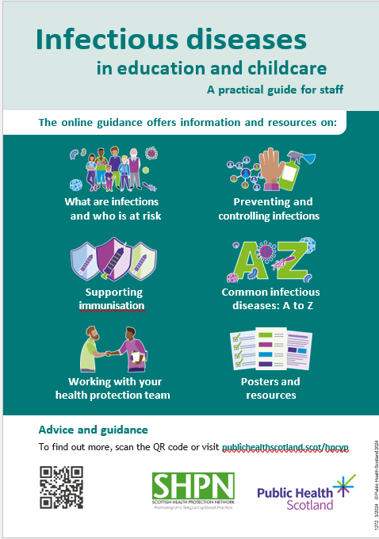
Appendix 1
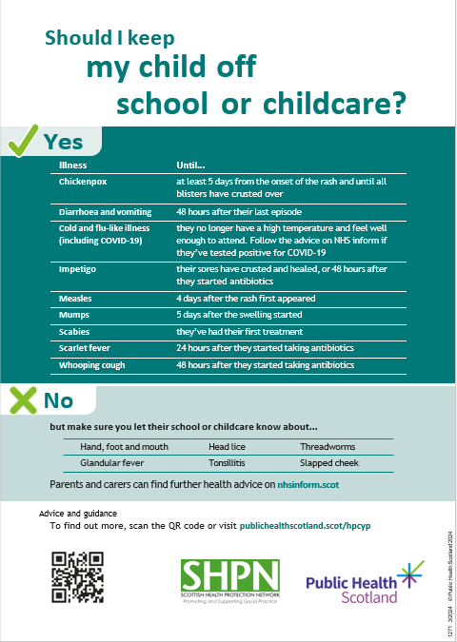
Appendix 2
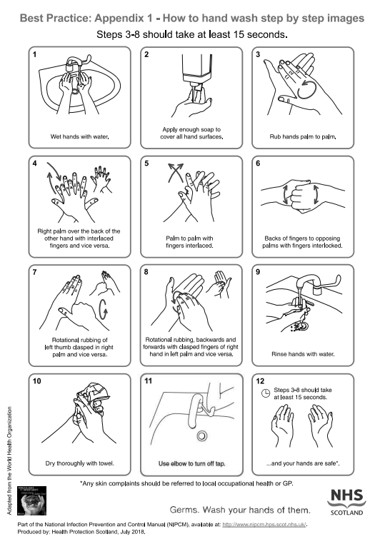
Appendix 3

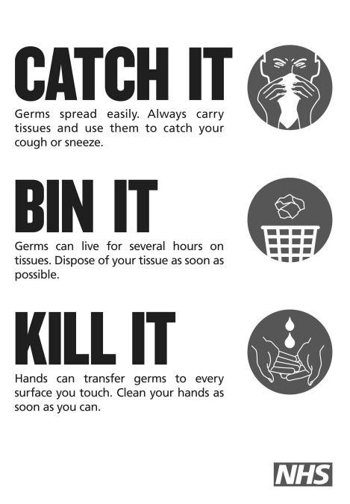
Appendix 4
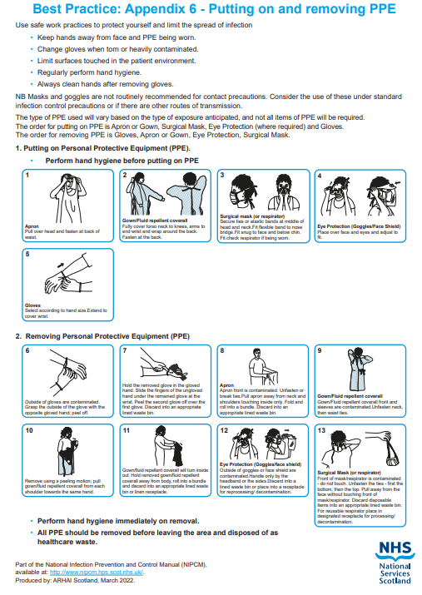
Appendix 5
Appendix 6
Weekly cleaning schedule
Start Date:
Created with reference to: Health protection in children and young people settings, including education - version 1 - Health protection in children and young people settings, including education - Publications - Public Health Scotland
Items and areas to be  cleaned | How often the cleaning should  take place | Method of cleaning (including whether the chemical  needs to be diluted) | Monitor and record (signed by the person responsible  for the cleaning)
 |  |  | Monday | Tuesday | Wednesday | Thursday | Friday
 |  |  | M
Appendix 7
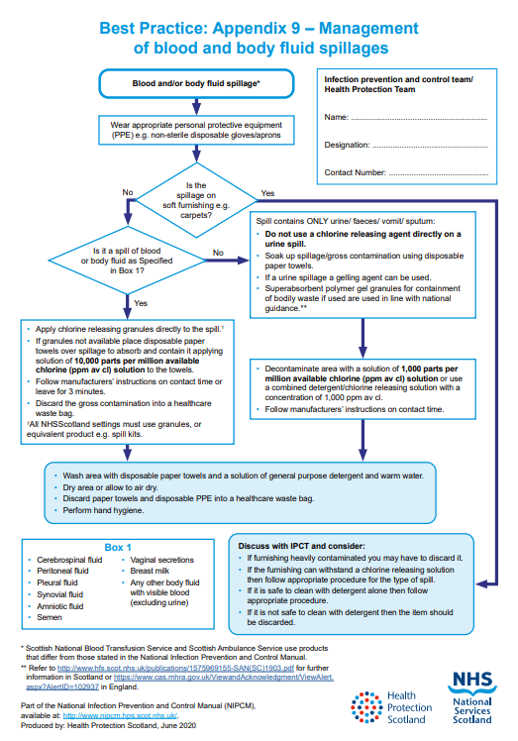

Appendix 8

Your local health protection team contact details:

NHS Health Protection team provides support and advice on all aspects of health protection in children and young people settings.
NHS Highland Health Protection Team
Larch House
Stoneyfield Business Park
Inverness
IV2 7PA
Email hpt.highland@nhs.scot – email is preferred for non-urgent queries.
Phone 01463 704 886 - In-hours number should be used between 09:00 and 17:00.

It is better to phone HPT than to email to discuss suspected outbreaks or incidents.

Appendix 9
Infection, Prevention and Control Policy
Staff Name - Print and Sign | Date Reviewed

Infection, Prevention and Control Policy
Staff Name - Print and Sign | Date Reviewed

Infection, Prevention and Control Policy
Staff Name - Print and Sign | Date Reviewed

