
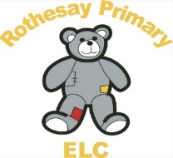

Rothesay Primary Pre5

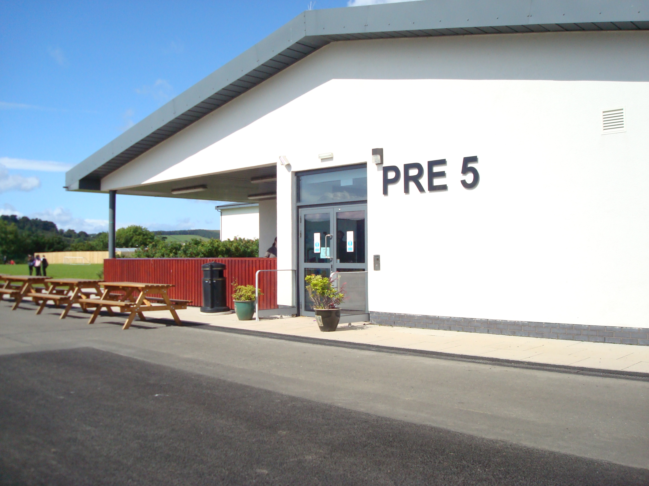

Children as learners’ policy.
This policy was adopted at a meeting of Rothesay Primary Pre5

On: 17th March 2026

Signed
Designation

This policy is underpinned by the UNCRC and Health and Social care Standards as reflected below.
Articles of the UNCRC (the UN Convention on the Rights of the Child)
Article 3 | The best interests of the child must be a top priority in all decisions and actions that affect children.
Article 29 | Goals of education.
Article 31 | Leisure, Play and Culture.

Health and Social Care Standards: My support, my life (Health and Social Care Standards - My support, my life.)
1.6 | I get the most out of life because the people and organisation who support and care for me have an enabling attitude and believe in my potential.
1.19 | My care and support meets my needs and is right for me.
1.25 | I can choose to have an active life and participate in a range of recreational, social, creative, physical and learning activities every day, both indoors and outdoors.
1.30 | As a child, I have fun as I develop my skills in understanding, thinking, investigation and problem solving skills, including through imaginative play and storytelling.
1.31 | As a child, my social and physical skills, confidence, self-esteem and creativity are developed through a balance of organised and freely chosen extended play, including using open ended and natural materials.
1.32 | As a child, I play outdoors everyday and regularly explore a natural environment.
2.22 | I can maintain and develop my interests, activities and what matters to me in the way that I like.
2.27 | As a child, I can direct my own play and activities in the way that I choose, and freely access a wide range of experiences and resources suitable for my age and stage, which stimulate my curiosity, learning and creativity.
4.11 | I experience high quality care and support based on relevant evidence, guidance and best practice

Statement of purpose.
Children as Learners “Young children come to early years settings as active, experienced learners with a natural curiosity. They are unique individuals eager to make sense of the world, to develop relationships, and to extend their skills.” (Curriculum for Excellence)
“The experiences and spaces for play we facilitate for the children should reflect the children’s ideas, aspirations curiosities and next steps in their learning. It is through play that children learn about themselves and make sense of the world around them.” (Realising the Ambition – Being Me)
“It is widely acknowledged that the provision of universally accessible and high quality ELC enriches children with skills and confidence to carry into, and multiply, throughout their schooling, and is a cornerstone for closing attainment and inequality gaps.
Expanded ELC has huge potential to improve outcomes for all children. It is a gateway to children getting the right start and will help to ensure that our children develop as successful learners, confident individuals, responsible citizens, and effective contributors.
High quality ELC can contribute to our wider actions to close the attainment gap, delivering opportunities to our young people no matter their family background.” (A Blueprint for 2020: The Expansion of Early Learning Childcare in Scotland)
Aims
Through play Rothesay Primary Pre5 aims to empower children to become successful learners, confident individuals, responsible citizens and effective contributors so they can:
- use communication and literacy skills,
- use technology effectively to support learning
- be creative, independent thinkers
- learn independently and when part of a group
- make logical evaluations
- identify, link and apply different kinds of learning in new situations
- relate to others and manage themselves
- follow a healthy and active lifestyle
- become self-aware
- grow and share their own beliefs and views of the world
- be as independent as they can
- consider risk and make informed choices/decisions
- become successful in different areas of activity
- consolidate and strengthen prior learning
- develop knowledge and understanding of the world and Scotland’s place in it.
- understand different beliefs and cultures
- make informed choices/decisions
- assess environmental, scientific and technological issues
- develop informed ethical views of complex issues
- communicate in different ways
- work in partnership and in teams
- take the initiative and lead
- apply critical thinking in new situations
- be creative
- solve problems
“By identifying more closely what we want children to learn and how best children learn we can enhance the range of learning opportunities and try to ensure that, whatever setting children attend, they have equal access to broad and balanced learning experiences.
Children learn and develop at different rates personal to themselves. They are continually trying to make sense of the world around them. Children learn best when they are active, busy learners. It could be said that they are learning all of the time from all of their experiences.” (Realising the Ambition – Being Me)
“Empowering teachers, parents and communities to achieve Excellence & Equity in Education – A Governance Review highlights that, when parents are fully involved in their child’s learning, and in the life and work of their school, we see better outcomes for children, parents and school.” (A Blueprint for 2020: The Expansion of Early Learning & Childcare in Scotland)
Rothesay Primary Pre5 will achieved this by ensuring adults provide an environment where they can support and extend children's learning through play, giving opportunities for choice, encouraging the children to:
- be highly motivated for most of the time
- be very interested in what they are doing
- show curiosity
- talk with knowledge and enthusiasm about previous experiences
- initiate and lead activities
- approach adults seeking information or assistance
- respond well to opportunities for choice for example deciding who to play with/follow interests/become absorbed in the activity of their choice
- choose from activities of various ability levels
- have responsibility for their own activities
- make regular independent use of resources
- be aware of what is expected of them and to do their best in any situation
- exhibit a sense of purpose when they are engaged in tasks
- demonstrate responsibility and self-discipline in an activity approach to learning
- follow group/individual activities
- take responsibility for their play, their order of choices of resources and for working without direct supervision as appropriate
- explore independently with staff extending learning with sensitivity when necessary
- use computers and other digital resources.
Resources
- Curriculum for Excellence
- A quality improvement framework for the early learning and childcare sectors
- Building the Curriculum 1,2,3,4,5
- Realising the Ambition – Being Me
- My World Outdoors
- Inventory of equipment upgraded/checked/reassessed annually
- Our Creative Journey
Evaluation
Rothesay Primary Pre5 constantly evaluate the spaces, interactions and experiences to ensure that appropriate opportunities for learning through play in the key aspects of children's development and learning are in place - Rothesay Primary Pre5 Educators will consider interests, how to motivate, the previous experience, the stages of development and the balance between free play and activities directed by adults for their learners.
Monitoring of this Policy
It is the responsibility of Rothesay Primary Pre5 Manager to ensure that all staff, including new or temporary staff, are familiar with this policy and to monitor that it is being implemented.

Appendix 1
Play Policy
I have read and understood this policy.
Staff Name - Print and Sign | Date Reviewed
Play Policy
I have read and understood this policy.
Staff Name - Print and Sign | Date Reviewed

