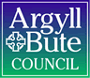

Standards and Quality Report 2024 - 2025

Port Ellen Primary School

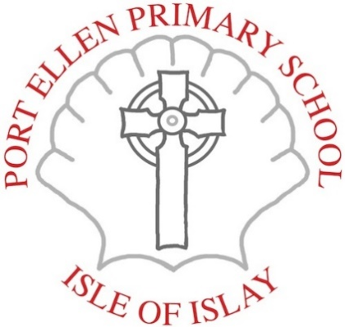

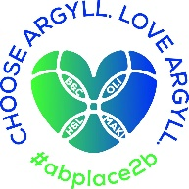


Context of the school
Port Ellen Primary School is a non-denominational and co-educational school situated on the south of Islay.

The School Roll for Session 2023- 24 was 80 P1-P7 and 23 in the ELCC including two year olds.
There are 4 classes - P1/2, P3/4 , P4/5and P6/7 .
The F.T.E. (full time equivalent) teaching compliment for the school session was 5.56 FTE
Port Ellen School is a Shared Headship with Bowmore Primary .
Our refreshed Vision , Values and Aims , done in consultation with parents, pupils and staff consists of the following ;

Our Mission Statement

We are to Learn as Long as we live – Chan eil thu tuilleach ’s sean airon ionnsachadh fhathast

Our School Values - based on 3 ‘I am’ statements ;

- I am Innovative
- I am Independent
- I am Included

Our aims- these link very closely to the values

- To encourage a curious and creative mindset with the ability to apply critical thinking
- To develop resilient and responsible individuals ecognise the importance of lifelong learning
- To create a caring community where there are opportunities for all

Port Ellen Primary catchment area includes the villages of Laohroaig, Lagavulin and Ardbeg and The Oa. Gaelic Culture is a big part of the children's heritage and Gaelic is taught throughout the school and in the ELCC.
The main industries on Islay are ; Whisky Distilling, Farming, Fishing and Tourism. There are 5 Whisky Distilleries within the catchment area of Port Ellen School and these are the biggest employer for many of our families .
Access to the island is by ferry or plane.
Being an island school within a strong local community rightly influences our place-based learning curriculum design.

Being an island school, the lack of availability of resources can be a challenge. However, we benefit from a strong local community and we work closely and innovatively with a range of partners and third sector agencies to develop learning across the 4 contexts and deliver curriculum entitlements for all.

Port Ellen Primary School SIMD profile is between deciles 5 - 7 or Quintile 4

Review of SIP | Priority 1
Pedagogy
Progress and Impact: -
Target 1
By June 25 all class teachers will have participated in teacher efficacy sessions where they will have planned, implemented and evaluated changes in their teaching practice that improve outcomes for all learners.
This session we began embedding a more consistent, evidence informed approach to teaching and learning through the introduction of Power up Your Pedagogy by Bruce Robertson. This approach also aligned with the new structure of our School Improvement Plan where priorities are grouped under the headings of Pedagogy, Attainment, Curriculum and Ethos.
All teaching staff participated in a SIP meeting where the key strategies and features of effective pedagogy were summarised and discussed. This created a strong platform for professional learning and reflection.
To support implementation in practice, class visit feedback forms were amended to align with the Power up your Pedagogy framework, allowing for focused, strategy- based feedback. The senior leadership team carried out two rounds of class visits and provided structured feedback to staff, reinforcing shared expectations and highlighting effective practice.
Staff completed a reflective survey in August 24 and in June 25, see below.
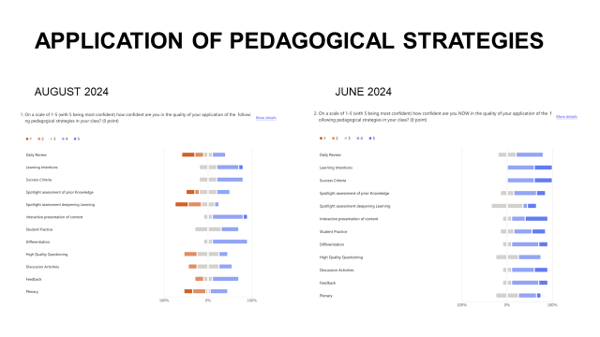
Responses show a positive impact, with teachers reporting a deeper understanding of high-impact pedagogical strategies and an increased confidence in applying them.
Importantly, there is now a shared language of pedagogy developing across the school, which is supporting more cohesive planning, collegial dialogue and collaborative improvement.

Target 2 –
By June 25 all children will have achieved outcomes in all 4 skills within the Oracy Framework
In addition we placed a focus on developing the 4 skills of Oracy - Physical, Linguistic, Cognitive and Social and Emotional. A teacher survey showed that teachers made the greatest impact on the Physical skill of Oracy, explicitly supporting pupils to develop voice projection, clarity and confidence when speaking. This contributed to improved pupil participation across learning. There were many opportunities throughout the session for pupils to use their Oracy Physical skills such as open mornings, Endeavour Fair, At the STEM nation visit etc. A group of Our Pupils were also chosen to meet with HMIE and discuss the positives and negatives of the school inspection model and provide suggestions going forward. The pupils received very positive feedback regarding their clarity and participation.
This work aligns with HGIOS 4 QI 2.3 Teaching, Learning and Assessment and supports children’s rights under the UNCRC Article 29, ensuring our Pedagogy enables all learners to develop their talents, thinking skills and confidence in communication – see overall evaluation of 2.3

Next Steps:
PEDAGOGY
From a teacher survey see below – Spotlight Assessments will be a focus going forward.
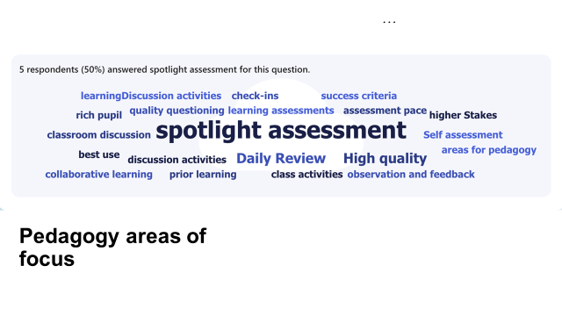

The Wordle shows clearly that class teachers would like to focus on Spotlight Assessments.

Building on the strong foundations established this year, next session we will continue to deepen our pedagogical practice in three key areas.
- Spotlight Assessments - linked to QI 2.3
Teachers will implement short, focused assessment tasks designed to check understanding of specific skills or concepts. These will be planned at key points in learning sand used formatively to guide next steps in teaching, provide timely feedback and support pupil reflection and evaluation.
Impact on Learners
Learners will gain greater clarity about what success looks like, receive feedback that supports their next steps and have more opportunities to reflect on and articulate their learning.
- Oracy- Cognitive Skill Development – Linked to QI 3.2
Having made strong progress in developing the physical skill of Oracy, teachers identified a need to focus on the cognitive dimension- having pupils to organise and express their thinking clearly, justify opinions and engage in exploratory talk across the curriculum.
Impact on Learners
Learners will develop confidence and skill in expressing complex ideas, engaging in structured talk and applying reasoning across the curriculum – particularly in literacy, numeracy and IDL
- Collaborative Inquiry and professional Learning through Reading Groups.
To further enhance teacher efficacy, we have invested in a range of high-quality professional reading materials. Staff will engage in reading groups focused on key areas of pedagogy aligned with our School Priorities. This will support deeper professional dialogue, informed experimentation in classrooms and ongoing improvement in practice at an individual and collective level.
Impact on Learners
Learners will benefit from more consistent research- informed teaching strategies that are better matched to their needs. As teachers refine their practice, pupils will experience more engaging, responsive and purposeful learning.

Review of SIP | Priority 2
Attainment
Progress and Impact:
Target 1 –
By May 25 pupils in almost all P2,3,5,6 will improve mathematical reasoning and number sense skills
GL Data June 25 – Overall Score Comparison Table 1
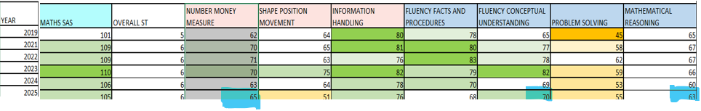
Our target was to improve Number, Fluency and Mathematical reasoning by 6 PP. While each of the target areas of maths have shown improvement, we did not realise the target set out and will need to maintain a focus on number fluency for next session.
Developing learners’ problem-solving skills remains a key priority for the school. Staff have engaged positively with the NRICH problem solving approach and have begun to develop a shared understanding of effective strategies for teaching problem solving. Progress in fully embedding this work across all stages was impacted by staffing changes and competing priorities throughout the session. All teachers are developing confidence and expertise in this area through professional learning and collaboration. With focused professional development planned for next session, the school is well placed to achieve greater consistency and improved outcomes in problem solving.
GL Data June 25 – Comparison Table 2 and 3 for;
class P2 in 2024 , now P3 2025 class P5 2024, now class P6 2025
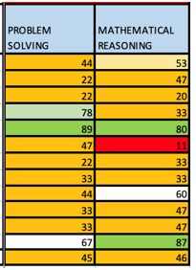
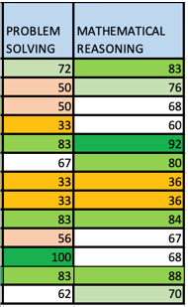
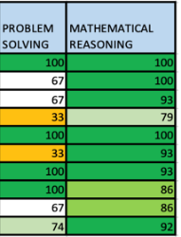
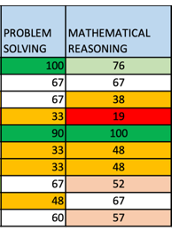

Given the decline in mathematical reasoning in P3 from June 2024 to June 2025 implemented targeted intervention and curriculum adjustment to plug gaps in conceptual understanding and the application of reasoning strategies will be actioned.
The now P6 cohort has shown a marked improvement in mathematical reasoning attainment compared to their P5 results last session. This improvement is closely linked to high-quality teaching, with the current class teacher demonstrating strong diagnostic skills- accurately identifying gaps in understanding and tailoring learning accordingly. A clear focus on precision in pedagogy, targeted support and high expectations has contributed significantly to this positive shift in learner outcomes.

Target 2- GL Data collated in May 25 will show learners in the numeracy target group will achieve a SAS score of 95 or above.
In P2 100% of the target group achieved a SAS score of 95 or over
In P3 56% of the target group achieved a SAS score of 95 or over
In P5 56% of the target group achieved a SAS score of 95 or over
In P6 83% of the target group achieved a SAS score of 95 or over
This data shows a need to continue to provide targeted support, refine assessment informed teaching and ensuring consistency in approaches to numeracy interventions across the school.

Target 3-
Monitoring of P&A / ACEL data will show a 5% increase in the number of pupils achieving or exceeding expected levels in numeracy

Port Ellen
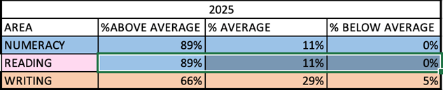
Table 4 SNSA Data 2025

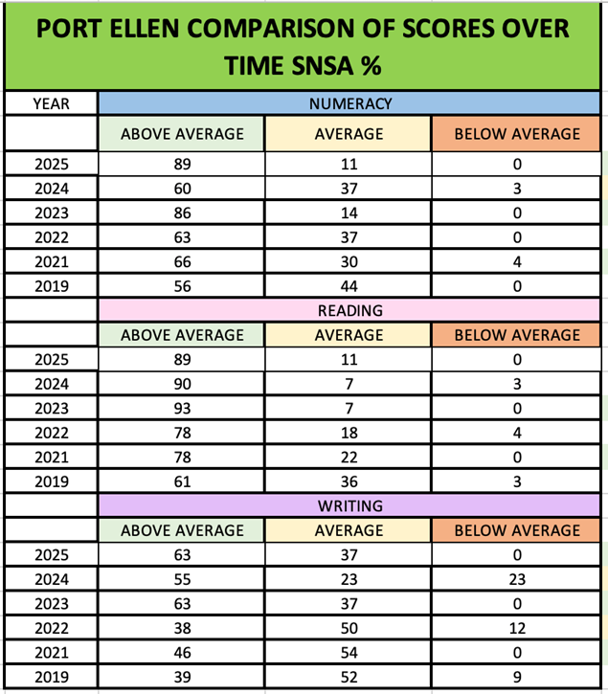

Table 5 SNSA Data Comparison over Time

SNSA Data for session 24/25 indicates that no learners in P1,4,7 performed below average in Number, Reading or Writing. This represents a notable improvement in overall attainment.
In writing this improvement aligns with a wider adoption of the CYPIC Writing Model, which has supported staff in delivering more structured, explicit instruction and regular opportunities for extended writing. In reading and numeracy, continued use of progressive frameworks and early interventions has supported secure developments in core skills.
While these outcomes are highly positive, we continue to triangulate data with class assessments, data analysis dialogue to ensure that all learners are supported and challenged.

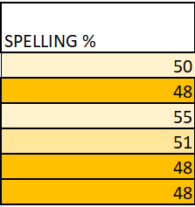
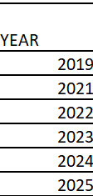
Table 6 – Comparison of spelling
Data from 2025 GL spelling assessments showed inconsistency in P2,3,5,6 spelling attainment and data over time indicates that there is a need to raise attainment in spelling skills.
Next Steps:
Problem Solving
QI 2.3 Learning, Teaching and Assessment
QI 3.2 Raising Attainment and Achievement
- Develop and implement a whole school progression framework for problem solving with shared strategies and expectations – refer to Counting on Excellence Framework
- Reintroduce structured use of nrich programme / resource to build depth and challenge
- Revise strategies such as bar modelling, Think Aloud
- Track and moderate problem-solving attainment in November and May to monitor consistency and progress.
Consistency in Pedagogy for Mathematical Reasoning
QI 2.3
QI 1.2 Leadership for Learning
- Facilitate joint planning and moderation (stage partners) focused on progression in mathematical reasoning
- Share effective practice internally (e.g. diagnostic approaches used in P6) to develop staff capacity
- Use peer observations and learning walks to support reflection and consistency in pedagogy
- Rigorous use of SEAL and Number Talks from ELC to P7
Raising SAS scores in P2,3,5,6 (GL Maths Assessment)
QI 3.2
QI 2.4 Personalised support
- Continued targeted, responsive interventions aligned with areas of difficulty identified in GL assessments
- Monitor progress through 1:1 data analysis dialogue and refine interventions
- Ensure classroom differentiation meets learner needs based on robust diagnostic information.
- Using the CYPIC Model to increase fluency, facts and procedures
Early Phonics
QI 2.3
QI 2.5 Family Learning
- Embed our new evidence-based phonics programme across early level (Floppy’s Phonics)
- Use formative assessment to track individual progress in phoneme recognition and blending
- Stage partners to moderate phonics pedagogy and intervention techniques
- Enhance home school links through parental guidance material and phonics ‘packs’
Spelling
QI 2.2 Curriculum
QI 3.2
- Implement Nelson Spelling from P3 – P7
- Develop a whole – school progression framework for spelling that dovetails and builds from Early phonics and supports consistency
- Embed regular, strategy-based spelling instruction across stages
- Use diagnostic assessments to target gaps and tailor instruction
- Promote application of accurate spelling through extended writing, proof reading and self-assessment.

Review of SIP | Priority 3
Curriculum
Progress and Impact:
Target 1- Literacy Strategy

By April 25, there will be a complete literacy strategy in consultation with all class teachers. There will be a standardised approach to teaching across all 3 literacy organisers and class teachers will be confident to implement strategies to target support.
We achieved our target of co-creating a literacy strategy – see link below
The development process has had a positive impact: staff confidence has increased through joint planning and moderation activities and there is a stronger shared understanding of what high-quality literacy teaching and assessment looks like across stages.
This is important in our context where staff changes can disrupt continuity. The strategy provides a clear framework for new or returning staff, supporting smoother transitions and a more consistent experience for learners
The strategy will be implemented fully from August 2025. We will use professional enquiry, tracking data, learning visits and pupil voice to review and amend the strategy as needed ensuring it remains responsive, practical and rooted in our learners’ needs.

Target 2 – IDL

Within the school session, teachers IDL Planning will demonstrate the application of valid skills from across the curriculum
Within the school session, teachers IDL Planning will demonstrate breadth, depth and challenge in planned experiences for all learners.
In August, Class Teachers collaborated with stage partners to co-create year to view IDL planning. The focus was on, ensuring breadth, relevance and the application of skills across learning. The planning process itself promoted professional dialogue around progression, contexts for learning and opportunities for deeper connections across the curriculum.
Teacher Self- Assessment Graph based on 6 Questions:
- How clearly are the intended learning outcomes from different curricular areas integrated and made explicit to learners during your IDL?
- In what ways does your IDL context provide real-life relevance and authenticity to learners?
- How do you ensure depth, challenge, and progression within the IDL experience, rather than just coverage of multiple subjects?
- What opportunities do learners have to influence the direction or content of your IDL projects?
- How do you assess and evidence learning across the different curricular areas within your IDL?
- How has collaboration (with other staff, learners, or the wider community) enhanced the quality and impact of your IDL work?
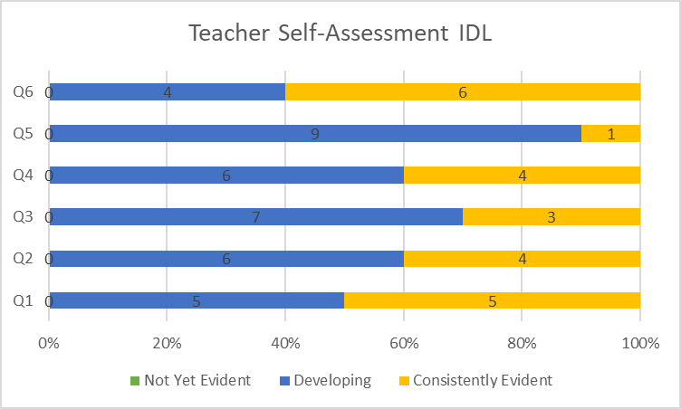
Self-evaluation data shows a positive shift in staff confidence in planning and delivering IDL. The majority of staff now identify their practice as either developing or consistently evident, with no responses indicating ‘not yet evident’
Feedback from staff suggests that our focus on structured, collaborative planning is building both capacity and shared understanding. There is also evidence of increased opportunities for skill transfer particularly in writing, digital literacy and science.
Moving Forward staff will be encouraged to build on this progress through moderation of IDL plans, the introduction of tracking Cross cutting themes, and sharing high quality assessments and effective practice.

Target 3
By March 25 class teachers will have implemented aspects of the newly created Science Progression Planner.
Following participation in the Curriculum Improvement Collaborative for Science (CIC), we made the professional decision to pause this work.
Through this National Forum, one of our PT attendees became aware of emerging changes linked to Scottish Curriculum reform, particularly the shift in emphasis towards outdoor learning, sustainability, pupil voice and IDL contexts. In light of this we chose not to proceed with developing a progression framework that may soon be misaligned with national expectations.
Progress was made among teachers with.
- Moderation of science learning across stages
- Increased professional dialogue
- Improved Shared understanding of expectations
- Reinforcing staff confidence in delivering science through IDL approaches
In the interim, science continues to be taught discretely and through IDL with an increasing emphasis on relevance.

Port Ellen Primary used Sea Story to explore plastics in the ocean and climate change. This creative and ethical context allowed learners to engage meaningfully with real-world issues while developing scientific understanding and critical thinking skills.

Moving forward we will continue to engage with national developments and further progress our STEM IDLs to include cross cutting themes and STEM outdoors relevant to our school context.
Next Steps:
QI 2.2 Curriculum
QI 3.1 Ensuring Wellbeing, Equality and Inclusion
Introduce Cross Cutting Themes (e.g. sustainability, digital literacy, equality) into long term planning to ensure coverage and coherence.
QI 2.3 Learning, Teaching and Assessment
QI 2.2
QI 1.1 Evaluation for Self-Improvement
Plan and deliver STEM-focused IDL across stages, with moderation alongside stage partners to ensure progression and consistency.
QI 2.2
QI 2.6 Transitions
QI 2.7 Partnerships
Embed outdoor STEM into Long term planning making best use of our local island context and environment.
QI 2.2
QI 1.3 Leadership of Change
Review and refine long-term STEM planning to ensure breadth, depth and relevance in line with curriculum design principles.
QI 2.2
QI 2.3
Our STEM is planned and delivered every term across all stages to maintain regular exposure in progression, scientific learning and skills development.

Review of SIP | Priority 4
Ethos
Progress and Impact:
Target 1 – Promoting Vison, Values and Aims
By August 25 all stakeholders will be familiar with the school’s vision, values and aims.
This session a key development in promoting our school ethos, has been the co-creation and installation of a bespoke wall art display at Port Ellen Primary School. This visual representation was designed collaboratively with staff and pupils, drawing curriculum rationale and the unique context of our island community. It aims to make our Vision, Values and Aims (VVA) more visible, meaningful and accessible to pupils, staff, families and visitors.
Although the display has only recently been installed, feedback from parents and carers at recent school events has been highly positive. Comments reflect how clearly the display illustrates our school’s values in action and affirms the sense of identity, place and belonging it promotes.
While formal evaluation is at an early stage, feedback suggests that the display is already having an impact in reinforcing a shared understanding of our ethos. This will be further promoted and referenced at assemblies, during class discussion and induction for new staff and pupils.
Our next steps are highlighted on the Maintenance Agenda of the SIP.
Wall Art Display Port Ellen Primary
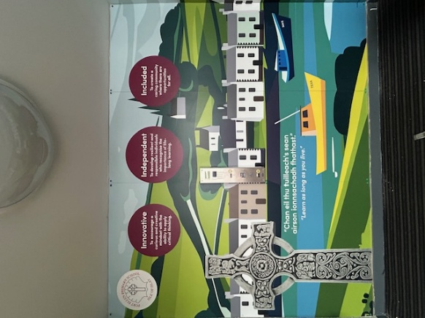
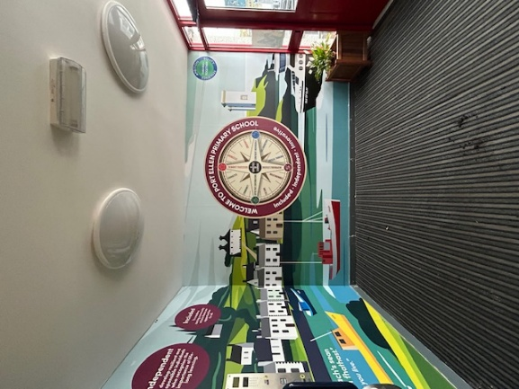
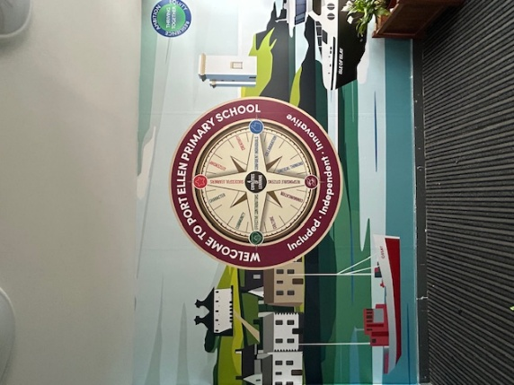

Target 2 – Improving Attendance and reducing lateness
By June 25 overall attendance will have increased by 1.5%
Lateness will be reduced by 25% within the target group
In session 2024/25 we prioritised improving pupil attendance with a target to raise average attendance by 1.5%. Through a targeted and relational approach we achieved measurable progress; attendance rose from just over 92% to 94.17%.
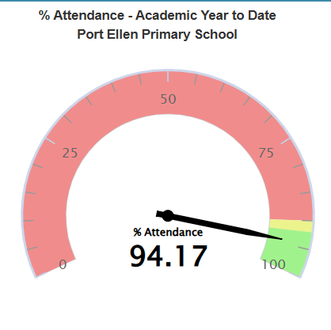
Port Ellen Attendance 2024/25
Key to success was proactive engagement with families through.
- Termly personal reminders to parents/ carers of pupils whose attendance fell below 90%.
- Communicating current attendance figures through Newsletters, at whole school and parent events.
- Sending expression of thanks for cooperation to families whose attendance made significant improvement.
While we have not reached our stretch aim of 94.5%, the improvement in figures indicates that gentle, relational accountability paired with clear communication has had a positive impact.
The average occurrences of lateness in a target group of 4 pupils was 16% at the beginning of this session. With constant monitoring and reminding parents of the impact of lateness this fell to 9% so we surpassed our target of reducing lateness by 25%.
While we recognise the progress made, we also acknowledge the need to further embed a rights-based approach to attendance that empowers children and families to understand the importance of regular attendance in relation to article 28 – UNCRC.
The next steps will be on the Maintenance agenda of the SIP.

Target 3 – Leadership
Pupil Leadership
By June 25 all pupils in P4-7 will have led an aspect of citizenship.
This session we set out to ensure that all pupils from P4-7 would lead an aspect of action within one of our Citizenship groups – Reading Schools, Health and Wellbeing, Eco Schools and Rights , Respecting Schools (RRSA- Embedding Silver)
This target was successfully achieved with every pupil taking on a meaningful role aligned to one of these Improvement Priorities.
Pupils led projects such as;
Promoting Community Involvement in Reading.
The Reading group regularly sent articles to the local newspaper, The Ileach, to share the school’s reading initiatives.
The group also collaborated with Islay Podcasters, Authors online, The Islay Book Festival and P1-3 from all Islay and Jura Schools which tied in with our Reading Schools Target:
Throughout the session there will be Increased engagement with a variety of community groups to promote reading

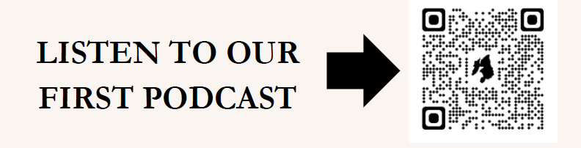
This community engagement reached an older audience beyond the school community. The Reading group received positive feedback from reading volunteers and from the wider community.

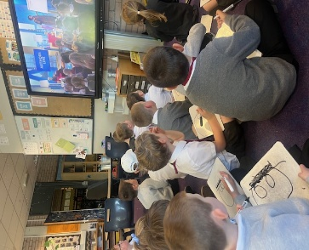
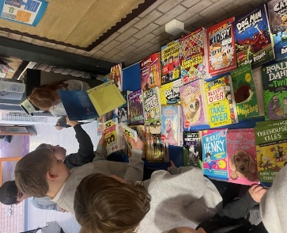
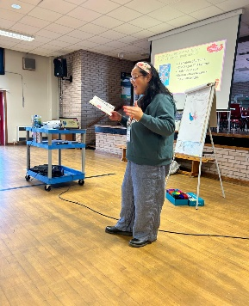
Photos show Reading Group Led Activities such as;
Engaging with Author’s Live Sessions
Holding a Book Swap
Co-organising the Islay Book Festival Author Visits

The above activities evidence Pupils being empowered as Reading Leaders. The Reading Group helped to update libraries in each class ensuring our collections are diverse, inclusive and learner curated.
All classes participated in a Novel Based IDL connecting curricular areas through a shared context linking literacy with creativity and critical thinking while developing reading skills.
Driving Forward our Eco Schools Work.
The group continued to campaign against litter, walking to school, planting and growing maintaining our green flag status.
Supporting the Wellbeing of peers.
This included playground check-ins, walking activities, yoga, monitoring healthy eating, highlighting citizenship and promoting kindness.
Championing Children’s Rights Silver to Gold Journey
This session we continued to embed and sustain the actions outlined in our RRSA Silver Award Plan. Children’s Rights remained central to our ethos and school improvement work, particularly through the increased involvement of pupils in campaigns and policy development.
Pupils took a more active leadership role by initiating and participating in a range of rights-based campaigns including those linked to inclusion, sustainability and wellbeing. These helped raise awareness across the school community and gave pupils meaningful opportunities to influence change – a key step towards Gold level practice.
Children were also directly involved in shaping our relationships policy ensuring the language and expectations reflect the principles of dignity, respect and fairness in line with UNCRC.
There is now a stronger culture of participation and a clearer link between pupil voice, school policy and real-world action. These developments place the school in a strong position to progress towards Gold Rights Respecting where rights are embedded not only in policy but in classroom practice, leadership and wider school culture.

Target 3 contd
By the end of this school session all teachers will have led on an aspect of the SIP.
All teaching staff took leadership responsibility for a clearly defined area of the school improvement plan this session, achieving our target for distributed leadership. Staff demonstrated a strong understanding of their priorities, gathered purposeful evidence and tracked their progress effectively against agreed targets. This indicates increasing confidence in leading improvement and engaging with self-evaluation in line with HGIOS 4 QI1.2 Leadership of Learning and 1.3 Leadership of Change.
A key strength was the collaborative ethos shown within and beyond the school. Staff worked collegiately across stages and also with colleagues from Bowmore Primary School, particularly in relation to shared improvement priorities such as the Reading Schools journey. This supported professional dialogue, reduced workload and created shared ownership of success.
Staff leadership directly contributed to;
- Embedding RRSA Silver Action Plan
- Maintaining Green Flag Status – Eco Schools
- Leading ELC Improvement across three settings.
- Advancing Pedagogy through preparation for professional reading groups linked to Power Up Your Pedagogy
- Creating a literacy strategy
- Co-ordinating a successful Care Inspection in our ELC.
- Championing STEM
This growing culture of confident, collaborative leadership is a strength of both schools and is contributing to sustainable improvement.
Next Steps:
Embedding our VVA – Maintenance Agenda
QI 3.1 Ensuring wellbeing, equality and inclusion
Aligning pupil achievement awards more explicitly with our core values of I am Innovative, Included and Independent at celebration assemblies.
Introducing Value themed rewards (e.g. pencils, pens etc with key VVA words or symbols) to promote visibility and reinforce positive recognition linked to our ethos
These will strengthen a shared understanding of what our values look like in action and ensure they are meaningfully integrated into our ethos and culture.

Continuing to Increase attendance and reduce lateness – Maintenance Agenda
QI 3.1
UNCRC – Article 28 – Right to Education
Continue HT measures as highlighted above
Develop pupil voice opportunities to explore the importance of regular attendance through a rights-based lens linking to Article 28 through Citizenship Group Campaign. This would involve highlighting Article 28 through a child friendly action to share with the school community.
Continue to share the impact of lateness with parents

Next Step within the Ethos Priority
RRSA – Towards Gold – Ethos Target 3
QI 1.2, 2.3, 3.1
Deepen children’s understanding of the UNCRC by embedding rights learning across the curriculum and within everyday practice.
Strengthen the role of the RRS Citizenship Group by creating opportunities for pupils to lead monitoring, advocacy and evaluation including input into school improvement planning and learning environments.
Establish peer education opportunities such pupils leading assemblies or digital campaigns on rights.
Continue to embed a rights-based lens into policies, classroom charters and decision-making ensuring consistency and visibility across the school.
Gather structured evidence of impact across teaching, leadership, pupil engagement and parental awareness to support the Gold accreditation process.

Strengthen leadership at all levels by embedding a culture of shared responsibility for improvement across pupil and staff.
QI 2.1 2.3, 2.4 3.1
UNCRC – Article 12 – Right to be heard, Article 28 Right to education and Article 29 – Goals of education.
Pupil Leadership
Will be deepened through structured roles in Citizenship groups, House Leadership, peer support, and digital wellbeing campaigns. Learners will lead and evaluate aspects of school improvement, contributing directly to our RRSA Gold Award and rights-based Ethos – as above
These actions will contribute to a thriving school community where leadership is purposeful and visible, behaviour supports wellbeing and learning and everyone – pupils and staff alike is empowered to make a meaningful contribution.
Embed Digital Wellbeing across the curriculum by establishing a pupil-led Digital Citizens group to promote healthy, safe and balanced technology use through peer campaigns, class mini lessons and family engagement approaches.

Staff Leadership – Distributed Leadership / RRSA Gold / Whole School Makaton
Will be developed through distributed leadership opportunities, with all staff taking ownership of an aspect of school improvement, leading or co-leading CLPL or championing aspects of the school curriculum. Staff will be supported to engage in Middle Leadership roles and leadership pathways including Aspiring to Headship or equivalent professional learning programmes.
Complete the RRSA Gold Award Submission
Use the RRSA Gold Framework
Introduce and embed a whole school approach to Makaton to enhance inclusive communication for all learners, particularly those in the Early Years and with ASN. Provide regular opportunities for staff and pupils to learn and use core signs in daily routines, assemblies and classroom interactions ensuring communication is accessible, supportive and consistent across the school.
Establish a systematic and collegiate approach for staff to share progress on improvement targets throughout the year.
Build this into the Working Time Agreement (WTA) to allow for regular updates, reflection and professional dialogue within improvement time.
Continue to promote cross-school collaboration particularly with Bowmore PS, to build leadership capacity and reduce duplication of effort across shared priorities.
Support staff to produce evidence portfolios for their improvement work with clear links to school targets, HGIOS 4 and professional learning.

Review of SIP | ELC Priority
Improve Communication skills
Progress and Impact:
Target
Improved communication skills to underpin all areas of their learning
What we Did
Staff reviewed and adapted the physical environment indoor to rationalise and organise resources, creating a calmer more purposeful space that supports free flow play and emotional regulation.
Emotion Works was actively done by the P1/2 teachers during transition activities to enhance children’s ability to recognise and communicate feelings.
Staff increased the quality and frequency of adult-child interactions, using responsive strategies such as emotional check-ins, learning talks (shared on Seesaw) and consistent modelling of positive communication.
We enhanced communication development through supportive approaches including visual timetables Makaton, Book Bug Sessions (also involving families), Digital Day in the Life of…and floorbook planning to amplify pupil voice.
The Care inspectorate SIMOA elephant was introduced to promote safety awareness through storytelling and imaginative play.
Staff engaged in targeted CLPL including Small Talk Café and a designated Communication Champion role was implemented to sustain and lead improvement
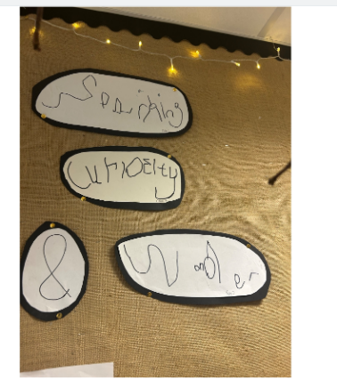
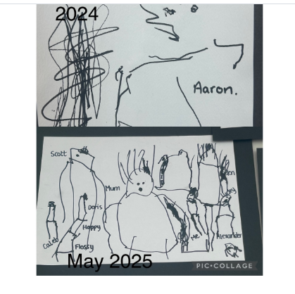
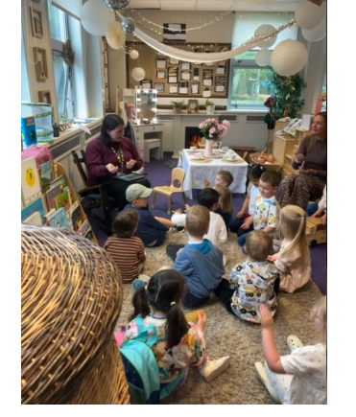
Photos show
Labelling and annotating by children
Makaton Singing
Progress in drawing from May 24- May 25

Impact
Children are showing increased confidence in expressing their needs, emotions and ideas, with more frequent and purposeful verbal and non-verbal communication observed across the setting.
The calmer, well-organised environment has led to improved engagement, longer periods of sustained play and greater independence.
Staff have reported a deeper understanding of how to respond sensitively to children’s cues and communication styles, resulting in more meaningful interactions and stronger attachments.
The use of Makaton and Emotion works has supported children in naming and regulating their emotions, while digital Day in the life of on Seesaw and Floor book planning have increased opportunities for self-expression and agency.
Children with ASN are being supported more effectively through consistent, inclusive strategies and families have become more engaged through Book Bug sessions and shared learning opportunities
Staff Small Talk Café sessions has strengthened confidence and consistency in practice, with the Communication Champion providing valuable leadership across the team.
Tracking Data showed 100% of 3 YO and 92% of 4 YO are on track in communication and language development. 67% of 3YO and 15% of 4YO are demonstrating clear understanding of language and 77% are confidently using communication strategies with understanding and independence.
The setting was recently inspected by Care Inspectorate. The evaluation for each QI was;
- Nurture Care and Support Very Good
- Play and Learning Very Good
- Facilities Very Good
- Quality Assurance Very Good
- Staff Deployment Very Good

Next Steps:
Continue to build on progress by embedding consistent use of communication supports across all routines and transitions, with a focus on increasing the number of children confidently using strategies with understanding.
Implement The Care Inspectorate Actions from recent inspection

1.1 Attainment Data
Attainment of Literacy Curriculum for Excellence levels 2020/21, 2021/22, 2022/23, 2023/24 and 2024-2025 (teacher judgement – confirmed levels – 5-year trend).
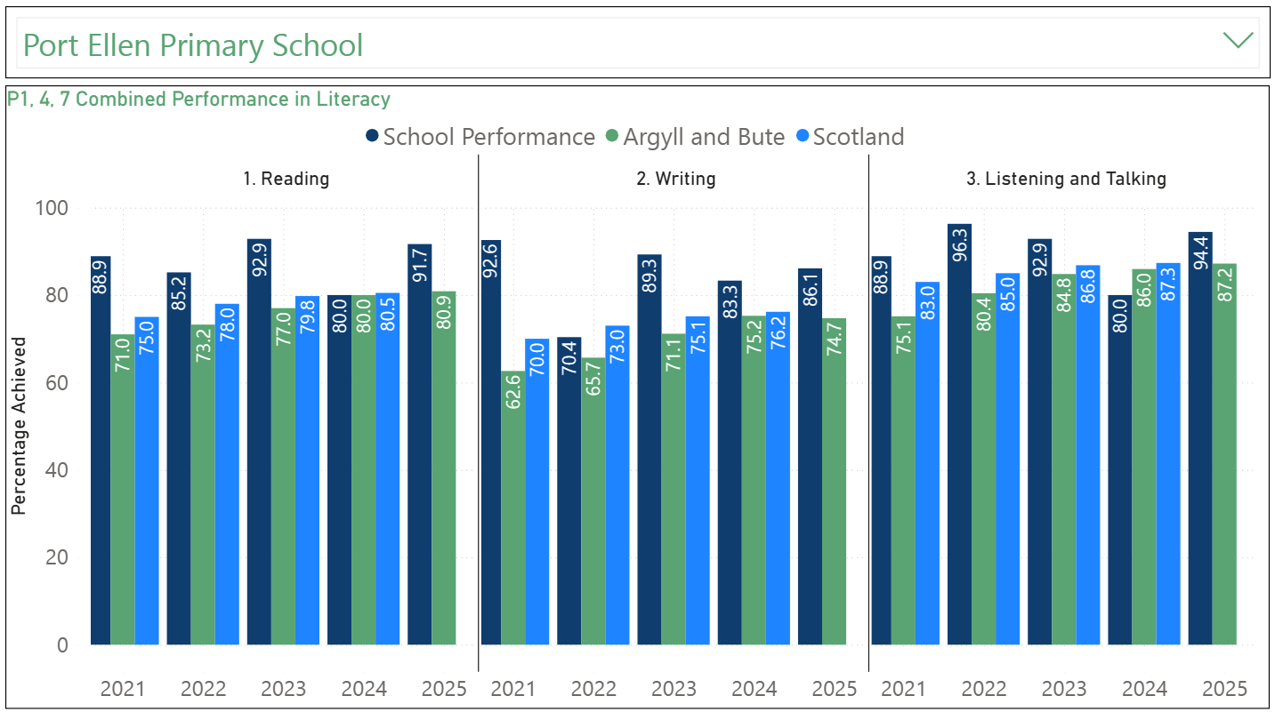

Please Note:
The above data (1.1 and 1.2) reports achievement of a level – P1/P4/P7 combined.
Due to the Covid 19 pandemic, there was no collection of ACEL data by Scottish Government in 2020.
1.2 Attainment Data
Attainment of Numeracy Curriculum for Excellence levels 2020/21, 2021/22, 2022/23, 2023/24 and 2024-2025 (teacher judgement – confirmed levels – 5-year trend).
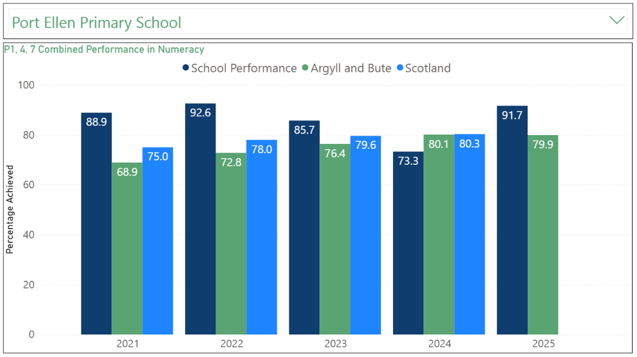

Please Note:
The above data (1.1 and 1.2) reports achievement of a level – P1/P4/P7 combined.
Due to the Covid 19 pandemic, there was no collection of ACEL data by Scottish Government in 2020.
Wider achievements
At Port Ellen school we believe that every child has unique strengths and talents and that learning happens in many different ways.
Living and learning on an island gives our children fantastic opportunities to connect with their local environment, history and community. This year they have taken part in outdoor learning adventures, community projects, music workshops, fundraising campaigns and innovative personal challenges that have helped them grow in confidence, responsibility and independence.
We aim to make sure all children feel included, valued and proud of what they achieve – whether it’s trying something new, helping others or working towards a personal goal. We are proud of the way our learners support one another and rise to challenges, and we continue to build a school culture where wider achievement is recognised, shared and celebrated.
Here are just a few examples.
Inclusive Participation
Linked to; QI 3.1 & SHANARRI – Healthy, Included and Nurtured
Photos show Bikeability, Walking Club, Reading Buddies, Big Breakfast
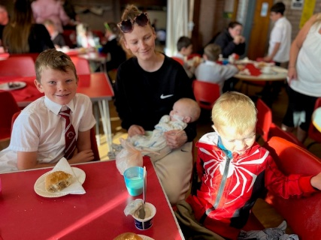
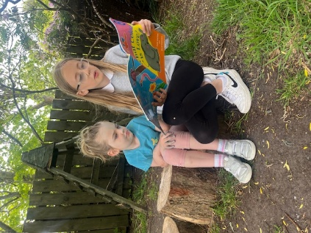
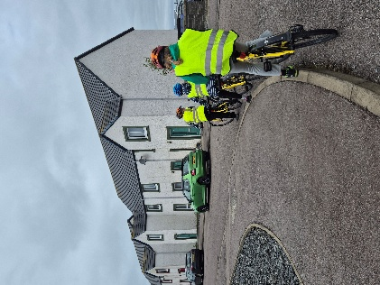
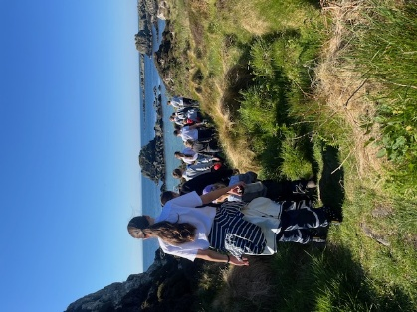

- All P5 children completed Bikeability, including children with ASN through adapted bikes , promoting inclusion and lifestyle.
- Targeted walking club supported social connection, emotional regulation and health for key groups, including snack and reading time.
- Free daily fruit and our weekly breakfast club ensured equitable access to nutrition and readiness to learn.
Leadership and Learner Voice
Linked to; QI 3.1, 2.2 & SHANARRI – Responsible, Respected and Included
Photos show – Beach Clean, RRSA Group’s organising of Blytheswood Shoebox Appeal, Scottish Water Visit, Playground leadership (Buddies) and Cross Stage working – P1/2 and P6/7 visit to the Islay Museum
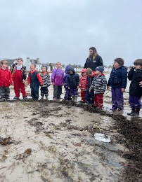

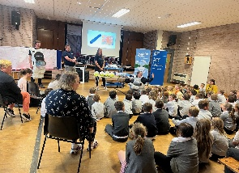
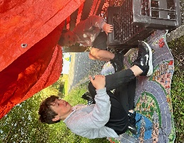
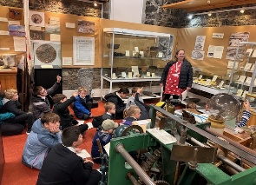
Eco Group led local Beach cleans fostered environmental awareness and responsibility.
RRSA Citizenship Group initiated and organised fundraising, charity events, developing leadership and civic engagement.
P6/7 Took on a leadership role in the playground and by planning and delivering a local history trip for P1/2, encouraging cross stage collaboration and confidence.

Creativity and Ambition
Linked to; QI 2.2 & SHANARRI –Achieving, Respected, Responsible
All P6/7 learners engaged in Endeavour Project Learning selecting personal challenges and developing skills in perseverance, independence and creativity – all skills linked to Developing the Young Workforce
Some pupils pursued entrepreneurial and STEM related projects.
Our P7 boys represented the school at the first ever Argyll and Bute STEMovator event in Oban where they showcased their design for an Eco House.
Pupil –Led Community Impact
Linked to; QI 3.1 & SHANARRI –Achieving, Included and Respected
Photos show the P1/2 Journey to fundraising for the Dinosaur Visit to Islay
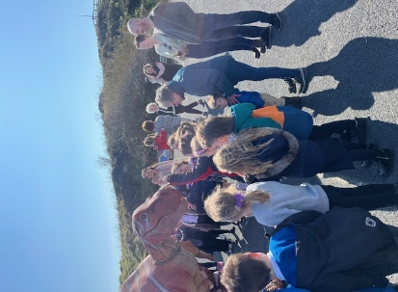
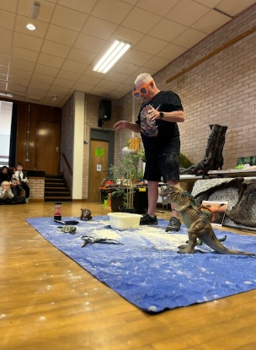
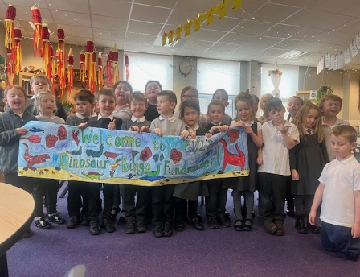
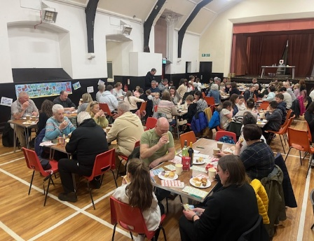
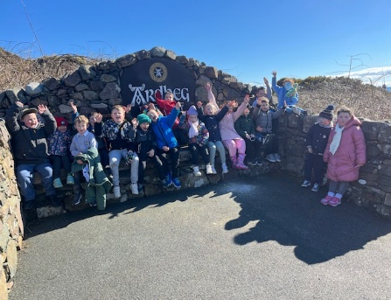

One example of excellent Community Impact is the P1/2 fundraising efforts to bring the Natural History Museum of London to Islay. The children raised over £2000 by engaging in a sponsored walk and organising a family bingo.
The visit resulted in rich cross school IDL workshops on dinosaurs demonstrating ambition, pupil voice and real-world impact .
Cultural and Arts Enrichment
Linked to; QI 2.2 & SHANARRI – Achieving, Healthy and Included
Pupils from the wind band travelled off island to take part in music workshops with the Army supporting confidence, cultural capital and collaboration
P5 Pupils participated in the YMI drumming programme building rhythm, co-ordination and musicality in a fun, inclusive environment. The pupils also organised parent workshops promoting parental engagement.

Celebrating Wider Achievement
Linked to; QI 3.1 & SHANARRI – Included, Respected and Nurtured
Photos show the P6/7 Islay and Jura outward bound trip to Lochgoilhead and Port Ellen Juniors Football Team
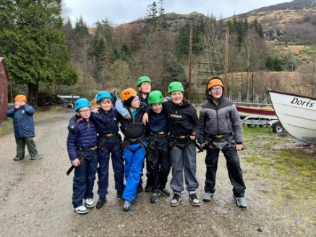
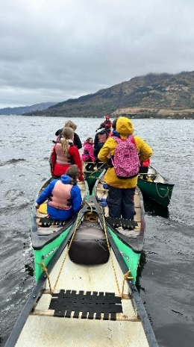
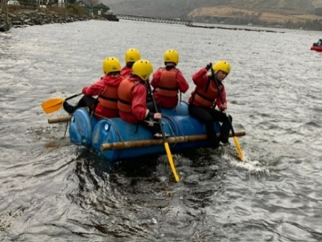
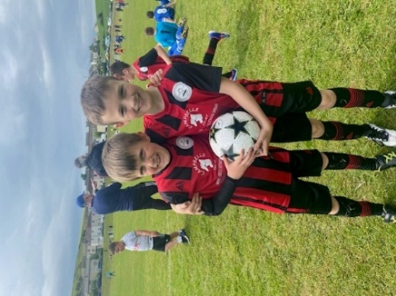
Children’s out of school achievements (e.g. football, swimming, dancing, Karate) are tracked and shared via Seesaw encouraging home-school partnerships.
Successes are celebrated through assemblies, school newsletters, public facing events and in the Ileach , fostering pride and a positive culture of achievement.

Impact
Cross cutting impact across QI 3.1 & SHANARRI – All indicators evident.
Increased learner confidence, motivation and engagement in personal and collective achievement.
Improved participation and wellbeing among targeted groups through inclusive and supportive provision
Enhanced sense of ownership and learner agency with pupils increasingly shaping their learning and making meaningful contributions to their community.

Pupil Equity Funding
£10800
Progress and Impact:
Literacy
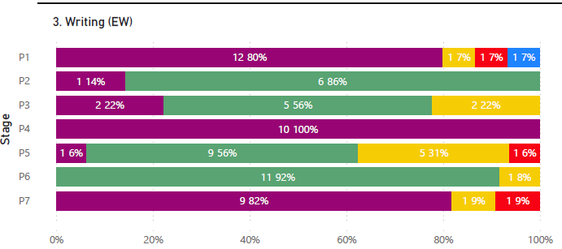
Writing (QI 2.3, 3.2)

50% of Staff participated in the CYPIC Writing Programme leading to improved pedagogy and raised attainment in writing for targeted learners
Data shows that in almost all classes and while improvement in writing across the school is evident, all teachers now need to participate in training and implement the CYPIC programme, particularly for targeted learners.

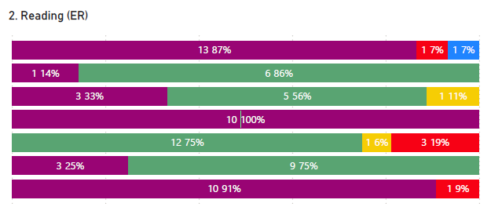
Reading (QI 3.1, 3.2)
Listening Books enabled children with literacy barriers including dyslexia, could access and enjoy texts more independently. This supported inclusion and engagement in reading across stages.
We increased the range of phonic readers targeted at a group of learners at risk of not achieving expected reading outcomes. This led to more frequent independent reading and improved fluency and confidence in the target group.
Data shows that in almost all classes; children are on track. The current P5 class will require further interventions.
Numeracy
Staff CLPL (QI 2.3, 3.2)
Staff participated in Count on Us training. This helped increase the focus on number fluency and flexibility in classroom practice. Each class has a bank of associated Blueprint resources to support fluency and reasoning.

Increased Number / Maths Resources (QI 1.5, 3.2)
Maths and Numeracy support resources such as Numeracy Ninjas, Number Talks, Power of 2/ Plus 1 / Fraction Talks and concrete material were extended and used in all classes. This resulted in measurable improvements in attainment at P1,4,7 especially in mental maths and calculation strategies. There was also observed learner engagement in most classes. Some classes, however, still require targeted support to secure sustained improvement.
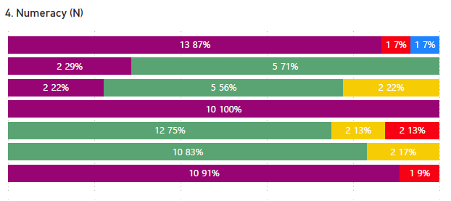
Numeracy Data shows a very positive picture across the school evidencing interventions and priorities are improving outcomes for all learners

Wellbeing and Inclusion (QI 3.1, 1.5)
Emotion Works resources supported targeted nurture and class wide emotional literacy, improving pupil emotional awareness, however, further interventions need to be prioritised to reduce behaviour incidences and increase tolerance and respect. This is a target going forward.
The provision of free fruit daily for all learners to promote healthy eating and readiness to learn continued in session 24-25. This model is no longer financially sustainable.

A focus on Pedagogy to Improve Teaching and Learning
Bruce Robertson’s Power Up Your Pedagogy was purchased for each class teacher. We revised our classroom observation format, placing a greater emphasis on the conditions for learning and equitable participation. This supported reflection and collaborative professional learning across the school.

Pupil Equity Funding was used strategically to support the key drivers of attainment, wellbeing and inclusion, with positive progress noted in writing attainment, engagement in reading, numeracy confidence and emotional literacy. The focus on professional learning, inclusive resources and targeted intervention has built capacity and contributed to measurable gains for learners affected by poverty.
We will continue to focus on:
Embedding consistent numeracy pedagogy across all classes.
Evaluating and refining targeted supports using data and learner voice
Sustaining equity focused health and wellbeing supports in cost-effective ways
Extending the impact of professional learning through collaborative enquiry
Sustain writer attainment through 100% staff being CYPIC trained, implementing an early level phonics progression pathway, implement a more robust approach to spelling by purchasing a new resource for each child from P3 – P7.

Quality Indicator | How are we doing? | How do we know? (Evidence) | School Self-Evaluation (1-6) *
1.1 Self-Evaluation for Self-improvement | There is a strong and improving culture of self-evaluation across the school and the ELC.  Staff work collaboratively to reflect on practice using a range of evidence to inform improvement priorities and track impact. Professional dialogue, data analysis and focused CLPL have driven improvements in key areas including Literacy, Numeracy and communication. Termly tracking and professional learning conversations inform timely, targeted interventions for identified pupils, particularly in writing, early reading and number sense.  Staff routinely engage in evaluative activities using HGIOS 4, Power up Your Pedagogy and key frameworks (e.g. Reading Schools, RRSA, NRICH).  Evidence is triangulated – quantitative, qualitative and stakeholder voice (surveys, questionnaires etc)  In ELC changes to the physical environment, adult interactions and the use of visual supports have led to improved outcomes in communication.  A Key strength in our self-evaluation for improvement is evident in our recent Care inspection where we achieved five evaluations of very good across all the focused QIs. Staff use self-evaluation tools such as Realising the Ambition and HGIOELC.  There is a whole school culture of improvement which is in response to self-evaluation in the day to day of the school.  There is a strong ethos of empowerment where staff lead and evaluate change confidently. Pupils lead improvement groups and track progress with adults.  Staff have begun to engage in enquiry and professional reading such as Power up Your pedagogy and use this to inform both self-evaluation and improvement planning. | Robust tracking and data analysis in literacy and numeracy.  Attainment 1:1 meetings and targeted support plans  Evaluation wheels for key Qis  Self-Evaluation frameworks (Reading Schools, RRSA, NRICH,)  Seesaw Learning Journals  ELC Communication data  Pupil Leadership Groups (Citizenship Groups and House Leaders, Sports Leaders)  Systematic and Routine Collegiate Reflection.  Triangulated data ensures judgements are robust balanced and credible | 4 – Good
1.3 Leadership of Change  This QI also focusses on the following aspects of empowerment:  - curriculum.  - improvement activities.  - parental and community engagement; and  - pupil participation. | There is a strong and growing culture of shared leadership and collaboration across our school and ELC. Senior Leaders provide clear strategic direction, rooted in our school values, national guidance and local priorities.  Staff are increasingly confident in leading change, engaging with research and reflecting on practice through collegiate dialogue, enquiry and self-evaluation.  Our Improvement planning is well paced and ambitious with measurable outcomes that are tracked over time.  We are able to demonstrate the effectiveness of leadership at all levels and our capacity to embed sustainable, child centred improvement. This is underpinned by a clear Vision, distributive leadership and the meaningful use of evidence to inform change.  Staff have taken ownership of key developments such as Reading Schools, RRSA, Makaton, Nurture, STEM and curriculum reform – all of which reflect high quality leadership of learning.  Pupil leadership continues to grow in areas of the improvement plan such as RRSA, Reading, HWB and Eco Schools.  Leadership is supported by clear systems for monitoring, reviewing and adjusting practice to meet learners’ needs. | Staff Leadership of aspects of curriculum and SIP priorities.  3 Year Curriculum plan co-designed with staff and community input.  Pupil led groups such as the Citizenship groups, ambassadors  Implementation of Power up Your Pedagogy (PUYP) to build a shared understanding of effective teaching and change. | 4-Good
2.3 Learning, teaching and assessment | Across the school and ELC learning experiences are inclusive, engaging and increasingly well matched to learners’ needs and interests.  Staff know the learners well and are committed to improving outcomes through responsive pedagogy, high quality interactions and a strong focus on emotional wellbeing. Play and Learning is strong in ELC and in the majority of classes.  Staff are developing a shared language around pedagogy through our work with PUYP which is beginning to influence classroom practice and professional dialogue. Learners benefit from increasingly purposeful contexts for learning including our growing emphasis on STEM IDL, Digital Wellbeing, Rights-based learning and outdoor Education.  Reading and Writing have been key areas of focus, with improvements in pupil engagement, choice and targeted interventions.  In numeracy diagnostic use of assessments is improving and staff use data to inform next steps in a more targeted way.  Pupil Voice is becoming a stronger feature of learning, supported by approaches such as floor book planning, the NAR approach and pupil led groups.  Digital technologies are used meaningfully to enhance learning, and staff are developing consistency in using learning intentions and success criteria, though this remains an area of continued focus.  Assessment is used regularly to inform planning and target support particularly in literacy and numeracy.  Staff refer to the assessment calendar into their Year planning.  We are working to further strengthen consistency and rigour in moderation and professional judgement especially in numeracy and across all three literacy organisers. | Learning Walks and Floor book evidence in ELC and Early Level  Staff are using PUYP to shape pedagogy  Reading Schools Silver Status; pupil engagement in reading for pleasure  Communication rich learning environments using visuals and Makaton (not consistent)  Use of A&B tracking tools for Literacy and Numeracy  Moderation across all levels  CYPIC Model used in most classes for writing – to be expanded and used to support number fluency.  Implementation of the Assessment Year planner  Termly feedback and evaluations of IDL  Targeted interventions in literacy and numeracy. | 4- Good
3.1 Ensuring wellbeing, equality and inclusion | The school and ELC have a strong, inclusive ethos where relationships are positive respectful and nurturing.  Our commitment to children’s rights, emotional wellbeing and equity is embedded in daily practice, supported by a range of universal and targeted approaches.  Staff deployment affirms the strength of our inclusive and child centred practice.  This year we made improving communication and inclusion a key priority, particularly in our ELC through embedding Makaton, Emotion Works and Visual supports. These have enhanced children’s ability to express themselves and participate fully in the life of the setting.  Across school, work on our Rights and Reading Schools has helped embed values of empathy, fairness and respect with pupil voice increasingly evident in the life and leadership of the school. | Makaton Roll out, Visual schedules, Emotion Works and communication data.  Progress towards RRSA Gold has begun.  SHANARRI Wellbeing tracking and staged intervention documentation  Targeted interventions through in house IEPs  Pupil surveys and learning conversations | 5- Very Good
3.2 Raising attainment and achievement | Across the school and ELC, attainment is being carefully tracked and is improving through focused interventions, targeted support and increasingly relevant and engaging learning contexts.  In literacy, staff have prioritised early reading, writing development and pupil engagement through strategies such as reading for pleasure, pupil writing targets and parental involvement e.g. Bookbug  In numeracy assessment data is used to plan targeted support and staff are developing a more diagnostic approach to understanding pupil gaps.  Wider Achievement is celebrated and supported across the school and ELC through Rights Group, Reading Leaders, HWB Leaders and Eco Group)  Data and professional judgement show that most children are making appropriate progress in literacy and numeracy.  Attainment is tracked and interventions are targeted and reviewed.  Staff are developing confidence to use the refreshed benchmarks to support robust professional judgement although further work is needed to ensure consistency in progression in numeracy and literacy. | Termly Tracking data analysis meetings for numeracy and literacy  Reading Schools Silver evidence and writing support strategies (CYPIC)  Pupil-led initiatives  Moderation across all levels  Floor book and observation evidence  Wider Achievement is logged on Seesaw and there is a celebration system for recognition. | 4- Good

