Head Teacher’s Report Port Ellen PC AGM 30th Jan 2025

As always there are many positives to report for session 23/24 .
Staff worked hard together over the session and We now have a comprehensive Vision for our school , agreed values and aims that align with the values .
Our refreshed Vision , Values and Aims , done in consultation with parents, pupils and staff consists of the following ;
Our Mission Statement
Learn as Long as You Live
Our School Values - based on our I AM model ;
- Innovative
- Independent
- Included
Our aims- these link very closely to the values .
- To encourage a curious and creative mindset with the ability to apply critical thinking – INNOVATIVE.
- To develop resilient and responsible individuals who recognise the importance of lifelong learning – INDEPENDENT
- To create a caring community where there are opportunities for all.

Our school priorities from last year were ambitious and challenging. Here is a very brief summary as to how we did;
PRIORITY 1 –Rights Respecting Schools
Achieved the Silver RRS accreditation! Well reported priority with impact for pupils linked throughout. There are a number of next steps identified for our 2 year Gold accreditation journey. There is an opportunity here for pupils to be a part of choosing what data to capture, how to capture it and then be part of gathering and reporting on it as well?
PRIORITY 2 – Reading Schools Accreditation
Pupils have had increased opportunities around reading and building a reading culture. School Achieved Silver Award

Priority 3- Raise Attainment in Writing at 1st /2nd level
Reduction in writing attainment compared to 2023 but have improvement within the cohort. Continue to use the CYPIC model to support improvements in writing over the next session.
Priority 4 Increasing Pace and Raising Attainment in Numeracy
Clear story about pupils’ attainment. Number Fluency, Mathematical Reasoning and Problem Solving are our focus areas. Data for P147 for Listening and Talking , Reading, Writing, Numeracy
Assessment Data 23/24 -
Listening and Talking
80% of P1,4,7 achieved . This is 4.73% below the Local Authority – focus on Oracy skills.
Reading
80% of P1,4,7 achieved . This is 2.31% above the Local Authority – continue to increase our positive reading culture
Writing
83.33% of P1,4,7 achieved . This is 11.72% above the Local Authority – our programme of writing will continue and new staff will be trained.
Numeracy
73.33% of P1,4,7 achieved . This is 3.58% below the Local Authority – need for more focus on mathematical reasoning skills , number fluency and problem solving skills
ELC Priority Learning Journeys
Good evidence to show increased opportunities within the chosen design principles. It is great to see shared practice visits across your settings and that staff were empowered to identify which elements of curriculum design they were going to focus on. Next steps identify continuing to use SeeSaw to monitor and moderate curriculum
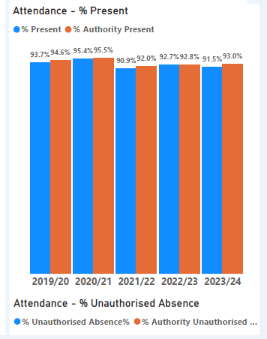
Attendance

The new target for the school is 93 % attendance
To date 94.62% 30/1/25

2024/2025 Priorities - PACE MODEL
- Embedding the new uniform
- Continue to Improve Teaching and Learning – Pedagogy
- Continue to raise attainment – Attainment
- Improve Oracy (or talking skills ) , maths and numeracy , Reading and Writing – Attainment
- Create Programmes and Pathways – across Science , for Oracy and for PS – Curriculum
- Embed our Vision Values and Aims – Ethos
- Increase Leadership Opportunities for ALL – Ethos

Finman 17m2 Hut with floor to be purchased and constructed
ELC 5x3 outdoor classroom to be purchased and constructed

