School Priority | Activities
Family Learning – stretch aim – overarching over all other priorities | - Implement plans for Early Intervention by Engaging the wider parent body before their children start school  - Strengthen home / school links and increase parent confidence to assist with learning across the curriculum  - Family Support and Nurture  - Safeguarding and Child protection
Becoming a Reading School  (Scottish Book Trust Accreditation) | - Create and develop a Reading Leadership Group  - Visible staff role modelling across the school  - Learner role modelling  - Whole-school action plan  - Participate in National events and celebrations  - Opportunity to engage with authors (writers, illustrators or storytellers)  - Update books and other reading materials  - Ensure every learner does one interdisciplinary project per year and teachers Read Aloud in class  - Raising the profile of reading with families  - Monitor Progress and Impact
Raise Attainment in numeracy and Maths | - Develop a maths rolling Programme  - Develop a strong Number sense  - Whole school mini maths topic –  - Support for Maths
H&W – Becoming A Rights Respecting School – Bronze Award | Teaching and learning about rights-  Teaching and learning through rights – ethos and relationships  Teaching and learning for rights – participation, empowerment and action
IDL – Topic Learning | Revamp IDL planning-
Stay and Play ELC | Implement after October Holidays  Practitioners to plan a range of activities and experiences  Increase opportunities for parents to engage in a variety of play  Input from Health partners
Maintenance Improvement Planning
These outcomes are a continuation of our priorities from session 2022-2023
- Continue to Raise Attainment in Writing
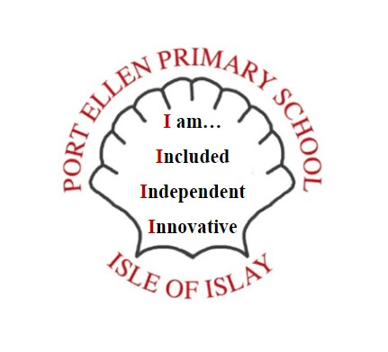
- Continue Self – Evaluation for Self Improvement
- Continue our Digital Ambition
- Embedding our Rationale

New Logo – Values taken from parent and pupil questionnaires

