Port Charlotte Primary School

& Pre5 Unit

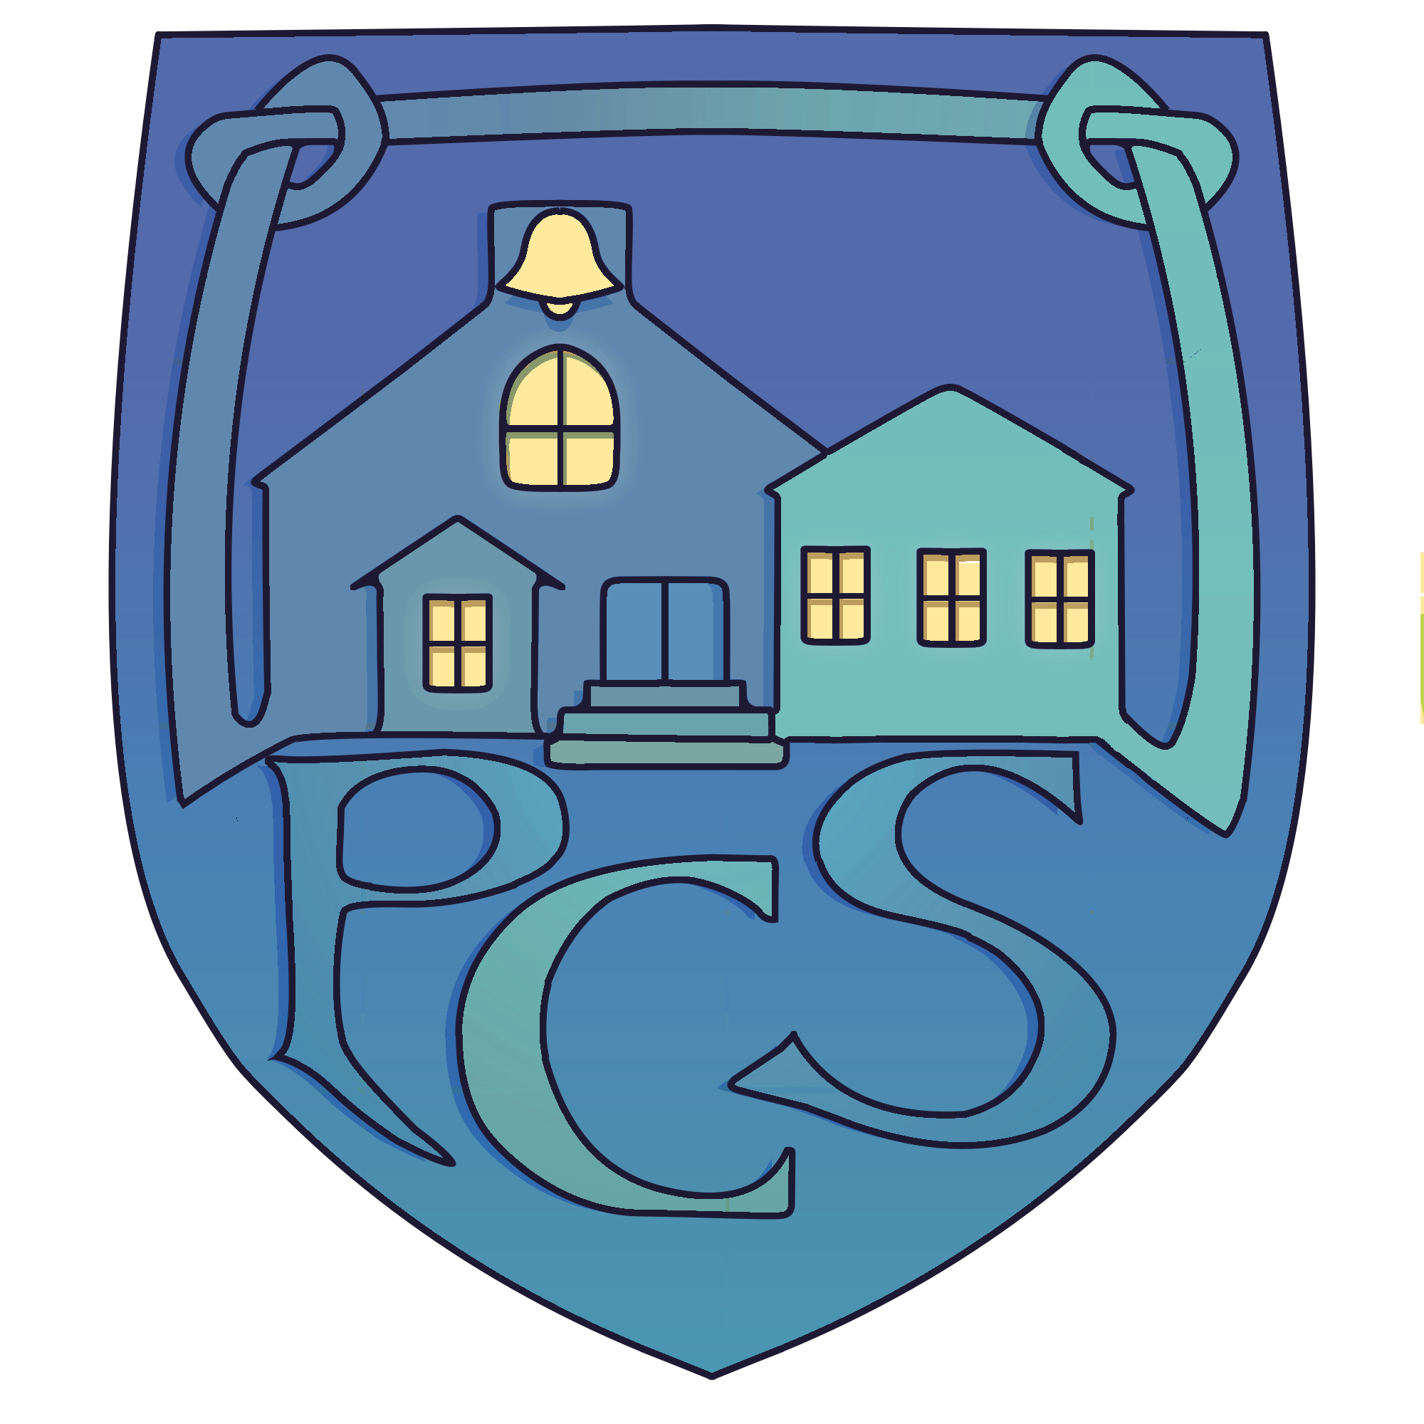

**Contents:**

1. Overview of Establishment 3 Year Cycle of Improvement Plan Priorities
2. Strategic Improvement Planning for Establishment
3. Operational Improvement Planning (Action Plan) for Establishment
4. Establishment Maintenance Improvement Planning
5. Pupil Equity Funding | Planning and Reporting

|  |  |  |  |
| --- | --- | --- | --- |
| **Overview of Establishment 3 Year Cycle of Improvement Plan Priorities** | | | Session: 2024 - 2025 |
| **National Improvement Framework Key Priorities**   * Placing the human rights and needs of every child and young person at the centre of education * Improvement in children and young people’s health and wellbeing * Closing the attainment gap between the most and least disadvantaged children and young people * Improvement in skills and sustained, positive school-leaver destinations for all young people * Improvement in achievement, particularly in literacy and numeracy. | | | |
| **National Improvement Framework Key Drivers** | **HGIOS 4 and Early Learning and Childcare Indicators** | | **Argyll and Bute Education Key Objectives** |
| * School and ELC leadership * Teacher and practitioner professionalism * Parent/carer engagement and family learning * Curriculum and assessment * School and ELC improvement * Performance information | 1.1 Self Evaluation for self-improvement  1.2 Leadership for learning  1.3 Leadership of change  1.4 Leadership and management of staff  1.5 Management of resources to promote equity  2.1 Safeguarding and child protection  2.2 Curriculum  2.3 Learning teaching and assessment  2.4 Personalised support  2.5 Family learning  2.6 Transitions  2.7 Partnership  3.1 Ensuring wellbeing, equality and inclusion  3.2 Raising attainment and achievement/Securing children's progress  3.3 Increasing creativity and employability/ Developing creativity and skills for life and learning | | * Raise educational attainment and achievement for all * Use performance information to secure improvement for children and young people * Ensure children have the best start in life and are ready to succeed * Equip young people to secure and sustain positive destinations and achieve success in life * Ensure high quality partnership working and community engagement * Strengthen leadership at all levels |
| **Strategic Priorities 3 Year Cycle** | | | |
| 2024 – 2025: | | 2025 – 2026: | 2026 – 2027: |
| 1. Leadership for pupils: Global Citizenship 2. Skills for Play  3. Curriculum Development: Planning for Deep Learning  4. EY: Inclusive Environments | | Curriculum Development: Numeracy  Embedding STEM  Performance information to secure improvement | Curriculum Development: Literacy  Digital Strategy  Family Learning |

|  |  |  |  |  |  |  |
| --- | --- | --- | --- | --- | --- | --- |
| **Strategic Improvement Planning for Establishment: Overview of Links to Key Policies** | | | Session: 2024 - 2025 | | | |
| **National Improvement Framework Key Priorities**   * Placing the human rights and needs of every child and young person at the centre of education * Improvement in children and young people’s health and wellbeing * Closing the attainment gap between the most and least disadvantaged children and young people * Improvement in skills and sustained, positive school-leaver destinations for all young people * Improvement in achievement, particularly in literacy and numeracy. | | | **Collaboration and Consultation** | | | |
| **Who?** | **When?** | | **How?** |
| Pupils & Parents | Jan 25 & Jun 25 | | Survey & focus groups |
| Staff | May 25 & Jun 25 | | Focus groups & Survey |
| Partners | June 25 | | Survey |
| **National Improvement Framework Key Drivers** | **HGIOS 4 and Early Learning and Childcare Indicators** | | **Argyll and Bute Education Key Objectives** | | | |
| * School and ELC leadership * Teacher and practitioner professionalism * Parent/carer engagement and family learning * Curriculum and assessment * School and ELC improvement * Performance information | 1.1 Self Evaluation for self-improvement  1.2 Leadership for learning  1.3 Leadership of change  1.4 Leadership and management of staff  1.5 Management of resources to promote equity  2.1 Safeguarding and child protection  2.2 Curriculum  2.3 Learning teaching and assessment  2.4 Personalised support  2.5 Family learning  2.6 Transitions  2.7 Partnership  3.1 Ensuring wellbeing, equality and inclusion  3.2 Raising attainment and achievement/Securing children's progress  3.3 Increasing creativity & employability/ Developing creativity & skills for life & learning | | * Raise educational attainment and achievement for all * Use performance information to secure improvement for children and young people * Ensure children have the best start in life and are ready to succeed * Equip young people to secure and sustain positive destinations and achieve success in life * Ensure high quality partnership working and community engagement * Strengthen leadership at all levels | | | |
| **Priorities** | **Proposed Outcome and Impact** | **Measures** | | | **Linked to PEF** (Y/N) | |
| 1. Leadership for pupils: Global Citizenship | By May 2025 all pupils (p1-7) will have been involved in improving the life and work of the school through participation in leadership sessions on school improvement, Eco schools, Rights Respecting Schools and School Grounds. | SMART Targets:   1. Almost all school pupils will engage with the How good is OUR school document and participate in self-evaluation and school improvement activities at two leadership sessions by May 2025. See Clan Floorbooks. 2. Almost all school pupils will engage with Eco schools activities and participate in self-evaluation of sustainability at two leadership sessions by May 2025. See Clan Floorbooks. 3. Almost all school pupils will engage with Rights Respecting Schools materials and work on the Silver Action plan at two leadership sessions by May 2025. See Clan Floorbooks. 4. Almost all school pupils will engage with evaluation and improvement of our School Grounds at two leadership sessions by May 2025. See Clan Floorbooks. | | | N | |
| 2. Skills for Play | By May 2025 almost all pupils (p1-7) will have developed their understanding of the 6C global competencies and almost all older pupils (p4-7) will be able to describe how these competencies link to their own learning. | SMART targets:   1. Almost all pupils will show increased understanding of 6 C skills for learning through play- See google survey August 24 and May 25 and records from P4-7 focus group March 2025. 2. By March 2025 almost all pupils in p4-7 will independently use Seesaw to share learning through play, linking this to the 6C global competencies. See Seesaw p1-4 & p5-7 classes. | | | N | |
| 3. Curriculum Development: Planning for Deep Learning | In session 24-25 all pupils in P1-7 will follow a broad and balanced curriculum, supported by technology which has involved at least 2 projects with community partners and an element of pupil leadership by May 2025. | SMART targets:   1. Almost all p1-7 pupils will follow a broad and balanced curriculum based on revised bundles of Outcomes which fit coherently together and include the new technology outcomes by May 2025. See   New 3 year rolling programme and Teachers’ planning.   1. All class teachers will use our connections with community partners as detailed in the revised Bundles of Outcomes at least twice for each class by April 2025. See teachers’ planning and project evidence on Seesaw. 2. Leadership of Learning: Almost all pupils will be involved in at least two projects which involve an element of pupil leadership by May 2025. See Class Floorbooks and project evidence on Seesaw, pupil focus group results March 2025. | | | N | |
| 4. EY: Inclusive Environments | The CIRCLE framework will be used to ensure the provision of an inclusive environment in our pre5 unit by March 2025. This will mean that all pupils have the areas they need in place and will complement work on developing inclusive environments in p1-4 & p5-7 (PEF) | 1. The nursery will have a more inclusive environment suitable for all pupils in place by March 2024. Compare CIRCLE checklists August and March | | | Y | |

**Note: This section of the Improvement Plan can be made available to all relevant stakeholders to provide an overview of the session’s priorities.**

|  |  |  |  |  |
| --- | --- | --- | --- | --- |
| **Operational Improvement Planning (Action Plan) for Establishment:** | | | | Session: 2024 -2025 |
| **Strategic Priority 1:** | Title: Leadership for pupils: Global Citizenship | | | |
| **National Improvement Framework Key Priorities**   * Placing the human rights and needs of every child and young person at the centre of education * Improvement in children and young people’s health and wellbeing * Closing the attainment gap between the most and least disadvantaged children and young people * Improvement in skills and sustained, positive school-leaver destinations for all young people * Improvement in achievement, particularly in literacy and numeracy. | | | | |
| **National Improvement Framework Key Drivers** | **HGIOS 4 and Early Learning and Childcare Indicators** | | | **Argyll and Bute Education Key Objectives** |
| * School and ELC leadership * Teacher and practitioner professionalism * Parent/carer engagement and family learning * Curriculum and assessment * School and ELC improvement * Performance information | 1.1 Self Evaluation for self-improvement  1.2 Leadership for learning  1.3 Leadership of change  1.4 Leadership and management of staff  1.5 Management of resources to promote equity  2.1 Safeguarding and child protection  2.2 Curriculum  2.3 Learning teaching and assessment  2.4 Personalised support  2.5 Family learning  2.6 Transitions  2.7 Partnership  3.1 Ensuring wellbeing, equality and inclusion  3.2 Raising attainment and achievement/Securing children's progress  3.3 Increasing creativity and employability/ Developing creativity and skills for life and learning | | | * Raise educational attainment and achievement for all * Use performance information to secure improvement for children and young people * Ensure children have the best start in life and are ready to succeed * Equip young people to secure and sustain positive destinations and achieve success in life * Ensure high quality partnership working and community engagement * Strengthen leadership at all levels |
| **Key Actions (How)** | | **Lead Person** | **Timescale** | **Success Criteria to facilitate evaluation of learners’ progress** |
| **During Self-Evaluation activities in session 23-24, staff identified a need to increase pupil involvement in self-evaluation to develop a shared understanding of the strengths and improvement needs of the school. It was decided to use the Clan structure (vertical groupings) and rotate the 4 areas of school improvement, Rights respecting schools, Eco schools and School grounds termly so that all pupils have an opportunity to contribute during a school session.**   1. A teacher will facilitate each group, using relevant resources e.g. How good is OUR school, Rights Respecting Schools materials to evaluate current practice and plan improvements for that term. | | Maggie McLellan HT- School Improvement  Lizzi Wiggins CT-  Eco Schools  Lorraine Gillies, PT-  Rights Respecting Schools  Jane McCormick ST-  School Grounds | August 24- May 25  Each Clan takes on 1 responsibility per term, minimum 2 meetings per term | SMART targets   1. Almost all school pupils will engage with the How good is OUR school document and participate in self-evaluation and school improvement activities for one term. 2. Almost all school pupils will engage with Eco schools activities and participate in self-evaluation of sustainability for one term. 3. Almost all school pupils will engage with Rights Respecting Schools materials and work on the Silver Action plan for one term. 4. Almost all school pupils will engage with evaluation and improvement of our School Grounds for one term. |

|  |  |  |  |  |
| --- | --- | --- | --- | --- |
| **Operational Improvement Planning (Action Plan) for Establishment:** | | | | Session: 2024 – 2025 |
| **Strategic Priority 2:** | Title: Skills for Play | | | |
| **National Improvement Framework Key Priorities**   * Placing the human rights and needs of every child and young person at the centre of education * Improvement in children and young people’s health and wellbeing * Closing the attainment gap between the most and least disadvantaged children and young people * Improvement in skills and sustained, positive school-leaver destinations for all young people * Improvement in achievement, particularly in literacy and numeracy. | | | | |
| **National Improvement Framework Key Drivers** | **HGIOS 4 and Early Learning and Childcare Indicators** | | | **Argyll and Bute Education Key Objectives** |
| * School and ELC leadership * Teacher and practitioner professionalism * Parent/carer engagement and family learning * Curriculum and assessment * School and ELC improvement * Performance information | 1.1 Self Evaluation for self-improvement  1.2 Leadership for learning  1.3 Leadership of change  1.4 Leadership and management of staff  1.5 Management of resources to promote equity  2.1 Safeguarding and child protection  2.2 Curriculum  2.3 Learning teaching and assessment  2.4 Personalised support  2.5 Family learning  2.6 Transitions  2.7 Partnership  3.1 Ensuring wellbeing, equality and inclusion  3.2 Raising attainment and achievement/Securing children's progress  3.3 Increasing creativity and employability/ Developing creativity and skills for life and learning | | | * Raise educational attainment and achievement for all * Use performance information to secure improvement for children and young people * Ensure children have the best start in life and are ready to succeed * Equip young people to secure and sustain positive destinations and achieve success in life * Ensure high quality partnership working and community engagement * Strengthen leadership at all levels |
| **Key Actions (How)** | | **Lead Person** | **Timescale** | **Success Criteria to facilitate evaluation of learners’ progress** |
| **Following on from School Improvement work on Play Pedagogy in 2023-2024, it was noted that children did not yet have a clear understanding of the 6Cs -global competencies- and that staff needed a common language to describe these.**   * All Staff will take part in training on Play Pedagogy and the 6Cs. * Teachers and Support Staff will facilitate and support use and regular discussion of 6 Cs through assemblies, pupil leadership (Clan) activities, Free Play Friday and in classes. * P4-7 pupils will be supported to use Seesaw to share learning through play, highlighting the skills they are learning | | Lorraine Gillies, PT | August 24 – May 25 | SMART targets:   1. Almost all pupils will show increased understanding of 6 C skills for learning through play- See google survey August 24 and May 25 and records from P4-7 focus group March 2025. 2. Almost all pupils in p4-7 will independently use Seesaw to share learning through play, linking this to the 6C global competencies. See Seesaw p1-4 & p5-7. |

|  |  |  |  |  |
| --- | --- | --- | --- | --- |
|  | | | | Session: 2024 - 2025 |
| **Strategic Priority 3:** | Title: Curriculum Development: Planning for Deep Learning | | | |
| **National Improvement Framework Key Priorities**   * Placing the human rights and needs of every child and young person at the centre of education * Improvement in children and young people’s health and wellbeing * Closing the attainment gap between the most and least disadvantaged children and young people * Improvement in skills and sustained, positive school-leaver destinations for all young people * Improvement in achievement, particularly in literacy and numeracy. | | | | |
| **National Improvement Framework Key Drivers** | **HGIOS 4 and Early Learning and Childcare Indicators** | | | **Argyll and Bute Education Key Objectives** |
| * School and ELC leadership * Teacher and practitioner professionalism * Parent/carer engagement and family learning * Curriculum and assessment * School and ELC improvement * Performance information | 1.1 Self Evaluation for self-improvement  1.2 Leadership for learning  1.3 Leadership of change  1.4 Leadership and management of staff  1.5 Management of resources to promote equity  2.1 Safeguarding and child protection  2.2 Curriculum  2.3 Learning teaching and assessment  2.4 Personalised support  2.5 Family learning  2.6 Transitions  2.7 Partnership  3.1 Ensuring wellbeing, equality and inclusion  3.2 Raising attainment and achievement/Securing children's progress  3.3 Increasing creativity and employability/ Developing creativity and skills for life and learning | | | * Raise educational attainment and achievement for all * Use performance information to secure improvement for children and young people * Ensure children have the best start in life and are ready to succeed * Equip young people to secure and sustain positive destinations and achieve success in life * Ensure high quality partnership working and community engagement * Strengthen leadership at all levels |
| **Key Actions (How)** | | **Lead Person** | **Timescale** | **Success Criteria to facilitate evaluation of learners’ progress** |
| **Building on School Improvement work on Play Pedagogy in 2023-2024, staff decided to use the philosophy of Deep Learning to deepen and enrich pupils’ learning at Port Charlotte, focussing on two of the four elements of Deep Learning this session: Leveraging Digital and Learning Partnerships.**  **-*Deep Learning* Michael Fullan, Joanne Quinn, Joanne McEachen (Corwin Press and Ontario Principals’ Council, 2018)**   * Further training to develop staff understanding of 4 elements of Deep Learning. * Review of school programme of ‘bundled’ experiences and outcomes, ensuring these include the new technology outcomes. * Develop current use of community partners to support interdisciplinary learning. * Strengthen student agency by ensuring they are partners in the design, implementation and measurement of learning. | | Maggie McLellan, HT | August 24- May 25 | SMART targets:   1. Almost all p1-7 pupils will follow a broad and balanced curriculum based on revised bundles of Outcomes which fit coherently together and include the new technology outcomes by May 2025. See   New 3 year rolling programme and Teachers’ planning.   1. All class teachers will use our connections with community partners as detailed in the revised Bundles of Outcomes at least twice for each class by April 2025. See teachers’ planning and project evidence on Seesaw. 2. Leadership of Learning: Almost all pupils will be involved in at least two projects which involve an element of pupil leadership by May 2025. See Class Floorbooks and project evidence on Seesaw, pupil focus group results March 2025. |

|  |  |  |  |  |
| --- | --- | --- | --- | --- |
| **Operational Improvement Planning (Action Plan) for Establishment:** | | | | Session: 2024 - 2025 |
| **Strategic Priority ELC:** | Title: Inclusive Environments | | | |
| **National Improvement Framework Key Priorities**   * Placing the human rights and needs of every child and young person at the centre of education * Improvement in children and young people’s health and wellbeing * Closing the attainment gap between the most and least disadvantaged children and young people * Improvement in skills and sustained, positive school-leaver destinations for all young people * Improvement in achievement, particularly in literacy and numeracy. | | | | |
| **National Improvement Framework Key Drivers** | **HGIOS 4 and Early Learning and Childcare Indicators** | | | **Argyll and Bute Education Key Objectives** |
| * School and ELC leadership * Teacher and practitioner professionalism * Parent/carer engagement and family learning * Curriculum and assessment * School and ELC improvement * Performance information | 1.1 Self Evaluation for self-improvement  1.2 Leadership for learning  1.3 Leadership of change  1.4 Leadership and management of staff  1.5 Management of resources to promote equity  2.1 Safeguarding and child protection  2.2 Curriculum  2.3 Learning teaching and assessment  2.4 Personalised support  2.5 Family learning  2.6 Transitions  2.7 Partnership  3.1 Ensuring wellbeing, equality and inclusion  3.2 Raising attainment and achievement/Securing children's progress  3.3 Increasing creativity and employability/ Developing creativity and skills for life and learning | | | * Raise educational attainment and achievement for all * Use performance information to secure improvement for children and young people * Ensure children have the best start in life and are ready to succeed * Equip young people to secure and sustain positive destinations and achieve success in life * Ensure high quality partnership working and community engagement * Strengthen leadership at all levels |
| **Key Actions (How)** | | **Lead Person** | **Timescale** | **Success Criteria to facilitate evaluation of learners’ progress** |
| **Due to the high profile of ASN in the pre5 unit for 24-25 it was decided that a review should be made of the early years’ space to ensure the provision of an inclusive environment.**   * Staff training in use of the *CIRCLE framework for inclusion* to support development of knowledge and experience in using the tools to promote effective inclusive practice. * Staff to undertake ‘before and after’ assessments of the Early Years’ space. | | Margaret Brown & Breagh Woodrow.  CCEWs | August 24 – March 25 | SMART Target:   1. The nursery will have a more inclusive environment suitable for all pupils in place by March 2025. Compare checklists August 24 and March 25. |

|  |  |  |
| --- | --- | --- |
| **Establishment Maintenance Improvement Planning – Optional** | | Session: 2024 - 2025 |
| **National Improvement Framework Key Priorities**   * Placing the human rights and needs of every child and young person at the centre of education * Improvement in children and young people’s health and wellbeing * Closing the attainment gap between the most and least disadvantaged children and young people * Improvement in skills and sustained, positive school-leaver destinations for all young people * Improvement in achievement, particularly in literacy and numeracy. | | |
| **National Improvement Framework Key Drivers** | **HGIOS 4 and Early Learning and Childcare Indicators** | **Argyll and Bute Education Key Objectives** |
| * School and ELC leadership * Teacher and practitioner professionalism * Parent/carer engagement and family learning * Curriculum and assessment * School and ELC improvement * Performance information | 1.1 Self Evaluation for self-improvement  1.2 Leadership for learning  1.3 Leadership of change  1.4 Leadership and management of staff  1.5 Management of resources to promote equity  2.1 Safeguarding and child protection  2.2 Curriculum  2.3 Learning teaching and assessment  2.4 Personalised support  2.5 Family learning  2.6 Transitions  2.7 Partnership  3.1 Ensuring wellbeing, equality and inclusion  3.2 Raising attainment and achievement/Securing children's progress  3.3 Increasing creativity and employability/ Developing creativity and skills for life and learning | * Raise educational attainment and achievement for all * Use performance information to secure improvement for children and young people * Ensure children have the best start in life and are ready to succeed * Equip young people to secure and sustain positive destinations and achieve success in life * Ensure high quality partnership working and community engagement * Strengthen leadership at all levels |
| **Key Actions (from previous plans):** | | |
| MAKATON  Pre5 staff to continue to learn alongside pupils and develop use of Makaton signs during nursery routines and activities  WHOLE SCHOOL NURTURE  Embed current Nurture initiatives with a view to applying for Platinum Award- Maggie McLellan HT, Jane McCormick ST, Lorraine Gillies PT, Elizabeth Wiggins CT, Margaret Brown, Breagha Woodrow, CCEWs  MODERATION  Moderate at Early, First, Second levels within Port charlotte Primary school- in Talk for Writing/ questioning to encourage talk and one other curricular area  Moderate with small school TLC group, Port Charlotte, Keills & Small Isles- group meets 5 times per session  Moderate Second Level Literacy, Maths, Social Subjects, Gaelic with Islay Cluster, P7/S1 teachers. Moderate Literacy at Early and 1st levels.  Take part in Authority-led Moderation programme as required | | |