Port Charlotte Primary School

ANTI BULLYING POLICY

November 2020

Anti-Bullying Policy

This policy reflects Respect for All – The National Approach to Anti-Bullying for Scotland’s Children and Young People (2017) and the wider policy context in Scotland.

It is also based on Argyll and Bute’s Anti-Bullying policy (June 2019)

Review Frequency | 3 Yearly | Review date | November 2023
Staff Responsible | M McLellan  L Gillies  L Wiggins  J McCormick | Date Produced | November 2020

Contents
Our principles and values 3
What is bullying?...........................................................................................................4
Prejudice-based bullying 5
Strategies to prevent bullying 6
Strategies to respond to bullying 7
Expectations and responsibilities 8
Recording and monitoring 9
Appendix 1 - Protected Characteristics
Appendix 2 - Prejudice- based Bullying definitions
Appendix 3 – Signs and Impacts of Bullying
Appendix 4 - Useful Links

Our principles and values
Argyll and Bute Council is committed to providing a safe and supportive environment for all people and at Port Charlotte Primary School, we aspire to be a safe learning community which ensures all pupils are supported, nurtured and feel included. We promote and celebrate differences by respecting the beliefs and opinions of others and build positive relationships and behaviour so that bullying is seen as unacceptable behaviour.
Consultation with all pupils, parents and staff will take place before this document is formally approved. All members of our school community are responsible for implementing it so that every child has the opportunity to reach their full potential.
This partnership approach ensures that everyone understands the needs, expectations, concerns and capabilities of each partner, and what they can expect to happen if bullying occurs.

As a rights respecting school we uphold children’s rights and are aware that bullying is a breach of the United Nations Convention on the Rights of the Child:

- The right to protection against discrimination (Article 2)
- The right to an opinion and for it to be listened to and taken seriously (Article 12)
- The right to protection from violence, abuse and neglect (Article 19)

The ethos of our school is built on the values of honesty, respect, responsibility and ambition. We encourage pupils to live these values, so that every child in our community may grow up free from bullying and will develop respectful, responsible and confident relationships with other children, young people, and adults.

What is bullying?
In Scotland, bullying is defined as:
“Bullying is both behaviour and impact; the impact is on a person’s capacity to feel in control of themselves. This is what we term as their sense of ‘agency’. Bullying takes place in the context of relationships; it is behaviour that can make people feel hurt, threatened, frightened and left out. This behaviour happens face to face and online.”
(respectme, 2017)

The national body, ‘Respect Me’ outlines some bullying behaviours as:
• name calling, teasing, putting down or threatening remarks
• racist, homophobic, biphobic, transphobic or sexist remarks
• hitting, tripping , pushing or kicking
• taking and damaging belongings
• ignoring, excluding or spreading rumours
• sending abusive messages electronically (via text, email or social networking sites. Online bullying is treated the same as face-to-face bullying.
• making people feel like they are fearful of bullying behaviour
• targeting someone because of who they are or perceived to be
• when a child feels hurt repeatedly as a result of an action by another/others

This list is not an exhaustive list; there may be other behaviours that can be classed as bullying.

All members of the school community should be aware that every individual has a right to be respected as an individual, considered of equal value and be given equal opportunities, particularly in relation to nine protected characteristics cited in The Equality Act, 2010 (these can be found in appendix 1) any bullying related to these characteristics is considered unacceptable.

It is crucial to take into account the impact that bullying behaviour has on a child or young person. The impact an incident has on a child or young person is more important than whether it is classified as bullying. Bullying is a behaviour which leaves people feeling helpless, frightened, anxious, depressed or demeaned. Actions can affect people in different ways and this should be taken into consideration.

Prejudice - based Bullying
Staff at Port Charlotte Primary School will challenge prejudice-based language and behaviour and provide role modelling appropriate responses and support. They recognise that bullying behaviour may be related to prejudice-based attitudes and behaviours which may compound other differences or difficulties in a child or young person’s life.

These include:
Homophobic, bi-phobic and trans-phobic bullying
Racist Bullying
Disablist bullying
Bullying and Body Image
Bullying: Sectarianism Religion and Belief
Sexism and Gender
Bullying based on economic status
Bullying of Care-experienced (Looked After & Accommodated Children) and Young Carers
Bullying of children and young people from the travelling community

Definitions for the above can be found in Appendix 2 or you can find out more about prejudice-based bullying at: www.respectme.org.uk/bullying/prejudice-basedbullying.

It is important to note that identifying some of these bullying behaviours does not always mean that bullying has definitely been displayed. At Port charlotte Primary School we know that children and young people will fall out and disagree with each other as they form and build relationships. This is a normal part of growing up and most children have the ability to bounce back from this type of behaviour. Staff will always investigate to establish the patterns and impact of the behaviour’.

Strategies and pro-active approaches
The following approaches are used within our school to prevent bullying behavior:
• Promoting the United Nations Rights of the Child
• All children are listened to and valued and emphasis is placed on dealing with the behaviour rather than assigning blame to a child.
• Childline (information for pupils)
• A respectful environment is at the core of successful learning and this is developed consistently throughout the school
• Respect Me (national body on whose Respect For All (2017) policy much of this statement is based)
• Health and Wellbeing is a responsibility of all staff and is part of core teaching
• Whole school Emotionworks programme
• Building a caring ethos within our school based on Respect
• Encouraging Responsible Citizenship (curricular activities, leadership roles)
• Peer Support (this is encouraged at all stages)
• Positive relationships are encouraged where all children are included
• Buddying (from Pre-5, in Primary 1, at secondary transitions)
• Lunchtime Provision (p7 clubs, playground games)
• Workshops (Childline, visiting theatre groups, Anti-bullying week)
• Internet Safety Training (for pupils/parents/carers and staff)
• Curriculum for Excellence - promoting positive roles within society and developing four capacities to become successful learners, confident individuals, responsible individuals and effective contributors
• Our School Values which promote individual responsibility
• The school will work with parents and carers to ensure there is a wide understanding of the school policy and practices and will encourage parents/carers to adopt and model a respectful attitude as well as teachers and other school staff.
• SHANARRI indicators are shared with the pupils to ensure we GIRFEC
Strategies to respond to bullying
Anti-bullying is the responsibility of all staff, parents/carers and pupils in Port Charlotte Primary School. Everyone in our community has the responsibility to report bullying behaviour and not to display it. Suspected bullying behaviour within the school should be reported to a member of staff.
If an incident of bullying is reported, we follow these steps:
All children involved will be treated with respect and listened to by teachers
It is investigated by a member of staff and a child-friendly incident form is used to record incidents
The incident is recorded with participation and agreement from the children involved to ensure an understanding is reached on the incident. The pupils are actively involved in discussions as appropriate to the situation. Mediation through the teacher and a programme of social skills may be appropriate for all pupils involved.
At every opportunity the child is involved in working out the next step
The Class Teacher and the Head Teacher, is informed.
The incident is recorded electronically in pastoral notes within the SEEMiS system and also in the Equality Module in SEEMis (see chapter 3 of Argyll and Bute’s Anti-Bullying policy)
Parents of both parties may be informed. The Head Teacher will decide on an individual basis based on the impact of the behaviour when it is necessary to inform and consult with parents
The pupils are monitored for future incidents. Staff need to be aware that even when the bullying incident is resolved, the impact may still be felt and need long-term monitoring and support (See appendix 3)
If there is a repeated pattern of bullying behaviour, parents are requested to discuss next steps with the Head Teacher. External support agencies may be contacted.
Anti-bullying practices do not come in ‘one size fits all.’ Each bullying incident will be reviewed individually and a number of different practices may be adopted before finding one that is effective.

Expectations and responsibilities
The Role of the Head Teacher:
It is the responsibility of the Head Teacher to implement the school anti-bullying strategy and to ensure that all staff (both teaching and non-teaching) are aware of the school policy and know how to deal with incidents of bullying. The Head Teacher provides reports about the effectiveness of the anti-bullying policy on request.
The Head Teacher ensures that all children know that bullying is wrong, and that it is unacceptable behaviour in this school. The Head Teacher draws the attention of children to this fact at suitable moments. For example, the Head Teacher may decide to use assembly as a forum to discuss aspects of bullying.
The Head Teacher ensures that all staff receive sufficient training to be equipped to deal with all incidents of bullying.
The Head Teacher sets the school climate of mutual support and praise for success, so making bullying less likely. When children feel they are important and belong to a friendly and welcoming school, bullying is far less likely to be part of their behaviour.
The Head Teacher responds to any request from a parent to investigate incidents of bullying. In all cases, the Head Teacher will conduct an investigation into the case and to report back to parents.
The Role of Other Staff Members:
Teachers and members of staff in our school take all forms of bullying seriously, and intervene to prevent incidents from taking place. They keep their own records of all incidents that happen in their class.
If teachers and members of staff witness an act of bullying, they do all they can to support the child who is being bullied. If a child is being bullied over a period of time, then, after consultation with the Head Teacher, the teacher informs the child’s parents.
All incidents are logged on SEEMiS as per authority guidance and incidents are monitored for patterns of behaviour.
If members of staff become aware of any bullying taking place between members of a class, we deal with the issue immediately, following the School’s anti-bullying strategy (as outlined above).
Teachers attempt to support all children in their class and to establish a climate of trust and respect for all. By praising, rewarding and celebrating the success of all children, we aim to prevent incidents of bullying.
The Role of Parents/Carers:
Parents who are concerned that their child might be being bullied, or who suspect that their child perhaps may be the perpetrator of bullying, should contact their child’s class teacher immediately.
Parents have a responsibility to support the school’s anti-bullying policy and to actively encourage their child to be a positive member of the school.
The Role of the Pupils:
Right to express their views in matters that affect them. They are expected to follow the rules for expected behaviours within our school and community. Children are expected to work constructively as part of any restorative practice.
The Role of Partner Agencies:
We expect all partners who work in our school (e.g. psychological services, social work services, police, community partners) to embrace the spirit of this policy and work to prevent and reduce bullying and prejudice among our children.

Recording and monitoring
The recording and monitoring in SEEMis will be used for evaluating progress in dealing with bullying and prejudice- based bullying incidents which relate to protected characteristics. The Equality Module on SEEMIS (see appendix 3 of Argyll and Bute anti-bullying policy) allows for this data to be gathered and analysed at both school and Local Authority level when the templates are populated.
Recording, monitoring and evaluation on bullying is on-going and is carried out in various ways at Port Charlotte Primary School.:
Recording of bullying incidents or concerns at a central point
Facilitating on-going working groups to discuss experiences of implementing the new policy and discussing both the positive aspects and the challenges that staff are facing
Keeping bullying on the agenda for regular discussion at Wellbeing committee meetings and team meetings
Use of questionnaires to discover the true nature and extent of the impact of the policy. This should be done prior to three yearly review.
This policy is monitored regularly by the Head Teacher, the pupils and school staff. This is to be done every three years and factored into Port Charlotte School’s improvement plan in advance.

Appendix 1- Protected Characteristics
The Equality Act, 2010 supports progress on equality, particularly in relation to nine protected characteristics these are:
- Appearance
- Ability/Disability
- Ethnicity
- Gender
- Social background
- Belief
- Age
- Marital status
- Nationality/Citizenship
- Sexual orientation
- Child protection.

Appendix 2 - Prejudice- based Bullying definitions
Homophobic, Bi-phobic and Transgender Bullying
Homophobic, Bi-phobic and Transgender bullying behaviour is mainly directed towards young people who have identified as lesbian, gay, bisexual or transgender (LGBT) or young people who are questioning their sexuality. Bullying behaviour can also be directed at young people who are perceived to be different for not conforming to strict gender norms. Ultimately, any young person can experience homophobic bullying behaviour and any young person can display homophobic bullying behaviour if negative attitudes, language and behaviour remain unchecked.

Racist Bullying
Racist bullying is a term used to describe prejudicial bullying based on someone’s race or ethnicity or someone’s perceived race or ethnicity. Children from ethnic minorities are more likely to experience bullying behaviour. The impact of racist bullying can go far beyond the individual person. This bullying behaviour can impact on their family and others perceived to be from the same or similar group. For example, children and young people from Gypsy/Traveller communities frequently report racial bullying behaviour. Racist bullying can take a variety of forms. Verbal abuse includes name calling, offensive mimicry of accent and/or pretending not to understand what is said. Mockery and mimicry may extend to dress, religious observance, diet and country of origin or perceived country of origin.
Non-direct bullying behaviour may include graffiti, vandalism of property, flaunting of racist badges, slogans, leaflets etc.
Disablist bullying
Disablist Bullying is the term used to describe the bullying behaviour of someone based on their physical, mental or learning disabilities or perceived disability. Many children and young people with a learning disability are bullied.
People who display bullying behaviour may see children and young people with disabilities as being less able to defend themselves and less able to tell an adult about the bullying behaviour.
Some children and young people may also experience mockery of their specific disability or disabilities: mockery of their contribution to work or play and refusal by other children to work, play or interact with them.
Low self-esteem often found in children and young people with disabilities can lead them to make friends with people who exploit them, and who, in reality, aren’t really ‘friends’ at all. This lack of confidence may also mean that they get hurt more easily and are less resilient in relationships with other children. In turn, there is a risk that the outward signs of bullying – a change in behaviour, low mood, disheveled clothing or bruises – may not be picked up by adults as an indicator of bullying behaviour.
Bullying and Body Image
Bullying behaviour on the grounds of body image/size/obesity is one of the most prevalent forms of prejudice-based bullying. Recently, the level of such bullying has been exacerbated by national concerns about rising levels of obesity. The media’s constant reinforcement of concerns about body image/size/obesity and the trivialisation of these issues is a key factor related to this problem.
Body image is hugely important to children and young people and bullying because of body image can have a real negative impact. The impacts of bullying behaviour on the grounds of body image can manifest in the development of poor eating habits and eating disorders.
Bullying: Sectarianism Religion and Belief
Bullying based on religion is directed against individuals and groups because of their actual or perceived religious belief or their connection with a particular religion or belief. For example, someone may be targeted because of the religion of a friend or family member, or because they are wrongly assumed to belong to a particular faith community, due to their appearance. As well as religious intolerance and bullying behaviour between one faith against another, bullying behaviour can also occur because of differences (or perceived differences) between different denominations or sects within the same faith, e.g. between Catholic and Protestant Christian. Sectarianism and religious intolerance put children and young people at greater risk of bullying directly and indirectly.
Sexism and Gender
Gender stereotyping based on the notion of acceptable and unacceptable male and female behaviour can leave children and young people who do not conform to these notions vulnerable to indirect and direct bullying. Personality traits that do not fit into the unwritten rules of ‘appropriate’ male and female behaviour can make children and young people a target for their perceived difference. For example, boys portraying compassionate and sensitive characteristics and girls who are seen as being assertive and loud can lead to bullying, questioning and targeting of their gender.
Bullying and Looked After & Accommodated Children and Young People
Children and young people who are looked after and accommodated (LAAC) by the local authority are vulnerable to bullying behaviour for a number of reasons. This can be due to regular changes in schools or care placements which can make forming friendships difficult, poor relationships skills stemming from attachment difficulties, inappropriate reactions to situations as a result of learned behaviours, a reluctance to make friends, low self-esteem, lack of role models and a heightened sense of the need to preserve privacy.
Looked after and accommodated children and young people may have very similar experiences of bullying behaviour to other young people, but often the bullying behaviour will focus directly on the fact that they are looked after.
Bullying and Young Carers
The lives of young carers can be significantly affected by their responsibility to care for a family member. Young carers may find themselves being bullied because of the differences or perceived differences in their family circumstances.

Appendix 1:
Port Charlotte Primary and Pre5
Anti-Bullying Questionnaire
Pupil Results
28 responses in total

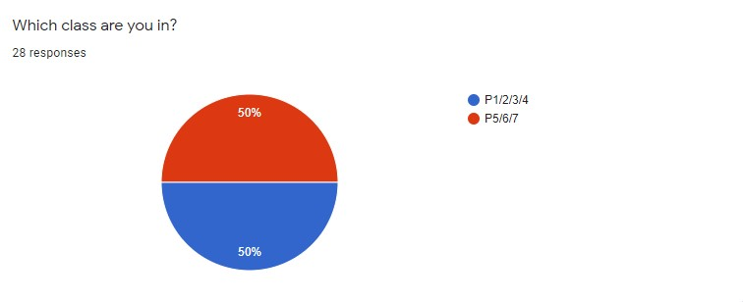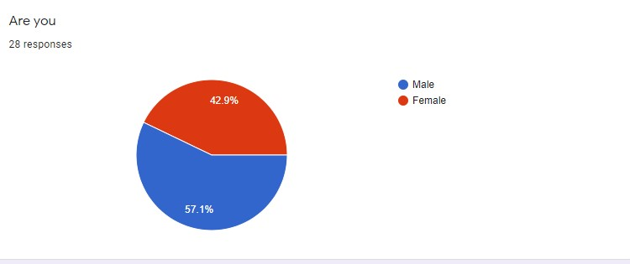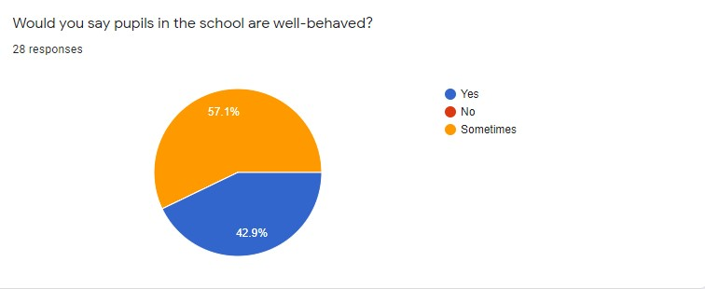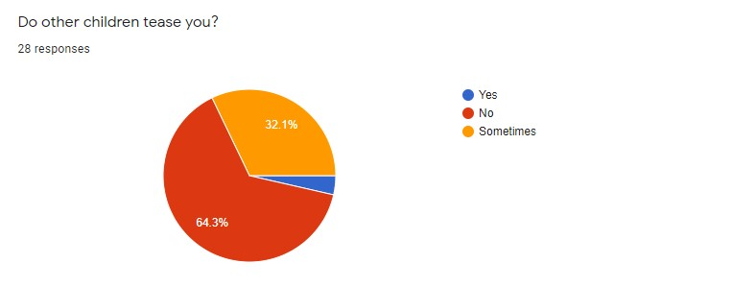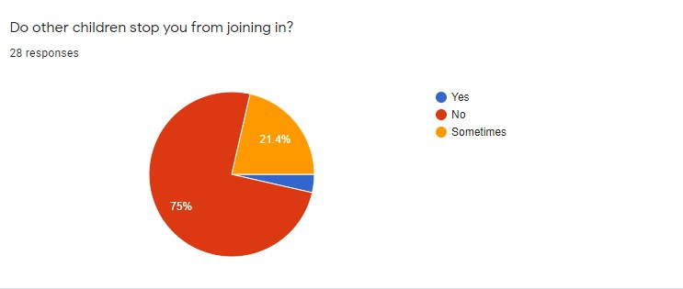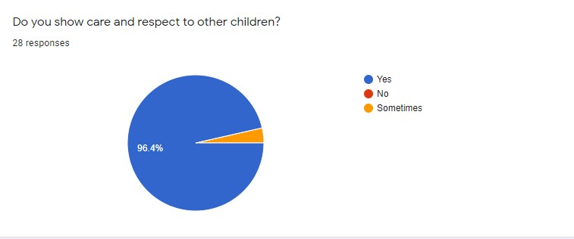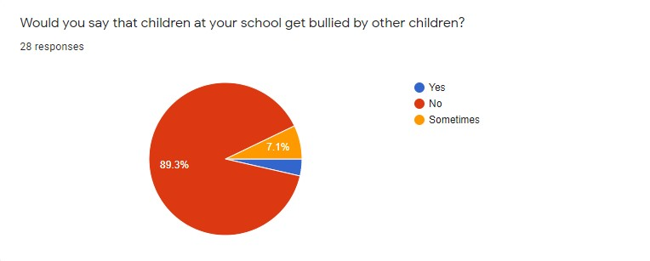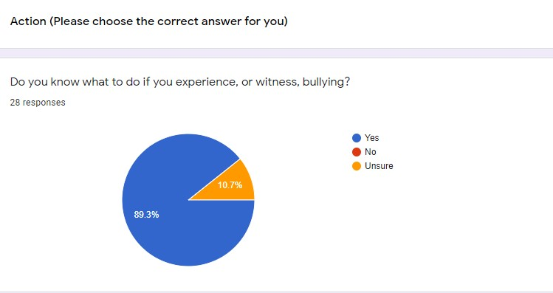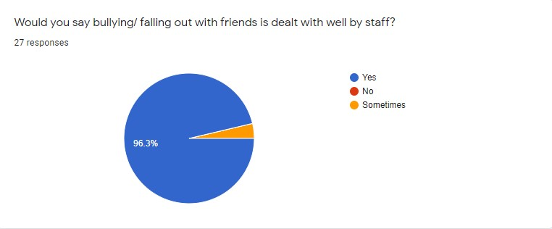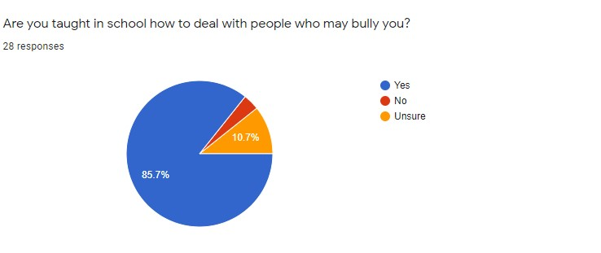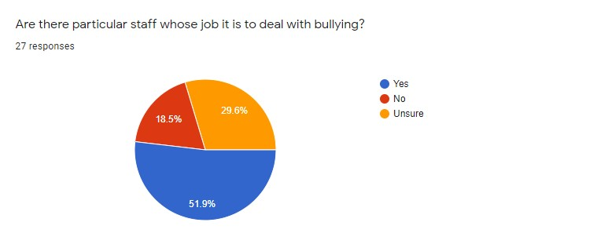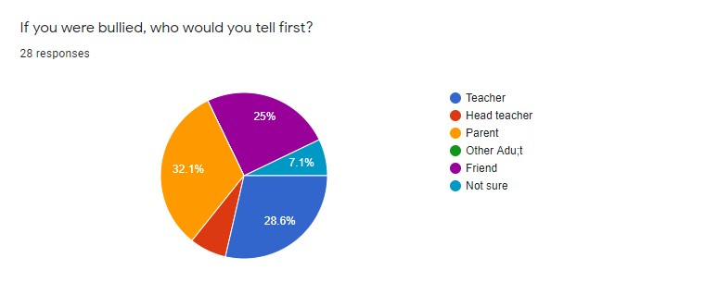
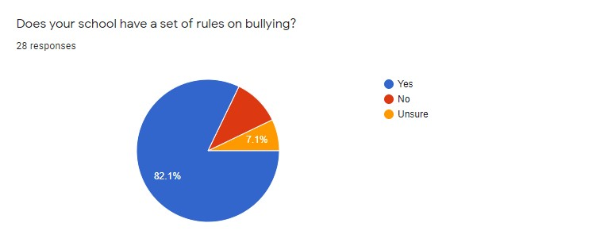What kind of bullying behaviour have you seen or been involved in?
8 responses
None.
i have not
people say mean things to me sometimes and don't stop.
none
Nothing
fist fight word trash talk
i have not see or been involved in bullying
no

What should the school do about bullying behaviour?15 responses
Prevent it.
tell them off !!!!!
3week suspension
tell the parents of the person who is bullying people so they know that there kid is not being nice to be other people.
give them a week suspension
the school should tell children how the other children could feel if they are being bullied.
help them
start talking about it more
dont know
don't know
I don't know
stop or talk to them
i dont know
sort it
the head teacher should talk with them

What should the school do with people who are bullying others?11 responses
Give them a warning.
detention and 1week suspension
speak to them
speak to them
talk to them a bit more about their behaviour and get them to stop doing it
dont know
don't know
punish or talk to them
tell them to STOP or else
sort it
kids that saw it should tell a teacher

What can you do to ensure there is no bullying in school?14 responses
Make sure everyone follows the guidelines.
be nice to others then they will probably not bully any one !!!!!!!!!!!!!!!!!!!!!!!!!!!!!!!!!!!!!!!!1
security cameras out side
make sure everyone is kind and people are not mean.
don’t bully
stop it
not bully and stick up for the children that are being bullied.
have an assembly or talk to them about it
make sure they know It is bad
talk to the bully
don't know
be nice to others
make rules of no bullying
no

Do you have any other comments about Bullying?
11 responses
its not nice
no
None.
it not nice
no
have an assembly about it
don't know
nothing
No

Appendix 2:
Port Charlotte Primary and Pre5
Anti-Bullying Questionnaire
Parent Results
10 responses in total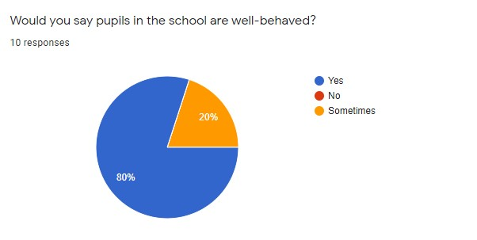 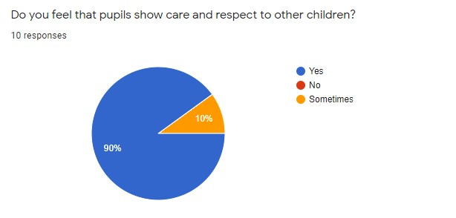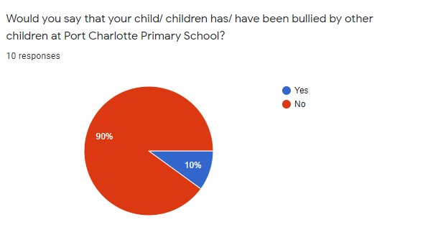
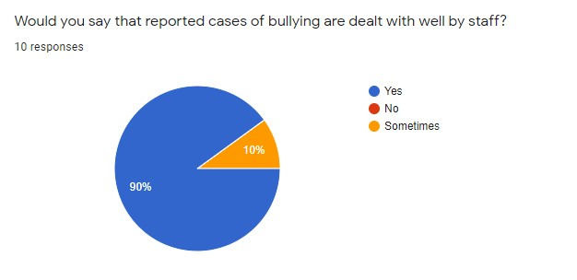
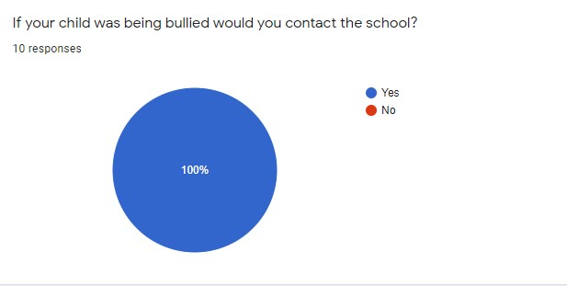

What should the school do about bullying behaviour?
7 responses

Investigate, discuss the issue with both pupils involved and monitor the situation carefully. Teach children what bullying actually is, how it would make someone else feel and what children can do about it.
In our opinion it is important to take reports of bullying seriously, communicate effectively with parents, keep accurate records and ensure all children involved are given the support they need. Some children may need increased supervision. A nurturing approach is good but in ongoing or more severe cases further sanctions should be looked at such as exclusion etc.
Collect evidence, investigate, remain impartial. Not allow labels without evidence.
The school deals with cases of bullying by following protocols that evidence proves works. All members of staff are approachable and available, or made available to both children and parents to talk to and confidentiality is taken seriously.
What they do already. Talk to individuals together and alone. Talk to parents. Monitoring in playground. Consequences for bully if continues. CONSISTENT approach - clear boundaries
Talk to kids. Sort it out.
The school has a procedure in place that reflects the school’s ethics. All my children have attended Port Charlotte. Not one of them has had a problem at school.

How should the school support pupils who are being bullied?
6 responses
Using a nurturing approach to make them feel supported. Help them develop resilience and monitor the situation as carefully as is practical.
Children who are bullied need reassurance that they are not the problem. They need to feel able to come forward and speak to an adult and to trust that the adult will deal with the bully effectively. Our child has found having a "secret signal" organised with her teacher has given her more confidence. She also feels more confident now that she sits at an individual desk and a set seat at lunch.
Listen, question, observe, use training and experience
All staff available to be a safe person for child to talk to, all evidence is taken and children involved watched. Any action taken is done discretely between children.
Checking in with them and parents.
The school follows anti-bullying procedures laid down by the council. It is a small school and there are always staff in the playground watching the behaviour of the children.

What more can the school do to discourage bullying behaviour?
7 responses

Encourage a culture of respect for others and use clear sanctions in more extreme cases. Take part in anti bullying initiatives such as the recent big anti bullying assembly funded by Nationwide and the Diana Award. School websites and facebook pages could be used to reinforce the anti bullying message in the wider school community.
Continue with regular classes about what bullying is, observe behaviour.
At school I feel that the children are well-educated in what counts for bullying. It was a massive worry of mine but I feel the school adapt change and constantly ensure bullying is not something that happens in school. I've personally witnessed kindesses delivered out of school.
Continue as it is with its nurturing and restorative approach. Continue to make all pupils feel understood.

I think they do bullying awareness every year anyway. Also I saw a campaign one year on Instagram to raise awareness where the children, teachers and parents all wore odd socks for a day.
The school has an open-door policy where parents are encouraged to get in touch over anything that concerns them. The school has respect as one of its main aims, along with being responsible to ourselves and others.

If you were told by the school or elsewhere that your child was thought to be bullying another child how would you deal with this?
9 responses
I would talk to my child and make sure they understand that this is not an acceptable behaviour.
We would firstly discuss the situation with our child, staff and the other parents involved to gather the facts and reassure everyone that we would do everything in our power to resolve the situation. Our first concern would be to get to the bottom of why our child was bullying. If they were lashing out in response to some upset or unmet need then that would be the first thing to fix. We would talk to our child about how they had made another person feel and how they could begin to put it right. We would expect our child to apologise to the bullied child and their family. If bullying carried on after that we would have to seek mental health support for our child and make sure they were aware of the long term consequences of bullying behaviour.
I would try to get to the route of the problem and find out why my child was behaving in such a way. I would explain how this was making the other child feel. I would be very firm and explain that this behaviour is unacceptable and work with the school or other establishment to ensure it stopped.
Contact the school, talk to my child and other parents, explain why another child is upset. Believe my child's story.
I would contact the school to ensure there is good enough evidence to support the claim and ask them to ensure that it is not tolerated. I would ensure and educate my child to prevent it from continuing. If mutual agreement of friendship couldn't be met I would ensure separation.
I would spend time with my child talking through bullying with them and trying to identify why they were bullying. I would use reflection and I'd check in with them regularly.
Talk to my child, explain it's wrong to bully.
I would speak to my child directly after finding out facts from the school.
My children find bullying to be abhorrent as everyone should be treated and respected as the individual theyare, however if they were labelled a bully I would be extremely disappointed in them as would their father and older siblings.

Any other comments?
7 responses
No.
I feel safe in the knowledge that my children are happy and safe at school. They are listened to by staff and should any bullying behaviour occur I feel it would be dealt with seriously and efficiently.
We're glad to have received this questionnaire and to know that anti bullying work continues at Port Charlotte. Our main hope is that we will never again see our child (or any other child) arrive home injured or in tears.
More weight should be given to the experience and impartiality of staff. A child should not be labelled a bully on the basis of one family's word.
From being extremely concerned about how my child would be treated to absolute ease with sending my child to a school where acceptance, patience and friendships are at the forefront of everybody.
I think Port Charlotte Primary School has been and still is at present an all round good school that has each child’s potential firmly in its goals.
Perhaps there is an online programme that could be recommended to parents about how to handle bullying or if their child is the bully. Emphasis on bullying being uncool. Work on all children's self-esteem. Encourage each other to intervene to stamp out bullying. Parents also need to take a uniform approach and maybe need handouts or information on how to handle bullying.

Appendix 3:
Port Charlotte Primary and Pre5
Anti-Bullying Questionnaire
Staff Results
8 responses in total

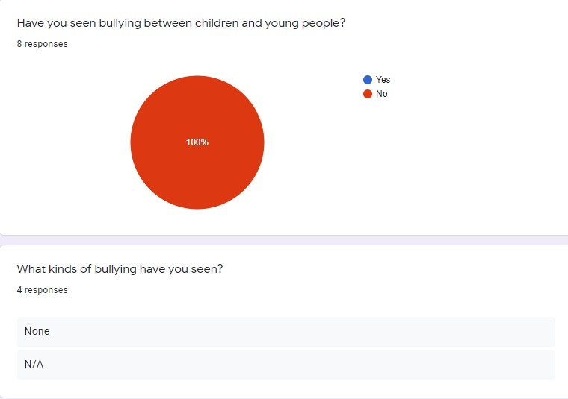
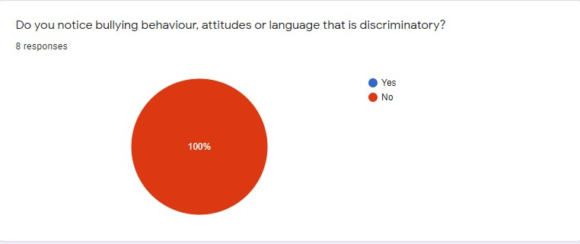
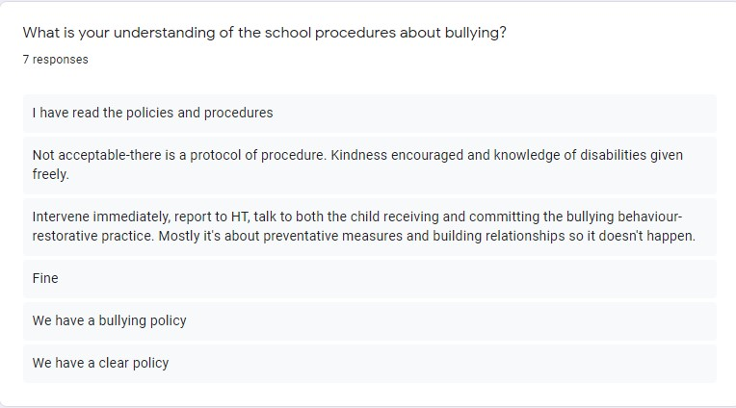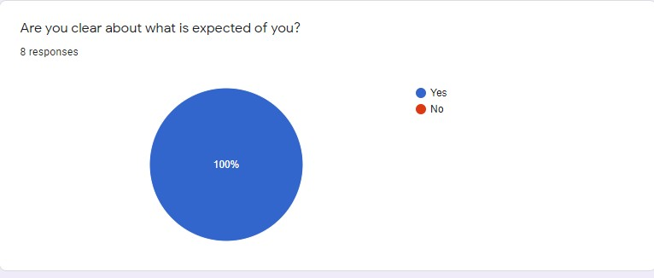

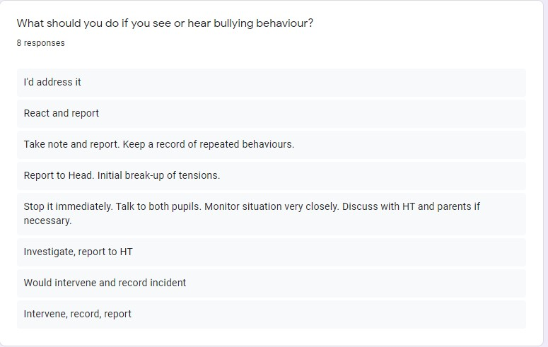
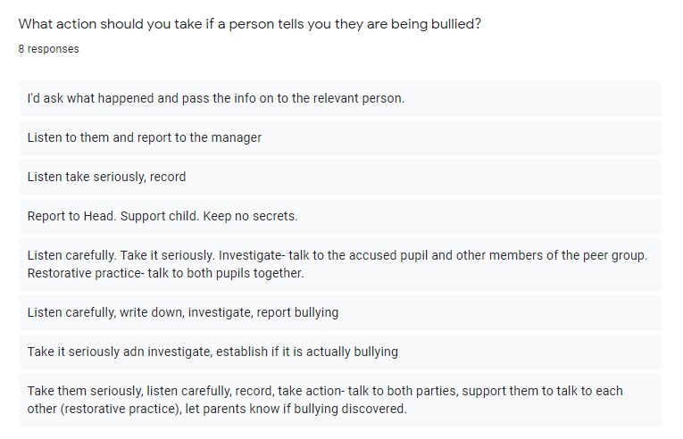
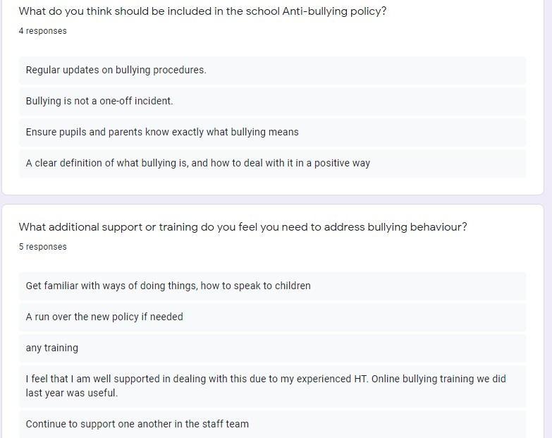
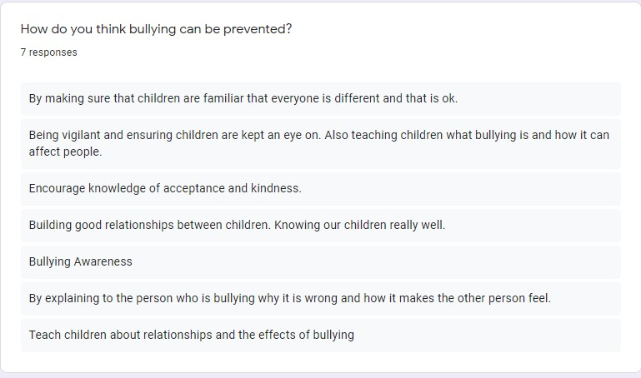
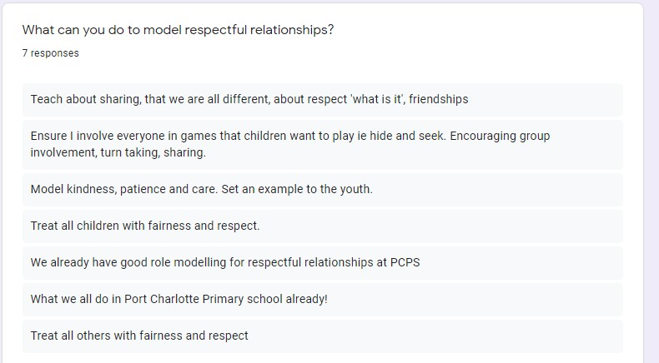

Appendix 4 – Signs and Impacts of Bullying
What are the possible signs of bullying to be aware of?
- Changes in mood and behaviour
- Increased anxiety
- Scratches and bruises that can’t really be explained
- Child doesn’t want to go to school or has trouble with schoolwork
- Changes in the route that is taken to school
- Torn or damaged clothing
- Child doesn’t want to go out and play with friends
- Unexplained head or stomach pains
- Easily upset, unexplained tears or ill-tempered behaviour
- Fear or alarm when text messages/emails are received
- Spending more time online or changing online behaviour

What are the possible impacts of bullying?
- RAW – children might try to Resist it, Acquiesce, Withdraw
- ANTICIPATION of something bad going to happen
- Changes to school attendance
- Eating disorders – too much/too little
- Violence towards others
- Self-harm
- Depression
- Limited aspirations
- Bullying behaviours
What are the impacts of bullying behaviour on families?
- Stress
- Anxiety
- Guilt
- Anticipation
- Strained relationships
- Helplessness
- Concerns regarding authority figures or establishments (lack of trust)
- Aggression in the household
What are the impacts of bullying on the school and staff?
- Relationship difficulties
- Undermining positive ethos and practice
- Group working difficulties
- Inhibit learning
- Inhibit group dynamics
- Lack of attendance
- Pressure on support services
What are the cultural pressures on children?
- Bullying behaviour celebrated in the media
- Difficulty in promoting pro social behaviour
- Negative messages in the media
- Negative role models
- Blame culture – everybody out for themselves
- Sectarianism
- Widespread use of internet and having mobile devices from a young age

Appendix 5 - Useful Links

Our children, their mental health and wellbeing

Our Children, Their Future

Argyll and Bute anti-bullying policy

Respect for all

https://www.argyll-bute.gov.uk/girfec

http://www.respectme.org.uk/publications.html

http://www.antibullying.net/parentsfamilies.htm

http://www.kidscape.org.uk/

http://www.childline.org.uk/explore/bullying/pages/bullying.aspx

http://www.tessaproject.co.uk/

http://ceop.police.uk/

