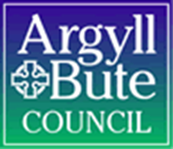
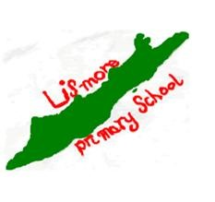

Lismore Primary School
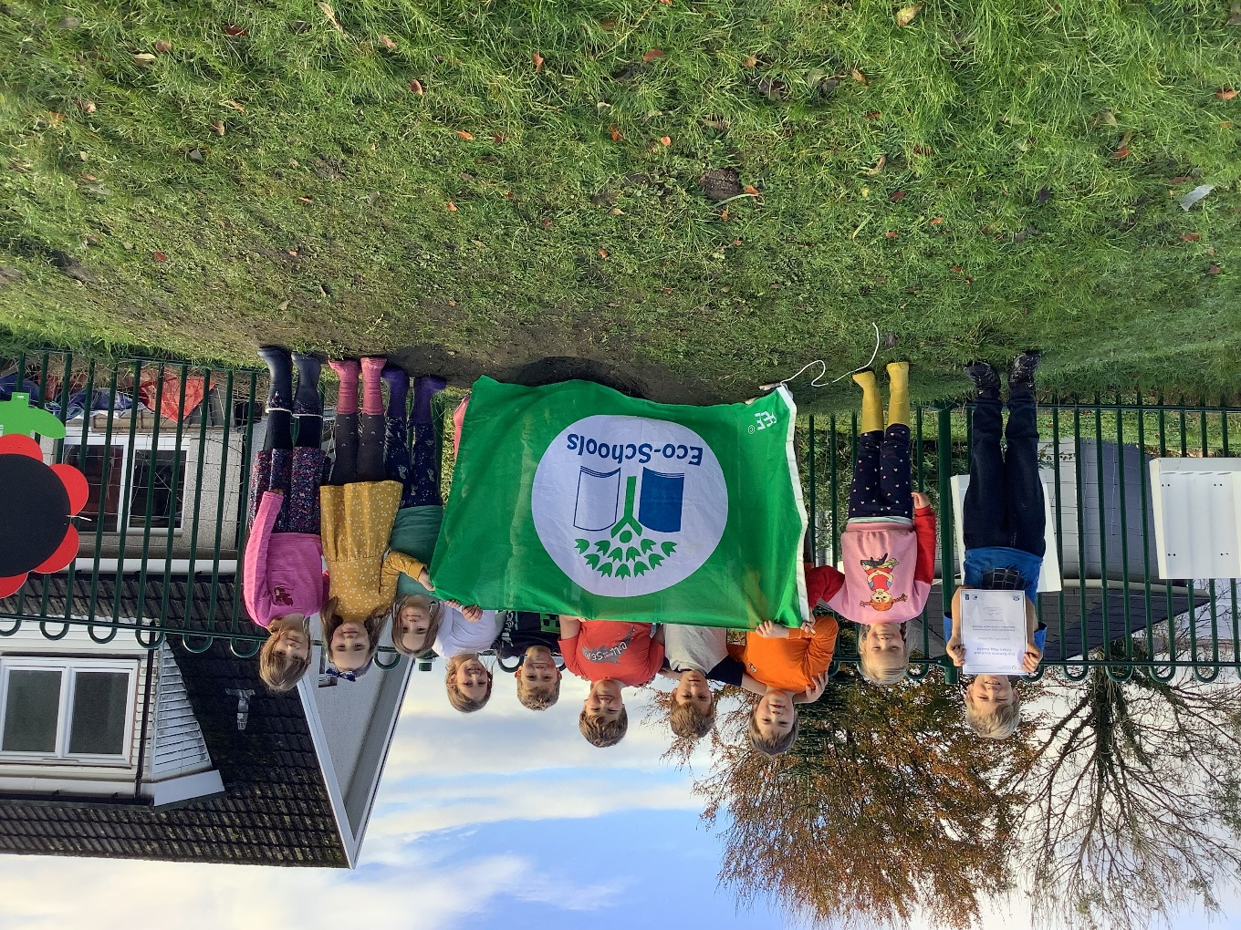

Standard and Quality Report 2021-2022

Standards and Quality Report 2021 - 2022
Name of school
Lismore Primary School

Context of the school
Including some or all of the following:
- basic school details (roll, class composition etc.)
- school vision, value and aims;
- local contextual issues;
- factors affecting progress (e.g. staffing changes/issues).

School details (roll, class composition)
Lismore Primary School is comprised of one class, P1-7, made up of 11 children across all stages. Our ELC was closed this session as we had no children.
We refreshed our school vision, value and aims, this session, in consultation with staff, pupils and parents.

Lismore Primary School Vision
For all at Lismore Primary School to be happy, safe and learning; to adopt a growth mind set and be provided with opportunities to be the best that they can be now and in the future.

Lismore Primary School Values
Kindness
Respect
Honesty
Equity
Compassion

Lismore Primary School Aims
- Provide choice, challenge and play to enable children to learn through enquiry and have access to uncapped learning.
- Encourage a growth mind set through setting achievable targets, celebrating success and embracing mistakes as opportunities to learn.
- Develop kindness through an ethos of mutual respect.
- Enable appreciation of our local community, diversity and the wider world.
- Create a calm, purposeful and fun learning environment in which children feel safe, happy and ready to learn.
- Celebrate and embrace difference and cultural diversity.
- Promote resilience and skills for life, learning and work.

Local context
Lismore Primary School is a small friendly school, which is embedded in the life of the community on our tiny island. It is a family school where children, families, staff, and friends can feel at home. The school is a happy, bright, and welcoming place where achievements and learning are celebrated by everyone.
The school serves children from the whole of the Isle of Lismore in the Lynn of Lorn. As a small school, all staff know the children and their families very well. During a ‘normal’ year, parents are encouraged to drop into school for a chat or to see what the children are doing. Of course this has been difficult again this year due to the global pandemic.

We have a deep understanding of each child and their individual needs. We draw out particular skills and can identify areas for development. Learning and teaching is tailored to the needs of each pupil and all plans begin with the children in front of us. We use floor books to encourage the children to be an integral part of the planning and reflecting process and ensure we then use this pupil voice to inform what’s next.
The school is bright and cheerful inside and together with the grounds creates a wealth of possibilities for learning. We seek to foster lively and enquiring minds and believe children should find learning enjoyable, worthwhile and challenging. We have the highest expectations for our young learners. They are encouraged always to do their best and to take a pride in everything they do. The children are involved in planning their learning, setting their own targets and assessing progress made. Staff, parents and friends also have the opportunity to make suggestions and put forward ideas for learning opportunities.

Factors affecting progress (e.g. staffing changes/issues)
Our ELC has been closed this session as we had no intake of pre-5 children. As a result, our ELC staff were relocated or made redundant. This had an impact on the school ethos as the ELC and school often work closely together. We tried to embrace the change in a positive way, rearranging our ‘big room’ (the ELC) as a space for our children to play and learn. We set up a library area, messy play area and games area for all children to use at several points throughout the school week.
At the beginning of the school session we welcomed a new teacher (NQT). The children and staff quickly developed relationships with our new staff member. We were then given the news that she was pregnant and would be leaving us some time in the third term. Although the ongoing lack of stability appears to have had some impact on the children’s sense of security, especially after the many staffing changes last session, they appeared to take it in their stride and demonstrated their resilience.
We welcomed another new teacher, to replace our NQT, at the end of term 3. The children are now getting to know her and appear to be managing the change well.
The continuation of restrictions, due to the global pandemic, has meant few opportunities for learning off site or for people coming in. However, with changes to this announced at the beginning of the 4th term we have taken all opportunities possible to rectify that. We have had visiting football and rugby coaches, have attended a rugby tournament and sports day (with other small schools) and have plans for a parents’ open afternoon.

Review of SIP | Priority 1 Raise attainment in Literacy
Progress and Impact:
Our aim was to raise attainment in literacy. At the end of last session we noted a need for improvement within writing and reading so decided to focus on these areas specifically. To do so we planned and implemented a number of key actions:
Writing
Extended Writing: Our aim here was to increase enjoyment as well as raising attainment.
Increasing enjoyment: After noting the children’s lack of enjoyment with writing, we asked for their views. At the beginning of the session the average enjoyment for writing was rated 3/10 by the children. By the end of the session, this had increased to an average of 7/10.
In term 1 we implemented a stop motion writing project. The children created settings and characters and used stop motion to use these to create stories. Impact: The enjoyment during these sessions was visable- you could see, hear and feel the buzz in the room.
In term 2, after creating some ‘buzz’ around writing we used Talk for Writing materials to extend our understanding of story structure. We used story maps to draw and act out our ideas for beginning, build-up, problem, resolution and ending. Impact: The children appeared to prefer drawing and acting out their stories and still found physically writing them strenuous at times. However, all children had ideas and were eager to share them- it was just a matter of supporting the technical aspects of writing now.
To continue with our theme of writing for enjoyment, we enrolled the children in online playwright workshops. Again, the structure for creative writing was explored but this time with the addition of dialogue. Impact: The children, once again, enjoyed creating stories and working in a way that allowed them to see their stories come to life, without writing them down. The playwright team would take the children’s ideas and act them out on stage: this was met with lots of smiles and giggles.
In term 3 we focused on writing for a real purpose. We teamed up with a school in Dumfries and Galloway to become pen pals. Throughout term 3 and 4 the children wrote several letters back and forward. Impact: High levels of enjoyment were evident. When the letters arrived in the mail the children were visibly excited and keen to open them and read their response. Each child enjoyed having their own pen pal and commented on getting to know them through their letters.
In term 4 we introduced ‘Free Writing Thursdays’. The children were issued with special writing journals and encouraged to write anything they wanted; they could choose from comic strips, diary entries, newspaper articles, mark making etc. We reassured the children that there would be no marking and no feedback (unless they chose to share their work and asked for it) and that the journals were theirs to use how they liked, with only one rule: they were to be used for writing. Impact: Immediate excitement from all. Our most reluctant writers were desperate to get started: one sat down and wrote a whole page in the first ten minutes recounting an incident with his pet chickens; another said ‘yes!!’ and proceeded to draw out a comic strip about a spaceship landing on Lismore.
Raising attainment: During the course of the session staff engaged with 4 writing CPD sessions offered by Clare Bryden. This helped us continually reflect on our own offering and consistently ask ourselves: what can we do different? Better? We also signed up for Talk for Writing training but the earliest available online session is in September 2022. Therefore, we found ways to change our approach through own means of research, purchased the resources and have taken a ‘dipping in’ approach this session with the view to rolling the programme out more fully, after staff have been trained. We took what we felt was most useful from the programme for our children, and continued using Big Writing materials to help us focus our sessions, co-create SC and set agreed upon realistic targets. Using these materials we focused on a different area of technical writing each term.

We have also continued to raise motivation using star writer certificates linked directly to success criteria and offer targeted support for writing for individuals that require it.
Impact: We assessed writing in September, January and May. We are seeing progress being made by all children but many are still working under their expected level.

Spelling: In term 1, after the completion of baseline assessments, we noted a need for improvement in spelling- especially in using common words in context (e.g. when writing an extended story where spelling was not the key focus). We decided to use the Stareway to spelling resource with the whole class. Throughout the remainder of the session we took a multi-sensory approach to common words- embedding this into our morning routine. Each day we start with a new spelling activity (e.g. making words with playdough) whilst focusing on the same set of 6 words for the week. We also used the Highland Literacy approach to spelling ensuring we were teaching encoding (spelling) rather than decoding (reading). We encouraged the children to play around with the words- stretch them, grow them, use them in context etc. Impact: All children have improved with spelling in context. This has been evidenced in their writing work. We can see the majority of children now spelling the first 200 spelling words accurately. Spelling assessments also evidence progress as all children in P3-P7 have improved upon their spelling age.
Reading: Again, the need to consider enjoyment alongside attainment was evident here.
Enjoyment: Creating an appealing reading area; new books; listening to children’s interests (e.g. non-fiction) and incorporating this into learning; free reading time; paired reading. Impact: All of these measures helped to increase reading enjoyment. This is evident in the classroom ethos. There is a notable shift in most of the children’s attitudes towards reading. At the beginning of the session the average enjoyment for reading was rated 5/10 by the children. By the end of the session this had increased to an average of 8/10.
Attainment: This session we have implemented RWI for our P1s. This consistent structured approach to phonics and early reading/writing appears to suit the needs of our learners. In Primary 2-7 we have focused on reading skills: reading for information; reading with expression; visualisation; using context clues; answering evaluative, inferential and compound questions and understanding the writer’s message. Impact: Assessment results (alongside observations and work) show P1 are on track to achieving early level reading. SNSA results in this area support this predication. From P2-7 all children (without an additional support need in the area of literacy) scored a higher reading age than their chronological age in their most recent reading assessment.
ASN: We have 1 child with dyslexia and 2 children with general learning difficulties. This session we have utilised new resources and approaches to better meet their needs. We use toe by toe to help support their reading development; we use Nessy to support spelling and reading and we use Clicker 8 to support writing. Impact: Implementing these supports certainly seems to have built our learners confidence and enjoyment of literacy; however, assessment results show little progress.

Next Steps:
Although we have made a lot of progress this session, especially with reading and writing for enjoyment, we still have work to do on raising writing attainment. Our aim is to fully implement a more structured writing programme next session to allow us to carefully monitor progress whilst retaining the enjoyment for writing we have already begun to create.

Review of SIP | Priority 2 Embed Digital Technology Across the Curriculum
Progress and Impact:
Our aim was to embed digital technology across the curriculum. To do so we planned and implemented a number of key actions:
Policy and Plans: In consultation with Argyll and Bute’s digital team we wrote a new Digital Skills Strategy for our school, setting out our vision and aims, with regards to digital learning. This in turn, helped us develop a termly plan for digital learning which links up to the Digital learning progression framework created by Argyll and Bute. Impact: Clear, strategic goals being set helped all staff implement effective digital learning opportunities. This session the children have been engaged with digital technology more often, are developing their basic skills and have been exposed to a wide variety of digital experiences.

Online Safety Week: We had a whole school online safety week in May 2022. The children were involved in exploring one aspect of online safety every day culminating in a digital day (in which they used digital skills to show case their learning from the week). We explored the dangers of online learning; discussed the SMART rules for accessing online learning; experimented with safe passwords; designed our own Cyber Safety Avatar and created an an i-movie showcasing our learning. At the beginning and end of the week we created a floor book page titled ‘What we know about Online Safety’ to informally assess our learning using a pre/post style assessment technique. We also sent home digital homework asking children and parents to consider technology in the home and monitor uses for it. Impact: Evidence from pre-post floor book of development in children’s understanding and awareness of online safety.

Basic Skills Baseline and Termly RAGs: At the beginning of the school term we assessed the children’s basic computer skills using a RAG template. We then continued to assess this after each term. Impact: All children have developed basic computer skills from P1-P7. They can log on to a computer; access learning programmes (e.g. Sumdog) independently using their login information; use a word document (changing font, style, positioning of letters as well as inserting text boxes and images); use a search engine to find information and use the different features of Power point.

Digital Focus Group: In term 3 and 4, we implemented a weekly digital group, where the children would work in small groups to solve problems with a digital spin. During these groups children learned about future technologies, coding and explored different Ipad functions. Impact: Children from P1-7 are more confident with digital learning and are beginning to understand more about digital experiences beyond computers. The children loved working with lego coding and bee-bots, describing these sessions as their favourite groups.

Seesaw: We purchased Seesaw in term 1 to provide a platform for children to archive experiences and share with their families. Each week the children choose work, photographs and videos to upload. Impact: Children becoming more confident with using QR codes, navigating the Seesaw platform and using functions like captions, audio recordings etc.

School Blogs: In term 3 and 4 our P7 pupil was responsible for writing and uploading a school blog to our school website. To do this they used information gathered from their peers in an earlier floor book session about the topic. They then summarised this information and chose photographs to match their writing then posted this on the school website. Impact: P7 pupil has learned how to edit a website- a valuable skill for life, learning and work.

Weekly Assessments/Reflections: In term 4 our class were responsible for collating information for our schools weekly assessment/reflection. This involved a discussion about the 4 contexts of learning which was then typed up. Later photographs were added and it was uploaded to our school website. Impact: We are beginning to give P6/7 responsibility for leading this activity. This will help them expand upon their knowledge of word; tlearned how to manipulate text and photographs to fit to a format and learn how to upload content to a website (again valuable skills for life, learning and work). All children benefit from reflecting on their successes.
Next Steps:
We are happy with the progress we have made this session but feel we are only at the beginning of our journey with this particular area. As such, we have decided to prioritise digital learning again next session. We are aiming to begin our digital schools award.

Review of SIP | Priority 3 Build on positive relationships (pupils, staff, parents)
Progress and Impact:
Our aim was to continue to build on positive relationships with pupils, staff, parents and the community. To do this we planned and implemented a number of key actions:

Re-vised our school vision, values and aims (VVA): We consulted with children, staff and parents to re-write our school VVA. Impact: All stakeholders now have a shared understanding of our school’s VVA. This allows us to further embed our values within our school ethos and work as a team to realise our vision and meet our aims consistently.

Positive relationships Policy: Last session we re-wrote our positive relationships policy. This has been successful in sustaining more consistent positive behaviour across the school. However, due to our high level of additional support needs we felt the need to expand upon this to ensure it was equitable and fair to all; this has lead us to a differentiated version of our current policy which encourages a needs based approach. These changes were brought about after professional dialogue with our educational psychologist and personal reading (recommended by our educational psychologist). Our adapted version has now been shared with staff members to ensure we offer a consistent approach. Impact: Children’s needs are being met using an approach that is right for them as individuals. This allows us to put our values of compassion and equity into practice and ensure we are getting it right for all.

ASN Observations: In order to develop a positive relationship with our children we feel it is of the utmost importance to understand them and their needs fully and respond with compassion and support. Many of our children have been awaiting an ASN observation for some time now (this has been delayed due to COVID 19 restrictions). In term 2 this year we were able to get the ASN Education officer out to observe a number of individuals and discuss next steps. We have since begun making connections with a range of partners to help support our learners’ needs. Impact: Children with ASN on correct level of staged intervention. ASN recorded accurately which will impact on our children as they move through primary school and transition to secondary school. Needs of all are now being fully met, using inclusive strategies alongside tailored interventions and support materials.

Curriculum Design: We consulted with pupils, staff and parents this session to re-fresh our curriculum design. The feedback received alongside the refreshed CFE materials were used to create a curriculum that is relevant to our current cohort of learners, meets the needs of our community and sits in line with national and global practice. Impact: We have a curriculum that fits us. This makes learning more relevant and engaging for all.

Seesaw: We purchased Seesaw in term 1 to provide parents with an insight to their child(ren)’s everyday school experiences and create an archive of the children’s achievements. Impact: Parents engaging with child(ren)’s school day helps support the home- school link and encourages a shared understanding across the child(ren)’s key environments.

Parents’ Meetings: We had two parents’ meetings this session: one at the end of term 1 and one at the end of term 3. This allows us to formally report to parents’ about their child(ren)’s wellbeing, attainment and overall experience at school. Impact: Provides a formal forum for parents to ask questions, provide feedback and share stories about their child(ren). Both sessions were particularly positive this session with all parents commenting on how happy they were with their child(ren)’s overall school experience this session.

Open Afternoon: We have invited parents in for an open afternoon during the last week of the school term. We aim to use this time to launch our new outdoor expeditions programme. The parents and children ill move round 4 outdoor stations based on the provocation: How do we share our Island stories? Each station will focus on a different skill: Explore, Design, Create and Celebrate/Share.

Sports Day: We attended sports day this session at Barcaldine primary school with Barcaldine and Strath of Appin. Impact: The children enjoyed mixing with new children, meeting new friends, competing with children in similar age groups and spending time in a different environment.

End of year reports: Our end of year reports were written in conjunction with the children and then sent home to parents. The parents were then asked to write a comment and return them. Impact: Strengthening home school link. Ensuring all stakeholders have some information- teachers, children and parents helps with consistency.

Next Steps:
This has now been our focus for 2 years and we feel we have achieved a lot of success in this area. With Covid restrictions easing we now look forward to building stronger links with the community and inviting partners in to the school. We plan to start up book bug club and a monthly pensioner tea- alongside many other ideas.

Review of SIP | GME Priority
Progress and Impact:
Next Steps:

Review of SIP | Developing in Faith Priority
Progress and Impact:
Next Steps:

1.1 Attainment Data
Attainment of Literacy Curriculum for Excellence levels 2016/17, 2017/18, 2018/19, 2020/21 and 2021/22. (teacher judgement – confirmed levels – 5 year trend).
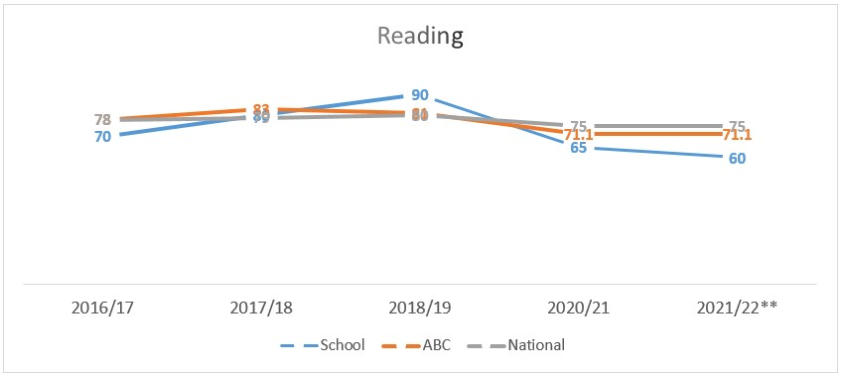
Example – Replace with school-specific data when provided
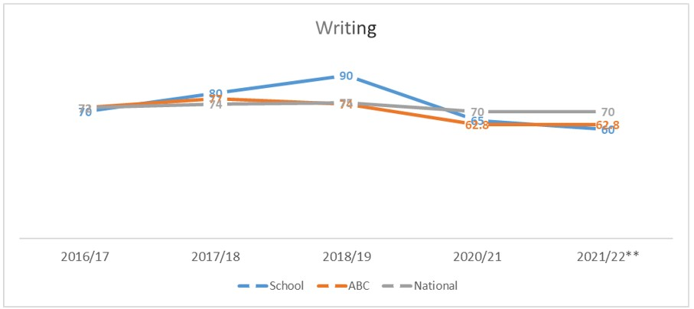
Example – Replace with school-specific data when provided
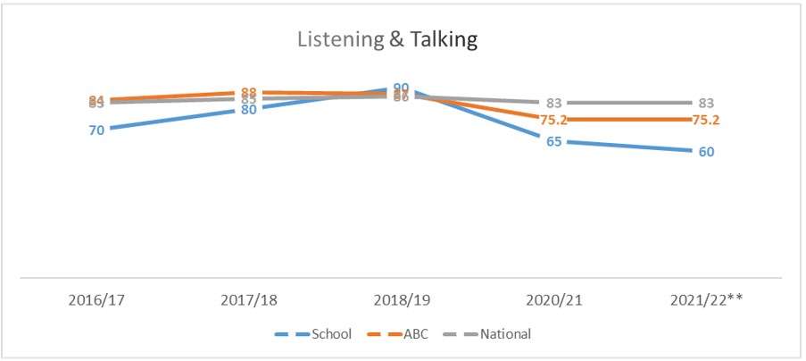
Example – Replace with school-specific data when provided

1.2 Attainment Data
Attainment of Numeracy Curriculum for Excellence levels 2016/17, 2017/18, 2018/19, 2020/21 and 2021/22. (teacher judgement – confirmed levels – 5 year trend).
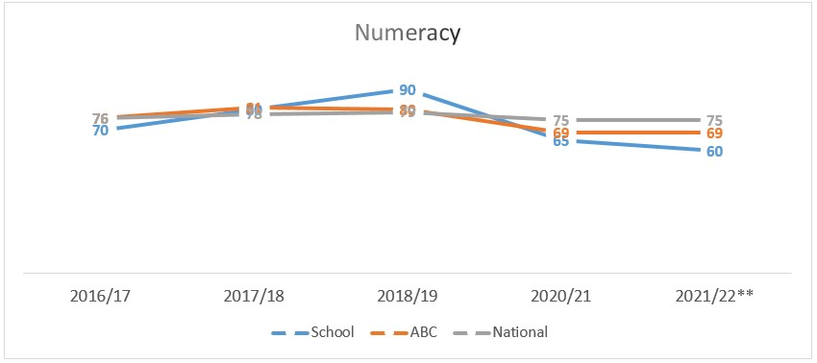
Example – Replace with school-specific data when provided

Please Note:
The above data (1.1 and 1.2) reports achievement of a level – P1/P4/P7 combined.
Due to the Covid 19 pandemic, there was no collection of ACEL data by Scottish Government in 2020.
Overall quality of our learners’ wider achievements Highlights of session 2021 - 2022
Outdoor Learning- Gardening Group: During the Spring and summer term, every Thursday the children work in the school garden. They plant vegetables and flowers, weed, compost, water etc. This session they have planted potatoes, sweetcorn, French beans, chives, tomatoes, sweet peas and leeks in our poly tunnel and raised beds. When we harvest our vegetables, we will use them to cook in school and may also try to sell them within the local community.
Eco Flag: This session we earned our 5th ECO Flag. Each Tuesday morning the children meet to form an ECO-group. This session we set 3 school targets that linked with the United Nations Sustainable Development Goals. We then set to work achieving our targets including learning about food miles; recycling, reusing and reducing; using locally sourced food and litter management.
Ukulele: Amy Bowman (local musician) continued with us for a further 18 hours of ukulele this session. The children have learned about strumming patterns, chords, beat and rhythm.
Samba Drumming: Martin, from Street drumming, joined us for two fun filled days of music. All children joined in to learn about Samba music from Brazil. They learned how to perform a song accompanied by drums and several other instruments.
Lismore Project: Two local musicians have been working with the children for 18 hours this session on what we have termed ‘The Lismore Project’ funded by Treòir\ Voar\ Virr. During this time, the children learned about crofting, farming, ceilidh dancing, the boating industry, Gaelic history and the sports and raft race tradition.
Rugby and Football Coaching: We have had several visits from rugby and football coaches this year. This culminated in a rugby festival for P4-7 with other small schools. The children’s progress has been evident here- from P1 developing their ball handling skills, to P7 developing their dodging and ducking skills.
World Gaelic Week: On the week beginning 21st March it was World Gaelic week. To celebrate this we took part in several Gaelic activities throughout the week including learning the song ‘Brochan Lom’ and taking part in a Gaelic safari.
Burn’s Day: This year for Burn’s day we learned the poem ‘Address to a Haggis’ and performed it at our Burn’s supper. We got to try haggis, neeps, tatties, irn-bru and short bread. We also learned a little bit about ceilidh dancing and explored the haggis as a mythical creature.
One Planet Picnic: In term 1, our Climate Change topic culminated in a One Planet Picnic. We invited people from our local community to donate locally sourced produce and used this to make items for our picnic. We learned about the key principles of local and seasonal foods, organically grown, reduced packaging and food waste.
Tree Planting: We sourced some trees from the woodland trust in term 2, planted them in our school grounds and gave them out to people in the local community to plant on their land. We also went on a trip to a local croft to help plant the trees and were rewarded with cake and hot chocolate!
Penpals: We teamed up with Nethermill Primary in Dumfries to become pen pals. Each child was paired with their own penpal. They wrote several letters back and forth sharing their lives with one another- from one rural setting to another.
Virtual Games: During term 2 the children took part in a virtual games competition with several other schools across the authority. This involved 5 weeks of practice, before recording their results and submitting them to the active schools co-coordinator. We are pleased to share that all children thoroughly enjoyed taking part and our P5-7 team won the competition.
Playwright workshops: During the second term the children took part in online playwright workshops with ‘The Write stuff’. The sessions taught the children about the recipe for writing a play. The children loved sharing their ideas with the actors on screen and seeing them be brought to life in a play.
Messy Play: We have continued with our messy play sessions this year. Once a week the children play with hands on, sensory materials such as sand, water, play dough or can visit our sensory den area. We have transformed our outdoor classroom into a messy play hut to provide a dedicated area to this much loved activity.
Floor books: On Tuesday mornings the children partake in a floor book group. Each week there is a different theme or question to explore- most often in relation to planning and reflecting on learning. This helps us maintain a strong sense of pupil voice and ensure learning and teaching is guided by the children.
Digital Group: In term 3 and 4, we implemented a weekly digital group, where the children would work in small groups to solve problems with a digital spin. During these groups children learned about future technologies, coding and explored different Ipad functions.
Achievements at home: Two of our pupils have been participating in weekly rugby training and have attended many rugby tournaments. One of our children has begun selling his hens eggs in the local shop. One of our pupils has been taking weekly fiddle lessons and learning to read music.
1 + 2 languages: This term all children have had French and Gaelic lessons. French, as our L2, is embedded within our school day/routine. Every morning we discuss the weather and date in French. We have also been learning about colours, numbers, family and hobbies. We have one Gaelic lesson per week, as our L3. Gaelic is special for us, as it is still widely spoken on the island. We try to embed it within our everyday communications- greeting one another in Gaelic and using if for thank you, cheers etc.
The Dig: We visited an archaeological dig site here on Lismore back in the first term. We saw skeletons from 1000-1500 years ago and coins from around 500 years ago. It was incredible to see evidence of life here, long before us and find out a little about what the evidence could tell us about their lives.

We track our offering alongside the children each session using floor books, newsletters, class blogs, weekly 4 contexts assessments and seesaw.

Comment on strategies that have been successful in engaging with children and young people, staff, parents and the wider community and the impact of these.
Children and Young People
Soft start: Every morning the children start their day with outdoor or indoor play to allow them time to socialise, settle into school and get ready for the day. Impact: Notable change in children’s readiness to learn (displayed through behaviour) and overall calmer classroom ethos.
Afternoon Break: We implemented an afternoon break towards the end of last session and have continued it this year. Impact: This helps with afternoon engagement. Children appear more motivated and less tired after their short break.
Check-in/Check Out: This was, again, first implemented last session. We use materials such as the GIRFEC wheel and blob tree to discuss children’s feelings and to open up conversations about their weekends. Impact: Children enjoy sharing stories and hearing other people’s news. Allows time for teachers to check in on children’s wellbeing and note any concerns.
New Messy Play hut (as above): This session we re-vamped our outdoor classroom to turn it into a messy play hut. In this space, the children have access to water, sand, play dough, paint and drawing materials. They also have access to a sensory den. Impact: The children have commented on the time in the hut, being their favourite time of the week and have described it as satisfying and relaxing.
Floor book (as above): On Tuesday mornings the children partake in a floor book group. Each week there is a different theme or question to explore- most often in relation to planning and reflecting on learning. Impact: This helps us maintain a strong sense of pupil voice and ensure learning and teaching is guided by the children.
Blogs (as above): In term 3 and 4 our P7 pupil was responsible for writing and uploading a school blog to our school website. To do this they used information gathered from their peers in an earlier floor book session about the topic. They then summarised this information and choose photographs to match their writing then posted this on the school website. Impact: P7 pupil has learned how to edit a website- a valuable skill for life, learning and work.
Staff
PRDs: Staff PRDs give staff protected time to discuss any issues and concerns, as well as explore their strengths, areas for development and path for the upcoming session. Impact: In our small school staff have lots of opportunities for professional dialogue- this being only one example of such. It helps to build positive relationships and ensure staff feel valued and listened to.
Staff Meetings: Whole school meetings are held once a month and at this time in-house CPD is offered. Impact: Staff have commented that regular CPD and check-ins (time to discuss things as they come up) has been beneficial to them.

Fun Fridays: Every second Friday, some staff members get together on a Friday after school (by choice) to chat and catch up about things beyond life at school. Impact: As we do not have a staff room/time in our day where children are not present, we find this time helpful in being able to build friendships.
Parents
Parents’ Meetings (as above): We had two parents’ meetings this session: one at the end of term 1 and one at the end of term 3. This allows us to formally report to parents’ about their child(ren)’s wellbeing, attainment and overall experience at school. Impact: Provides a formal forum for parents to ask questions, provide feedback and share stories about their child(ren). Both sessions were particularly positive this session with all parents commenting on how happy they were with their child(ren)’s overall school experience this session.
Seesaw (as above): We purchased Seesaw in term 1 to provide parents with an insight to their child(ren)’s everyday school experiences. Impact: Parents engaging with child(ren)’s school day helps support the home- school link and encourages a shared understanding across the child(ren)’s key environments.
Newsletters: Newsletters are sent home at the end of each term to share good practice with families. These are also shared on our school website to allow other stakeholders access. Impact: Parents and others in the community delighted to see photos of the children happy and thriving at school, see examples of work and hear about what’s going on.
Open afternoon (as above): We have invited parents in for an open afternoon during the last week of the school term. We aim to use this time to launch our new outdoor expeditions programme. The parents and children ill move round 4 outdoor stations based on the provocation: How do we share our Island stories? Each station will focus on a different skill: Explore, Design, Create and Celebrate/Share. Impact: This session is yet to happen but we hope it will help us further improve parental engagement and involvement.
Sports Day (as above): We attended sports day this session at Barcaldine primary school with Barcaldine and Strath of Appin. Impact: The children enjoyed mixing with new children, meeting new friends, competing with children in similar age groups and spending time in a different environment.
Community
The Dig (as above): We visited an archaeological dig site here on Lismore back in the first term. We saw skeletons from 1000-1500 years ago and coins from around 500 years ago. It was incredible to see evidence of life here, long before us and find out a little about what the evidence could tell us about their lives. Impact: The children enjoyed leaving the school to learn off site. They were very engaged throughout the visit and enjoy learning about their local heritage, which is important in their development of their sense of identity.
One Planet Picnic (as above): In term 1 our Climate Change topic culminated in a One Planet Picnic. We invited people from the local community to donate local sourced produce and used this to make items for our picnic. Impact: As a community we learned and shared our learning about the key principles of local and seasonal foods, organically grown, reduced packaging and food waste.
Tree Planting (as above): We sourced some trees from the woodland trust in term 2 and planted them in our school grounds and gave them out to people in the local community to plant on their land. We went on a trip to a local croft one day to help plant the trees and were rewarded with cake and hot chocolate! Impact: Contributed over 450 trees to the landscape of Lismore. This will have a positive impact on our environment.
Island Christmas Card: Every year we create an Island Christmas Card and deliver it to every house on the island. The islanders are invited to have their name inside the card for a small donation. Impact: Children able to be part of positive impact fro local environment as well as contribute to community spirit. Reduces paper use as many people of the island use this to send a Christmas wish to one another.
Sport’s Day signs: The children were asked to make signs and posters for our yearly sports and raft race. The posters were then displayed in the local shop, café and ferry. The signs will be used to direct people attending the sports and raft race to the site. Impact: The event is a long standing tradition on Lismore and it’s important for children to take part in contributing to their local community. This helps the children with a sense of belonging from a young age.
Picture’s for local community hall: The children were asked by the islands hall committee to make pictures to decorate the newly painted hall. The children made pictures of local sites and wrote about each of the different sites creating a ‘tour of Lismore’. Impact: The hall is the hub for social events on the island and having a bright and engaging display created by the children sustains the school’s visibility within the community and helps the children develop their individual identities as the youngest members of the community.

The Lismore Project: Two local musicians have been working with the children for 18 hours this session on what we have termed ‘The Lismore Project’ funded by Treòir\ Voar\ Virr. During this time, the children learned about crofting, farming, ceilidh dancing, the boating industry, Gaelic history and the sports and raft race tradition. Impact: This has been important in engaging the children with the local community and learning about what is important here and why. The children appear to be more engaged with island traditions and have a better understanding of their routes.

Comment on progress made with the following aspects of empowerment:
- curriculum;
- improvement activities;
- parental and community engagement; and pupil participation.

https://education.gov.scot/improvement/learning-resources/an-empowered-system/?dm_i=LQE,6RTY0,WAUPY4,R37A1,1
Curriculum (as above): We consulted with pupils, staff and parents this session to re-fresh our curriculum design. The feedback received alongside the refreshed CFE materials were used to create something that is relevant to our current cohort of learners, meets the needs of our community and sits in line with national and global practice. We have a curriculum that fits us. This makes learning more relevant and engaging for all.
Choice: Choice continues to be very important here at Lismore Primary School. The pupils often choose their tasks, level, who they work with and which order they work in as well as choices about homework, teaching and learning, rewards and responsibilities. Providing children with choice ensures their learning is not capped- this allows them to reach their potential. It also instils skills for life, learning and work.
Improvement activities: This session staff, pupils and parents have been involved in improvement activities to help reflect on our current improvement plan and shape our plan for next session. We have used staff and pupil surveys, RAG assessments, pupil reflections, HGIOUS materials and floor books to gather feedback which helps inform our next steps. All stakeholders in the children’s education, and specifically the children, are involved in decisions about their school experience and the improvements we want to make to keep this as positive as possible. This makes the children’s time here relevant, engaging and enjoyable and pushes them to be the best they can be.
Parental and Community Engagement: As mentioned above we have sought to engage parents and the community this session in using a variety of tools and approaches. We have uses see-saw, school blogs, floor books, our school website and our school social media site to be as transparent as possible in all we do here and increase our visibility in the local community. We have sought to involve the children in a number of community events such as the one planet picnic, tree planting, local dig, sports and raft race and Lismore project to build and sustain high community engagement.
Pupil Participation: The pupils are at the heart of all we do here. Each week they have the opportunity to plan and reflect on their learning during our floor book group. Each week they are involved in sharing and celebrating their learning using see-saw, class blogs and our weekly reflection/assessment. Our sense of pupil voice is something we continue to be very proud of and we are always looking at new ways to progress this further.

Comment on progress made with Pupil Equity Funding, taking account of the five key areas below:
- attendance;
- attainment;
- exclusion;
- engagement;
- participation.

Quality Indicator | How are we doing? | How do we know? (Evidence) | School Self-Evaluation (1-6)
1.1  Self-Evaluation for Self-improvement | All stakeholders (parents, pupils, staff, community links) are engaged in ongoing self-evaluation to support continuous school improvement. This was a central feature of work around the school’s positive relationships policy and curriculum design.  All pupils continue to be at the heart of all we do here. They are regularly asked for their thoughts and opinions on what they like/dislike and what their strengths and areas of development are. Feedback is used regularly for self-evaluation and improvement and the children’s achievements are continually celebrated.  All teaching staff have had regular meetings and lesson observations which has led to support high quality teaching and learning and opportunities for professional self-reflection.  We robustly track learning and wider achievements, share experiences with families and celebrate our success. | Stakeholder focus groups/questionnaires/etc. demonstrate feedback central to school improvement planning.  The school’s positive relationships policy was amended, in consultation with teaching staff and educational psychologist, and is based on children’s individual needs.  The school’s vision, values and aims were refreshed this session allowing all stakeholders to evaluate what is important for our school and create a shared understanding.  RAG Assessments are used at the end of each term to take account of the children’s views of their progress.  Individual targets are set at the beginning of each term alongside the children for literacy and numeracy. These are then reviewed at the end of the term using a reflection template.  Each week the HT works with the pupils to create a floor book page. This allows all learners to have a voice when planning and reflecting on their own learning.  P6/7 pupils were involved in writing class blogs which were published on our website this session. These provided learners with a chance to share a learning experience with others using their own words.  Quality assurance calendar illustrates regular monitoring of teaching and learning.  Minutes of professional discussions and PRD meetings demonstrate the links between planning-observation-reflection and action supported by identified professional learning.  This session the HT observed the NQT 2-3 times each term which led to a reflective conversation and agreed upon next steps.  See saw is used to track learning and share learning with families. The children update photos, videos, work etc. weekly- ensuring what is there is their choice.  Each week the children are involved in weekly assessments, using the CFE 4 contexts document as a template. They comment on the ethos of the school, curricular subjects, wider achievements and IDL.  We have a children’s work wall which is reserved for the children to display work of their choice. They are asked to choose work they are proud of and explain why. | 5
1.3  Leadership of Change | The school’s vision, values and aims have recently been re-written with input from pupils, staff and parents allowing everyone to have a shared understanding of what we are aiming for as a school.  All staff are committed to developing their practice to improve learning for each individual pupil in collaboration with the ASN Education Officer, Educational Psychologist, class teacher and parents/carers.  All learners are supported to understand the schools vision, values and aims through the 4 contexts of learning.  Digital learning programme introduced and new digital policy written. | Stakeholder focus groups/questionnaires/etc. demonstrate feedback central to school improvement planning.  HT created support need summaries to allow for streamlined information sharing.  Child Plan’s created for those on stage 3 intervention and reviewed regularly, with team around the child, to update targets and reflect on what’s going well.  School positive behaviour policy incorporates attachment aware, trauma responsive approach and is differentiated to suit the needs of our individual pupils. The policy also encourages high expectations, positive praise and uncapped experiences through the promotion of choice and challenge.  All staff (and other stakeholders) consistently involved in process of change.  Numerous CPD collegiate sessions on new positive relationships policy were held this session to ensure staff across the school created a shared vision of change, together.  Children reflect regularly on the school ethos and their learning experiences using weekly floor books, school blogs and the 4 contexts for learning weekly reflections.  Newsletters and seesaw used to share good practice and promote opportunities for discussion and feedback.  Digital Policy was created in conjunction with the digital hub. This allows all staff to understand expectations for digital learning.  Digital learning programme was introduced using Argyll and Bute’s progression frameworks to track progress. This has allowed digital learning to be appropriate to different ages and stages and a broad range of learning experiences within this area. | 4
2.3  Learning, teaching and assessment | Teaching and Learning is heavily influenced by the pupils themselves. They guide their own learning through choice.  Assessment has been very robust this year. We have triangulated evidence well using teacher observations, pupil comments, summative and formative assessment data to ensure we have a very clear picture of children’s assessment. We have also ensured children are involved in this process using termly targets, reflections and RAG assessments.  Curriculum rationale and design re-written based on national and local policy, stakeholders contributions and updated materials from education Scotland. | Teaching has been focused on pupil engagement and enjoyment. Enjoyment scales have been used throughout this session to measure children’s enjoyment in literacy, digital learning and outdoor learning.  Staff have signed up for CPD for writing (talk 4 writing) and numeracy (SEAL) to help us to continually, and consistently, raise attainment in these areas. These programmes were chosen with our specific children in mind as they advocate a hands on, practical, active approach to learning which our children have been very responsive to.  Our children choose their own work to be displayed on their work wall- this ensures we get a sense of what success looks like to them- we can use this to guide next steps.  Choice is embedded in what we do here. The children often choose who they work with, where they work, how they work and at which level they work (through chilli challenges).  Regular classroom observations of our teaching staff has resulted in a high degree of consultation and reflection with regards to teaching and learning. This results in teaching and learning being ‘just right’ for our learners.  Assessments have included YARCs, GL assessments, Suffolk Reading assessments and SNSA (for P1, 4 and 7). We use these assessment tools 3 times a year to monitor and track progress.  Tracking materials were updated to ensure each pupil has an individual tracker for literacy and numeracy. This is mapped on to a 3 year overview tracker to ensure our experiences of the curriculum are varied and broad. EXBRA data is recorded 3 times per session to assist with in school tracking and share our attainment results with Argyll and Bute Council.  Assessments for additional support needs have been carried out this year. The HT has used the Dyslexia toolkit alongside the ASN Education officer and the Educational Psycologist has carried out a general conceptual ability assessment with two pupils. This has helped us target specific needs and implement suitable support arrangements.  Children assess their own learning regularly using RAGs and floorbooks to encourage reflections and next steps.  Our curriculum rationale was re-written with the collaboration of our stakeholders- children, parents, staff and the wider community.  The re-writing of our curriculum rationale helped us gain the bigger picture on what is important to our individual children in our unique community. As such, improvements for next year have been set based on ‘what makes us, us?’ We will be exploring and expanding outdoor learning, play based learning, digital learning and languages (particularly Gaelic) to meet the needs and wants of our children and the community in which they live.  We purchased new resources to assist with active, play based and outdoor learning, as a result of the above. | 4
3.1  Ensuring wellbeing, equality and inclusion | Clear focus on continually developing positive relationships and on understanding and embedding our school values, vision and aims. The learning environment feels safe and happy.  Assessment of additional support needs has been ongoing. Inclusive strategies have been adopted to support all needs as and when they arise. Targeted strategies have also been implemented to fully support learners with additional needs.  Looking after our children’s holistic wellbeing is central to our practice here. | In term 3 the children learned about the rights of the child and their own responsibilities regarding their rights. This was then linked to GIRFEC and our school values/contract to allow children to see the links between national, council and school initiatives.  All stakeholders involved in consultation through focus groups/ questionnaires to create new VVA and positive relationships policy.  Positive Relationships policy differentiated to ensure it is based on children’s individual needs and is developmentally appropriate to them, which is particularly important in a multi-composite classroom.  Inclusive strategies to ASNs is integral to what we do. We use daily timetables, timers, 3 opportunities for change, time warnings, transitional tools (such as play and stories) etc. to meet the needs of all.  Targeted strategies such as the implementation of Clicker 8, Nessy and Toe by Toe have been incorporated to meet individual needs.  Child plans re-written and re-viewed for all children on staged 3 intervention. These are always reviewed with the team around the children at regular intervals throughout the year (3 meetings per year).  A class contract is created at the beginning of the session and referred to regularly to ensure all children are part of the process of setting and adhering to expectations they have decided are appropriate for a safe, happy ethos.  We use experiential rewards to praise positive behaviour. Children can choose things like play park time, sit beside a friend etc. when they have ‘filled their bucket’ (shown kindness to others).  We incorporated an extra afternoon break (shortened lunch time) to break our afternoon up after children presented as tired and unfocused. This has helped hugely with levels of focus in the class which is evident through children’s attitudes and the standard of their work.  We start each day with a soft start (outdoor play) to allow children to chat, catch up and play before we begin our first lesson. The children appear more focused in the morning after having this dedicated time.  We start each Monday with a check-in and finish each Friday with a check-out. This allows children the opportunity to share their experiences from home with their school community.  We incorporate lots of choice into all we do. This gives children a sense of autonomy, independence leadership and helps them feel in control of their own experiences and lead their own learning. | 4
3.2  Raising attainment and achievement | Notable improvements in the areas of spelling, handwriting, reading and numeracy for most children with some children exceeding expectations. However, we still have a way to go with all of the above, for most children.  Writing attainment has not progressed as much as we aimed for. Many children still working behind expected level.  Notable improvements in enjoyment of writing and reading.  We have implemented incentives to help with children’s motivation in literacy and numeracy, alongside using children’s feedback to plan for next steps. | Continuous robust assessment gives us accurate progress and achievement information and enables us to note ‘gaps’ and target learning.  Some children are exceeding expectations. 3/9 children exceeding reading levels (as noted in YARC and Suffolk reading tests, as well as classroom observations). 1/9 children exceeding spelling age (as noted in parallel spelling test and classroom observations). 1/6 children exceeding maths expectations (P6 pupil working on P7 maths work and hoping to move to third level by third term of P7).  Almost all children making adequate progress in numeracy and reading but only 3/9 children achieving writing at their expected level. Plans to implement talk 4 writing approach next session to target this area further.  Writing attainment remains a focus but enjoyment has increased. All children rated their enjoyment of writing higher in the post-test.  Planning for next steps based on children’s feedback and incentives such as star writer (based upon success criteria) and our work wall (based on what the children see as their success) has helped increase motivation across literacy. Taking an active play based approach to numeracy has helped increase motivation here. | 3

