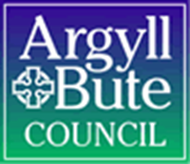

Lismore Primary School and Pre-Five Unit

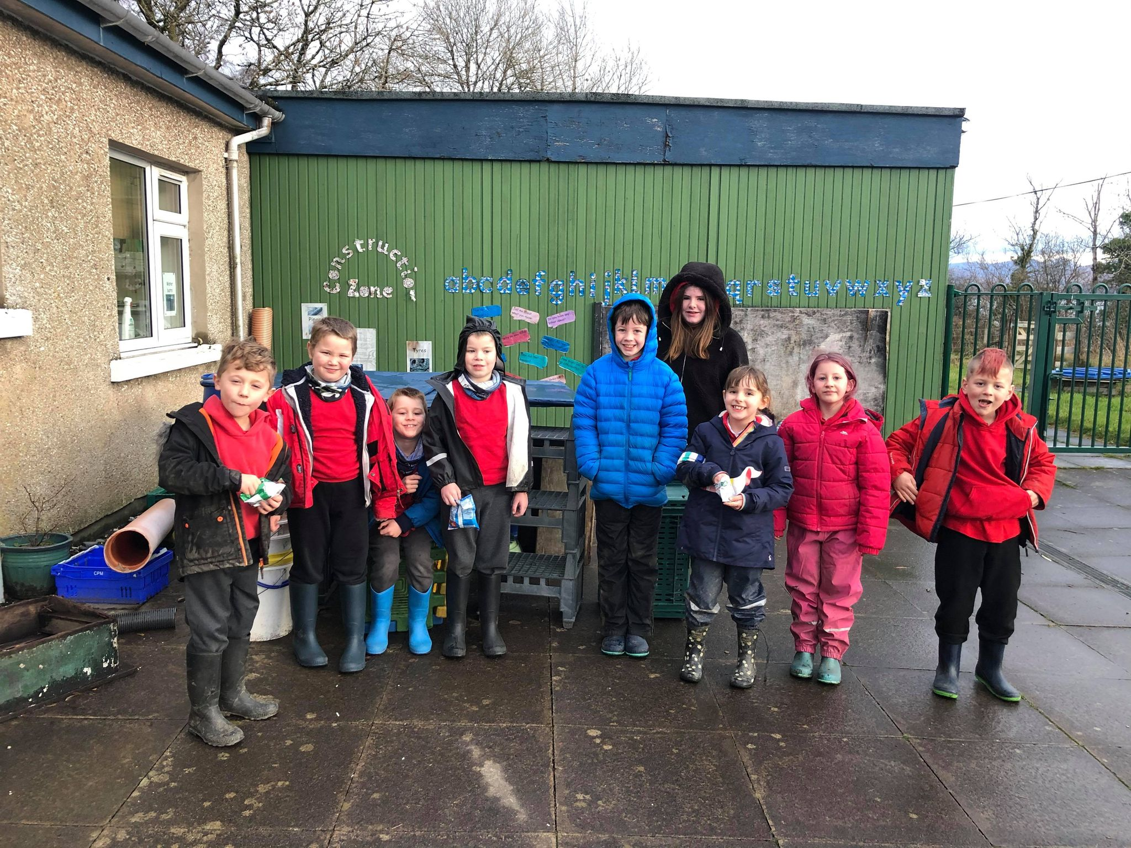
Standards and Quality Report 2020-2021

Standards and Quality Report 2020-2021

Name of school
Lismore Primary School

Context of the school
Including some or all of the following:
- basic school details (roll, class composition etc.)
- school vision, value and aims;
- local contextual issues;
- factors affecting progress (e.g. staffing changes/issues).

School details (roll, class composition)

Lismore Primary School is comprised of one class, P1-P7, made up of 10 children across all stages. We have an ELC with 3 children.

As a school, under new management, we have decided to re-visit our vision, values and aims to ensure they are relevant to our current cohort of pupils, families, staff and any community stakeholders. Our values were updated in 2020-2021 and our vision and aims will be updated in 2021-2022.

School vision, value and aims

Our Vision

We are striving to become an excellent school that enables our pupils to become successful learners, confident individuals, responsible citizens, and effective contributors. The pupils and our other stakeholders will be re-visiting this vision next year to update and ensure relevance to our currant cohort.

Our Values
We have been working hard to re-establish our school values this year. In consultation with the children and with the natural unfolding of what is important to us within the ethos of the school, we have embedded respect, compassion, equity, kindness and honesty. We have come to find that we live these values daily in order to feel secure, be happy and be ready to learn.
Our Aims
We aim to make the school a happy place for all with a friendly, relaxed atmosphere where pupils can thrive. The children are currently re-writing these aims to incorporate what is important to them as individuals and as a class community. We also intend to reach out to our other stakeholders, including parents, to ensure we have the perspective of all involved in our wee school.

Local context
Lismore Primary School is a small friendly school, which is embedded in the life of the community on our tiny island. It is a family school where children, families, staff, and friends can feel at home. The school is a happy, bright, and welcoming place where achievements and learning are celebrated by everyone.
The school serves children from the whole of the Isle of Lismore in the Lynn of Lorn. As a small school, all staff know the children and their families very well. During a ‘normal’ year, parents are encouraged to drop into school for a chat or to see what the children are doing. Of course this has been difficult this year due to the global pandemic.
We have a deep understanding of each child and their individual needs. We draw out particular skills and can identify areas for development. Learning and teaching is tailored to the needs of each pupil and all plans begin with the children in front of us. We use floor books to encourage the children to be an integral part of the planning and reflecting process and ensure we then use this pupil voice to inform what’s next.

The school is bright and cheerful inside and together with the grounds creates a wealth of possibilities for learning. We seek to foster lively and enquiring minds and believe children should find learning enjoyable, worthwhile and challenging. We have the highest expectations for our young learners. They are encouraged always to do their best and to take a pride in everything they do. The children are involved in planning their learning, setting their own targets and assessing progress made. Staff, parents and friends also have the opportunity to make suggestions and put forward ideas for learning opportunities.

Factors affecting progress (e.g. staffing changes/issues)
There have been many staffing changes this session which may have had an impact on progress. The new HT started on June 8th 2020 as a virtual head teacher due to the global pandemic. At this time, the new HT, worked alongside the CT (who took up the role of acting HT).
Since the beginning of the current session we have had challenges with staffing. Our classroom teacher left after the first term to open a local business and we have been unable to recruit since. As a result we have had several supply teachers in throughout the year and the HT has taken on more teaching responsibility when no supply has been available. At times, the inconsistency in staffing has had an adverse effect on the school ethos and the behavior of the children.
We have had several other staffing changes including a new Clerical Assistant, Classroom Assistant and Catering Manager. For such a small school this has meant a lot of change for our children; some of whom have taken it in their stride, but others have found the consistent changes and uncertainty unsettling.
Due to the global pandemic, the school was closed for part of the 3rd term (from Christmas break until February 22nd). During this time, children were learning remotely. We used google meet, google classrooms and physical resource packs to help our children consolidate prior learning and access new learning. Overall, this was successful and engagement was high. Many parents and pupils commented positively on their experiences during this time. However, some pupils were adversely impacted (pupils with ASN) who require a structured routine.

Review of SIP | Priority 1 Develop Positive Relationships
Progress and Impact:
Our aim was to develop positive relationships amongst children, staff and parents. To do so we planned a number of key actions:
- Re-write our positive relationships policy in consultation with our stakeholders: After consulting with pupils, parents and staff we re-wrote our positive relationships policy in October 2020. We shared changes with all stakeholders using our new website as a platform for sharing information. Impact: Positive behaviour across the whole school noted- Change in ethos noted by both pupils and staff.
- CPD for staff on attachment/nurture/trauma informed practice/inclusive pedagogy: CPD in these areas has been delivered throughout the year with the aim of having all staff respond to behaviour in a consistent inclusive manner. This whole school approach to behaviour was first implemented in November 2020 and has been used consistently since. Impact: Positive behaviour noted across the school. Staff confidence levels in managing distressed behaviour has improved. Children appear happier and have commented on feeling safe, secure and happy (recorded in school floor book) and using GIRFEC wellbeing wheel.
- Implement consistent and equitable approach to behaviour: This has been challenging to achieve with the number of staffing changes. However, staff that have been here throughout the course of the year have been utilising our new positive relationships policy to help inform their responses to behaviour and a whole school nurturing ethos has been established. Impact: Ethos notably calmer. Improvements with progress and achievement noted as children appear ‘ready to learn’.
- Use wellbeing wheel to track and monitor children’s wellbeing: We used the GIRFEC wellbeing wheel at the beginning and start of the year but not consistently enough to comment on the impact of this. This is something we will develop as part of our next steps.
- Keep parents involved and up-to-date during COVID: We launched our new school website in October 2020 to streamline communication with parents and share good practice with our stakeholders. We have issued a termly newsletter to our parents to keep them up to date with what’s going on at school and, again, share good practice. We held wellbeing meetings at the end of term 1 to check in with parents on their children’s wellbeing. We held parent’s meetings at the end of term 3 to discuss wellbeing and progress and achievement. We visited parents at their garden gate every Friday during school closure. Impact: Positive relationships appear to be developing; this has been noted through parental feedback which has been positive overall- particularly in relation to how the school delivered learning and communicated with families during school closure.
Next Steps:
Continue to review positive relationships policy with all stakeholders, amend when necessary and share with new staff/pupils/families.
Continue CPD next year offering refreshers on trauma informed practice.
Use the GIRFEC wellbeing wheel to monitor and track children’s perception of their wellbeing throughout the year.
Look at ways to get parents and other community stakeholders into the school (when guidance allows) to support further development with parent-school relations.

Review of SIP | Priority 2- Embed Digital Technology Across the Curriculum
Progress and Impact:
Our aim was to embed digital technology across the curriculum. To do so we planned and implemented a number of key actions:
- Establish a new school website on Glow (pupils to be responsible for updating website throughout the year): We launched our new school website in October 2021. Although this has been a great tool for sharing information and good practice with stakeholders, we have not reached the stage of pupil ownership (mainly due to pupils needing more support with accessing ICT than initially assumed). Impact: Our P7 pupil has been involved with our school website and has commented on thoroughly enjoying this. We hope to get all pupils more involved next session. The website has been useful for stakeholders to learn a little about our school but it is not fully utilised by parents who appear to prefer communication through our school face book page (commenting that this is where they would check more often).
- Begin Glow Blogs- Reach out to Island Communities to establish quadblogging project: Some of our pupils (P4-7) have been involved in writing school blogs and posting them on our school website. This has not yet been extended to create a link with island schools and remains on our agenda for next session. Impact: P4-7 building confidence in digital skills needed for blogging. This has been measured through pupil feedback and notable progress across blogs (using different features, writing for purpose).
- Plan for the use of ICT across the curriculum: We have incorporated ICT across the curriculum, using programmes such as reading eggs and sumdog to consolidate learning in literacy and numeracy; using powtoons and powerpoints to present information for IDL and using photo/video to inform art projects, writing stimulus and to record good practice. This could, however, be expanded to encompass more of the curriculum and the children still need a lot of support to access this technology. Impact: All children able to log in to school computers, access and navigate several programmes that enhance learning independently. All children have grown in confidence when using computers but there is lots of room for further improvement as noted in our next steps.
- STEM Project: We delivered a STEM project in term 2 which allowed children to explore different areas of technology such as coding, using algorithms, video game design and using green screen. Impact: Children thoroughly enjoyed this project- often asking ‘is it STEM time?’. The project naturally developed to have a greater focus on team working skills, as opposed, to developing digital skills and although we gave experience of how and why we would use this technology, further work would be beneficial to see the children’s skills develop in this area.
Next Steps:
Develop pupils’ autonomy with school website.
Revise school website considering ways to improve engagement with parents.
Involve all pupils with GLOW blogs and expand to island communities to create links with other rural schools.
Continue to embed ICT across the curriculum ensuring pupils are using basic ICT skills to enhance learning.
STEM to become part of Curriculum design. Look at CPD for staff to develop confidence in this area.

Review of SIP | Priority 3- Raise attainment in Writing
Progress and Impact:
Our aim was to raise attainment in writing. To do so we planned and implemented a number of key actions:
- Targeted support for writing to be implemented: In term 1 and term 2 learners were split into small groups based on where they sit in the assessment framework (EXBRA) and each group received support from an adult when working on extended writing. In terms 3 and 4 learners showing significant progress, and the ability to write independently, were encouraged to work without targeted teacher support. Impact: P4-7 now able to work independently. P1-3 still working with teacher support. Confidence has increased for all. This was measured using ‘I can’ assessment statements at the start and end of the year.
- Big writing teaching and assessment material to be utilised: We have been using big writing materials this year to provide a structured approach to teaching writing. We have also used assessment materials to monitor progression. We have undertaken 2 assessments this year in the 2nd and 4th term. Impact: All children have progressed with writing this year. Many children have moved up several levels on the big writing criterion scale.
- Star writers introduced: We introduced star writers to celebrate achievement. Each week children work with the teacher to co-construct success criteria. They then measure their own work against this success criteria at the end of each lesson. The teacher chooses a star writer based on who has met the success criteria. They are issued with a certificate and their work is shared and displayed. Impact: Children trying harder with writing. There has been a significant change in mind set towards writing from ‘I can’t’ or ‘I won’t’ to all learners fully participating and many commenting on enjoying writing. Children have stated the certificates give them a ‘confidence boost’ and something to be proud of.
- Writing targets set and reviewed: Writing targets have been set each term in consultation with the children and they have worked towards achieving their targets. When they have met their targets on more than 3 occasions the targets are reviewed and updated. Impact: Children know their next steps and as a result know what they are working on. Children have commented on how helpful this is.
- Use of popular culture stimulus: At the beginning of the session we had a class discussion about writing and what inspires us/engages us. We spoke about books, poems, pictures, videos and props. The children chose to focus on using film shorts as a stimulus for writing. Impact: This proved very successful in engaging children and motivating them to write. After watching the short, the children were given choices on which direction to take their writing. The children’s engagement increased significantly.
Next Steps:
Although we have made a lot of progress this session, in comparison to national writing levels, many pupils (especially our P2-4) are still working below the expected level. We would therefore like to continue with all of the above practice, adapting approaches where necessary to meet the needs/interests of our individual children next session.

Review of SIP | GME Priority
Progress and Impact:
N/A

Next Steps:

Review of SIP | Developing in Faith Priority
Progress and Impact:
N/A
Next Steps:

1.1 Attainment Data
Attainment of Literacy Curriculum for Excellence levels 2016/17, 2017/18, 2018/19, and 2019/20 (teacher judgement – confirmed levels – 4 year trend).
*Example below- school-specific data will be provided in the summer term
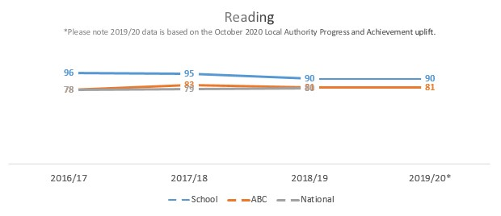
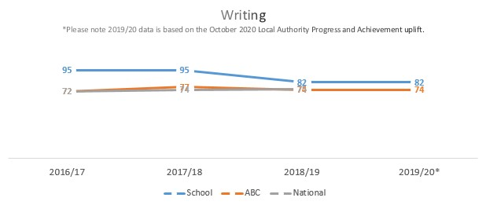
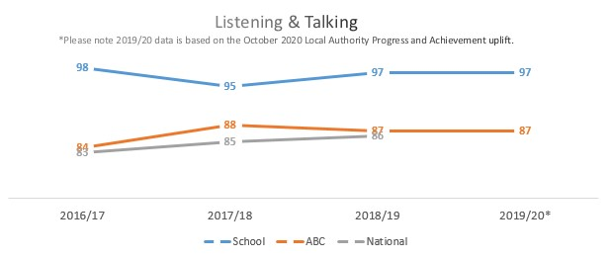

1.2 Attainment Data
Attainment of Numeracy Curriculum for Excellence levels 2016/17, 2017/18, 2018/19, and 2019/20 (teacher judgement – confirmed levels – 4 year trend).
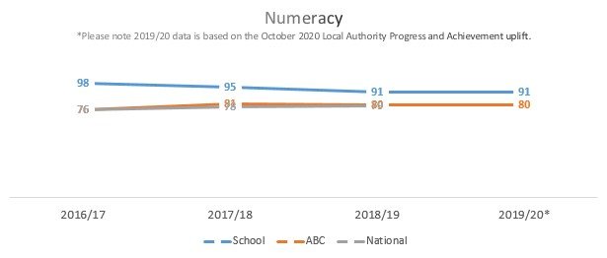

Please Note:
The above data (1.1 and 1.2) reports achievement of a level – P1/P4/P7 combined.
* Due to the Covid 19 pandemic, there was no collection of ACEL data by Scottish Government in 2020. Please note that the 2019/20 data is based on the October 2020 Local Authority Progress and Achievement uplift and cannot therefore be used to demonstrate school or authority improvement compared with previous years. Care is required when making any comparisons drawing on the 2020 data.

Overall quality of our learners’ wider achievements Highlights of session 2020-21
Outdoor learning/Gardening/Outdoor Experts: Every Tuesday morning the children are involved in an outdoor learning group. During this time they have been involved in exploring their senses, building obstacle courses, den building, scavenger hunts etc. Every Thursday afternoon the children are involved in a gardening club. During this time they have planted lots of vegetables (including lettuce, tomatoes, broccoli, potatoes, carrots) in our poly tunnel and raised beds. They have also been creating their own compost reusing food waste. They have been learning about how to take care of vegetables as they grow- learning about watering, weeding, sunlight and wind. On the 10th and 11th of July, we had outdoor experts from Ardroy visit us. The children learned how to cut firewood, make fire using flint and steel, work as part of a team to complete challenges and orienteer. They enjoyed the outdoor days immensely and learned a lot about life in the outdoors.
Music: For 25 hours over the course of the year, children have been taking part in Ukulele lessons. They have been learning about different strums and chords and have also been writing and performing their own songs. We have also had a music teacher in on a Monday and Friday looking at beat, rhythm, notation and different percussion instruments. One of our P4 pupils has continued with fiddle lessons (started last session) developing her skill and confidence in this area.
Achievements at home: Two of our pupils have been attending rugby sessions in Oban this year and have thoroughly enjoyed this. They are currently getting ready to compete in a tournament. One pupil has been attending boxing classes in Oban after school, which has helped with developing social skills and regulation. Two of our pre-5s have attended mini-athletics in Appin and have been enjoying learning new skills and meeting new people.
Baking and Cooking: During the first term we had an international cooking week across the school and pre-5 unit to link in with our world culture and global affairs topic. The children learned about and cooked a dish from 5 different countries they were exploring. The pre-5 unit continued this with an international snack week later in the term where the children could prepare and try snacks eaten in other countries. Every Friday the children are part of a baking group with a focus on healthy baking/using raw ingredients. This week they are linking their baking to our IDL topic (Scottish History) making War time sponge.
Messy Play: Every Tuesday afternoon the children are involved in messy play. This began in the 2nd term when a parent donated a box of messy play materials including coloured sand, slime, gel balls etc. The children have continued with this throughout the year and are now working on making their own messy play recipe book with instructions on how to make your own slime, gooey lava lamps etc. Many children have said this is their favourite time of the week. We have noted progression with team working skills and problem solving skills.
Floor book group: On Tuesday mornings the children partake in a floor book group. Each week there is a different them or question to explore and the children work in a small group with an adult to share their thoughts and ideas. We have used this, this session, mainly for planning and reflecting on learning and to ensure all that we do is guided by the children.
Kilmartin museum- Julia Hamilton from Kilmartin museum visited us on the 16th and 17th of June to teach us all about natural history and different time periods. We looked at artefacts; learning about dress and tools at these times. We also explored soil and clay and learned how things preserve. The visit was very interesting and the children learned a lot.
Glow Blogs: Our P7 pupil has been involved in writing a Glow blog for our school website this session. She has learned how to upload and label photos with captions, write for purpose and make edits to her work. She has also enjoyed sharing information with our wider stakeholders.
STEM: In term 2 we had a focus on STEM. The overall focus of each session was to explore different aspects of science, technology, engineering and mathematics whilst developing collaborative working skills and problem solving skills. The children loved this project- especially learning how to create their own video games using code.
Crafting for the Community: In term 2, on the lead up to Christmas, the children started a crafting for the community project. Once a week they would come together to make crafts from different materials such as clay, weaved wool etc. The week before Christmas. the children delivered their crafts to the elderly residents on the island. They left their crafts in their gardens with a little note of love and care.
Burn’s competition: We learned about Robert Burns in January during remote learning. The pupils were then tasked with learning the Burn’s Poem to a Mouse, performing it (whilst being videoed) and uploading it to our google classroom page. We chose two winners, who were awarded a certificate.
Theme Days: In term 4 we had 3 theme days exploring different aspects of our Improvement Plan. On day 1 we looked at our school values and took part in lots of practical activities to explore them, such as learning sign language and using words of kindness. On day 2 we explored digital technology learning about photography and the rule of thirds, social media/screen time and safety and how to send an e-mail. On day 3 we explored writing in the context of Scottish history creating brochures for local landmarks. The children thoroughly enjoyed working in smaller groups and learning through a context.

Comment on strategies that have been successful in engaging with children and young people, staff, parents and the wider community and the impact of these.
Children and Young People
Soft Start: Introducing a soft start this session (table top games, class challenges (problem solving), quiet reading, mindfulness colouring etc.) has helped our children settle in at school and get ready for the day. Impact: Notable change in children’s readiness to learn (displayed through behaviour) and overall calmer classroom ethos.
Morning Movement: Each morning, after our soft start, the pupils participate in 15 minutes of movement of their choice. This session they have chosen: Just Dance (most popular choice), yoga, daily mile, mirror me movement and themed tag games. Impact: Introduced to help with Health and Wellbeing after a long time off school. Evidence shows how exercise can help with mind set and readiness to learn. This has been notable here, as the children have appeared more settled and ready to learn this session.
Check-in/Check-out: Every Monday/Friday we have a check-in and check-out circle time allowing children to explore their feelings and share some personal news about what has been or what has to come. Impact: Children less disruptive during lessons when they had the time they need to share.
Afternoon Break: We introduced an afternoon break in term 3 when the children returned from home learning to help them adjust to the demands of school. We found that in the afternoon engagement was low. Impact: The breaks have had a very positive impact of engagement with children coming in from their second break ready to learn.
Outdoor Learning: We have provided lots of opportunities for outdoor learning this session and the children have thrived. Impact: Greater interest in taking care of our outdoor space and learning about our immediate outdoor environment. Children eating more vegetables (as they have grown and picked them). Children excited about being outdoors- no matter the weather.
Floor book: Children have been using a class floor book this session to be involved in planning and reflecting on their own learning. Impact: Increased engagement as learning experiences are guided by the children.

Staff
Staff wellbeing Meetings: Individual staff wellbeing meetings have been offered throughout the year. Impact: Although uptake has been minimal, staff have commented it is great to know the time has been set beside (should they need it).
Regular staff Meetings: Whole school meetings are held once a month and at this time CPD is offered. There have also been bi-monthly meetings for Early Years Staff and Primary Staff focusing on topics which arise naturally. Impact: Staff have commented that regular CPD and check-ins (time to discuss things as they come up) has been beneficial to them and has helped increase confidence.
Staff Suggestion Box: A suggestion Box has been made available to staff to post ideas in, as and when they come, in place of having a face-to-face discussion to try to suit the needs of all staff. Impact: This has not been used this session but staff have said they are reassured with it in place- and that they know they can use it, the individual meets, or group staff meets to share (commenting ‘it is nice to have different platforms to suit all’.)
Parents
HWB meetings: Meeting to discuss children’s HWB/how they were setting in after returning to school were held at the end of the first term via google meet. We did not focus on or discuss children’s attainment at this time but instead looked at how happy the children were at school. Impact: First chance to check in with parents and hear about their child’s HWB from the home perspective. Was the beginning of developing new relationships. All parents were very positive and happy with the adjustments the school had made to accommodate their child’s needs.
Parents’ Meetings: Meetings were held at the end of term 3, using google meet, to discuss children’s HWB, progress and achievement and anything else the parents wished to discuss. Impact: Parents have platform to share views. Parents consulted on what’s happening in school and information shared about their child. Parents were again very positive and happy.
Garden Visits (remote learning): At the beginning of term 3, when the children were learning from home, I visited their gardens every Friday to drop home learning packs and check in with parents and children. Impact: Parents commented on feeling ‘in the loop’ with all that was going on and were happy to have a space and time to share their views. Many parents also commented on the usefulness of the physical resource pack in ensuring their child could engage with remote learning. Many commented on being happy with how online lessons were structured/how their child’s day had been structured to take account of individual needs.
Newsletters: Newsletters are sent home at the end of each term to share good practice with families. These are also shared on our school website to allow other stakeholders access too. Impact: Parents and others in the community delighted to see photos of their children happy and thriving at school, see examples of work and hear about what has been going on.
New Website: We launched our new school website in term 2 in an attempt to streamline communication with parents and give us a secure platform to share information about the school and good practice. Impact: Staff and children are beginning to use the website (slowly) but parent engagement has been poor with higher engagement on our school face book page. This is something we intend to re-visit next year.
Wider Community
Crafting for the Community: As mentioned above the children crafted for the community and delivered their crafts at Christmas time. They also baked a Christmas cake that was handed out at the community Christmas Fayre. Impact: School still visible in local community (which has been exceptionally hard with the global pandemic). Members of the local community ‘delighted’ at the outreach from pupils.
Xmas Video message to community: At Xmas time, the children made a video (using IMovie) showcasing our good work this year and sending Christmas wishes to all. This was shared on our community facebook page. Impact: Parents and other members of the community commenting on how lovely it is to see what’s been going on in school and have messages of love and care from the children during this difficult time.

Comment on progress made with the following aspects of empowerment:
- curriculum;
- improvement activities;
- parental and community engagement; and pupil participation.

https://education.gov.scot/improvement/learning-resources/an-empowered-system/?dm_i=LQE,6RTY0,WAUPY4,R37A1,1
Curriculum: We have begun creating our curriculum map, gathering the voices of pupils and staff, to consider what captures the unique context of our school and pre-5 unit. We plan to continue creating this next session, consulting with parents and additional stakeholders in the community.
Choice: Choice is very important here at Lismore Primary School. The pupils often choose their tasks, level, who they work with and order in which they work as well as choices about homework, rewards and responsibilities. Our staff are consulted often to make choices on areas they would like to lead and identify areas they may need support. As a small school, we make many big decisions as a whole school team (staff and parents together).
Improvement Activities: This session staff and pupils have been involved in improvement activities that help to reflect on our current improvement plan and shape our plan for next session. We have used HGIOS materials, collegiate time and floor books to gather feedback which helps inform our next steps. We have also spent time looking at relevant QIs. We intend to develop this further by involving parents and members of the community in our consultation process next session.
Parental and Community Engagement: This session has put adaption and flexibility at the forefront of all we do- including how we communicate with and engage parents during a year where they are unable to visit the school in person. We have launched a new school website to streamline communication and share good practice; sent out termly newsletters; had online parents’ meetings in the first and fourth term; checked in with parents in their gardens and continuously ask for parents’ thoughts and opinions on our school face book page. We have tried to remain visible within our community during this challenging time through our community Christmas Cake offering, Island Christmas Card and Crafting for the Community project.
Pupil Participation: The pupils are at the heart of all we do here. Every week they have the opportunity to plan and reflect on learning in our floor book group. As a result of what pupils have said/shown we have implemented the following: soft start; morning movement; messy play sessions for whole school; baking group; outdoor group; planting group; extra break in the afternoon; check in and check out; STEM project and much more.

Comment on progress made with Pupil Equity Funding, taking account of the five key areas below:
- attendance;
- attainment;
- exclusion;
- engagement;
- participation.

N/A

Quality Indicator | How are we doing? | How do we know? (Evidence) | School Self-Evaluation (1-6)
1.1  Self-Evaluation for Self-improvement | - All staff and pupils involved in self-evaluation activities  - Moderation activities  - Regular collegiate sessions  - All staff and children involved in writing and reviewing School Improvement Plan  - Use of Floor books | - Parent council minutes  - Staff Meeting minutes  - Collegiate calendar  - Positive feedback from parents and pupils  - Use of pupil Voice- Floor books- record of pupil planning and reflecting | 3
1.3  Leadership of Change | - Pupils and staff have worked together to create new school values and embed these in our ethos.  - School are working on new, relevant curriculum rationale and curriculum design  - All stakeholders contribute to/consulted on change  - Time is dedicated to professional dialogue, collegiate learning and self-evaluation  - Pupil floor book groups weekly to enable learners to lead their learning and reflect | - School Values embedded  - Parent Council Meetings  - Minutes from staff Meetings  - Floor book reflections and plans from pupils  - Collegiate calendar  - School Newsletters  - New School Website  - Strong sense of pupil voice | 4
2.3  Learning, teaching and assessment | - Almost all children are eager to learn and show enthusiasm towards learning  - All learners are given choice  - We use technology to enhance learning experiences  - Inclusive teaching approaches are implemented  - Feedback, appropriate to age and stage, is offered often  - All learners are engages in planning and reflecting on learning  - Active learning  - Outdoor learning prioritised | - Classroom observations recorded  - GL assessment  - SNSA  - Floor book group- Pupil Voice  - XBRA data  - ACEL data  - School tracking  - School newsletters  - Pupil feedback  - End of term/unit pupil assessments  - School ethos | 3
3.1  Ensuring wellbeing, equality and inclusion | - Inclusive approaches used by all  - Equity embedded as school value  - SHANARRI wellbeing webs used for tracking/reflecting  - Positive relationships policy re-wrote in consultation with pupils and staff  - Children listened to and treated as individuals  - IEPs in place for those requiring staged intervention  - Close family links with children on child plans  - Pupil voice/actions listened to and adaptations made to bring about change | - Soft start  - Morning movement  - Extra afternoon break  - Experiential rewards  - Class Contract  - New school values  - Use of visual timetable  - Choice prioritised  - Preventative and restorative approaches to behaviour in place  - IEPS  - Child’s Plans  - School ethos  - Wellbeing wheels | 4
3.2  Raising attainment and achievement | - All learners have made progress this session in numeracy and literacy.  - Tracking system for literacy, numeracy and HWB in place.  - Achievement celebrated by all.  - Equity and Inclusion embedded through our school values.  - Floor book group for pupil voice helps learning be guided by the learners.  - Play based learning opportunities for all.  - Incorporated soft start to help with ‘readiness the learn’  - Moderation of writing | - Tracking system  - ACEL data  - XBRA data  - GL assessments  - SNSA  - Pupil Voice  - IEPS  - Child’s Plans  - Learner discussions  - Learners working wall- work of their choice is displayed  - Messy Play engagement | 3

