Lismore Primary School
Child Protection Policy

‘All children and young people have the right to be cared for and protected from harm and abuse and to grow up in a safe environment in which their rights are respected and their needs met. Children and young people should get the help they need, when they need it and their welfare is always paramount.’

National Guidance for Child protection in Scotland 2012

General Introduction

It is recognised that teachers play an important role in identifying potential cases of child abuse. It is also important that all relevant agencies involved in child abuse co-operate together for the benefit of the child. All schools have a designated teacher for child protection, who liaises with Social Service departments and with teachers in school. For this procedure to work, it relies on the skills and expertise of every class teacher and adult within school to recognise or report concerns.

Child Abuse is described under one of five categories. These are:

- Physical injury
- Physical neglect
- Sexual abuse
- Emotional abuse
- Non-organic failure to thrive

At Lismore Primary the Head Teacher is the designated person for child protection. The class teachers also know the procedures. All staff have total commitment to child protection. They raise children’s awareness about themselves through Personal and Social Development, Health Education, and develop a trusting climate so that children feel able to talk and share their thoughts and feelings.

We may not be able to prevent child abuse, but by following child protection procedures, we are trying our best to protect all our children and this is our first and only responsibility.

All teachers make sure, through their care of children, to try to ensure that children keep safe, remain healthy and are able to say “NO”. Suspected cases are reported, procedures adhered to and subsequent actions are left to the appropriate agencies. We also care for children who have been abused and understand their problems.

Education has a fundamental duty to contribute to the welfare, safety and protection of all children and young people. In fulfilling this duty it must engage in close partnership with parents/carers and relevant agencies, primarily social work, health, authority reporter and police. In order to fulfil this duty most effectively educational establishments are expected to participate in the development of effective multi-agency working practices with these agencies using the Argyll and Bute Joint Working protocol as the template Circular 3.23 All staff should revisit the Child Protection Guidelines annually.

Aims

By following child protection procedures we:

- Care for the child

- Care for our school

- Care for the community we serve

- Respond to the guidelines and procedures of other agencies

Guidelines

In reporting concern or suspicion, all adults in school must follow the following procedures. The Head Teacher, will then follow the Argyll and Bute Child Protection Procedures.

Reasons for Following Procedures

- It protects the child to the best of our ability

- It avoids delay

- It provides consistency

- It protects all staff

- It ensures that, if further action is taken by another agency, then the school has followed the protection procedures

Staff are in contact with children all day and are in a position to detect possible abuse. They must not think that by voicing concern they are necessarily starting procedures. Wherever there is sufficient concern that a child has been abused or there is a suspicion of abuse or if a child discloses abuse, the following procedures must be followed:

- It must be reported to the Head Teacher immediately

- If the Head Teacher is not in school. Concerns must be reported to the the duty social worker or police.

- Staff must report/ record their concerns on the same day

- If there is a suspicion of abuse, staff must stop questioning the child

- Staff must not agree to keep secret any information that a child might have been abused or is at risk of abuse.

It is very important in these cases that prompt and correct procedures are followed under Argyll and Bute Child Protection Procedures.

The reporting teacher will be told of any further action taken i.e. Social Service referral, monitor etc. If the reported case is taken up and investigated by an external agency, then any meetings, case conferences or action taken will be followed through and the teacher concerned informed.

Staff have an important role in hearing what children have to say. The school can provide a neutral place where the child feels it is safe to talk. Sensitivity to the disclosure is vital. Staff must listen carefully to what the child is saying, treat it seriously, and value what they say.

Children may feel they will not be believed, or that they will be punished. Staff will need to say that whatever has happened it is not their fault. Fear of the consequences of telling is very common. It can be very tempting to offer a promise of confidentiality to the child. This is not realistic. The child needs to hear the truth about what will happen, together with a commitment to support the child. It is crucial not to ask leading questions. Our role is to enable the child to speak and then know what to do next.

A list of children causing concern would be kept in the secure filing cabinet in the office. This includes all children, who, for whatever reason, need to be monitored. Staff are kept informed of any child in their class who is on this register. Teachers must inform the Head Teacher of any changes/additions so that this list can be kept up to date.

Signs and Symptoms

This is intended as a guide. Please remember that the presence of one or more factors does not necessarily give proof that child abuse has occurred. It may, however, indicate that investigation should take place.

- Unexplained delay in seeking treatment which is needed

- Incompatible explanations

- Constant minor injuries

- Unexplained bruising:
  - Bruise marks in or around the mouth
  - Black eyes, especially if both eyes are black and there are no marks to forehead or nose
  - Grasp marks
  - Finger marks
  - Bruising of the ears
  - Linear bruising (particularly buttocks or back)
  - Differing age bruising

    - Bite marks

    - Burns and scalds

    - Cigarette burns

    - General physical disability

    - Unresponsiveness in the child

    - Soiling and wetting

    - Change in behavioural patterns

    - ‘Frozen’ look

    - Attention seeking

    - Apprehension

    - Antisocial behaviour

    - Unkempt appearance

    - Sexually precocious behaviour

    - Sexualised drawings and play

    - Sudden poor performance in school

    - Poor self-esteem

    - Self-mutilation

    - Withdrawal

    - Running away

    - Reluctance to return home after school

    - Resistance to PE (undressing)

    - Resistance to school medicals

    - Difficulty in forming relationships

    - Confusing affectionate displays

    - Poor attendance – repeated infections etc

Definitions of Child Abuse

An abused child is a boy or girl under the age of 17 who has suffered from physical injury, physical neglect, failure to thrive, and emotional or sexual abuse. The abuser is the person who has had custody; charge or care of the child and either caused or knowingly failed to prevent the abuse. Having custody, charge or care includes any person, in whatever setting, who, at the time, is responsible for that child.

Physical Abuse

Physical injury to a child, including deliberate poisoning, is where definite knowledge, or a reasonable suspicion that the injury was inflicted or knowingly not prevented.

Sexual Abuse

The involvement of dependent, developmentally immature children and adolescents in sexual activities that they do not truly comprehend, and to which they are unable to give informed consent; or they violate the social taboos of family roles.

Neglect

The persistent or severe neglect of a child (for example by exposure to any kind of danger including cold or starvation) which results in serious impairment
of the child’s health or development, including non-organic failure to thrive.

Emotional Abuse

Is the severe adverse effect on the behaviour and emotional development of a child by persistent or severe emotional ill treatment or rejection. All abuse involves some emotional ill treatment; this category should be used where it is the main or sole form of abuse.

Argyll and Bute Child Protection Procedures

These procedures are to be followed in reported abuse cases or suspicion of abuse. Copies of the procedure are in the school office

The Police investigate sexual abuse cases and Social Services can be present to assist them when interviewing a child.

The Wellbeing Wheel (SHANARRI)

We aim to create a world in Scotland where every child is:
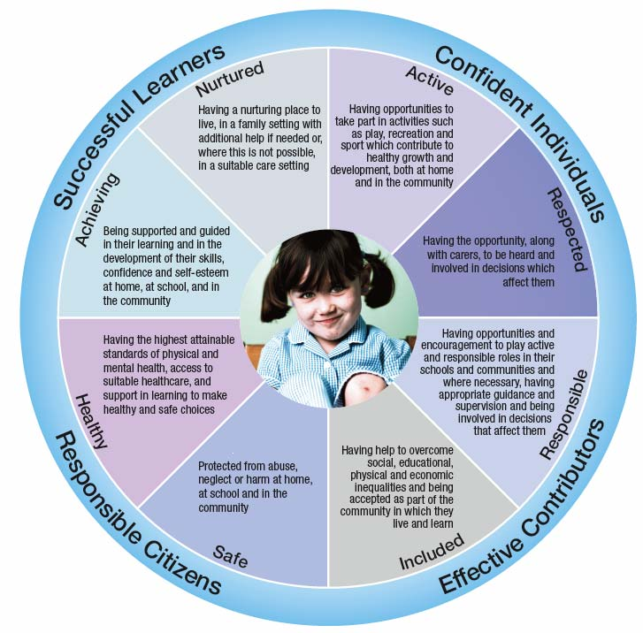

The SHANARI well-being indicators should be used as a prompt to identify initial areas of concern prior to using the ‘My World’ assessment tool

OUTCOMES FOR CHILDREN: All children in Scotland should be:-
Confident Individuals; Effective Contributors; Successful Learners; Responsible Citizens

SAFE
Protected from abuse, neglect or harm at home, at school and in the community
e.g. Child protection, family of concern. Practical care i.e home safety. Physical, social, emotional dangers i.e bullying. Parental support concerns, & identifiable risk factors i.e parental drug and alcohol problems.

HEALTHY
Having the highest attainable standards of physical & mental health, access to suitable health care & support to make healthy & safe choices
e.g. Vision, hearing, growth, immunisations, medical conditions, i.e. asthma, epilepsy, attention deficit disorder, developmental co-ordination disorder, genetic disorders, allergies, skin conditions, enuresis, encopresis

ACHIEVING
Being supported & guided in their learning & in the development of their skills, confidence & Self esteem at home, at school, & in the Community
e.g. Communication, language acquisition & expression, developmental milestones.

NURTURED
Having a nurturing place to live, in a family setting with additional help if needed or, where this is not possible, in a suitable care setting
e.g. provides love emotional warmth attachment, play stimulation & encouragement, physical & emotional care and an educationally rich environment. Accessed parenting programmes, accesses healthcare appropriately.

ACTIVE
Having opportunities to take part in activities, such as play, recreation & sport, which contribute to healthy growth and development at home and in the community
e.g. Known physical disabilities. Receives stimulation & encouragement to learn; child able to access play & leisure activities.

RESPECTED & RESPONSIBLE
Should be involved in decisions that affect them, should have their voices heard and should be encouraged to play an active and responsible role in their schools and communities
e.g. Any prejudices and tensions, level of resilience, self esteem, sense of identity, experienced loss/bereavemen

The Five Key Questions

Prior to involving other agencies there are five key questions practitioners need to ask themselves when they are concerned about a child or young person.

- What is getting in the way of this child or young person’s well-being?

- Do I have all the information I need to help this child or young person?

- What can I do now to help this child or young person?

- What can my agency do to help this child or young person?

- What additional help, if any, may be needed from others?

When practitioners have sufficient information to know what needs to be done to support the chid or young person, then they can ensure help is put in place without delay either by a single agency or more than one agency.

Guidance for

Assessing Children’s Needs

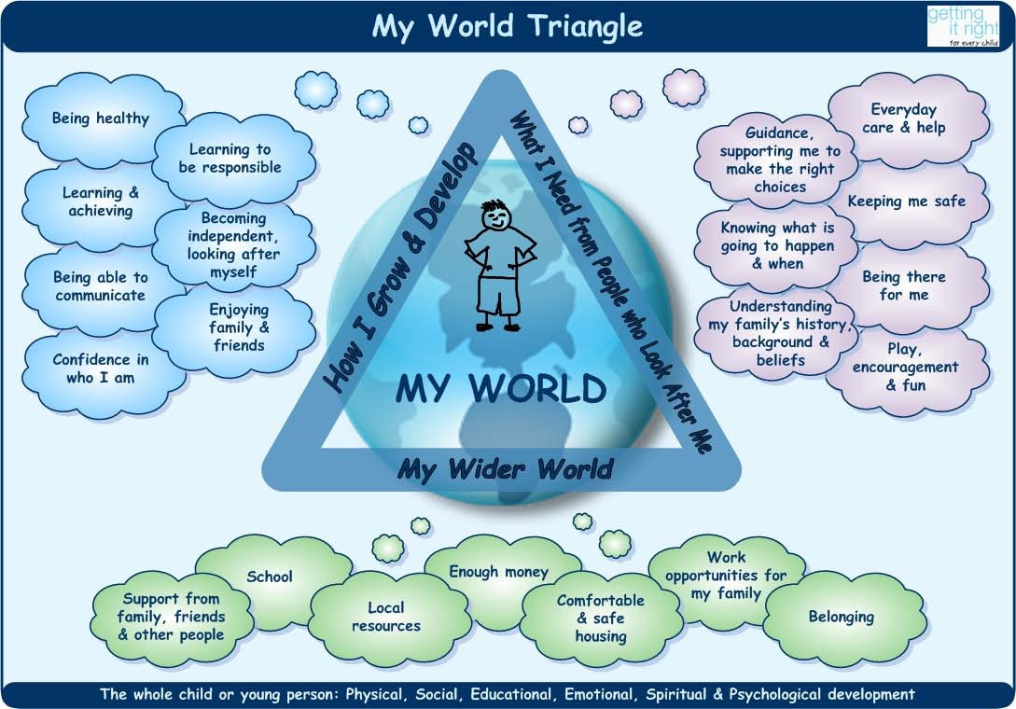

INTRODUCTION
The My World triangle illustrates the complex relationship between factors impacting on a child’s development and well-being. The following brief guidance aims to assist professionals to ensure children’s needs can be met.

ASSESSMENT OF CHILD’S NEEDS
How I Grow and Develop

Being Healthy
- This includes full information about all aspects of a child’s health and development, relevant to age and stage
- Developmental milestones, major illnesses, hospital admissions, any impairments, disabilities, conditions affecting development and health
- Health care, including nutrition, exercise, physical and mental health issues, sexual health, substance abuse

Learning and achieving
- This includes cognitive development from birth, learning achievements and the skills and interests which can be nurtured
- Additional support needs
- Achievements in leisure, hobbies, sport. Taking account of the unique abilities and needs of this child

Being able to communicate
- This includes development of language and communication
- Being in touch with others
- Ability to express thoughts, feelings and needs
- What is the child’s/young person’s preferred language or method of communication? Are there particular people with whom the child communicates? Are aids to communication required?

Being able to look after myself and be independent
- Early practical skills of feeding, dressing etc
- Engaging with learning and other tasks
- Acquiring skills and competence in social problem solving
- Getting on well with others
- Developing independent living skills and autonomy

Confidence in who I am
- Child’s/young person’s temperament and characteristics
- Nature and quality of early and current attachments
- Emotional and behavioural development
- Resilience; self esteem
- Ability to take pride in achievements
- Confidence in managing challenges; opportunities; difficulties appropriate to age and stage of development
- Appreciation of ethnic and cultural background
- Sense of identity which is comfortable with gender, sexuality, religious belief.
- Skills in social presentation

Enjoying family and friends
- Relationships which support, value, encourage and guide the child/young person
- Family and wider social networks
- Opportunities to make and sustain lasting significant relationships
- Encouragement to develop skills in making friends, to take account of the feelings and needs of others and to behave responsibly

ASSESSMENT OF PARENTING
What I need from people who look after me

Everyday care and help – this includes
- Day-to-day physical and emotional care, food, clothing and housing
- Enabling healthcare and educational opportunities
- Meeting the child’s changing needs over time
- Encouraging growth of responsibility and independence

Keeping me safe
- Keeping the child safe within the home and exercising appropriate guidance and protection outside. Practical care through home safety, such as fire-guards and stair gates; hygiene
- Protecting from physical, social and emotional dangers such as bullying, anxieties about friendships, domestic problems such as mental health needs, violence, offending behaviour
- Taking a responsible interest in child’s friends and associates; use of internet; exposure to situations where sexual exploitation or substance misuse may present risks; staying out late or staying away from home

Being there for me
- Love, emotional warmth, attentiveness and engagement
- Bonding and attachment
- Trust
- Provision of emotional security and responsiveness in the child’s current caring environment

Guidance, supporting me to make the right choices
- Values, guidance and boundaries
- Roles and rules of the household appropriate to the age and understanding of the child/young person

Being able to look after myself and be independent
- Early practical skills of feeding, dressing etc
- Engaging with learning and other tasks
- Acquiring skills and competence in social problem solving
- Getting on well with others
- Developing independent living skills and autonomy

Confidence in who I am
- Child’s/young person’s temperament and characteristics
- Nature and quality of early and current attachments
- Emotional and behavioural development
- Resilience; self esteem
- Ability to take pride in achievements
- Confidence in managing challenges; opportunities; difficulties appropriate to age and stage of development
- Appreciation of ethnic and cultural background
- Sense of identity which is comfortable with gender, sexuality, religious belief
- Skills in social presentation

Enjoying family and friends
- Relationships which support, value, encourage and guide the child/young person. Family and wider social networks
- Opportunities to make and sustain lasting significant relationships
- Encouragement to develop skills in making friends, to take account of the feelings and needs of others and to behave responsibly

ASSESSMENT OF ENVIRONMENT & FAMILY
My Wider World

Support from family, friends and other people
- Networks of family and social support. Relationships with grandparents, aunts and uncles, extended family and friends
- What supports can they provide?
- Are there tensions involved or negative aspects of the family’s social networks?
- Are there problems of lost contact or isolation?
- Are there reliable, long term networks of support which the child or family can reliably draw on?
- Who are the significant people in the child’s/young person’s wider environment?

Taking responsibility; behaving well
- Learning appropriate social skills and behaviour
- Values; sense of right and wrong
- Consideration for others
- Ability to understand what is expected and act on it
- Key influences on the child’s social development at different ages and stages

School
- From pre-school and nursery onwards, the school environment plays a key role
- What are the experiences of school and peer networks and relationships?
- What aspects of the learning environment and opportunities for learning are important to the child/young person? Availability of study support; out of school learning and special interest
- Sanctions - constructive and consistent
- Appropriate responses to behaviour, modelling behaviour that represents autonomous, responsible adult expectations

Knowing what is going to happen and when
- The child’s/young person’s life - stable and predictable
- Routines and expectations appropriate and helpful to age and stage of development
- The child’s/young person’s needs given priority within an environment that expects mutual consideration
- The family members and others important to the child/young person
- The people who look after her or him be relied on to be open and honest about family and household relationships, about wider influences, needs, decisions; and to involve the child/young person in matters which affect him or her

Understanding my family’s background and beliefs
- The child/young person should have a good understanding of their own background; their family and extended family relationships and their origins
- The child/young person’s cultural heritage given due prominence
- Those around the child/young person respect and value diversity

Belonging
- Being accepted in the community, feeling included and valued
- What are the opportunities for taking part in activities which support social contact and inclusion e.g. playgroups, after school clubs, youth clubs, environmental improvements, parents’ and residents’ groups, faith groups
- Are there local prejudices and tensions affecting the child’s or young person’s ability to fit in?

Play, encouragement, fun
- Provides stimulation and encouragement to learn and to enjoy life
- Spends time with the child/young person, communicating, interacting, responding to their curiosity, and providing an educationally rich environment
- Encouraging the child’s/young person’s progress by sensitive responses to interests and achievements, involvement in school activities
- Acting as the child’s/young person’s mentor and champion

