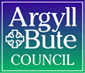

Standards and Quality Report 2019-2020

Name of school
Lismore Primary School

Context of the school
Including some or all of the following:
- basic school details (roll, class composition etc.)
- school vision, value and aims;
- local contextual issues;
- factors affecting progress (e.g. staffing changes/issues).

School details (roll, class composition)

Lismore Primary School is comprised of one class, P1-P7, made up of 12 children across all stages. We have an ELC with 3 children.

School vision, value and aims

Our Vision
We are striving to become an excellent school that enables our pupils to become successful learners, confident individuals, responsible citizens, and effective contributors. In the words of the pupils:

We are all working to make our school  - A happy place  - Feel safe  - A place we want to come to  - A place where we learn lots of things to help us when we are older  - Friendly and fair with nobody left out  - Eco-friendly | We will try our best to:  - Take responsibility for our learning  - Feel positive about ourselves  - Develop good relationships and be polite and thoughtful towards other people  - Enjoy school and help other children to do the same  - Lead a healthy and eco-friendly lifestyle  - Follow the school’s golden rules  - Be good Global Citizens

Our Values

Lismore Community - We value the co-operation between children, staff, parents/carers and the community which makes the school a unique place where children can be successful learners, confident individuals, effective contributors and responsible citizens.
Individuality - We treat every learner as an individual, recognising and responding to their different learning and personal needs and encouraging each to achieve their potential.
Safe - We are committed to safeguarding and promoting the welfare of learners, and to a policy of non-discrimination and freedom from prejudice with regards to gender, age, ethnicity, religion, disability, sexual orientation and race.
Mindset - We value the philosophy of positive reinforcement and believe that learners learn through encouragement and positive support.
Openness - We value the openness of our school community, where learners, parents, staff, and members of the community know they will be listened to if they voice their opinions or concerns
Respect - We encourage all to respect and value the beliefs and high achievements of others in order to create a mutually supportive learning environment.
Expectations - We value high standards and expect and encourage everyone to achieve their potential. We value and encourage creativity, a healthy lifestyle and high self-esteem.

Our Aims

Learning - We aim to make learning engaging, relevant and challenging for every child
Independence – We aim to address geographical isolation; we will develop our links with other schools and encourage staff to take every opportunity to maintain their professionalism.
Success - We recognise that whilst academic achievement is fundamental, an all-round education will encourage a child to develop as a whole person. We therefore aim to provide opportunities for children to find their own interests and talents, to enjoy success and to persevere in the face of initial failure.
Motivation - We aim to develop an ethos of self-motivation for all through the Growth Mindset philosophy
Oneness - We aim to make the school a friendly place with a happy, relaxed, family atmosphere where children from all parts of the island work, feel safe and protected and where effort is valued, and success is celebrated.
Responsibility - We aim to encourage everyone to appreciate and celebrate Global Diversity, the environment and to have a positive attitude to health and well-being.
Experiences - We aim to create a rich and stimulating environment – to ensure that every child has the widest possible range of opportunities in which to experience success; to develop an enthusiasm for learning and to prepare them for the challenges they will meet in their education and in life outside school

Local context

Lismore Primary School is a small friendly school, which is embedded in the life of the community on our tiny island. It is a family school where children, families, staff, and friends can feel at home. The school is a happy, bright, and welcoming place where achievements and learning are celebrated by everyone.

The school serves children from the whole of the Isle of Lismore in the Lynn of Lorn. As a small school, all staff know the children and their families very well. Parents are encouraged to drop into school for a chat or to see what the children are doing. The children are proud of their school and enjoy showing friends and relations where they work and telling them about their learning.

We have a deep understanding of each child and their individual needs. We draw out particular skills and can identify areas for development. Learning and teaching is tailored to the needs of each pupil. Most children have a high level of participation in all activities from classroom discussions and circle times to concerts and plays enabling each child to develop the self confidence that comes from achieving and being recognised.

The school is bright and cheerful inside and together with the grounds creates a wealth of possibilities for learning. We seek to foster lively and enquiring minds and believe children should find learning enjoyable, worthwhile and challenging. We have the highest expectations for our young learners. They are encouraged always to do their best and to take a pride in everything they do. The children are involved in planning their learning, setting their own targets and assessing progress made. Staff, parents and friends also have the opportunity to make suggestions and put forward ideas for learning opportunities.

Factors affecting progress (e.g. staffing changes/issues)

The longstanding HT, retired in April 2020 and the new HT took up post on 8th June 2020. The classroom teacher, became Acting HT in April and remained in the post until summer putting the school in an unusual position in June having both an acting in situ HT and a remote substantive HT.

Due to the global pandemic (COVID-19) the school was closed on March 20th and children were required to work, learn, and play from home. Lismore PS set up an online classroom using Google Classrooms and assigned tasks for Numeracy, Literacy, HWB and Project Work. A space was created for children to create targets and complete reflections; and another space for them to celebrate their wider achievements out with their structured home learning tasks.

Engagement with online learning challenging. There were challenges in April and May with children’s access to working hardware, which was resolved due to a donation from Colin Green of Birnham Wood Data Solutions in Brisbane Australia. Since then, all children have had access to suitable hardware, but many are working with extremely slow internet speeds and so have found online engagement difficult. Connectivity on the island is poor.

The children however have been involved in many home learning opportunities including building, baking, painting, reading and lots of time outdoors. The school has been in regular contact with children and parents since the school closure.

Review of SIP | Priority 1- Raise attainment in Numeracy
Progress and Impact:
The aim was to raise attainment in numeracy. To do so we planned to review teaching and learning and establish a numeracy policy including learning intentions, a schedule of assessment and numeracy trackers.

A numeracy plan and tracker (learning intentions broken down to correspond with stage and term) were developed and implemented in August 2019. This allowed for progression tracking for all individuals in the Primary School.

Class numeracy assessments were scheduled for May 2020 but not completed due to school closure. SNSA assessments were scheduled for June 2020 but not completed due to school closure.

Tracking data for terms 1 and 2 show children making progress through the plan of work outlined and termly school assessments provide evidence of progress in children’s attainment, for some.

Staff have commented that the numeracy plan and trackers allowed for the progression of teaching and learning to be easily monitored.
Next Steps:
Continue use of numeracy plan and tracker and extend for use in the ELC.
Develop plan to show explicit links with Es and OS and links across the curriculum (where numeracy is being taught in a context).
Carry out end of term assessments during session 2020-2021 and SNSA assessments in term 1 and term 4 of session 2020-2021.
CPD for staff on current pedagogical theories in relation to teaching numeracy.

Review of SIP | Priority 2- Raise attainment through IDL
Progress and Impact:
Our plan was to raise attainment for all learners using cross curricular assessments which demonstrate that learners are able to apply their skills and knowledge across a range of curricular areas.

Topics were assessed after term 1, 2 and 3 and the HT reviewed what was needed going forward. There was no assessment in term 4 due to school closure.

Although these topics were covered, and assessed, there was limited opportunity for collaboration in the assessment process. Staff CPD sessions to discuss cross curricular assessment did not go ahead.

Children were involved in planning, and this helped with giving them ownership of their learning. The children demonstrated this through the use of effective questioning and displayed confidence when sharing their ideas and opinions.

The planning process was displayed, in keeping with the moderation cycle, linking to the E’s and O’s, and displaying clear learning intentions and success criteria. The planning wall was a large working document, which had contributions from both learners and teaching staff. Evidence was gathered via floor book pages, display and effective questioning. The children were involved in planning next steps, and feedback was given by both teachers and learners alike. Each child retains a copy of all topic planners in their files; this allows us to track individual attainment in an ongoing basis.

Next Steps:
Collaboration with staff on planning and assessment of IDL.
Assessments need to be re-considered to suit the needs of individuals.
Summative assessment could be diversified to incorporate choice (written/digital platform/performance etc.).

Review of SIP | Priority 3- Raise attainment at Early level
Progress and Impact:
The plan was to raise attainment by introducing daily Early Level sessions for Pre-Fives and P1,
improving our Early Level learning environment with a focus on provocative resources, improving learning experiences at appropriate level for P1 learners and introducing play involving emerging Literacy and Numeracy for all Early Level learners.

The year started with 3 teacher led sessions per week including 1 bilingual Bookbug session, a Literacy session and a Numeracy session. These were linked to IDL topics, where relevant.

Bilingual Bookbug- The children were able to recall songs and rhymes in at least two languages (English and Gaelic), sometimes up to four (English, Gaelic, French, Dutch). Parents were invited along to the sessions and high engagement and enjoyment was noted from staff, parents, and children.

Oral Literacy- These worked well, and the children benefited from story cards, dressing up and learning through teacher led play.

Numeracy- Teacher led numeracy sessions were not as effective. Some of the children were not fully engaged. Staff found planning and implementing these sessions challenging.
The learning environment was refreshed increasing access to literacy-based play opportunities by offering focussed resources, such as cheque books, diaries, pens, stamps etc, and scales both indoors and outdoors.

Next Steps:
Better links to IDL and other contexts that all learners find motivating/engaging.
Clearer structure to the sessions to support children with additional support needs.
Numeracy and Literacy trackers to be used across Early Years (including Pre-Fives).
SNSA data for Primary 1. Assessments not carried out in term 4 of session 2019/2020 due to school closure.
Developmental Milestone trackers to be used in conjunction with other assessment materials.

Review of SIP | Priority 4 Ensure that all learners are given as many opportunities as possible to achieve and to be prepared for the world of work.
Progress and Impact:
The plan was to ensure wider achievement and to give experience relevant to later life by introducing weekly sessions on the Lismore Award (Living Healthily, Independence, Skills, Making friends, Outdoors Responsibility, Employment) for every learner.
The Lismore Award was reintroduced to parents in August. Children were issued with a record book to keep track of their wider achievements.
The plan was to discuss this weekly and implement a session relating to work in school in conjunction with learning at home, this did not happen.
Progress was reviewed after term 1 and term 2 confirming parental engagement was low, and children were not recording their achievements. There was not enough time in class for children to share and celebrate these achievements and the LISMORE did not proceed as planned.
During lockdown the children and parents were continually encouraged to share wider achievements. A space was created for them to post videos, picture and anecdotes on our parental communication platform and google classrooms site. Around 60% of parents and children engaged with this.
Next Steps:
Review LISMORE award and how this can best be implemented through staff, parent, and child consultations.
Ensure explicit links are established between achievement in school, achievement at home, and achievement later in life, looking at opportunities that will be valuable for the world of work. A document should be created to support how this will be implemented in class.
Consider the use of online platforms in sharing and celebrating achievements moving forward. Establish a space on the School’s new Glow website to do this.

Review of SIP | Priority 5 - Encourage parents/carers to engage fully with their children’s learning so that the home-school partnership supports raising attainment and achievement.
Progress and Impact:
Our plan was to develop our home-school partnerships.
In August there was a preliminary meeting with parents to reiterate the home school partnership with regards to home learning and wider achievement.
Parent Council was relaunched.
In September target setting meetings were offered to all parents. Uptake was poor.
There was one open morning and all parents were invited in to school to observe learning and teaching. This was very successful, nearly all families were represented.
Numeracy packs to support home-learning were planned however these were not distributed. .
A whole school food topic was planned and created tasks to be completed at home and in school. This topic was successful, this will be reviewed to include all children 3 – 12.
During school closure, communications with parents continued regularly through online platforms. Response was intermittent.
Parent Council meetings were challenging as agreed times dates could not be reached. Evening meetings should be re-considered.

Next Steps:
Continue to plan for whole school topics and develop family learning projects to help bridge learning between home and school.

Look at new and different ways to engage all parents. Parental engagement is low, considering our small numbers. Given the current circumstances, with the pandemic, we need to ensure children feel supported at school and at home, this will take collaboration from all stakeholders.

Parents appear to respond more positively to informally being invited into the school for open afternoons/coffee mornings etc. We aim to implement more of these in the future and utilise our online platforms more consistently as we begin the recovery process from the pandemic. We are currently creating a new school website to streamline communication.

Review of SIP | Priority 6 -Develop the resilience of our learners so that they are equipped with the tools to cope with challenging situations.
Progress and Impact:
The plan was to give Leadership opportunities to all; to increase confidence in social skills of all learners and to improve resilience of all learners.
Our plan took a slightly different focus and we tackled building resilience through the introduction of sports coaching and leadership.
Active Schools delivered Sports Leadership programme. This was introduced in December for P6-7. All children were well engaged and enjoyed taking part. P5-7 took part with P6-7 completing the delivery. It was good for P5 to have a taste of what is to come when it is his turn to fully take part.
The sessions delivered by P6&7 were very successful and the increased confidence of the children was clear to see; this had a knock-on effect on their behaviour within the classroom, they were keen to take on further responsibility.
Coach led sessions were also successful and ALL P1-7 learners took part and were included effectively.

Next Steps:
Continue with Sports Leadership programme.
Re-visit Argyll and Bute Creative Music Programme.
Focus on children’s wellbeing and resilience in term 1 of 2020-2021 with children returning to school after a long period. Use ‘Friends for Life’ and ‘My Little Fun Friends’ resource to support this.
Staff CPD on developing resilience in children.
PATHS training for first and second level.

Review of SIP | GME Priority
Progress and Impact:
N/A
Next Steps:

Review of SIP | Developing in Faith Priority
Progress and Impact:
N/A

Next Steps:

1.1 Attainment Data
Attainment of Literacy Curriculum for Excellence levels 2016/17, 2017/18 and 2018/19 (teacher judgement – confirmed levels – 3 year trend).
*Example below- school-specific data will be provided in the summer term

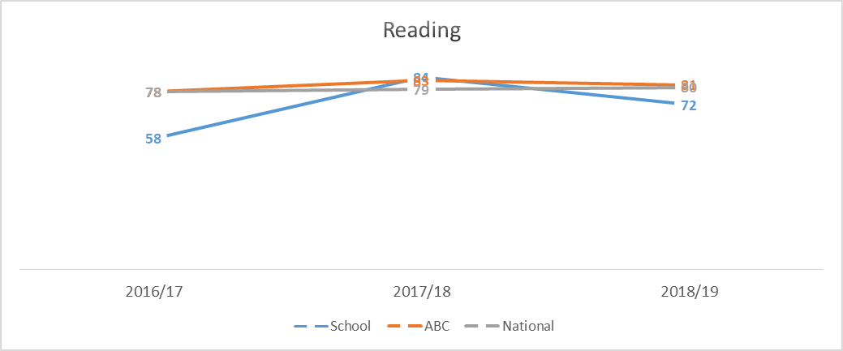
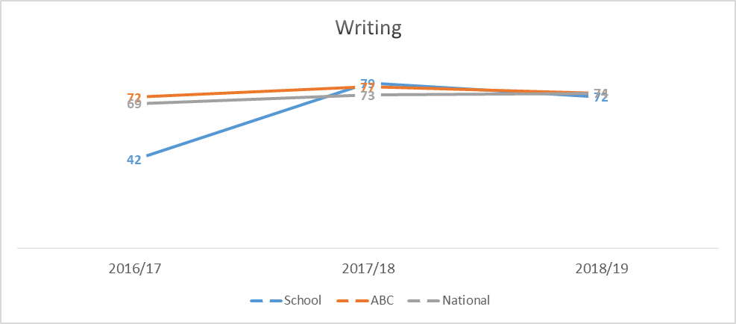
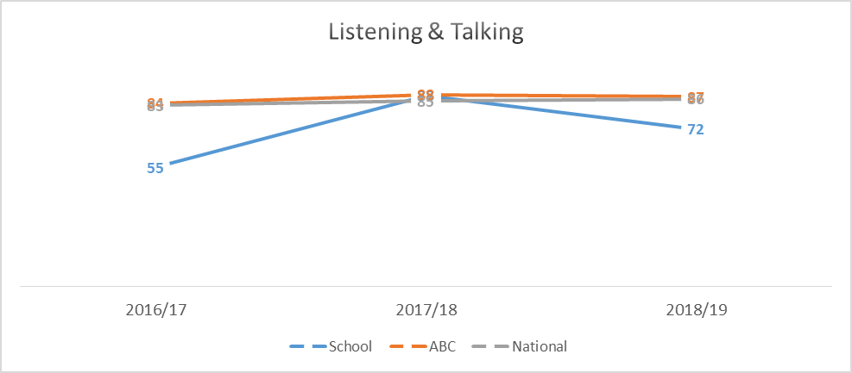

1.2 Attainment Data
Attainment of Numeracy Curriculum for Excellence levels 2016/17, 2017/18 and 2018/19 (teacher judgement – confirmed levels – 3 year trend).
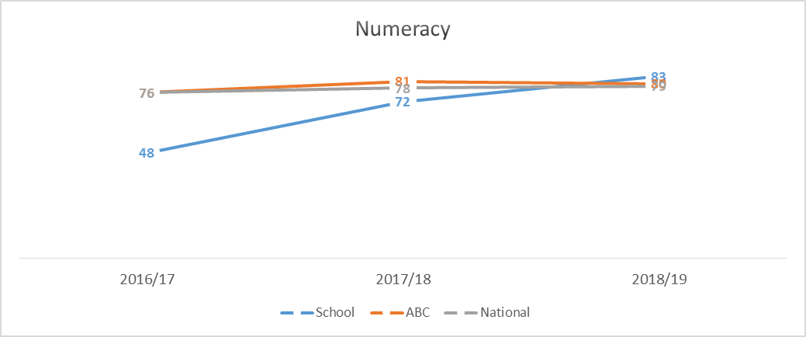

Overall quality of our learners’ wider achievements Highlights of session 2019-20
All learners took part in a community music project; learning, performing, and recording a song written by one of our teachers. This was released on an album in December. The project increased the confidence of all learners and gave them ownership of their learning; many community members and a much wider audience purchased the album. It has given the children an excellent sense of citizenship and identity within the community, as the album is about the island and the community, as a whole.
This. in turn, has increased the confidence of all learners and enabled them to take part in the Christmas Play ‘A Place for a Baby’; all learners had a speaking part, and all had the confidence to stand up perform in front of the wider community.
Learners renewed their Eco Flag. The children planted vegetables in raised beds and planted fruit trees. Opportunities for gardening in the school grounds were plentiful.
The school has facilitated wider social engagement for our learners. The P7’s have continued to attend Rugby sessions in Oban, which will aid transition to secondary; this is particularly important this year, given the current pandemic. Learners have taken part in swimming lessons, ballet classes and gymnastics; this has built on their confidence and improved their social skills. The children are now more familiar with other children during co-op days with other schools because they have built friendships out with the classroom environment.
A P3 pupil has begun fiddle lessons and has managed to continue this throughout the period of lockdown, using the phone and online video calling. This enables a sense of responsibility for learning, adapting to new ways of learning.
All learners took part in a workshop learning how to harvest oats. The pupils spent time with older members of the community and skills were passed through the generations. The learners were able to listen, observe and take part in the process. It was a rich learning experience for all and fostered a sense of respect for traditional skills within the community, whilst learning about modern day equivalents.
All learners were involved in recruiting our new HT. Candidates for the position visited the island in March and the children were invited to interview each candidate asking a selection of pre-prepared questions. They then spent some time with the candidates informally and shared their opinions with the recruiter.

Comment on strategies that have been successful in engaging with children and young people, staff, parents and the wider community and the impact of these.
Every parent invited to an individual meeting to discuss their children’s learning going forward.
- This encouraged parents to be actively involved in target setting with their children and allowed school and home to work together to support learning for all children.
Daily diaries were sent home to parents
- Diaries shared what the children had been learning at school and strengthened our home/school link; it allowed all parents to maintain a link to their children’s schooling.
Sticker Rewards
- Sticker rewards were agreed with the children as part of class management strategies. It was agreed with the children each week on what was to be rewarded, and each child collected a range of stickers throughout the week. At the end of the autumn term, the children chose a reward. This year, all children chose to go climbing; all children achieved this and the whole experience helped them to gel as a group.
Daily Circle Time
- Daily circle time is a whole school activity; all learners are listened to and thoughts and opinions are valued. During this time, growth mindset is discussed, the use of positive language and positive thinking for all is encouraged.
Throughout the year many active and engaging learning experiences for the children have been delivered. These have included:
- Recording a CD in a professional studio. This was a rich learning experience which allowed the children to see the process through from the writing of the song, to the production of the finished album.
- Learning how to harvest oats, using both old farming methods and more modern methods. This allowed them to compare the two and look at the advantages and disadvantages of both.
- Learning how to thatch a roof: the whole primary class attended the local heritage centre and learned the thatching process from a professional thatcher. This was done bilingually using both English and Gaelic; it enabled the children to embrace local traditions and language.
- A day visit to the old lime kiln involved learning about the process of making lime render and how the lime kilns worked when they were active. The process of making up the lime was explained and the pupils took part in repointing the ancient lime kilns as part of a restoration project. They also learned about dry stone walling, and helped construct a wall.
The above experiences have helped children to be engaged in their learning. They can speak confidently about what they have learned, due to the experiential aspects of the tasks they were set.
Outdoor learning.
- Due to our location the pupils spend a great deal of time outside. We have access to the shore, to learn about sea life, and regularly have a ‘daily mile’; this offers the children the opportunity to chat about their learning outside the classroom, work as a group, and get exercise. This is a core part of Lismore school life.

Comment on progress made with the following aspects of empowerment:
- curriculum;
- improvement activities;
- parental and community engagement; and pupil participation.

https://education.gov.scot/improvement/learning-resources/an-empowered-system/?dm_i=LQE,6RTY0,WAUPY4,R37A1,1
Curriculum
We strive to empower learners daily by implementing choice across the curriculum (Shared Texts/Topics/Outdoor Projects etc.).

Improvement Activities
Teaching staff undertook a course with Jenny England on how music can be used across the curriculum.
A new music resource was obtained from the local authority, which will be used to teach H&WB, and Music (not utilised yet).
Early years practitioners and teaching staff took part in an online STEM course.
New PE equipment was purchased for the children taking part in the sports leadership activities.
Teaching staff took part in digital learning webinars.

Parental and Community Engagement
Parents were invited to attend bilingual bookbug, informal coffee mornings, target setting meetings.
Parents were involved in recruiting new HT.
A CD was made with and about local community.
Members of local community have been working with children on project work/attending school events.

Pupil Participation
Pupils have participated in HT interviews.
Pupils created their own class contract and decided upon appropriate sanctions and rewards.
Pupils have lead their learning through Sports Leadership Programme.

Comment on progress made with Pupil Equity Funding, taking account of the five key areas below:
- attendance;
- attainment;
- exclusion;
- engagement;
- participation.

No Pupil Equity Funding received.

Quality Indicator | How are we doing? | How do we know? (Evidence) | School Self-Evaluation (1-6)
1.1
Self-Evaluation for Self-improvement
1.3
Leadership of Change
2.3
Learning, teaching and assessment
3.1
Ensuring wellbeing, equality and inclusion
3.2
Raising attainment and achievement

