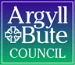

Standards and Quality Report 2025 - 2026

Keills Primary School & ELC

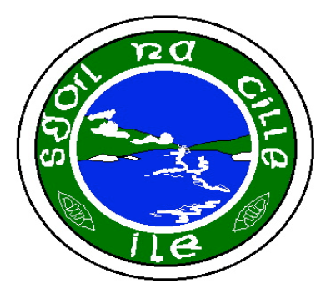

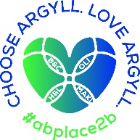


Context of the school
Including some or all of the following:
- basic school details (roll, class composition etc.)
- school vision, value and aims;
- local contextual issues;
- factors affecting progress (e.g. staffing changes/issues).

Keills Primary and ELC is a non-denominational and co-educational school situated in the village of Keills on the island of Islay. In session 2025/26, we had 17 children ranging from P1-7 and 3 children in our Pre 5 unit.

Our school staffing consists of a full-time class teacher for P5-7, two part time class teachers for P1-4, one of whom is also our Principal Teacher.
A classroom assistant also supports both classes. A Shared Head Teacher works between Small Isles and Keills on the neighbouring island of Islay.

In ELC, we have two full time Childcare and Education workers for Pre 5 and an ELC Classroom assistant. The ELC unit had a Care Inspectorate Inspection in October 2025.

The school is a relatively modern single storey building with two classrooms and a separate ELC unit. There is a large hall which functions as a dining room and PE hall.
The school has a large grass area to the rear with trim trail, huts and hard surface play areas.
In session 2025/26, approximately 18% of pupils resided outwith the school catchment area.
The majority of pupils require bus transport (75%) given the sparse location of housing settlements on Islay.
Our attendance as of June 2026 was 95.66%.

Our associated High school is Islay High.

Our Vision, Values and Aims were established in 2024 and are as follows:

Our Vision: At Keills, we strive for our children to flourish, be creative, become caring local and global citizens, be themselves and be celebrated for who they are.
Our values are: Respect, Compassion, Creativity and ‘Can Do’.
We aim to:
O Ensure our children reach their full potential by showing determination and resilience, using skills for life and having a positive Growth Mindset
O Be creative, imaginative, problem solve, and work together to achieve inside and outside of school.
O Be kind and considerate towards all, supporting each other to always make the right decisions.
O Listen to each other and make sure everyone has a voice.
O Ensure that Children’s Rights are at the heart of everything we do!

Keills Primary is situated in the village of Keills in the northeast of Islay. We sit near the ferry port village of Port Askaig. The main industries on Islay are; Whisky Distilling, Farming, Fishing and Tourism. Access to the island is by ferry or plane.

Being an island school within a strong local community rightly influences our place-based learning curriculum design. In June 2025, Keills PS earned GOLD status in the Rights Respecting schools Award. A Rights Respecting Gold school in Scotland is a school that has achieved the highest level of the UNICEF UK Rights Respecting Schools Award (RRSA). This Gold accreditation signifies that the school has fully embedded children's rights throughout its policies, practice, and ethos, using the United Nations Convention on the Rights of the Child (UNCRC) as its foundation.

SCHOOL
Quality Indicator | How are we doing? | How do we know? (Evidence) | School Self-Evaluation (1-6) *
1.1 Self-Evaluation for Self-improvement | All staff, parents and pupils are regularly consulted and involved in improving life and work of the school.  Regular opportunities for parent views through Google Forms and PC meetings.  Regular opportunities for pupil views through weekly assemblies and consultations.  Staff work effectively as a team. All involved in SIP.  Children involved in aspects of school improvement.  Children regularly reviewing own learning.  Staff engage in up-to-date research and relevant literature to inform practice.  Parents have regular opportunities to support improvement. | Collegiate Calendar developed in consultation with staff. Quality Assurance Calendar developed.  Regular staff meetings through course of the year to address SIP priorities.  Parent and pupil consultations. Results actively used in SIP planning.  All pupils in Improvement Teams. Views sought and acted upon.  Regular opportunities for joint planning within school and between cluster schools.  Pupils review work and set next steps both verbally and by recording in jotters.  Pre 5 staff engaged in reading tasks relating to Realising the Ambition document, Literacy and Numeracy tracking and assessment.  PTA support with funding resources and transport. | 4
1.3 Leadership of Change  This QI also focusses on the following aspects of empowerment:  - curriculum;  - improvement activities;  - parental and community engagement; and  - pupil participation. | All staff have high expectations of all learners.  All staff have a clear understanding of local context and use this to shape vision.  All staff clear on areas of improvement and future vision of school.  Staff are involved in leading change throughout the school.  Children are involved in leading change across the school | Regular dialogue at staff meeting regarding expectations, vision, evaluations and improvement.  Staff live locally and have established relationships with families.  Children involved in redesigning VVA. Linked to HWB curriculum and RRSA work.  Children involved in developig a new relationships policy.  Opportunities for staff to attend collegiate meeting with cluster schools eg. TLC and Moderation meetings.  Regular HT consultations with stakeholders on areas for improvement.  RRSA GOLD Status Award.  PRD meetings highlight areas for staff CLPL and opportunities to lead aspects of school improvement.  Staff attending CPD events relevant to SIP and own development needs.  Staff are given areas of SIP and are supported by HT.  PT supports CT and Pre 5 staff when HT not in school. | 4
2.3 Learning, teaching and assessment | Children are motivated and active participants in learning.  New planning formats developed to allow for high quality learning experiences.  Learning experiences are varied and use high quality resources now including digital technologies.  Learners receive high quality feedback and create own next steps.  Learners are involved in learning process.  Tracking and monitioring is now in line with XBRA and being used effectively.  Power up Pedagogy elements introduced this session. | Robust Quality assurance calendar created to ensure a variety of evidence (Observations, pupil conversations, jotter monitoring, peer shadowing)  HT and CT tracking meetings taking place using various evidence including assessments and teacher professional judgemements alongside benchmarks.  Shared expectations across learning community and authority wide with moderation activities (TLCs and INSET Moderation session) Learners activley involved in decision making around planning across school and including Pre 5.  Peer Observation & Collaboration  Professional Learning Logs  Co-Constructed Rubrics | 4
3.1 Ensuring wellbeing, equality and inclusion | Staff and Pupils Wellbeing placed as high priority each year.  Staff and pupils have a shared understanding of wellbeing and learners can demonstrate how to be safe, healthy, achieving, nurtured, active, respected, responsible and included.  Positive relationships across school community.  Staff model behaviour which supports wellbeing of all.  Children are active participants in discussions and decisions.  Children with additional learning needs supported with interventions.  Outdoor space used more to enhance learning experiences and wellbeing. | Rights Respecting School award: GOLD  Regular staff check in meetings.  Regular Leavens observations for children and scores tracked, interventions in place if required.  Weekly whole school and Pre 5 assemblies on Wellbeing Indicators, school values and Rights.  Staff, pupil and parent feedback on positive and supportive ethos of school.  School Improvement Teams actively involved in leading school change.  HT observations, term 1 based on learning environment.  Improvement Teams led by children  Regular involvement of children in discussions around school improvement at assemblies.  Allocated classroom assistant time given to interventions to raise attainment and support pupils.  Island partnerships established and new partnerships recently formed. | 4
3.2 Raising attainment and achievement | Attainment levels are a central feature of SIP.  Interventions/catch up plan/additional teacher put in place to support pupils not on track to achieve a level.  Children involved in decision making relating to own learning. | Literacy and Numeracy Data tracked from termly Progress and achievement tracking meetings. XBRA tracking used.  HWB information tracked over time using Leuvens Scales.  Interventions planned, monitored and evaulated termly.  Teaching judgements are made using benchmarks and range of assessments | 4

ELC Keills ELC had a CI Inspection in October 2025-Evaulation is based on the findings from this Inspection
Quality Indicator | How are we doing?  (Progress) | How do we know?  (Impact + Evidence) | Establishment  self-evaluation  (1-6) *
Leadership and management of staff and resources | The setting demonstrated a clear vision, values, and aims that were firmly embedded in practice. Its vision placed children at the centre of the service, ensuring they were supported to reach their full potential.  ELC has been on a journey of improvement and has identified key areas for development, including the garden, personal plans and strategies, and the quality assurance process.  Early stages of self-evaluation and had plans to develop staff knowledge on the Care Inspectorate and His Majesty's Inspectorate of Education in Scotland's quality improvement framework for the early learning and childcare sectors and develop a community of reflection and evaluation through mentorship and more knowledgeable practitioners to promote a high-quality service.  Staff are registered with the Scottish Social Services Council (SSSC), supporting continuous improvement and upholding professional standards. | The stated values of Can Do, Creativity, Compassion, and Respect were evident throughout the environment and interactions. Staff are observed consistently implementing a respectful approach, creating an atmosphere where children's rights were prioritised and upheld. The whole school, including the pre-5 unit, recently achieved a rights respecting school award. This fostered a rights-based environment that was supporting children's emotional wellbeing.  Evidence of the improvement plan's priorities is visible in the setting for parents to view, fostering a collaborative approach to improvement  Regular informal meetings enable the staff team to reflect together, using these reflections to bring about positive changes to outcomes and experiences for children and families.  The head teacher has introduced practice supervision. | 4-Good
Curriculum | Our curriculum design has a strong pedagogical basis, blending a rights-respecting ethos with Froebelian principles that value play and full-bodied movement as core vehicles for learning. We maximise our unique island location, utilizing our local environment, community, and heritage to provide a context-rich, outdoor-heavy learning experience.  The curriculum framework is highly responsive, adapting dynamically to the shifting interests, developmental stages, and universal needs of our young learners.  Literacy, numeracy, and health and wellbeing are seamlessly integrated across both our indoor and outdoor environments. Practitioners use high-quality interactions, intentional questioning, and rich vocabulary to extend learning during spontaneous play. Health and wellbeing is an exceptional strength; our outdoor environment offers robust opportunities for children to evaluate risk, develop gross motor skills, and build emotional resilience through active physical exploration. | A written, shared Curriculum Rationale document co-created by staff that explicitly cites Realising the Ambition: Being Me  Planning documentation and floorbooks that demonstrate a clear shift away from rigid, adult-led weekly themes toward child-initiated pathways of exploration  Parental feedback confirming that families understand and value our focus on outdoor, community-connected, and play-based learning.  Environmental Audits showing a print-rich environment, accessible numeracy resources (measuring tapes, loose parts for counting), and dedicated quiet reading zones indoors and outdoors.  Classroom observation data showing staff using open-ended questions to stimulate critical thinking and mathematical vocabulary. | 4-Good
Learning, teaching and assessment | Children experience fun and engagement as they explored and played in spaces that promoted imagination and creativity. The play areas are arranged to encourage a range of play experiences | Observations state:  Children were enjoying reading books on tractors and sharing their local knowledge of the farms, demonstrating their curiosity and connection to their community. Staff demonstrated strong awareness of children's interests and effectively used this information to inform planning and extend lines of development. For example, floor books captured children's ideas and interests, supporting a child-led approach that engaged children in play and deepened their learning. Staff showed a clear understanding of children's developmental needs and supported learning through responsive and intentional interactions. | 4-Good
Nurturing care and support | Children are consistently treated with warmth and compassion. Staff are attuned to children's emotional needs and responded with sensitivity and care.  Children's privacy and dignity are respected  Children experience relaxed and positive mealtimes where they are supported to be independent.  Hygiene and infection prevention are embedded in daily routines. | Observations state:  Secure attachments and positive relationships between children and staff were evident, contributing to a strong sense of emotional safety and wellbeing. Staff adopted an individualised approach to transitions, phoning parents and carefully considering the impact on both children and families during these periods. This approach promoted emotional security during transitions, helping children and families settle into the setting with confidence.  Staff maintained a nurturing and caring approach, delivering personal care in a warm, kind, and respectful manner.  Mealtimes provided opportunities to socialise with peers and engage in conversation with staff, promoting language development. Children demonstrated independence by setting tables, chopping fruit, and self-serving, which supported confidence, fine motor skills, and independence  Consistent handwashing after  toileting, before eating, and when coming indoors. This practice helped reduce the spread of infection and  supported the development of good hygiene habits. | 4-Good
Wellbeing, inclusion and equality | A strong culture of care, warmth, and mutual respect underpins our entire setting. Practitioners prioritise the emotional and physical wellbeing of every child, using the SHANARRI indicators to dynamically assess and support individual needs. Children demonstrate a strong sense of security, belonging, and emotional literacy. Our commitment to rights-respecting values ensures that children feel deeply respected and responsible, with their views actively shaping the daily life and environment of the playroom | Regularly updated Personal Plans that explicitly track health, wellbeing, and medical needs in partnership with families  RRSA Gold accreditation documentation showing that rights-respecting vocabulary and principles are embedded within daily playroom interactions  Daily use of emotional check-ins and nurture-based tools that allow children to communicate their feelings and self-regulate effectively  Strong connections and relationships with families were a clear strength of the service. Staff and parents highlighted effective communication. | 4-Good
Children’s progress | All children are making steady, measurable progress in early literacy, communication, and numeracy.  Children are confident communicators who regularly articulate their needs and ideas.  Children are making exceptional progress in their physical development, emotional literacy, and overall wellbeing. | Use of Authority ELC Developmental Trackers showing a high percentage of children achieving their expected milestones in Literacy and Numeracy.  Evidence in Floorbooks and Learner Journeys of children applying new concepts spontaneously during play.  Individual Personal Plans and wellbeing profiles that record steady milestones in social-emotional development and self-care. | 4-Good

Evaluation 6-point Scale
6 Excellent
5 Very Good
4 Good
3 Satisfactory
2 Weak
- Unsatisfactory

Review of SIP | Priority 1
Teaching and Learning: Power up Pedagogy
Strategic Aim: To significantly improve the quality of learning, teaching, and assessment across all stages, ensuring all learners are engaged, challenged, and achieve their full potential.
Progress and Impact:
Strategic focus on Bruce Robertson’s "Power Up Your Pedagogy" has successfully elevated the baseline of pedagogical skills and knowledge across the school. Collaborative professional dialogue, both in school and within our cluster, has allowed staff to refine classroom practices and ground their daily routines firmly in the science of learning.
Explicit evidence of this strategy can be seen in our multi-composite environment, where teachers actively apply intentional presenting and high-impact questioning techniques. The implementation of structured daily reviews and spaced retrieval practice has noticeably improved pupils' retention of core knowledge, providing a stronger foundation for critical thinking. While pedagogical confidence has grown, our next step is to maximise differentiation by embedding these strategies adaptively within our literacy curriculum. Informed by this year’s attainment data, we will alter the pacing and structure of retrieval tasks to better support vulnerable learners in bridging the gap between reading confidence and independent writing.

Teachers
100% engagement from teaching staff in termly self-evaluation cycles, have led to a clear, data-driven overview of strengths and development needs via RAG rating.
Observation feedback notes showing a measurable increase in specific strategies (active use of show-me boards, reduced teacher talk time, purposeful questioning).

Professional learning logs successfully triangulate theory and practice, providing clear evidence that teachers applied core principles of good practice directly to their classroom environments.

Staff surveys and professional discussions indicate increased teacher confidence in self-regulation and a more collaborative approach to sharing choices of good practice elements.

Triangulation of teacher self-evaluation data and Senior Leadership Team (SLT) class observations provides clear evidence that our target has been met. A majority (50–74%) of pupils across all stages now consistently demonstrate active engagement, deeper conceptual understanding, and independent learning skills.

Collaborative cluster working has significantly deepened professional dialogue, with teachers engaging with peers to critically self-evaluate their pedagogical knowledge and practice. A key outcome of this moderation has been the co-creation of robust pedagogical rubrics. These frameworks have empowered staff to accurately benchmark their current practice and identify precise pathways on their journey to excellence. This collaborative approach strongly aligns with HGIOS 4 QI 1.1 (Self-evaluation for self-improvement) and QI 2.3 (Learning, teaching and assessment), demonstrating a shared, evidence-based commitment to raising attainment through high-quality, reflective teaching.

Learners
SLT observation data highlights that the strategic shift toward a more dynamic pedagogical approach has successfully minimized passive listening. In the majority of lessons observed, pupils were actively utilizing critical thinking skills to solve problems and were using self-scaffolding tools to drive their own independent learning. Teacher self-evaluations note a corresponding rise in pupil stamina during independent tasks.

By May 2026, the strategic shift toward a more dynamic pedagogical approach has resulted in a highly visible increase in pupil engagement and ownership of learning across all stages. The embedding of daily retrieval practice and structured questioning has visibly deepened pupils' understanding, moving them away from passive listening toward active cognitive participation.

Learners are increasingly able to articulate how they learn, demonstrating growing critical thinking skills during collaborative tasks. In our open-plan setting, independence has flourished; pupils utilise self-scaffolding tools and peer-feedback routines effectively, reducing their reliance on direct teacher direction. This development in independent learning skills ensures that pupils are not only highly motivated but are also active co-creators of their learning journeys.

Class survey data shows that all learners rated 100% of Pedagogy elements amber or green. All learners rated the following elements green: Daily review, Sharing Learning Intentions, checking in, teacher role modelling, Questioning, thinking time and feedback.

This data demonstrates that the embedded pedagogy framework is actively and consistently felt by the learners. The 100% Amber/Green rating shows there are no blind spots in our core teaching delivery; learners experience a safe, predictable, and highly effective learning environment. Specifically, the universal 'Green' rating for foundational elements (such as daily reviews, teacher modelling, and thinking time) indicates that high-impact formative assessment is now standard practice across all classrooms. As a result, learners are not passive recipients of education—they are explicitly aware of how they are being taught, feel cognitively supported, and are experiencing high-quality, equitable learning experiences.

Our tracking and monitoring data confirms that our target has been fully achieved. A majority (50–74%) of our primary pupils (P1–7) are achieving expected CfE levels in both Literacy and Numeracy. Crucially, 100% of our pupils demonstrate measurable, positive progress over time from their individual starting points.

Next Steps:
Writing and Reading Frameworks: Establish a consistent, evidence-informed approach to the teaching and learning of reading, with a sharp focus on:
Effective Questioning strategies to deepen comprehension.
High-Quality Feedback that guides learners on their next steps.
The consistent implementation of Spotlight Assessments.
Extend the use of Personal Learning Logs from session 2025/26, empowering teachers to direct their own professional development toward specific areas requiring improvement within their classrooms.
Embed the use of co-constructed rubrics across classrooms to promote teacher autonomy, self-evaluation, and developmental growth.
Literacy Trackers: Design and implement comprehensive Reading and Writing Trackers to ensure robust, consistent, and accurate monitoring of pupil progress over time.
Triangulated Assessment: Strategically incorporate Standardised Testing data into regular attainment reviews to validate and support holistic teacher professional judgment.
Sustain high levels of staff engagement in professional reading and collegiate discussion through Staff Meetings, Teacher Learning Communities (TLCs), and Cluster Collaboration.
Introduce a structured Peer Observation model, directly responding to recent staff survey data highlighting this as a priority for sharing best practices.

Review of SIP | Priority 2
Curriculum Rationale (Year 2)/OCTF Launch
Strategic Aim: A Curriculum Rationale alongside OCTF will deepen all stakeholders understanding of the ‘Why?’ This will provide a purposeful, cohesive and impactful experience, providing direction, understanding and leads to improved outcomes for both educators and learners.
Progress and Impact:
We have successfully achieved our priority to refresh our curriculum framework. By October 2025, robust consultation with staff, families, and learners culminated in the joint creation of a clear, context-specific curriculum rationale.
This process successfully brought our community together to define what makes a Small Isles education unique. By explicitly embedding refreshed OCTF key objectives into the foundation of the rationale, we have bridged local authority strategic goals with our distinct island context. Our multi-composite classes now benefit from a curriculum structure that clearly maps out how local industry, children's rights (Gold RRSA), and place-based learning interact to ensure all learners achieve their full potential.
Full participation across all stages has resulted in a comprehensive and vibrant Curriculum Rationale/OCTF wall display that actively reflects our school ethos. Every learner, from our youngest in ELC to our P7 pupils, contributed high-quality work, evidence, or reflections to the project.
Professional dialogue and learning walks confirm that this process has successfully deepened pupil understanding of their curriculum framework. Evidence gathered directly from classroom activities demonstrates that learners are not only aware of the OCTF objectives but are beginning to apply them to assess their own progress. The display stands as a clear, visual testament to our place-based curriculum design, proving that our children understand how their learning connects to their community and their rights.
Through targeted professional learning and regular, focused staff meetings, 100% of our staff have successfully developed a deep and secure understanding of the refreshed OCTF framework and our school’s Curriculum Rationale.
Following a comprehensive internal audit of practice, the strengths of our curriculum framework were clearly identified and verified. Using this robust evidence base, staff successfully designed and produced a bespoke 'OCTF at Small Isles' leaflet to showcase our educational approach. This document was shared directly with our school community, serving as a vital bridge between classroom theory and parental understanding. The leaflet has successfully deepened the home-school partnership, ensuring parents, carers, and local partners are fully informed and actively aligned with the strategic direction of the school. Furthermore, the leaflet was shared with the local authority via a shared Teams site, effectively demonstrating how our context-specific curriculum rationale aligns seamlessly with strategic, authority-wide Our Children, Their Future objectives.
Pupil Survey 100% Response
A comprehensive consultation of pupils demonstrates that the school is highly successful in embedding the core principles of Argyll and Bute’s refreshed vision, Our Children, Their Future – Thriving Together. Across all 24 quality indicators surveyed, 100% of pupil responses indicated non-negative sentiment, with an exceptional 93.75% of children expressing strong agreement. Most notably, ten distinct indicators achieved a 100% agreement rate from the pupils, highlighting complete satisfaction regarding adult kindness, physical and mental wellbeing support, and digital safety.
Family End of year survey (50% response) Conducted by parents in collaboration with children.
The survey assesses performance across parameters aligned with Argyll and Bute’s overarching strategy, “Our Children, Their Future”, focusing on key areas such as learner agency, wellbeing, achievement, inclusion, and curriculum enrichment.
The questionnaire captured responses across 27 distinct indicators of pupil experience. Overall, the findings indicate an exceptionally high level of satisfaction and alignment with school values, with 19 out of 27 indicators achieving 100% positive agreement (Agree/Strongly Agree) from respondents.
Evaluative data from the Keills Primary and ELC Parental Questionnaire 2026 confirms a deeply embedded culture of partnership and mutual respect. 100% of stakeholders agree that the school community joins together effectively to meet learner needs, supporting growth and development. Furthermore, 100% of respondents recognise that there is a strong understanding of children's rights respected by all, fostering a profound sense of community inclusion and collaborative support.
Our commitment to authentic learner agency is clearly evidenced by survey outcomes, with 100% of respondents agreeing that pupils are consistently consulted on decisions that affect them and that their ideas are listened to and acted upon. This directly correlates with the success of our pupil-led 'Keills Improvement Teams'. Additionally, 100% of stakeholders affirm that our children are developing effectively as local and global citizens who actively care for their wider community environment.
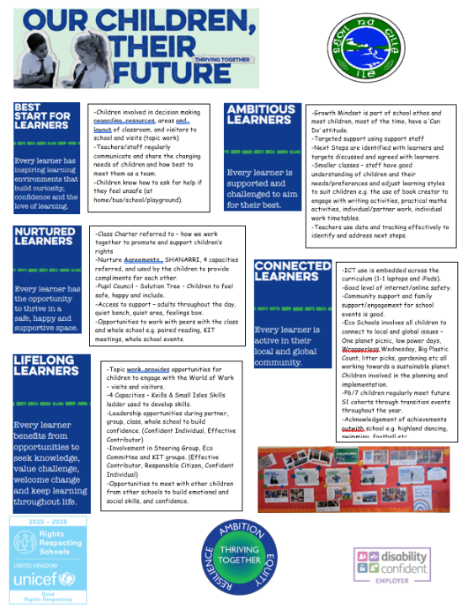
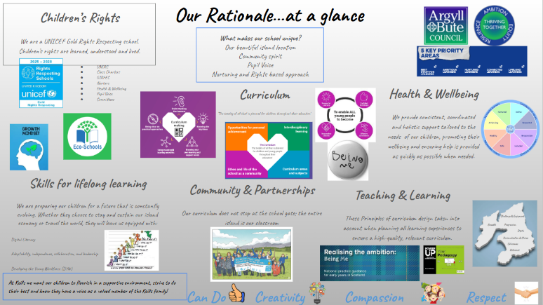
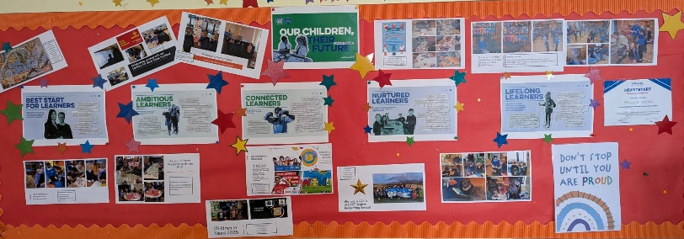
OCTF Parent Leaflet highlighting class practice
Our OCTF Display highlighting events over the year linked to 5 priorities
Keills Curriculum Rationale
Next Steps:
Strategic Intention: Move pupils from knowing the OCTF key elements to using them to track their own progress.
Actions:
Embed "OCTF Reflection Time" into weekly plenaries, where pupils use the language of the rationale to self-evaluate their learning stamina, critical thinking, and citizenship.
Adapt pupil learning profiles to feature the core pillars, allowing pupils to physically or digitally tag pieces of work that demonstrate these values in action.
While overall positivity remains exceptionally high, targeted focus will be given to raising individual pupil expectations and nurturing learner resilience. We intend to further optimise our learning environments to ensure they are universally experienced as inspiring and inclusive, while building robust frameworks that empower all learners to feel 'brave' when embracing new, challenging learning experiences.
To build upon the positive trends identified in this session's survey, our next step is to address the 50% response rate to ensure all families have an active voice. Moving forward, we will work closely with our Parent Council and 'Keills Improvement Teams' to co-design shorter, more accessible surveys. By reducing barriers to participation and sharing 'You Said, We Did' outcomes more visibly, we aim to significantly increase stakeholder turnout and deepen collaborative decision-making.
Review of SIP | Priority 3
Policy Development inc Pupil versions
Strategic aim: To establish a clear, consistent and safe framework that guides the entire school community in achieving the school/authority objectives and fostering a positive and productive environment.
Progress and Impact:
By October 2025, our strategic policy review schedule was successfully established, resulting in the rigorous updating of two core operational frameworks: our Teaching and Learning Policy and our Rights Respecting Policy. Both documents were fully modernised in line with national guidance to reflect our high standards of practice.

Our updated Teaching and Learning Policy is now a highly comprehensive framework, having strategically integrated our planned parental engagement policy into its design. Grounded firmly in Bruce Robertson’s 'Power Up Your Pedagogy' methodology, this overarching document ensures that high-quality classroom instruction and home-school partnerships are driven by the same core standards. To ensure transparency, this document was shared and discussed with families at a recent parent meeting event.

Alongside this, our Rights Respecting Policy was fully refreshed to align with our UNICEF Gold status, ensuring children’s rights remain embedded at the heart of our school ethos. While both master policies are now complete and actively guiding staff practice, the co-creation of their corresponding child-friendly versions was deferred this session. This has been carried forward as a priority next step for the upcoming session, where we will work alongside pupil leadership groups to translate these strategic standards into accessible formats for all learners.
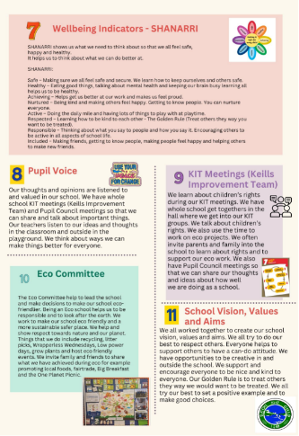
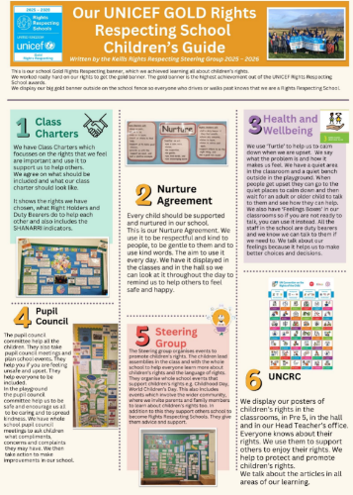
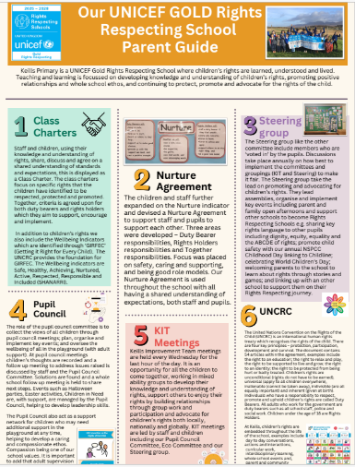
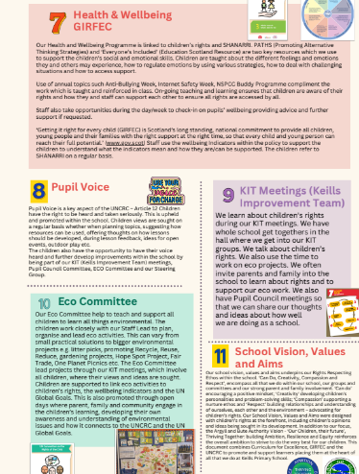

RRSA Children’s Guide-Developed by Steering group
RRSA Parent Guide-Developed by Steering group
Next Steps:
Building upon the successful finalisation of our comprehensive master frameworks this session, our policy review schedule will focus on expanding our library of current guidance, driving pupil ownership, and ensuring absolute transparency across our school community.
Our immediate priorities for development are:

Pupil Ownership & Accessibility: We will actively collaborate with student leadership teams and the Rights Steering Group to co-create and embed child-friendly versions of our existing Teaching and Learning and Rights Respecting policies, ensuring our learners across P1–7 fully understand and own these standards.
Health and Wellbeing Frameworks: In partnership with staff, pupils, and parents, we will design and implement modernised, context-specific policies for Anti-Bullying and Nurture, aligning our daily multi-composite practices with trauma-informed and rights-respecting principles.
Community and Lifestyle Alignment: We will review, refresh, and launch updated policies on Homework and Healthy Eating. These will be designed in close consultation with our families at upcoming parental engagement events, ensuring our curriculum rationale seamlessly bridges school expectations with island family life.

Review of SIP | ELC Priority
Developing Our Outdoor Learning Environment.
Outcome: To transform the outdoor space into a high-quality, inclusive, and challenging learning environment that integrates seamlessly with indoor play, in line with My World Outdoors and Space to Grow guidance.

Audit & Alignment: We conducted a comprehensive audit of existing outdoor resources against national best-practice benchmarks.
Space Transformation: We re-zoned our outdoor area to provide a diverse range of learning experiences:
Natural Elements: Created dedicated water stations, hidden spaces, active areas with natural resources, relaxing reading area, a hammock, alongside dedicated literacy and numeracy areas.
Physicality & Gross Motor Skills: Optimized open space for running, climbing, and wheeled-toy use to challenge physical boundaries.
Risk & Challenge: Designed "managed-risk" zones that provide stimulating environments, encouraging children to test their physical abilities safely.
Dynamic Environments: Balanced open, active zones with "hiding spots" and quiet areas for reflective or small-group play.
Pedagogical Integration: Ensured true "free-flow" access, allowing children to drive their own learning and move between indoor and outdoor contexts without adult-led restriction.
Universal Design: Audited all new spaces for accessibility and inclusion, ensuring resources are adaptable to different developmental stages and Additional Support Needs (ASN).
In addition to developing our physical environment, we have embedded Froebelian principles into our ELC outdoor practice. We recognise that movement is the "language" of young children; by providing environments that facilitate full-bodied physical challenge, we are supporting their cognitive, emotional, and physical development simultaneously.
Full-Bodied Engagement: We have intentionally curated spaces that invite complex motor movements—swinging, sliding, jumping, crawling, hanging, and climbing. These are not merely play activities but essential tasks that build physical confidence, spatial awareness, and resilience.
The "Unity" of Play: Following Froebelian philosophy, our outdoor space is designed to support the "whole child." By providing these diverse opportunities for physical exertion, we see a direct correlation to improved focus and readiness to engage in indoor, more sedentary tasks.
Learner Autonomy: By providing the equipment and space for these movements, we empower children to set their own challenges, gauge their own risks, and develop a sense of agency over their physical capabilities.

Evidence of Success (Impact)
Full Completion: All planned actions were successfully implemented within the session.
Pedagogical Alignment: Our outdoor space has been re-imagined through a Froebelian lens, prioritising the child’s need for 'full-bodied' movement as the foundation for cognitive growth. By providing diverse, challenging opportunities to swing, slide, jump, crawl, hang, and climb, we have transformed our outdoor area into a laboratory for physical and intellectual exploration.
Holistic Development: The success of our outdoor development is evidenced by the children’s increased agency and physical self-regulation. By facilitating complex movements that require balance, spatial awareness, and strength, we have observed a direct improvement in pupils' ability to engage in sustained, focused indoor tasks, demonstrating the 'unity' of learning that underpins our Froebelian approach.

Inclusive Risk-Taking: In line with Space to Grow, our outdoor environment now offers carefully calibrated challenges that encourage children to assess their own physical boundaries. Through the provision of varied terrains and natural elements, children are developing resilience and confidence, transitioning from hesitant learners to active participants who feel empowered to 'research' their environment through movement.
Practitioner Confidence: Our practitioners have successfully moved beyond facilitating play to acting as intentional pedagogues. Supported by professional learning in outdoor education, the team now confidently observes and extends learning through movement, ensuring that our outdoor provision is not merely 'free time' but a vital, planned component of our curriculum.

To advance our outdoor pedagogy, our next strategic step is to further develop our environment through a Froebelian lens by introducing living willow dens and archways. These natural structures will act as dynamic "in-between" spaces, intentionally designed to balance our active zones by offering children quiet, sensory-rich areas for retreat, imaginative play, and social connection. By involving the children directly in the design and seasonal care of these living installations, we will foster a strong sense of environmental stewardship and child-led agency, while simultaneously promoting gross motor skills and providing safe, managed environments for creative risk-taking.
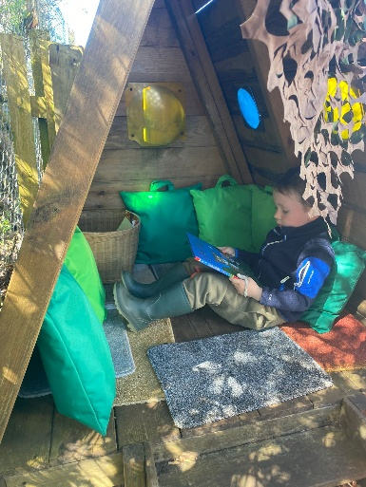
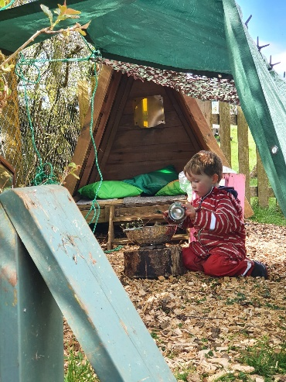
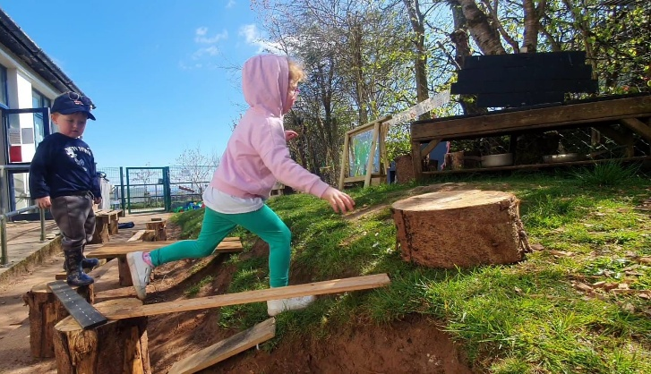

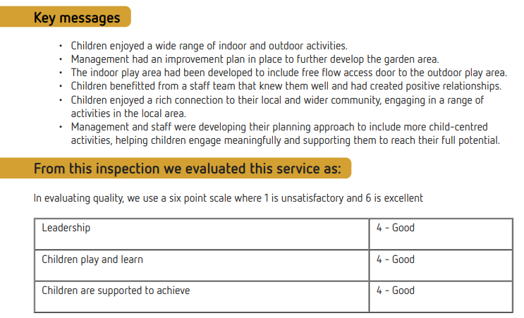
The setting was inspected by the Care Inspectorate in October 2025. The report is published on the Website https://www.careinspectorate.scot/find-care/search-for-care/care-services/CS2003014657/keills-primary-pre-five-unit

PICS!
Next Steps:
Next step is to formally engage with the Counting on Excellence programme to enrich our play-based numeracy pedagogy. We will introduce a standardized Early Level Numeracy Progression and conduct an environmental audit to launch tactile, open-access "Discovery Zones" across our indoor and outdoor spaces. Furthermore, we will prioritize cross-sector moderation and collaborative planning, utilizing the expert skills of our ELC practitioners within the Primary 1 classroom. This partnership will establish a unified language of numeracy and a shared methodology, securing confident transitions and continuing to close the developmental attainment gap from day one of formal schooling.

1.1 Attainment Data
Attainment of Literacy Curriculum for Excellence levels 2021/22, 2022/23, 2023/24, 2024-2025 and 2025/2026 (teacher judgement – confirmed levels – 5 year trend).
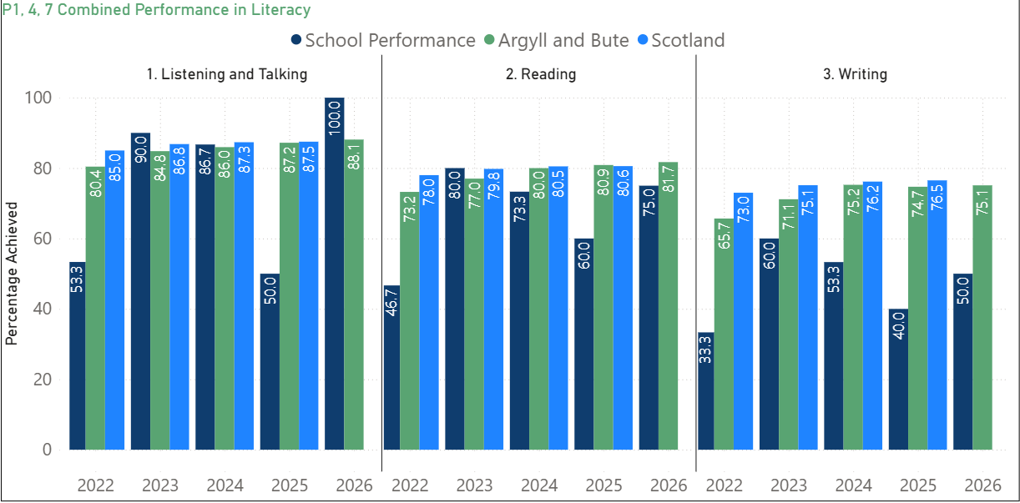

Please Note:
The above data (1.1) reports achievement of a level – P1/P4/P7 combined.

1.2 Attainment Data
Attainment of Numeracy Curriculum for Excellence levels 2021/22, 2022/23, 2023/24, 2024-2025 and 2025/2026 (teacher judgement – confirmed levels – 5 year trend).
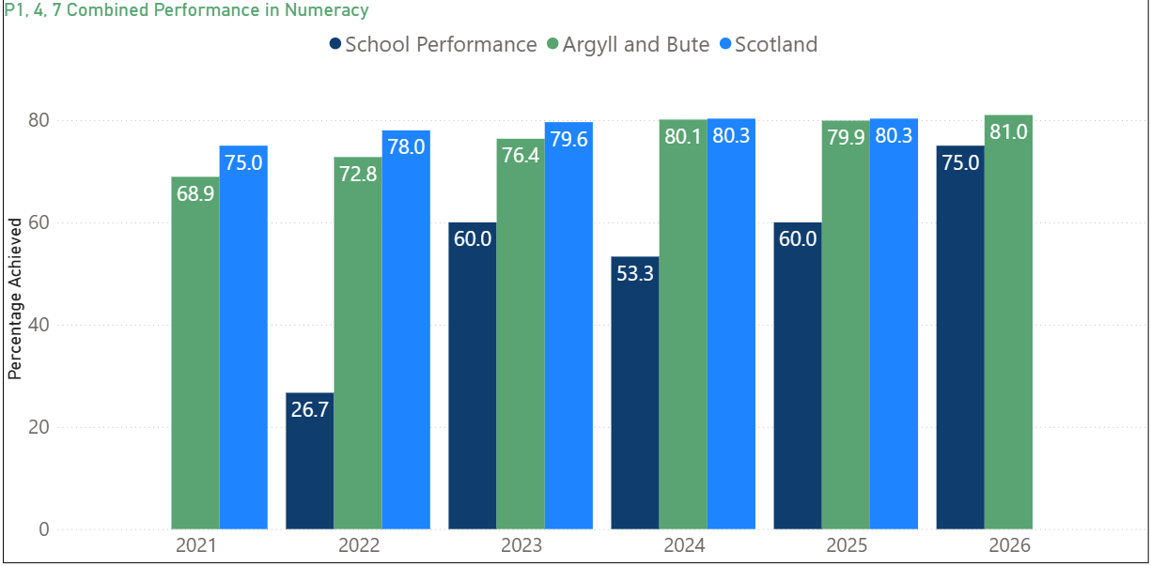

Please Note:
The above data (1.2) reports achievement of a level – P1/P4/P7 combined.

Wider achievements
- What opportunities for wider achievement were offered?
- What systems are in place to track and monitor participation?
- How have you addressed any gaps in participation?
At Small Isles, we embrace the diverse strengths and unique learning pathways of every individual. Our distinct island context serves as a rich, living classroom, offering meaningful opportunities for learners to connect deeply with their local heritage, environment, and community. Over the past session, pupils have enriched their skills through contextualised experiences, including outdoor learning, community partnerships, creative arts, and charity campaigns—fostering noticeable growth in their independence and resilience. Successes are tracked and celebrated through assemblies, school newsletters, public facing events and in the Ileach, fostering pride and a positive culture of achievement.
Below are just some of our highlights:
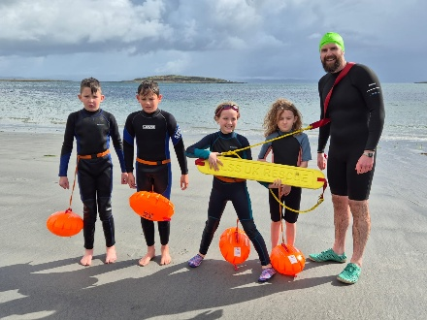
Inclusive Participation and Partnerships
‘Connected Learners’ ‘Lifelong Learners’ ‘Nurtured Learners’
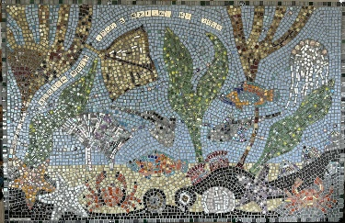
In partnership with the Argyll Hope Spot this year, the school collaborated with a local artist to produce a whole-school mosaic, which was successfully presented at a local community showcase event. Furthermore, this valuable partnership enhanced our outdoor education curriculum by delivering an environmental beach workshop and sea swimming experiences for pupils in P5/6.

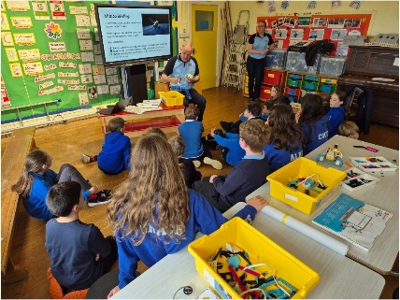
STEM and Digital Innovation
Curriculum enrichment was further strengthened this session through an innovative STEM project that introduced Lego Coding to the P5/6 class, significantly enhancing pupils' digital literacy and computational thinking. This learning was celebrated at a well-attended community showcase event in June, providing pupils with a meaningful platform to demonstrate their technical and collaborative skills.

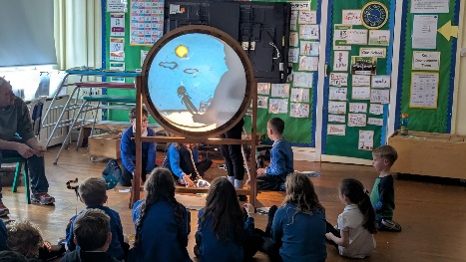
Children in P5-7 continue to receive additional funding to provide Chanter and woodwind tuition. 4 children from the P5-7 receive weekly Chanter tuition and 3 receive Woodwind instruction. Opportunities to perform are given throughout the year.
In partnership with the Jura Music festival a creative collaboration has been established for 2 years now with professional storytellers. This allowed pupils to develop literacy and expressive arts skills by creating, developing, and performing their own shadow puppetry.

Creativity and Ambition
‘Ambitious Learners’ ‘Lifelong Learners’ ‘Best start for learners’
Our children have regular opportunities to showcase their work to the community and these events are well attended by families. These opportunities lead to increased confidence and self-belief, resilience, communication skills, teamwork and collaboration, problem solving, planning and organisation. This particularly evident in our yearly ‘Endeavour’ projects. This year, P1-7 have taken part in Endeavour projects.
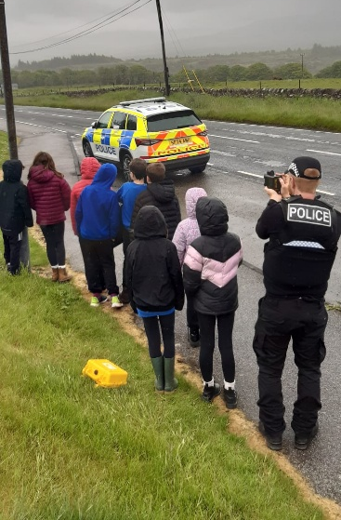
Wider Achievement: Pupil Leadership and Active Citizenship
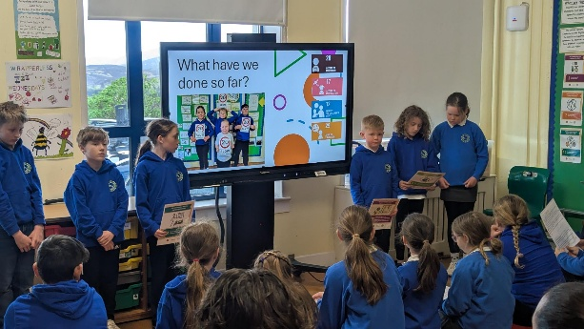
‘Connected Learners’
All children actively contribute to school improvement through participation in our 'Keills Improvement Teams.' This framework provides a platform for authentic learner agency, empowering pupils to lead change across the school community. Demonstrating a strong commitment to active citizenship, pupils successfully initiated and led a robust road safety campaign. This pupil-led initiative effectively highlighted the deficit in local traffic signage and safety measures surrounding the school campus, fostering critical leadership and advocacy skills.

Holistic Wellbeing and Wider Attainment
‘Best Start for Learners’ ‘Connected Learners’ ‘Lifelong Learners’ ‘Nurtured Learners’
Targeted opportunities successfully enhanced pupils' confidence, resilience, and collaboration skills this session. Key highlights included a robust transition program for P5/6, featuring outdoor learning experiences such as fire building and team-building challenges, a P6 'Try a Sport' cluster day, and an experiential visit to the High School woodwork department. Practical life skills were advanced through Bikeability sessions for P4/5. Furthermore, leadership capacity was fostered through pupil-led initiatives, notably lunch clubs autonomously run by P5 pupils. Our highly effective, ongoing partnership with MYCOS also continued to enrich our extracurricular offer through the delivery of an inclusive after-school games club.
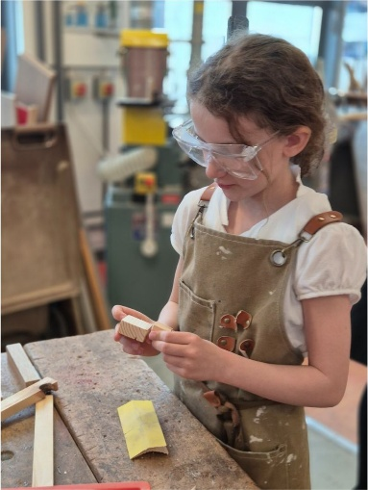
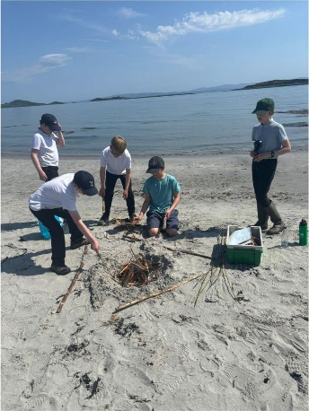
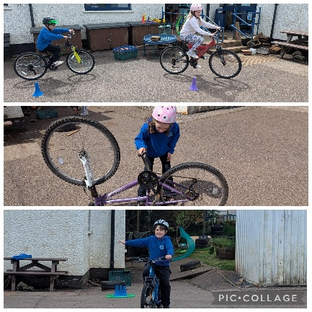

Pupil Equity Funding

Literacy Target Group
Target Group: 4 pupils in total (Primary 5: 2 pupils | Primary 6: 2 pupils).
Identification Rationale: This cohort was identified as underperforming in literacy through a triangulation of ACEL (Achievement of Curriculum for Excellence Levels) data, XBRA Tracking, and teacher professional judgment/classroom observations.
Purchase of age-appropriate, high-interest/low-readability books specifically selected to engage and motivate reluctant readers.
Implementation of a Sumdog Spelling Subscription to provide adaptive, gamified, and targeted spelling practice tailored to individual pupil gaps.
Regular, targeted support during writing and reading blocks to ensure the application of spelling strategies.
Pupil Voice: Periodic learner conversations focusing on shifting mindsets, measuring increased self-efficacy, and tracking growing confidence during reading, writing, and spelling tasks.
Classroom Observations: Focused learning walks and observations to ensure pupils are actively applying their new spelling and reading strategies independently in day-to-day work.
Targeted PEF funding utilised for bespoke reading resources and digital spelling tools has delivered a positive impact on the identified cohort. Qualitative evidence, gathered through pupil voice and regular learning walks, highlights an increase in learner self-efficacy and classroom motivation. Quantitative tracking over time confirms that all participating pupils have made steady improvements from their August 2025 baselines. In particular, the introduction of age-appropriate reading books acted as a key catalyst in overcoming reluctance, resulting in sustained focus and active participation during literacy blocks.

Access to Opportunities for Wider Achievement
Due to the rural location of Keills Primary School, access to local amenities presents a significant geographical and financial barrier for our families. To ensure equity of access to essential life skills, a total of £720 from the Pupil Equity Fund was allocated to cover transport costs (6 coach journeys) to the local swimming pool.
Crucially, this funding allowed us to expand access from a traditionally targeted P5–7 cohort to a whole-school approach (P1–7), removing barriers to participation and supporting the broader health, wellbeing, and engagement indicators of the PEF framework.

2. Baseline Data (Pre-Intervention)
Prior to the swimming sessions, a baseline audit revealed significant gaps in equity and water confidence across the school:
20% (5 children) did not attend the local swimming pool outwith school.
40% of learners identified themselves as lacking confidence in the water.
8% (2 children) had never, or very rarely, visited a swimming pool environment.

3. Evaluative Impact and Outcomes
The impact of funding whole-school transport has been highly successful across quantitative data, pupil voice, and parent feedback.

Quantitative Attainment & Participation Gaps Closed
Following the completion of the 6 blocks:
40% of children now visit the swimming pool more regularly in their own time.
20% of the school cohort have actively signed up for weekly, independent swimming lessons outwith school hours.
85% of learners report a measurable increase in their water confidence.
Qualitative Evidence (Pupil and Parent Voice)
Pupil Voice: Children reported a substantial boost in their self-esteem, self-confidence, and overall enjoyment. Reluctant swimmers made noticeable, accelerated progress across the sessions.
Parental Engagement: Feedback from parents was overwhelmingly positive, particularly regarding the inclusion of the P1–4 classes. Parents highlighted a rise in confidence among our youngest learners.
Equity of Access: Feedback explicitly validated the removal of barriers, with one parent noting that “school swimming lessons are the only time [we] can get our child to the pool.”
Professional Observations
Class teachers and the external swimming coordinator observed significant physical progression among previously reluctant swimmers.

Nurture & Wellbeing Support
Due to significant staff absence during the academic session, the planned daily nurture intervention for the identified cohort was not fully implemented as originally designed. While we were unable to facilitate the structured daily nutritional and emotional support programme, the school continued to prioritize the wellbeing of these pupils through universal supports.

We recognise that the interruption of this specific intervention limited the targeted emotional and nutritional support initially intended for these three learners.

During periods of staff absence, we ensured that pastoral support remained a priority through existing school systems, utilizing our class teachers and Principal teacher to monitor pupil wellbeing. This was in the form of informal Nurture check ins.

Reflecting on the challenges of the previous session, we have restructured our approach to ensure our nurture interventions are resilient to staffing fluctuations. Nurture is now a priority within our School Improvement Plan for 26/27. With increased teaching capacity in the coming session, we are formalising dedicated nurture time for our identified cohort. This provision will be further strengthened through the strategic use of PEF carry-forward funding, ensuring sustained, consistent support for these learners' emotional and social development.

