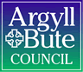

Standards and Quality Report 2024 - 2025

Keills Primary



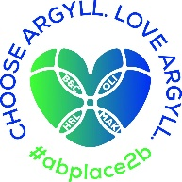


Context of the school
Keills Primary School is a non-denominational and co-educational school situated in the village of Keills on the island of Islay. In session 2024/25, we had 25 children in P1-7 in August 2024 and 5 children in our Pre 5 unit. The school roll increased to 27 pupils in May 2025 and the Pre 5 decreased to 4 in May 2025.
School staffing is 2.96 FTE. Staffing this session consisted of a part time Principal teacher (0.6) and three 0.6 Class teachers. A Shared Head Teacher who works 2.5 days (0.5). We have two full time Childcare and Education workers and a 20hr classroom assistant for the ELC. We also have a classroom assistant for 9.5hrs and ASN support assistant for the school working 30hrs between both classes.
The school is a relatively modern single storey building with two classrooms, one large open plan classroom which provides teaching bases for the P1-3 school pupils and those pupils who attend the Pre 5 unit and one classroom for P4-7. There is a large hall which functions as a dining room and PE hall. Our Pre 5 unit underwent a refurbishment in the summer and a dividing wall with double doors was created in the large classroom.
The school has a large grass area to the rear with trim trail, huts and hard surface play areas.
In session 2024/25, approximately 18% of pupils resided outwith the school catchment area.
The majority of pupils require bus transport (75%) given the sparse location of housing settlements on Islay.
Our attendance as of June 2025 was 95.96%.
Our Vision: At Keills, we strive for our children to flourish, be creative, become caring local and global citizens, be themselves and be celebrated for who they are.
Our values: Respect, Compassion, Creativity and ‘Can Do’.
We aim to:
O Ensure our children reach their full potential by showing determination and resilience, using skills for life and having a positive Growth Mindset
O Be creative, imaginative, problem solve, and work together to achieve inside and outside of school.
O Be kind and considerate towards all, supporting each other to always make the right decisions.
O Listen to each other and make sure everyone has a voice.
O Ensure that Children’s Rights are at the heart of everything we do!

Keills Primary is situated in the village of Keills in the northeast of Islay. We sit near the ferry port village of Port Askaig.. The main industries on Islay are; Whisky Distilling, Farming, Fishing and Tourism. Access to the island is by ferry or plane.
Being an island school within a strong local community rightly influences our place-based learning curriculum design.

In June 2025, Keills PS earned GOLD status in the Rights Respecting schools Award. A Rights Respecting Gold school in Scotland is a school that has achieved the highest level of the UNICEF UK Rights Respecting Schools Award (RRSA). This Gold accreditation signifies that the school has fully embedded children's rights throughout its policies, practice, and ethos, using the United Nations Convention on the Rights of the Child (UNCRC) as its foundation.

Review of SIP | Priority 1
QI approach to improving writing
Progress and Impact:
Work on this priority has led to the following outcomes:
The implementation of Pareto Charts provided a data driven and highly effective method for teachers to identify and prioritise specific areas for targeted teaching. This maximised teaching efficiency and student outcomes as evidenced in teaching observations. The Pareto Charts indicated the areas for targeted as Conjunctions followed by Punctuation.
The multi-composite class had clear stretch aims for overall pupil progress and at least 2 specific teaching aims relating to measurable tools for writing skills. By May 2025 ​​67% of pupils ​​will be on track ​​for their age and stage.​​
Targeted aims for each stage were also created as follows:
P5:
1 - By October 2024, 100% of children can link 5 sentences using 5 different conjunctions.
(Baseline 50%) This target was met in October.
2 - By October 2024, 100% of children can create 5 sentences using 5 different forms of punctuation.
(Baseline n/a or 0%) This target was met in October.
P6:
By October 2024, 100% of children can link 6 sentences using 6 different conjunctions.
(Baseline 0%) This target was met in October.
2 By October 2024, 100% of children can create 6 sentences using 6 different forms of punctuation.
(Baseline 0%) This target was met in October.
P7:
By October 2024, 100% of children can link 7 sentences using 7 different conjunctions.
(Baseline 0%) This target was met in October.
2 - By October 2024, 100% of children can create 7 sentences using 7 different forms of punctuation.
(Baseline 15%) This target was met in October.
Both teachers implemented the writing bundle in full, including sharing run charts with pupils.
All pupils were be able to talk about their progress and next steps both individually and as a class. This was evident in teacher observations.
Before and after measurements of pupil engagement demonstrated an increase in enjoyment of writing. This was evident through the pupil voice statements. Comments included:
I’d like 10 minutes editing time (P6).
We’d like to use Word on our 1-1 devices (all logged in Week 3) – Various across P5, 6 and 7.
We like the rewards and the chart going up (Various).
We really like the Literacy Shed (for videos) and we watch them at home (P5).
I'm trying short writing targets as extra homework (P7).
Through discussion with HT, teachers overwhelmingly reported enjoying teaching writing during this project including indicating a positive and engaging learning environment for pupils.

By May 2025, the overall stretch aim for P5-7 of 67% pupils being on track was not met. 60% of children were on track with one pupil discussed and agreed that they would meet the appropriate level by October 2025. The baseline for this aim was 47%. An increase of 13% was therefore evidenced over this year.

The integration of writing across the class planning demonstrates a strong commitment to literacy development and a recognition of its importance in all areas of learning.

Next Steps:
Continue to embed this writing strategy and include the new P5 cohort in this work next session.
Look at involvement of parents and seek views on how we can increase parent engagement and understanding i.e. Parent workshops, display of learning, sharing practice on learning.

Review of SIP | Priority 2
Whole School Play Pedagogy (Year 2)
Whole staff sessions on Play pedagogy took place and this became a focus for the cluster TLC meetings. A professional learning folder was set up on the shared drive to allow staff access to reading on play pedagogy. As a result of this work, staff gained a greater understanding of play and this began to support them in identifying key priorities within their class practice to promote play based learning.
In the P1-4, the classroom environment was set up to encourage a play based approach. Observations evidenced children having increased access to play based learning experiences.
All learners are highly engaged in the environment, regularly taking the lead initiating diverse play experiences. Older pupils are supporting younger in play experiences. This has been particularly effective with a P2 pupil who has difficulty engaging in direct teaching. Over the year this pupil has been observed initiating play and is demonstrating key skills that this approach offers including problem solving creativity and collaboration.
Resources were placed to enhance the environment giving children ease of access. This is evidenced through children’s access to a wide variety of play materials which is developing their play based skills.
In P5-7, the class teacher has effectively planned for increased child led planning through IDL and an additional Endeavour project. Children have also been involved in planning using Es and Os. This is helping to further improve pupil voice and children having an increased sense of ownership over their learning. This has been evidence in pupil feedback. Digital technologies have been used effectively to promote play.
Whole school, weekly, timetabled play (indoor or outdoor) for all children has been implemented. Staff balance a mixture of child initiated provocations and free play. This has resulted in the whole school and Pre 5 playing together.
Observations and collated data from pupil conversations at the end of this year has shown that pupils:
Feel like they have more play opportunities across the week.
Have a greater understanding of the benefits of play noting skills such as teamwork, communication, problem solving and creativity.
Feel that they have more ownership over their own learning.
Observations and collated data from staff conversations at the end of this year has shown that staff:
Have a deeper understand of what play looks like in a school environment and that this may look different in a P1-4 and P5-7 class.
Show an understanding of the important of spaces, interactions and experiences
Next Steps:
A play policy to be developed along with staff, children and parents.
Further engagement with parents-Workshops to raise awareness.

Review of SIP | Priority 3
Curriculum Design Rationale
Progress and Impact:
All school staff, led by HT, worked through the following components of the Northern Alliance Curriculum Rationale Toolkit:
1. What is your Moral Purpose?
2. What is your Why?
3. Vision Values and Aims
4. What is meant by curriculum?
5. What is a Curriculum rationale?
6. Our Curriculum Rationale
Sessions prompted a deeper thinking of what is important in the current culture of education and views were sought to determine if our curriculum matched these needs. Staff engaged well and reflected on current practice. There was a high level of agreement on what our curriculum should prioritise. HT observations and staff views evidenced a clear and sound understanding of Curriculum Rationale in the current climate.
A parent workshop was held to gain views on what is important to parents in terms of curriculum and what makes Keills unique.
Views were collated and included common themes between staff and parents including, island rural context, outdoor learning, Rights Respecting, VVA at the heart, Early Years, skills for lifelong learning and child led learning/play pedagogy.
Before the start of this work, staff had limited knowledge of Curriculum Rationale, as result of these sessions, staff are able to talk confidently about their progress though the development of a curriculum and the benefits to learners.

Next Steps:
The final session in September 2025 will focus on designing a curriculum Rationale. Following this, the following consideration will be discussed ( Year 2 actions will be detailed in SIP)
● How will this be shared with all stakeholders across your school community?
● How is this lived in the experiences, spaces and interactions within your school or setting?
● How does everyone know it, see it, live it?
● What does this mean for your curriculum?
● What needs to be adapted, adopted or abandoned?
- How does our Curriculum Rationale fit with the new A&B Vision ‘Thriving Together’?

Review of SIP | ELC Priority
Self-Evaluation and Improvement planning
Progress and Impact:
Practitioners undertook the following actions:
Joint Training sessions with HT and shared ELC held to build knowledge and understanding of the following Indicators:

How Good Is Our Early Learning and Childcare (1.3/2.2/2.3/3.1/3.2)

Care Inspectorate Quality Framework (CIQF) (1.1/1.3/2.2/3.1/4.3)

Practitioners evaluated and created action points for each indicator along with proposed dates for completion.

This was supported by QI visits from EY team and HT walk rounds focussing on the QIs.

Impact:

Evaluation is now increasingly based on concrete evidence rather than assumptions.

The new Childcare Worker's confidence in the guiding frameworks that underpin our principles has grown significantly.

A culture of continuous reflection and improvement within the ELC has been established. It has helped track progress against established goals and adapt strategies as needed.

A culture of professional learning among practitioners. By reflecting on their own practice, engaging with research, and receiving feedback, practitioners have identified areas for improvement within the ELC.

Staff now possess a significantly clearer and deeper understanding of the HGIOELC Quality Indicators and their associated themes, leading to more informed practices.

All CCEWS have developed a clearer understanding of High-Quality Practice Features and Challenge Questions, demonstrating how these tools facilitate effective self-evaluation for continuous improvement. This is clearly evidenced in Head Teacher discussions.

Improvement folders and self-evaluation floorbooks have been established to systematically track and showcase our continuous progress, offering a clear narrative of improvement over time.

All staff can confidently articulate our improvement journey, highlighting the direct impact each action has had on learners
Next Steps:
Continue to embed the ongoing process of self-evaluation linked to QIs.

1.1 Attainment Data
Attainment of Literacy Curriculum for Excellence levels 2020/21, 2021/22, 2022/23, 2023/24 and 2024-2025 (teacher judgement – confirmed levels – 5 year trend).
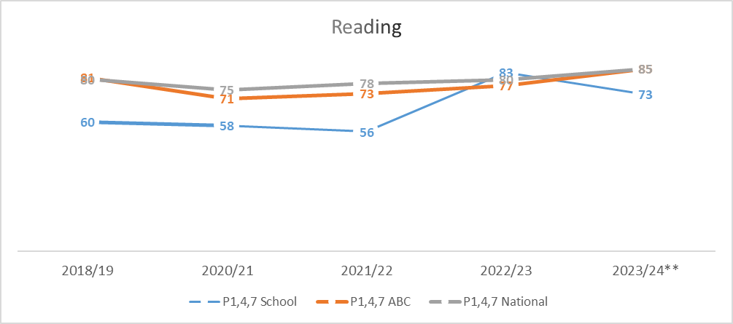
Example – Replace with school-specific data when provided
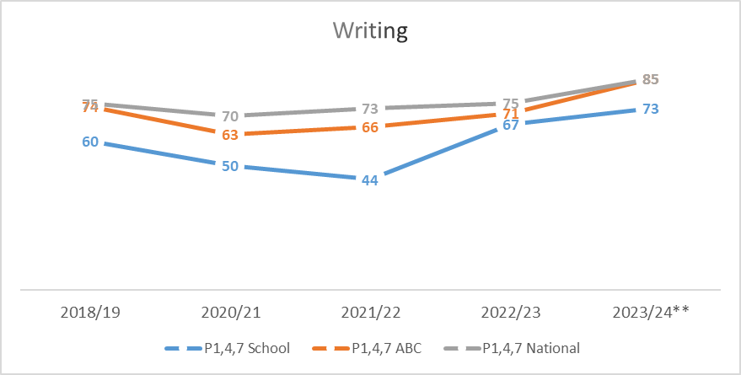
Example – Replace with school-specific data when provided
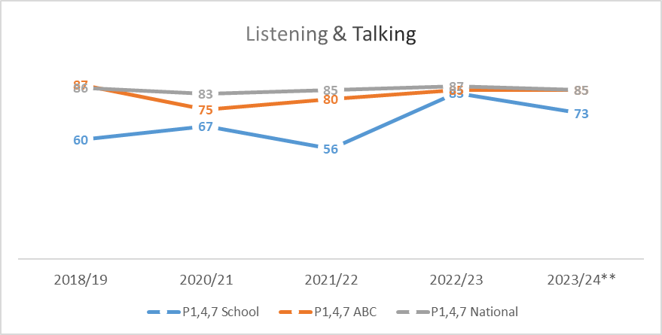
Example – Replace with school-specific data when provided

Please Note:
The above data (1.1 and 1.2) reports achievement of a level – P1/P4/P7 combined.
Due to the Covid 19 pandemic, there was no collection of ACEL data by Scottish Government in 2020.
1.2 Attainment Data
Attainment of Numeracy Curriculum for Excellence levels 2020/21, 2021/22, 2022/23, 2023/24 and 2024-2025 (teacher judgement – confirmed levels – 5 year trend).
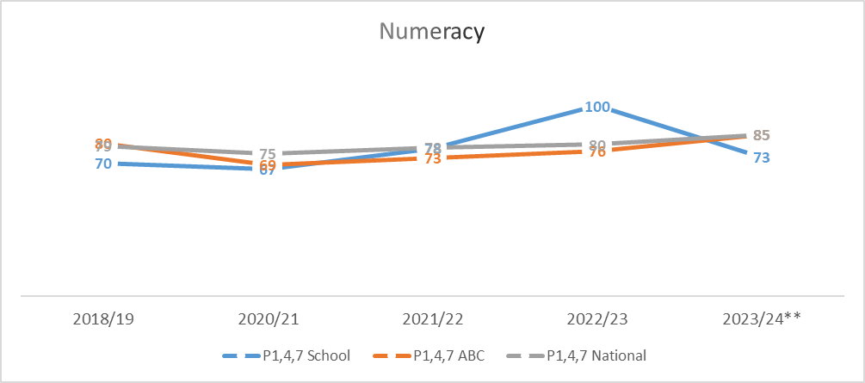
Example – Replace with school-specific data when provided

Please Note:
The above data (1.1 and 1.2) reports achievement of a level – P1/P4/P7 combined.
Due to the Covid 19 pandemic, there was no collection of ACEL data by Scottish Government in 2020.

Wider achievements
- What opportunities for wider achievement were offered?
- What systems are in place to track and monitor participation?
- How have you addressed any gaps in participation?
Wider Achievements are celebrated across the school. An Achievements wall highlights children’s achievements outside of school. These are also celebrated in weekly assemblies and on Seesaw. Children also share wider Achievements with teachers via Seesaw.
Our new Pupil Profiles also celebrate wider achievements. Children have regular opportunities to reflect on achievements, link to skills, share and celebrate these with their peers.
After school clubs aimed at all children took place this session.
P1-7 games club in partnership with MacTaggart Youth Group: 60% attendance (Full year)
Each year, all children performed the yearly Pantomime to the local community. Again this was well attended in the school and provides a platform for all our children to be part of a whole school expressive arts performance.
Children continue to be involved in fundraising events over the year. This is taken on by our Pupil Council and Rights Steering groups this year we have supported Children in Need and UNICEF as well as a pupils organising a school ‘Santa Ramble’ fundraiser to purchase new loose parts play equipment.
Our children have regular opportunities to showcase their work to the community and these events are well attended by families. These opportunities lead to increased confidence and self-belief, resilience, communication skills, teamwork and collaboration, problem solving, planning and organisation. This particularly evident in our yearly ‘Endeavour’ projects.
Our children are all involved in ‘Keills Improvement teams’ giving them an active voice to lead change in the school.
Children in P5-7 continue to receive additional funding to provide Chanter and woodwind tuition. 4 children from the P5-7 receive weekly Chanter tuition and 3 receive Woodwind instruction. Opportunities to perform are given throughout the year.
This session we have actively sought to promote and campaign on environmental issues. Our ECO team led a ‘One Planet Picnic’ and highlighted issues around Fairtrade and plastic pollution.
Our P1-4 class took part in the Pocket Garden Design competition and came 3rd overall. Comments included;
Your pupils have so much to celebrate:
Their work has already been enjoyed by the school community as well as the hundreds of strangers that voted for it.
They have supplied food and shelter for pollinators and other minibeasts, adding value and increasing sustainability of local populations
They are supplying food for people to enjoy that is locally grown, as fresh as can be without a carbon footprint
They are inspiring other pupils in the school, demonstrating what can be achieved to improve where we live and the world around us.
Keills Primary also gained the GOLD Rights respecting award in June 2025. Comments from assessors included:
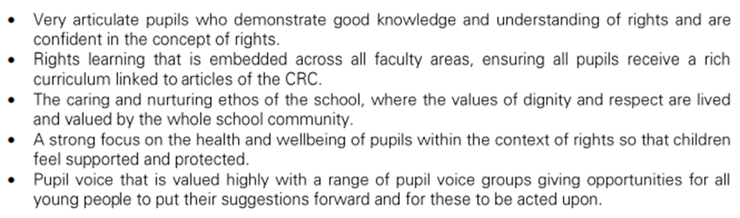

The school also gained their 3rd ECO flag in June 2025.

Pupil Equity Funding
Summarise progress and next steps in relation to pupil equity funding

Progress and Impact:
Due to our low numbers, many interventions are implemented school-wide to effectively target and support all children impacted by inequity.
Hope Spot £600 (Resources, additional day session and school mural completion)
This whole school project was not initially planned for. It was already part funded but we requested additional workshops based on observations of pupil engagement.
Whilst inherently this was a funded creative project, teacher observations evidenced that all children were fully engaged in this process and the project enhanced well-being for many of our learners. This project set out to enhance the confidence and self-expression of our whole school, leading to greater engagement in school activities. Teacher observations noted that children were not only fully engaged during the creative sessions, but either side of these sessions in other curricular areas. This was also noted in targeted children based on rural isolation/larger families. One child who we highlighted as being particularly isolated has found it difficult to engage in much of her learning this year. This project captured her attention and fully immersed her in the process. Teacher observations noted a significant increase in involvement and well-being (Leavens scale results)
In the short term, this project has increased confidence, taught new skills (mural making) increased engagement and improved well-being. 25 pupils participated (100%) Pupil survey comments noted the following: ‘I love this work!’ ‘I loved the visit to the RSPB, it helped me with ideas for my art work’ ‘We have a mural that will last forever!’
The finalised mural will be on display at a local Gaelic college over the summer before being placed in the school. While the final art product is important, the process of creating is where the most significant outcomes occurred. A feedback session with teachers and collaborators highlighted that participants demonstrated collaboration, problem solving, resilience and self-expression.
This mural will be showcased after the summer where parent and community members will be invited to the school. Pupils will have the opportunity to talk about the work.
We had planned a parent workshop, however, time did not allow for this. It is our intention to continue our partnership with the local artist. We have asked her to quote us for parent sessions and after school clubs to build on this engagement. This will be funded by PEF for next session.

Transport to swimming. £720 (6 x Journeys to local swimming pool)
This funding has allowed us to access swimming for the whole school this session. This funding has allowed us to increased engagement to all children this year. Previous years have only targeted P5-7 children.
Swimming lessons contribute to the broader goal of PEF, which go beyond just academic to include health, wellbeing and engagement.
Due to the location of Keills, access to local amenities is a barrier and requires the hiring of a bus to transport children. We strongly feel that using PEF to fund transport removes barriers to participation and ease equity of access.
Funding access to swimming lessons for all children (P1-7) has provided equitable access to this life skill.
This was also a request from our parents during the 2024 whole school survey.
Baseline surveys found that within the school 5 children (20%) did not attend the local swimming pool, 40% were not confident swimmers with 8% (2 children) having never been to a pool (or very rarely)
As a result of funding transport for 6 sessions: 40% of children are now attending swimming more regularly. 20% are now signed up to weekly swimming lessons. 85% feel more confident in the pool.
Parent feedback has been overwhelming positive regarding the P1-4 class being in attendance and has highlighted increased confidence amongst our youngest learners. Parent comments also highlight access and one parent commented that the school swimming lessons are the only time that they can get their child to the pool.
Children have reported increased self-esteem, self-confidence and enjoyment in the pool.
Teachers, including the swim teacher highlighted the progress of many of our reluctant swimmers and through discussion with the child swim coordinator, more children from Keills PS are attending swimming lessons out with school.

Music making: £240 YMI Tutor Fee. £730-Purchasing of Drums
Identified need for more after school clubs at Keills (parent survey 2024) The opportunity arose to provide an after school club aimed at older children (P3-7) Currently, music is offered on a one to one basis (woodwind/chanter) to pupils. The aim of this club was to offer larger group music making sessions- This would indirectly enhance literacy and numeracy, increase engagement and boost confidence. These sessions were also set up to promote wider access to music opportunities and remove any barriers of cost.
Unfortunately, the uptake of this club was low. We began with 10 (P3-7) children (40%) uptake and this gradually dropped to 4 (17%) children after 4 weeks of running the club. Reasons for drop out were lack of interest, children wanting to just play at the end of a school day. Although these sessions were designed to be fun and engaging, the timing of after school was not working.
Discussions will take place in August 25 to continue this project but deliver during school hours to increase uptake. A more strategic and creative delivery will be considered including some parent/pupil workshops to capture interest and strengthen parent/school links.

.

Quality Indicator | How are we doing? | How do we know? (Evidence) | School Self-Evaluation (1-6) *
1.1 Self-Evaluation for Self-improvement | All staff, parents and pupils are regularly consulted and involved in improving life and work of the school.  Regular opportunities for parent views through Google Forms and PC meetings.  Regular opportunities for pupil views through weekly assemblies and consultations.  Staff work effectively as a team. All involved in SIP.  Children involved in aspects of school improvement.  Children regularly reviewing own learning.  Staff engage in up to date research and relevant literature to inform practice.  Parents have regular opportunities to support improvement. | Collegiate Calendar developed in consultation with staff. Quality Assurance Calendar developed.  Regular staff meetings through course of the year to address SIP priorities.  Parent and pupil consultations. Results actively used in SIP planning.  All pupils in Improvement Teams. Views sought and acted upon.  Regular opportunities for joint planning within school and between cluster schools.  Pupils review work and set next steps both verbally and by recording in jotters.  Pre 5 staff engaged in reading tasks relating to Realising the Ambition document, Literacy and Numeracy tracking and assessment.  PTA support with funding resources and transport. | 4
1.3 Leadership of Change  This QI also focusses on the following aspects of empowerment:  - curriculum;  - improvement activities;  - parental and community engagement; and  - pupil participation. | All staff have high expectations of all learners.  All staff have a clear understanding of local context and use this to shape vision.  All staff clear on areas of improvement and future vision of school.  Staff are involved in leading change throughout the school.  Children are involved in leading change across the school | Regular dialogue at staff meeting regarding expectations, vision, evaluations and improvement.  Staff live locally and have established relationships with families.  Children involved in redesigning VVA. Linked to HWB curriculum and RRSA work.  Children involved in developig a new relationships policy.  Opportunities for staff to attend collegiate meeting with cluster schools eg. TLC and Moderation meetings.  Regular HT consultations with stakeholders on areas for improvement.  RRSA GOLD Status Award.  PRD meetings highlight areas for staff CLPL and opportunities to lead aspects of school improvement.  Staff attending CPD events relevant to SIP and own development needs.  Staff are given areas of SIP and are supported by HT.  PT supports CT and Pre 5 staff when HT not in school. | 5
2.3 Learning, teaching and assessment | Children are motivated and active participants in learning.  New planning formats developed to allow for high quality learning experiences.  Learning experiences are varied and use high quality resources now including digital technologies.  Learners receive high quality feedback and create own next steps.  Learners are involved in learning process.  Tracking and monitioring is now in line with XBRA and being used effectively. | Robust Quality assurance calendar created to ensure a variety of evidence (Observations, pupil conversations, jotter monitoring, peer shadowing)  HT and CT tracking meetings taking place using various evidence including assessments and teacher professional judgemements alongside benchmarks.  Pre 5 milestone and tracking meetings take place to assess progress and plan next steps.  Pre 5 Literacy and Numeracy tracking meetings.  Shared expectations across learning community and authority wide with moderation activities (TLCs and INSET Moderation session)  Learners activley involved in decision making around planning across school and including Pre 5. | 4
3.1 Ensuring wellbeing, equality and inclusion | Staff and Pupils Wellbeing placed as high priority each year.  Staff and pupils have a shared understanding of wellbeing and learners can demonstrate how to be safe, healthy, achieving, nurtured, active, respected, responsible and included.  Positive relationships across school community.  Staff model behaviour which supports wellbeing of all.  Children are active participants in discussions and decisions.  Children with additional learning needs supported with interventions.  Outdoor space used more to enhance learning experiences and wellbeing. | Rights Respecting School award: GOLD  Regular staff check in meetings.  Regular Leavens observations for children and scores tracked, interventions in place if required.  Weekly whole school and Pre 5 assemblies on Wellbeing Indicators, school values and Rights.  Staff, pupil and parent feedback on positive and supportive ethos of school.  School Improvement Teams actively involved in leading school change.  HT observations, term 1 based on learning environment.  Keills Improvement Teams led by children  Regular involvement of children in discussions around school improvement at assemblies.  Allocated classroom assistant time given to interventions to raise attainment and support pupils.  Island partnerships established and new partnerships recently formed. | 5
3.2 Raising attainment and achievement | Attainment levels are a central feature of SIP.  Interventions/catch up plan/additional teacher put in place to support pupils not on track to achieve a level.  Children involved in decision making relating to own learning. | Literacy and Numeracy Data tracked from termly Progress and achievement tracking meetings. XBRA tracking used.  HWB information tracked over time using Leuvens Scales.  Interventions planned, monitored and evaulated termly.  Teaching judgements are made using benchmarks and range of assessments including baselines, standardised assessments and evidence from forward plan evaluations.  Planned time for pupils to be active participants in learning process. Setting Success criteria, self assesment and setting next steps all part of class practice.  Attendance levels are high. No exclusions.  Achievements regulary celebrated by CT and HT.  School and individual achievements shared with local paper, school Twitter and Seesaw. | 4

Evaluation 6-point Scale
6 Excellent
5 Very Good
4 Good
3 Satisfactory
2 Weak
- Unsatisfactory

