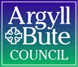

Standards and Quality Report 2021 - 2022
Name of school
Keills Primary

Context of the school
Including some or all of the following:
- basic school details (roll, class composition etc.)
- school vision, value and aims;
- local contextual issues;
- factors affecting progress (e.g. staffing changes/issues).

Keills Primary School is a non-denominational and co-educational school situated in the village of Keills on the island of Islay. From August 2022, we will have 37 children in P1-7 and 4 children in our Pre 5 unit.
School staffing is 3.02 FTE. Staffing this session consisted of a part time Principal teacher (0.6), a full time class teacher, a part time class teacher (0.8) and a Shared Head Teacher who works 2.5 days (0.5). We have two part time Childcare and Education workers and a part time classroom assistant for the ELC We also have a classroom support assistant and ASN support assistant for the school.
The school is a relatively modern single storey building with two classrooms, one large open plan classroom which provides teaching bases for the P1-3 school pupils and those pupils who attend the Pre 5 unit and one classroom for P4-7. There is a large hall which functions as a dining room and PE hall.
The school has a large grass area to the rear with trim trail, huts and hard surface play areas.
Our Vision: At Keills, we strive to provide a safe, caring learning environment where mutual respect and tolerance are fostered and pupils can achieve their full potential in all aspects of the curriculum.
Our values: Excellence, Respect and Friendship.
A long term staff absence and reduction in hours for our P5-7 teacher has significantly impacted on the school’s SIP progress this session. Priority 1 (Numeracy) will be carried over to next session.

Our values: Excellence, Respect and Friendship.

Review of SIP | Priority 1 Raising attainment in Numeracy
Progress and Impact:
Staff were consulted on Numeracy and Mathematics across the school and effectiveness of current planning and frameworks. It was identified that a consistent framework and planning format was required.

The Northern Alliance Numeracy learning progressions were introduced. A New termly planning format for Numeracy was developed and included opportunities for assessment, outdoor and parent involvement.

Staff training sessions were delivered on use of Northern Alliance documents and staff knowledge confidence has increased with these discussions and input.

Long term staff absence and a reduction in hours has significantly affected the opportunities for staff to meet collegiately for input.

Baselines were introduced to ensure effective tracking system in line with XBRA.

PEF funding has allowed us to purchase Sumdog and observations has shown that this has increased pupil engagement.

Additional teacher hours were allocated and an additional teacher was brought in to create and deliver a catch intervention programme up for our P2 cohort. However, we were unable to fill this post. A temporary classroom assistant was appointed and this support was used in our P4-7 class.

This impacted the progress of our P2 cohort, however, the majority (5/8) achieved Early level by October 2021 and all have achieved in June 2022.

For our P1 cohort 2/4 learners achieved Early level in June 2022.

The P4-7 input resulted in support for our P4 and P5 cohort this session. This cohort still require intervention as 2/9 P4s achieved First Level with 7/9 at the Reinforcing and Applying stage. 2/5 P5 learners are on track to achieve a level. All P6 learners are on track and P7 were Applying in June 2022.

Numeracy will continue to be a priority in next year’s SIP, where targeted support will be delivered and a further audit of practice along with professional learning resources will be put in place.

Observations and jotter monitoring has evidenced a range of teaching strategies and a focus on Concrete, Pictorial and Abstract learning. Children are aware of their learning, have elements of choice in applying strategies to solve problems and maths is also taken outdoors.

Support for parents (workshops) to encourage development of skills at home was impacted for the first three terms with Covid restrictions. This will be continued next session.
Next Steps:
SIP Priority to continue next session.
Review of SIP | Priority 2 Further develop delivery of outdoor learning curriculum
Progress and Impact:
Staff initially engaged in development opportunities and in house training with Key documents/resources (CFE and Ed Scotland resources) Staff SIP review evidenced an increase in staff confidence in the delivery of an outdoor curriculum and ensuring that outdoor learning is considered when planning at the start of a term.

Pupils are involved in development of school grounds-Resources have been purchased to aid delivery of outdoor learning curriculum and utilise school grounds.

Outdoor space has been utilised effectively and this has enhanced teaching practice allowing learning to be taken outdoors. Staff feel more confident in using outdoors to enhance learning.

PEF Funding was used to purchase waterproof clothing. This has resulted in increased time outdoors in all weathers. Pupil and staff surveys note that children have a greater sense of ownership of outdoor space.

Observations evidence that pupils are involved in planning outdoor activities linked to areas of the curriculum and outdoor learning opportunities are recorded in curricular planners.

There has been an increase in opportunities for off-site visits. P5-7 set up a partnership with a local estate and have been involved in visits linked to a conservation topic. They have also re-established links with the RSPB and we were a trial school for a Corncrake project delivered by the RSPB.

In the recent pupil survey (June 2022) all children can state benefits of outdoor learning in terms of social skills, creativity, teamwork, leadership and problem solving. Staff have also noted a greater sense of children risk assessing outdoor play. Observations has evidenced children playing more together and older children supporting younger.

Teacher observations show that children are growing more independent and are given the opportunity to achieve beyond core curricular subjects.

Outdoor learning activities continue to be a feature on our Shared Learning grids to involve parents and families. Feedback from this homework shows that parents enjoy this aspect of grids.

A P6/7 Cluster outdoor learning residential has been organised for Feb 2023 bringing all Islay and Jura schools together.
Next Steps:
Launch an Outdoor Policy.
Continue to build partnerships. Apply for funding and utilise PEF to take children further ‘off island’.
Secure additional funding for more loose parts play.
Continue with the School improvement teams ensuring that pupil voice is heard and acted upon.

Review of SIP | Priority 3 Improvement in opportunities relating to UNCRC-Rights Respecting School Award
Progress and Impact:
The school has been awarded Rights Respecting Schools status; Bronze award, rights committed.

Action plan key features and impact:

- Staff CPD session. Coordinator to introduce RRSA and the UNCRC to teaching staff. Staff to complete Questionnaire.
- Coordinator to introduce to all P.1-7 pupils, RRSA and UNCRC using UNICEF resources.
- Pupil Steering group formed to audit and create an action plan.
- Steering Group/Pupil Council to promote the UNCRC around school i.e. in each classroom, hall, staffroom and on Pupil Council Notice Board.
- Coordinator to send letter to parents explaining UNCRC and RRSA (UNICEF resource).
- Wednesday Improvement Teams meeting to raise pupil awareness of UNCRC and link to SHANARRI indicators.

Outcome: Children, young people and the wider school community know about and understand the UN Convention on the Rights of the Child and can describe how it impacts on their lives and on the lives of children everywhere.

- Work will be shared online via Seesaw to allow parents to view learning and through School Website for wider community. Parents will be encouraged to engage with discussions at home with their children on how that right is experienced/supported/promoted at home.
- HT through school assemblies will promote and reinforce RRS work undertaken applying rights language, reference to display and posters (articles) around the school.
- Opportunity through group work and Pupil Council meetings, will allow the children to identify issues and address how we can work together to improve experiences.
- Positive relationships will continue to be promoted through PATHS (Promoting Alternative Thinking Strategies) across the school, with strategies continuing to be developed to assist children at all levels to resolve issues independently or with some or little support, using rights respecting language
- Nurture work (one-to-one or group meetings with PT/HT) will continue to provide support to those children who require it.
- Opportunities through Pupil Council meetings for children to share views about their school by applying the 3Cs during meetings. Raising the importance of identifying areas that are working well being recorded in the ‘Compliments’ section and areas of ‘Concern’ or ‘Complaints’ to be addressed. Promoting the positives as much as raising the needs.

Outcome:
In school children and young people enjoy the rights enshrined in the United Nations Convention on the Rights of the Child.
Relationships are positive and founded on dignity and a mutual respect for rights
Children and young people are safe and protected and know what to do if they need support.
Children’s social and emotional wellbeing is a priority. They learn to develop healthy lifestyles.
Children and young people are included and are valued as individuals.
Children and young people value education and are involved in making decisions about their education.

- Article 12 (child’s voice) will be encouraged during all whole school meetings. Thoughts and ideas will be valued and where appropriate will be implemented to enhance the school learning environment/resolve issues.
- Pupil Council will take an active role in promoting children’s views and taking forward issues and aiming for appropriate solutions.
- Communication with Pupil Council and Parent Council/Parents will be supported to raise awareness of UNCRC with an aim to promoting the children’s ability to access their rights.
- Teachers during class teaching, where relevant, will highlight rights using the rights language and referring to CRC posters on display.
- Whilst linking the SHANARRI indicators to the articles and identifying how the school supports children to enjoy their rights, opportunity will be given to broaden the children’s knowledge and understanding of Local and Global issues. These issues may be current or on-going. Children in their groups will be encouraged to discuss why children are not able to access their rights and what we can do to support e.g. raise awareness and fund raising. Children will be encouraged and supported to raise awareness online via Seesaw to our parents, School Website and wider community through local newspaper (Ileach). Led by pupil councils, and supported by the school community events will be planned and implemented by children to raise funds for children who are in need.
Outcome:
Children and young people know that their views are taken seriously.
All children and young people have taken action to uphold their rights and the rights of others, locally and globally.
In a recent Pupil survey (May 2022) Almost all pupils felt they were confidently able to talk about their rights and all feel there voice has been heard and acted upon. Observations through the year along with pupil surveys evidenced that
1.Children are healthier and happier
2.Children feel safe
3.Children have better relationships
4.Children become active and involved in school life and the wider world
Next Steps:
Continue to work on action points in the Action plan for Silver and prepare for accreditation visit.
Involve parents further in awareness raisin.
Review of School Visions, values and aims – pupils, with the support of staff, will begin to reflect on the school’s current vision, value and aims in line with RRS and CRC - School Charter.
Review of SIP | GME Priority
Progress and Impact:
Next Steps:

Review of SIP | Developing in Faith Priority
Progress and Impact:
Next Steps:

1.1 Attainment Data
Attainment of Literacy Curriculum for Excellence levels 2016/17, 2017/18, 2018/19, 2020/21 and 2021/22. (teacher judgement – confirmed levels – 5 year trend).
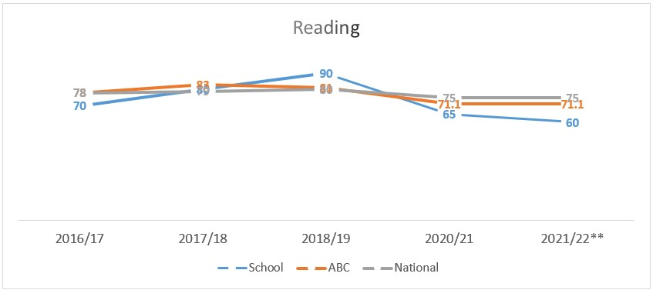
Example – Replace with school-specific data when provided
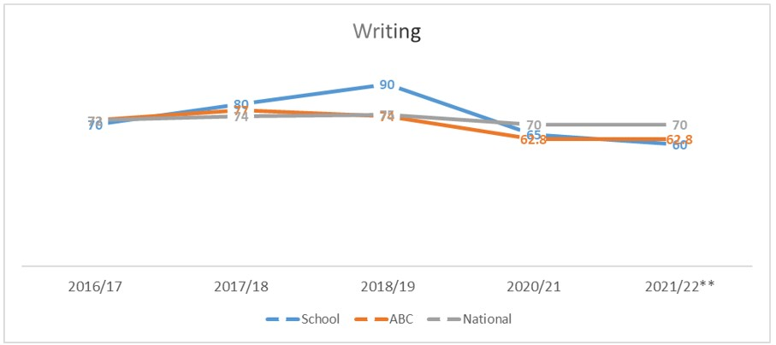
Example – Replace with school-specific data when provided
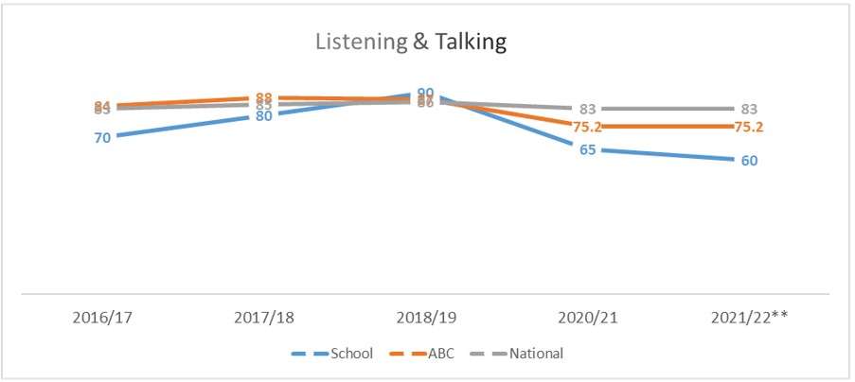
Example – Replace with school-specific data when provided

1.2 Attainment Data
Attainment of Numeracy Curriculum for Excellence levels 2016/17, 2017/18, 2018/19, 2020/21 and 2021/22. (teacher judgement – confirmed levels – 5 year trend).
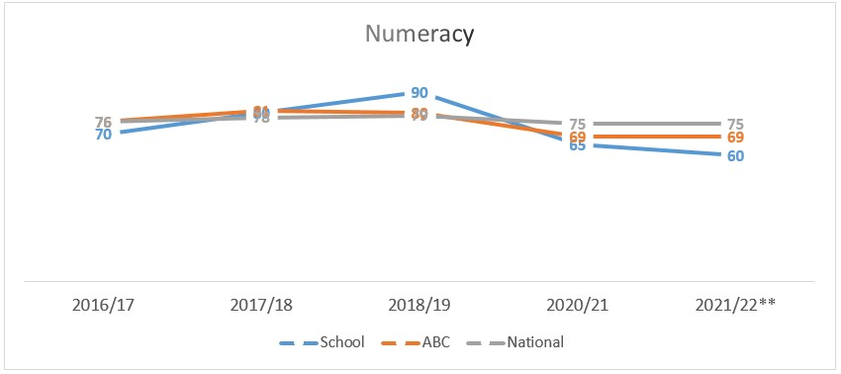
Example – Replace with school-specific data when provided

Please Note:
The above data (1.1 and 1.2) reports achievement of a level – P1/P4/P7 combined.
Due to the Covid 19 pandemic, there was no collection of ACEL data by Scottish Government in 2020.
Overall quality of our learners’ wider achievements Highlights of session 2021 - 2022
Rights Respecting Schools Award: The school’s work on engaging with the UNCRC and involving all pupils in ‘Keills Improvement teams’ was recognised and we received Bronze status: Right committed.

Pupils have regular opportunities in class and during assemblies to celebrate wider achievements. Pupils were able to showcase at the Leaver’s assembly this year.

Pupils in P5-7 worked with a local Rugby coach and took part on a inter island competition.

Teambuilding sessions for p5-7 were set up with Port Charlotte and Small Isles on Jura. These gave our children opportunities to visit other children across islands and this also formed our P7 transition project.

We have been involved in the Treoir Gaelic creativity project and our P1-3 class worked with local island based artists over two terms. Gaelic, creativity, art and music were the focus for these sessions.

Islay music festival outreach worked with our P5-7 class with sessions on singing, fiddle and accordion.

Our Pre5 have re-established link with the local farm and regularly take children on visits to learn about the culture of the island.

Lunchtime clubs were set up giving pupils opportunities to lead and take part in a wide range of activities-Reading, art and crafts and digital tech. These were well attended and will be built upon next session.

A gardening group (Pre 5-P7) was established and led by our Classroom assistant.

Restriction did impact these opportunities at the beginning of the session and we hope to build on the success of Term 4 next session.

Comment on strategies that have been successful in engaging with children and young people, staff, parents and the wider community and the impact of these.
Seesaw has been an effective tool in engaging parents in the life of the school and Pre 5. We have built on previous success with this platform. We are beginning to get children to choose samples of work they are proud of to share with parents. Parents have been able to comment and provide feedback to children. Parents have also been able to share home experiences with ELC and school staff. Informal annnouncements from teachers have also been useful engaging parents. All families in Pre5 and the school are actively using Seesaw and feedback from parent surveys is very positve on this method of parent engagement.
As we are a small school (35 pupils), we have opted to work together, staff and pupils on a regular basis. In the main the RRSA work is undertaken on a weekly basis with the whole school (staff and pupils). Children work in groups with a Steering Group (Reporter) included in each. Adults work to support groups as they learn and develop. We have currently, as a whole school, agreed to call our ‘gatherings’ as KIT meetings (Keills Improvement Team) as we also use the opportunity to cover other work linked to RRSA during that time e.g. ECO Schools, Pupil Council Meetings, whole school curricular activities, fund raising events, theme days/weeks etc. KIT meetings are be led by myself (RRSA Coordinator), with staff supporting.
Regular parent consultations are carried out using Google Forms. The majority (50%-74%) parents provided the school and Pre 5 with feedback.
Keills Primary and Pre 5 Parental Questionnaire (May 2022) This is an annual consultation based on the following aspects of school improvement: Health and Wellbeing, Communication and engagement with the school, Teaching & Learning, What is going well? Even better if…
The good practice of Keills was highlighted during this survey, parent highlights below:
Of the collated responses,
All parents rated the school Health and Wellbeing 4 and 5 out of 5.
All parents rated the school Communication 4 and 5 out of 5.
All parents stated agree or strongly agree that their child has made progress in Literacy and Numeracy.
All parents stated agree or strongly agree that their child has the opportinuty to learn outdoors.
All parents stated agree or strongly agree that their child has regular feedback and takes an acitve part in their learning.
All parents stated agree or strongly agree that their voice is heard and that the school is well led and managed.
The overwhelming consensus this term was a need for parents to be back in the building. This was adressed with Stay and play sessions in Pre 5. Sports day, leaver’s assembly and face to face parent meetings were alos held in Term 4.

Comment on progress made with the following aspects of empowerment:
- curriculum;
- improvement activities;
- parental and community engagement; and pupil participation.

https://education.gov.scot/improvement/learning-resources/an-empowered-system/?dm_i=LQE,6RTY0,WAUPY4,R37A1,1
Key priorities for the SIP 2022/23 have been informed by the above consultations with Parents, pupils and staff.

Pupils are frequently involved in their own learning by teachers. Examples include, pupil led topics, creating Success criteria and setting next steps in their learning. School Improvement teams were set up to ensure pupil are involved in decision making.

Pupils are consulted on school improvement during class assemblies.

All staff are leading aspects of school improvement in the SIP.

Support staff are allocated time to feedback and plan with staff.

Partners are consulted regularly on progress and next steps for improvement (Gaelic, active schools, YMI)

Cluster schools collaborate during TLCs (Teacher learning communities) and decide on priorities to take forward.
Cluster HTs regularly meet to discuss progress and next steps in terms of Island priorities (Digital) and transition to high school.

Comment on progress made with Pupil Equity Funding, taking account of the five key areas below:
- attendance;
- attainment;
- exclusion;
- engagement;
- participation.

Raising attainment/engagement in Numeracy:
An audit at the beginning of the year highlighted the need for 5 Ipads to be purchased to complement existing number of school Ipads.
This ensured that all children has access to an Ipad or laptop to enhance delivery of the curriculum.
Sumdog was also purchased to target attainment and engagement in numeracy and staff evidenced a marked improvement in mental agility.
Seesaw was purchased and this targeted family engagement. Shared learning, homework support, work to be proud of were all shared and we were able to engage almost all families using this platform.
Waterproofs and outdoor resources were purchased to enhance outdoor learning and allow all children from Pre 5 –P7 to access outdoors. This has increased participation in outdoor activities on school grounds linked to core curriculum and has had a positive impact on opportunities to play outdoors.

Quality Indicator | How are we doing? | How do we know? (Evidence) | School Self-Evaluation (1-6)
1.1  Self-Evaluation for Self-improvement | All staff, parents and pupils are regulary consulted and involved in improving life and work of the school.  Regular opportunuties for parent views through Google Forms and PC meetings.  Regular opportunities for pupil views through weekly assemblies and consultations.  Staff work effectively as a team. All involved in SIP.  Children invovled in aspects of school improvement.  Children regularly reviewing own learning.  Staff engage in up to date reseach and relevant literature to inform practice.  Parents have regular opportunties to support improvement.  **Rating impacted this session due to long term absence and reduction in teacher hours. | Collegiate Calendar developed in consulation with staff. Quality Assurance Calendar developed.  Parent and pupil consultations. Results actively used in SIP planning.  All pupils in pupil council. Views sought and acted upon.  Regular opportunities for joint planning within school and between cluster schools.  Pupils review work and set next steps both verbally and by recording in jotters.  Pre 5 staff engaged in reading tasks relating to Realising the Ambition document, Literacy and Numeracy tracking and assessment.  PTA support with Outdoor learning resources. | 3
1.3  Leadership of Change | All staff have high expectations of all learners.  All staff have a clear understanding of local context and use this to shape vision.  All staff clear on areas of improvement and future vision of school.  Staff are involved in leading change throughout the school.  **Rating impacted this session due to long term absence and reduction in teacher hours. | Staff live locally and have established relationships with families.  Children regulary reminded about Vison, aims. Linked to PAThs curriculum and RRSA.  Opportunities for staff to attend collegiate meeting with cluster schools eg. TLC and Moderation meetings.  Regular HT consultations with stakeholders on areas for improvement.  PRD meetings highlight areas for staff CLPL and opportunities to lead aspects of school improvement.  Staff are given areas of SIP and are supported by HT.  PT supports CT and Pre 5 staff when HT not in school. | 3
2.3  Learning, teaching and assessment | Children are motivated and active participants in learning.  New planning formats developed to allow for high quality learning experiences. Reintroduction of IDL created by TLC.  Learning experiences are varied and use high quality resources now including digital technologies.  Learners receive high quality feedback and create own next steps.  Learners are involved in learning process.  Tracking and monitioring is now in line with XBRA and being used effectively. | Robust Quality assurance calendar created to ensure a variety of evidence (Observations, pupil conversations, jotter monotoring, peer shadowing)  HT and CT tracking meetings taking place using various evidence including assessments and teacher professional judgemements alongside benchmarks.  Pre 5 milestone and tracking meetings take place to assess progress and plan next steps.  Pre 5 Literacy and Numeracy tracking meetings.  Shared expectations across learning community with moderation activities (TLCs)  Learners activley involved in decision making around planning across school and including Pre 5. | 4
3.1  Ensuring wellbeing, equality and inclusion | Staff and Pupils Wellbeing placed as high priority upon return from COVID closure and throughout the year.  Staff and pupils have a shared understanding of wellbeing and learners can demonstrate how to be safe, healthy, achieving, nurtured, active, respected, responsible and included.  Positive relationships across school community.  Staff model behaviour which supports wellbeing of all.  Children are active participants in discussions and decisions.  Children with additional learning needs supported with interventions.  Outdoor space used more to enhance learning experiences and wellbeing. | Rights Respecting School award: Bronze.  Regular staff check in meetings.  Regular Leavens observations for children and scores tracked, interventions in place if required.  Weekly whole school and Pre 5 assemblies on Wellbeing Indicators and school values.  Staff, pupil and parent feedback on positive and supportive ethos of school.  School Improvement Teams set up and actively involved in leading school change.  HT observations, term 1 based on learning environment.  Whole school Pupil Council.  Regular involvement of children in discussions around school improvement at assemblies.  Allocated classroom assistant time given to interventions to raise attainment and support pupils.  Island partnerships established and new partnerships recently formed. | 4
3.2  Raising attainment and achievement | Attainment levels are a central feature of SIP.  Interventions/catch up plan/additional teacher put in place to support pupils not on track to achieve a level.  Children involved in decision making relating to own learning. | Literacy and Numeracy Data tracked from termly Progress and achievement tracking meetings. XBRA tracking used.  HWB information tracked over time using Leuvens Scales.  Interventions planned, monitored and evaulated termly.  Teaching judgements are made using benchmarks and range of assessments including baselines, standardised assessments and evidence from forward plan evaluations.  Planned time for pupils to be active participants in learning process. Setting Success criteria, self assesment and setting next steps all part of class practice.  Attendance levels are high. No exclusions.  Achievements regulary celebrated by CT and HT.  School and individual achievements shared with local paper, school Twitter and Seesaw. | 4

