Chalk Mosaic
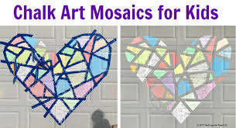

Choose any shape and tape it to the pavement or wall with masking tape. Colour each shape in with a different colour of chalk then peel off the masking tape to reveal your masterpiece!

