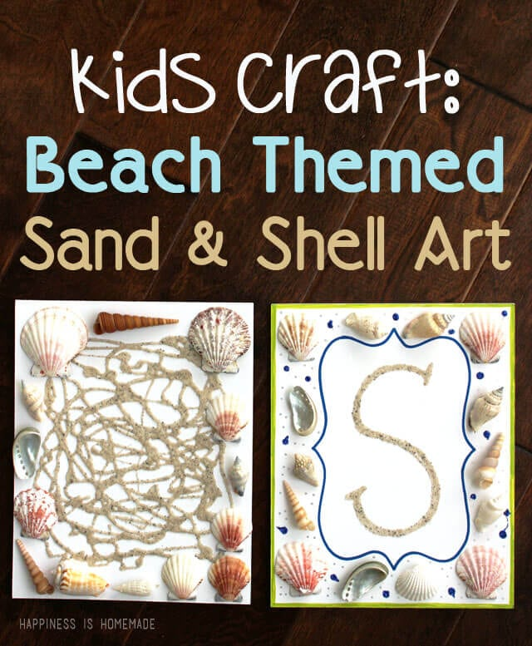

This would be a great idea of you take walks to the beach with your families!

