Monster Truck Painting

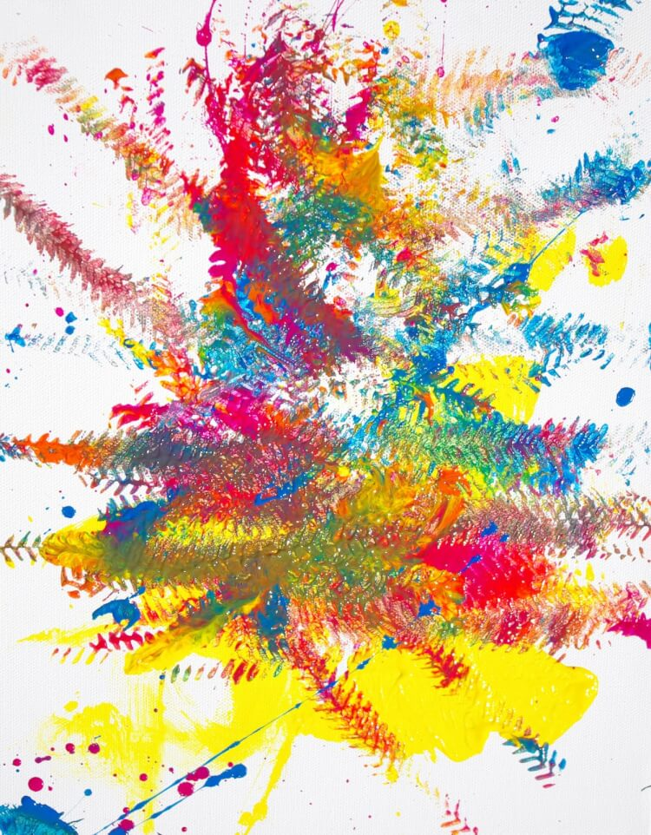

You will need: Paint and any kind of toy vehicle or animal to do footprints!

Let the children be creative and see what they come up with! This is a nice way for them to see the patterns the different vehicles make or footprints the animals make.
Have Fun!

