Pinecone Birdfeeders
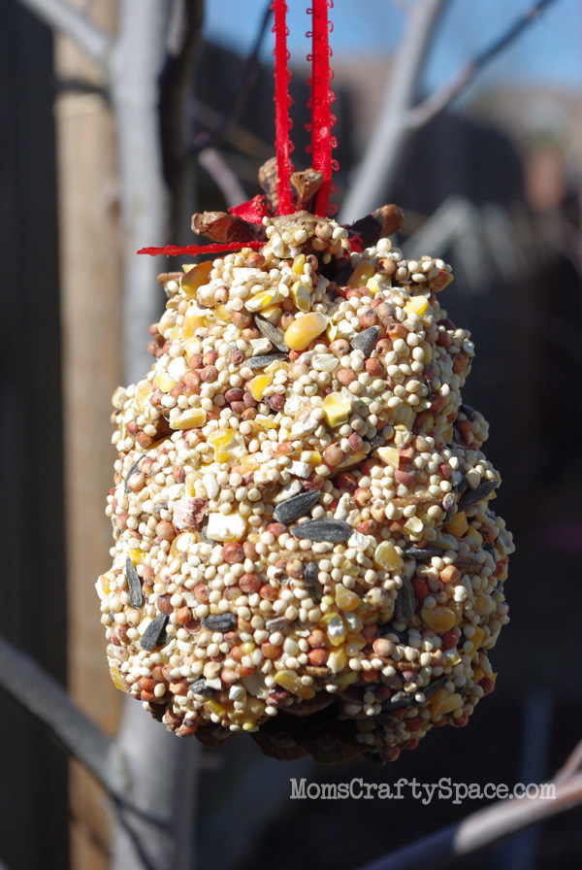
We selected a couple of pinecones that we collected on our last nature walk, and the boys got to work covering the pinecones with peanut butter.
Once your pinecone is completely covered with peanut butter, place it into the tray of birdseed. We chose to leave the very top of our pinecones un-peanutbuttered for easier handling and ribbon tying later.
Roll the pinecone around in the birdseed until it is completely covered.
Tie on a ribbon, hang it from your favourite tree, and wait for your feathered friends to come and feast!

