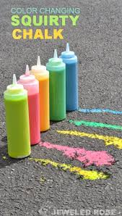
Squirty Chalk Experiment

You will need
- 2 x empty squirty bottles
- Bicarbonate of soda
- Cornflour
- White vinegar
- Food colouring
- Water
Instructions
Label the two squirty bottles A and B
Remove the lids from both bottles
Add bicarbonate of soda to bottle A until it is one-third full
Add cornflower to bottle A until another third is full - the bottle should now be two-thirds full
Add a few drops of food colouring to bottle A
Fill the remainder of bottle A with water
Fill bottle B with white vinegar
Add a few drops of food colouring to bottle B
Securely replace the lids on bottles A and B and shake hard!
Squeeze bottle A to draw a picture on the ground
Trace the picture with bottle B to see the fizzy chemical reaction!
Top Tips
Use your squirty chalk outside - a flat even surface works best
The squirty chalk can be easily washed away with water
Wear clothes you don't mind getting messy
Try using different food colourings in each bottle for a rainbow of fun!

