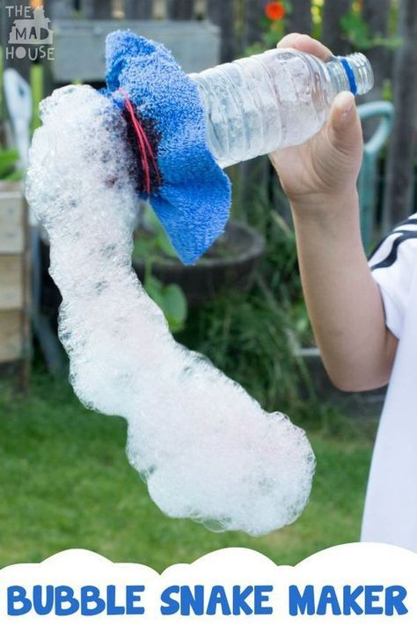
How to make a bubble snake

You will need:
- A large bowl or container to put the bubble mixture in
- Some dish soap
- A jug of water
- An old plastic bottle
- Sharp scissors (an adult will need to cut through the plastic bottle)
- An old clean sock
- An elastic band or a piece of string
First make the “snake maker”.
- Take the plastic bottle and give it a good wash
- Now cut the bottom off the bottle with the scissors. You’ll need to do this part for your child!
- Take the old sock and place it over the cut off bottom of the bottle. You can secure it with the elastic band or a bit of string
Now it’s time to get bubbly. The messy part starts here.
- Put a good squirt of dish soap into the bowl or container
- Add a small splash of water to make the mixture a bit more liquid
- Dip the sock end of the bubble maker into the liquid and give it a good soak
- Lift the bubble maker out and blow through the other end of the bottle
- Once your little one has got the knack of making bubble snakes they can add some colour. By dropping different splashes of colour on to the sock the soap bubbles will come out like rainbows

