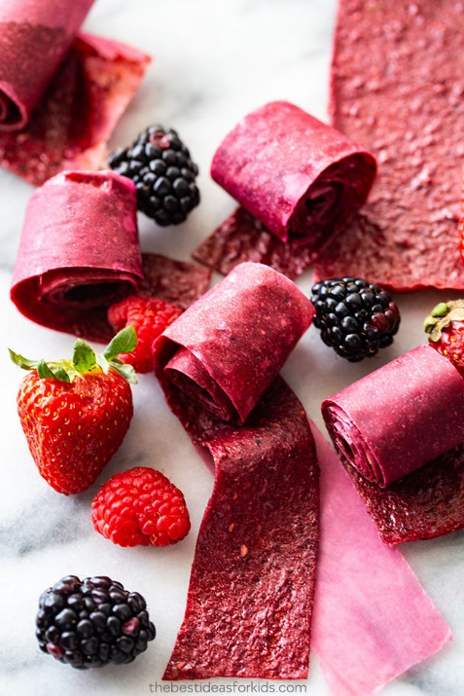
Homemade Fruit Roll-Ups

You will need:
5 cups berries
1/4 cup honey
2 tbsp lemon juice
Instructions
Preheat oven to the lowest temperature your oven will go.
Line a large (17x12 inch) rimmed baking pan with parchment paper or a silicone baking mat.
Rinse berries and remove stems from berries, if necessary.
In a blender or food processor, add the berries.
Add honey and lemon juice and then blend until smooth.
For a smooth finish, pour puree through a fine mesh strainer to remove seeds.
Pour pureed fruit onto baking sheet and spread evenly over the entire pan.
Place pan in oven and bake for 5-6 hours, rotating the pan halfway through the drying process. Remove from oven when the puree has set and is no longer sticky.
Allow the pan to cool completely. If you used a silicone baking mat, gently peel the cooled fruit leather and transfer onto a large sheet of wax paper.
Cut the paper-lined fruit leather into long strips and roll.
Store fruit roll-ups in an airtight container for up to 2 weeks.

