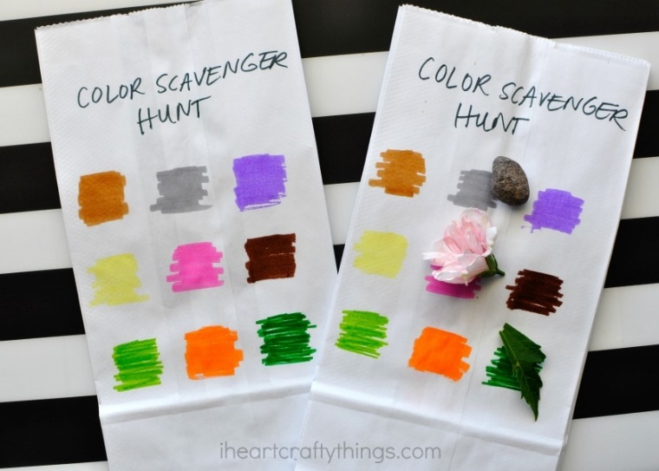
Colour Treasure Hunt

You will need: Paper and coloured pens

This simple activity is great fun and will keep children entertained. You can use this activity indoors or out and can even change the colours to letters to make it a little more challenging.

Happy Hunting!

