Cereal Box Aquarium
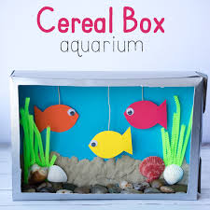

If you have any empty boxes at home, why not try to create an aquarium. These are so much fun to make and you can always collect some stones or shells if you are out for a walk with your family!
Be creative, what else could you make with old cardboard boxes?
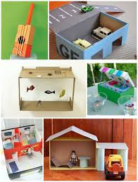
Here are some more ideas…
Have Fun!!

