Tracing Leaves
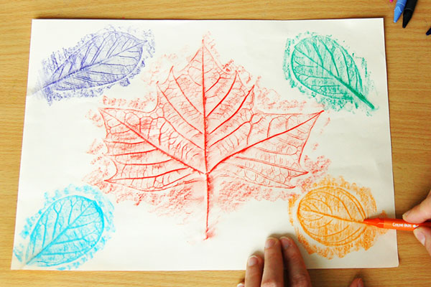

You will need: Paper, Leaves and Crayons
- Collect leaves of various shapes and sizes. You can use fresh leaves or dried fallen ones.
- Place a leaf with its bottom side facing up.
- Put a sheet of paper, preferably thin or lightweight, over the leaf.
- Rub the side of a crayon or an oil pastel gently on the area over the leaf. As you do this, you'll see the coloured areas start to take the shape of the leaf.
- Continue until you've rubbed over the entire leaf.
- Remove the leaf from under the paper. This completes the basic steps for making a leaf rubbing.
- Make more leaf rubbings using other colours and different leaf shapes.

Can you name all the different leaves you have traced?
Is it easier to see the details in your leaf?
What else might this work with?
Maybe you could find 5 things from outside to try and 5 things from inside.

Have fun!

