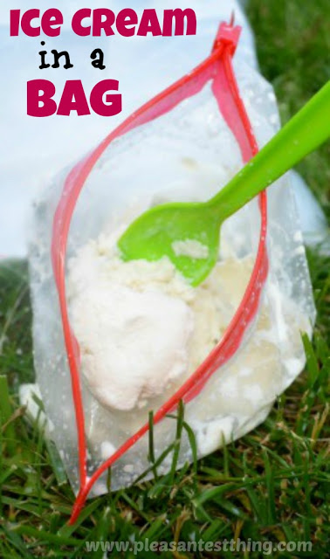
Ice Cream in a Bag!

Kids love making ice cream in a bag because they can actually make the ice cream by running around!

Ingredients for the Ice Cream Bag:
- 1/2 cup heavy whipping cream or half and half
- 1 tsp vanilla
- 2 1/2 tsp sugar
Place these ingredients into a tightly sealed sandwich sized bag, pressing the air out as you seal it. Then put this into another tightly sealed sandwich bag. Fill a gallon size resealable bag half-way full of ice cubes, and mix with 6 tablespoons of coarse kosher salt. Then put the sealed sandwich-size bag into the middle of the ice, and seal the larger bag. I also recommend doubling up the gallon size bags as well, especially if you have little helpers.
To make the ice cream, get moving! You need to shake the bag for about 5-10 minutes.

