Toilet Roll Butterflies
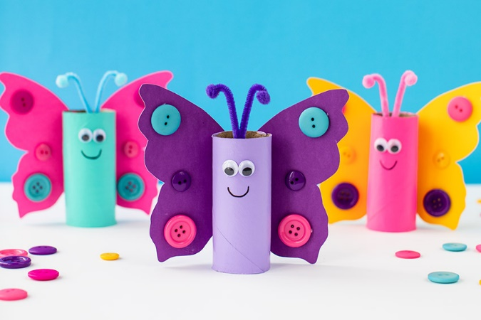

You will need:
Toilet roll tubes
Pens, Paint, Paper (to decorate)
Card
Glue

Step 1. Decorate the toilet roll tube however you like.
Step 2. Take a piece of card and fold it in half. Cut it out to create a wing shape for your butterfly.
Step 3. Next decorate the wings of your butterfly and let it dry before sticking the toilet roll tube you decorated earlier on the fold.

Why not try making some other animals too!
