Skittles Rainbow Experiment
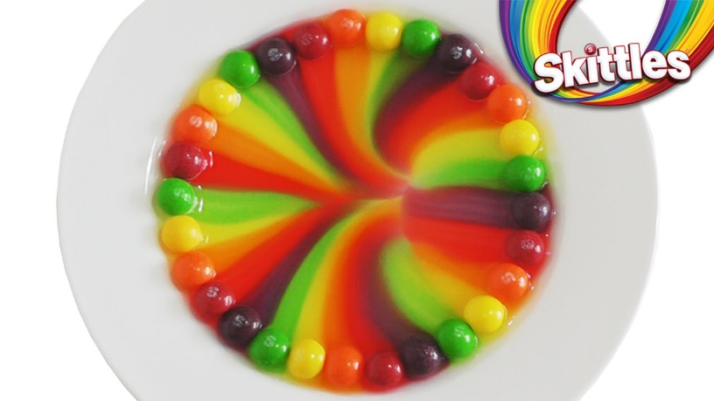

You will need: Skittles, a plate and some boiling water.

STEP 1 : You want to empty out your skittles and check out the colours.

STEP 2: Next, lay out your plates.

STEP 3: Now’s the fun part, make patterns! It’s up to you on how you want to place your colours. Make a rainbow or any sort of pattern that interests you. You can experiment with placing different colours next to each other.

STEP 4: Once you have your patterns placed, gently begin pouring water in the middle of the plate until it reaches all the candies and just barely covers them.

Wait and watch to see what happens!

Give your children a chance to ask questions, make observations, and explore. Why not test the 5 senses and encourage them to look, listen, feel, taste, and maybe hear what’s happening.
Ask open-ended questions to get children thinking! What changes could they make to this experiment?

- Could this skittles science experiment work with another type of sweetie?
- What would happen if you tried a different liquid and compared the results?

Learning about science is all about asking questions, testing ideas, and finding solutions!

Have Fun!

