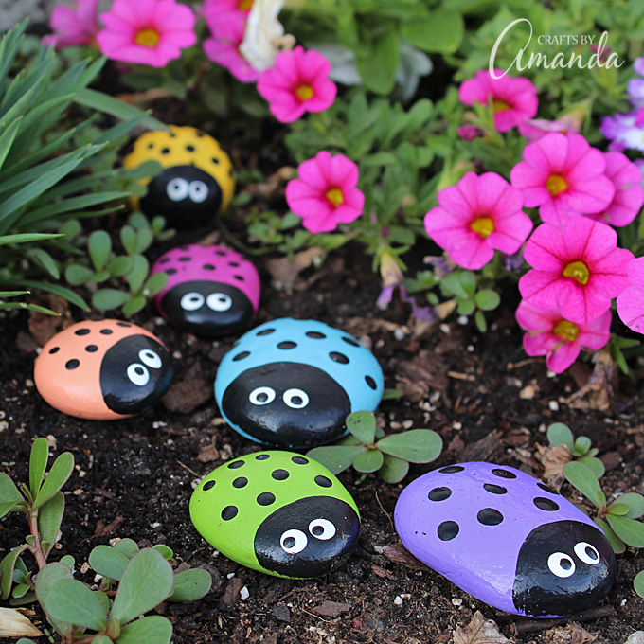
Ladybird Rocks

You will need:
Smooth flat rocks
Paints
Glitter (optional)

Paint the rocks any colour.
Next add a black circle for the face and give him some spots.
Now add some eyes.
You can even add some glitter to make your lady birds sparkle in the garden.
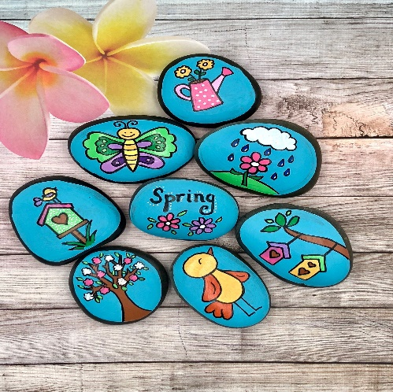

You could even decorate some rocks with your own design and leave them around Gigha when you’re out a walk with your family for you friends to find!

