Homemade Paper Shapes
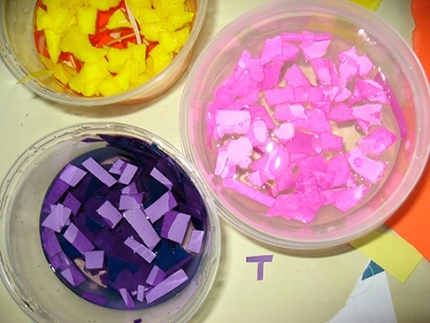
- Tear paper into small pieces and put in plastic container filled halfway with water. Soak for at least 24 hours. If you are using coloured paper, you may want to separate your colours into different containers or put similar colours together.

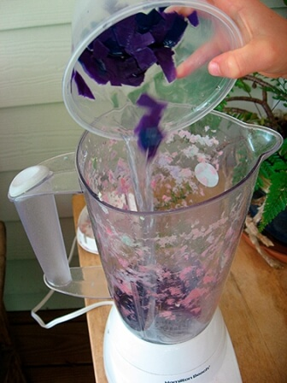
- Add about a half-cup of torn paper to your blender with about a cup of water. Add glitter if desired. Process until paper breaks up into a pulp.

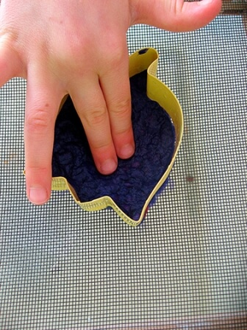
- Place a cookie cutter or any other shape on a piece of cling film and press a layer of paper pulp into it. (about the thickness of pound coin)

- Carefully lift the cutter from the shape and leave to dry.

