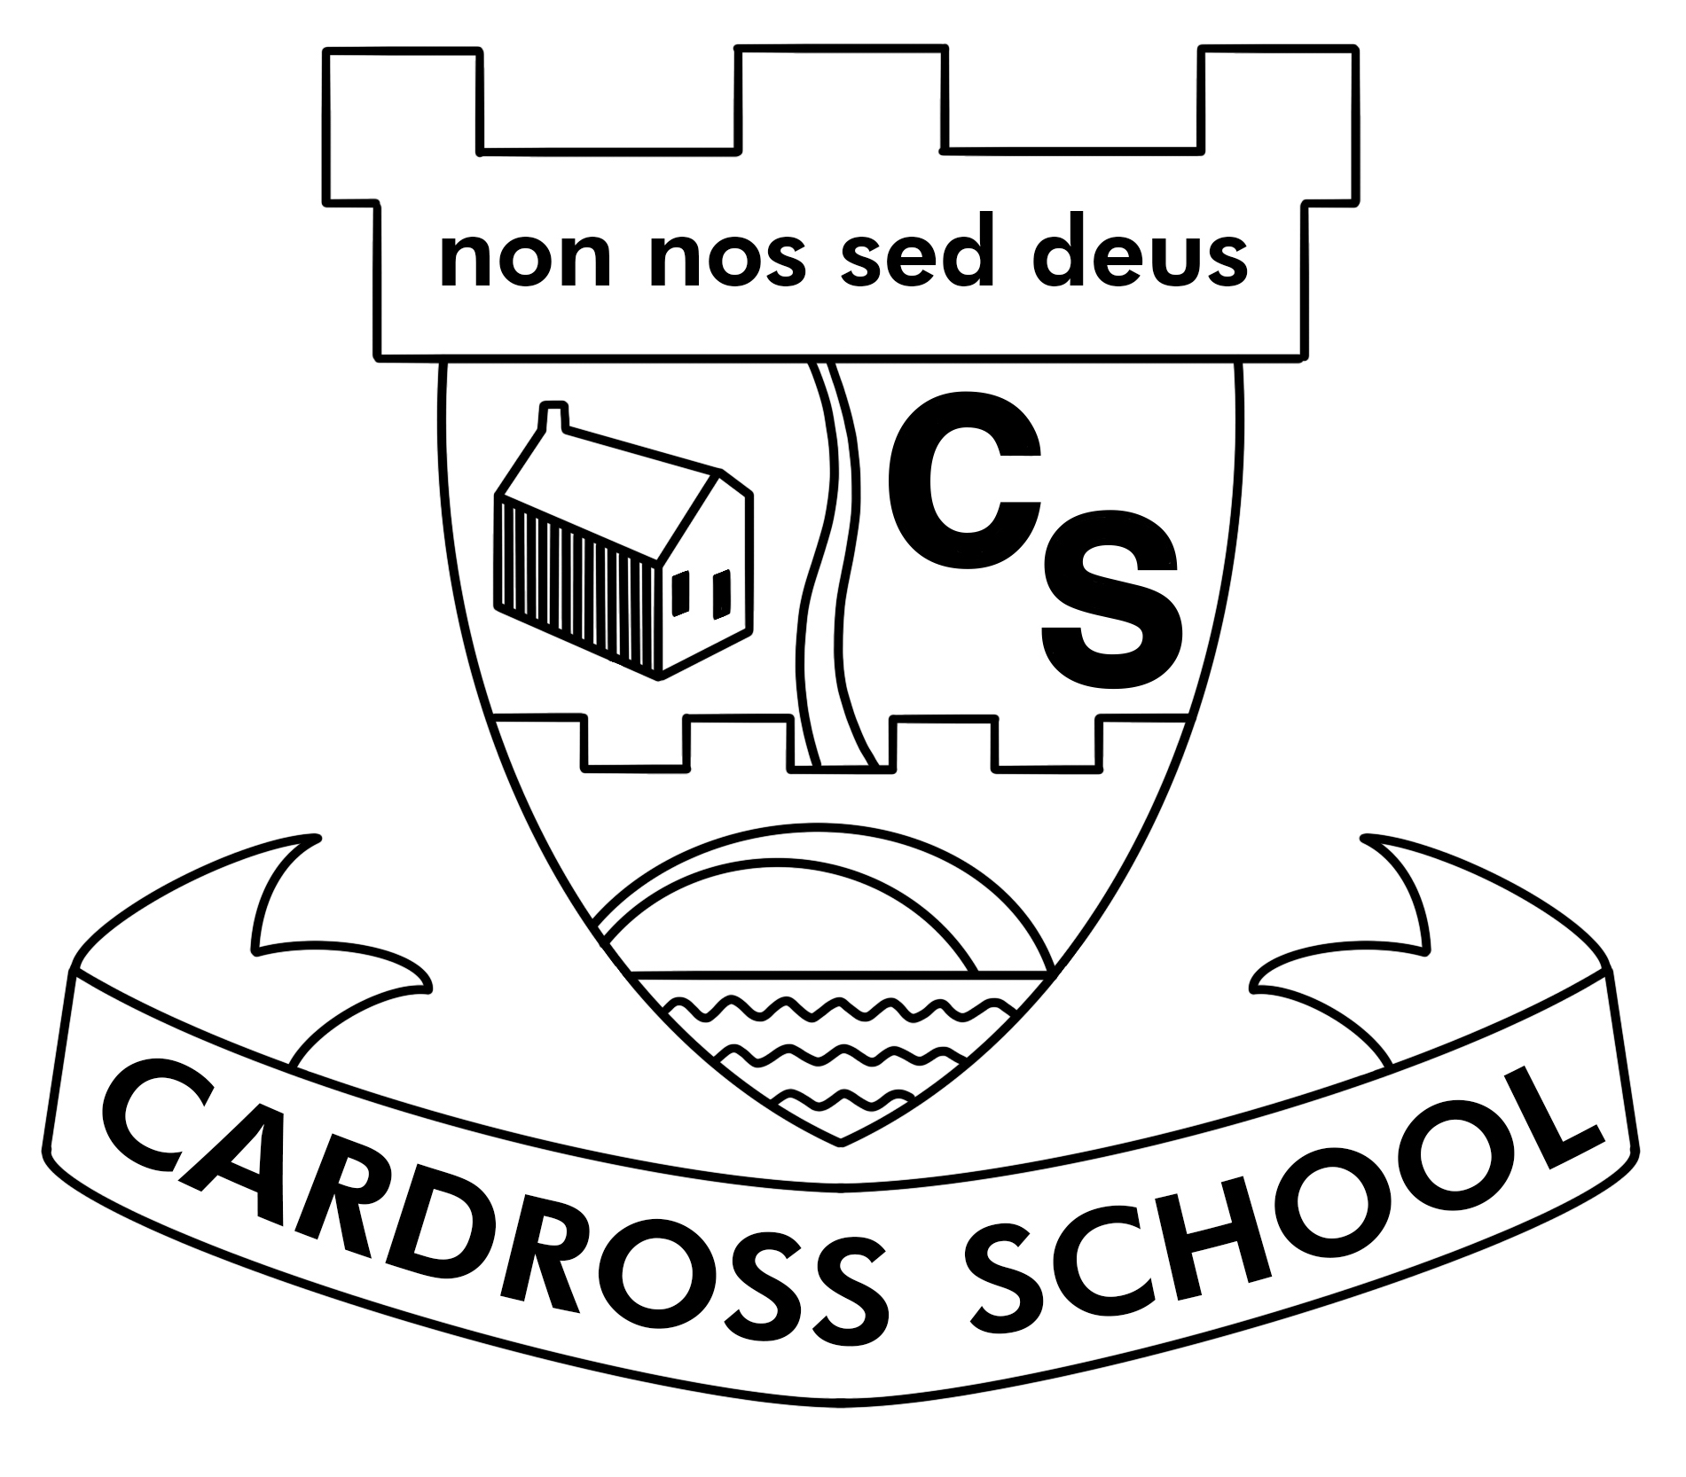
Whole School Family Learning Task – Book in a Box

We have lots of activities planned to celebrate World Book Day on 5th March 2020. We invite you to complete this Family Learning Task over the next few weeks and bring it into school on Friday 6th March. We will share our family learning tasks with the whole school and all of the book boxes will be put on display in our school library for a couple of weeks.

Challenge: Create a book in a box. Decorate the inside of a box with a scene from a book or fill it with items that represent different parts of the book. Include the title and author of the book as well as your child’s name or family name.

Siblings and family members can work together on the same box if they wish.

Choose any book – fiction or non-fiction, picture book or novel.

You can use any box - shoe box, cereal box or similar sized box.

Be creative – you can build, draw, paint, cut out from magazines, print from the internet etc.

You can also decorate the outside of your box if you wish.

You can include notes that explain the relevance of the items or describe the scene you have created.

We have attached another document with some examples. If you are stuck for ideas or need any help or materials please contact your child’s class teacher.

