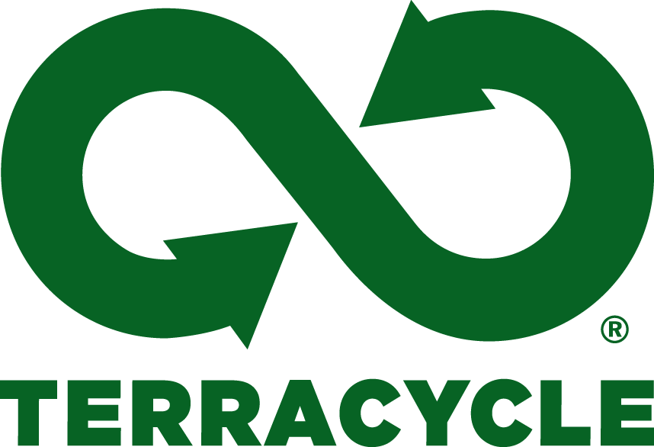

Cardross Primary School are recycling empty crisp packets.

Please bring yours to school and we’ll send them off to Terracycle for recycling. We can also recycle the multipack outer packaging.

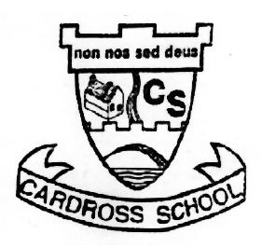
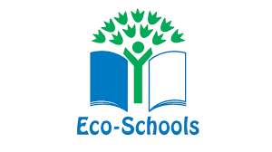Did you know…Once collected, the crisp packets are separated by plastic type, cleaned, and extruded into plastic pellets to make new recycled products.

