P1 Maths Learning Support at Home – Activities and Ideas

Websites:
Jack Hartmann: https://www.youtube.com/watch?v=A1Mazc-SsG0
Numberblocks: https://www.bbc.co.uk/cbeebies/shows/numberblocks

NUMERACY:
- Practise counting up to ten / twenty / thirty and then back to one.
- Missing numbers lay numbers to ten / twenty / thirty out in front of you. Cover one, e.g. number 5, and ask what is one more than 4, what is one less than 6. Extend this with larger numbers and/or asking what is 2 more or 2 less than.
1 2 3 4 5 6 7 8 9 10
- Solve maths problems at home. Work out "how many altogether" and "how many more". As your child questions such as "We have 3 red apples and 2 green apples, so how many apples do we have altogether?". You might ask them how many bananas to buy at the shop and why, or how long will it take you to get to Gran's/a friends house if walking, and/or by car.
- Play games that use counting. Hopscotch, hide and seek, What’s the Time Mr Wolf, skipping or hula hooping are great for practicing counting.
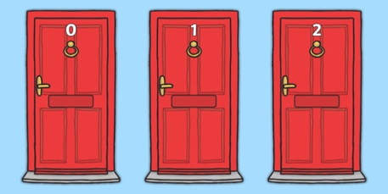
- Look for numbers on doors, buses, cars, signs, at the shops... anywhere. Remember to talk about what the numbers mean.

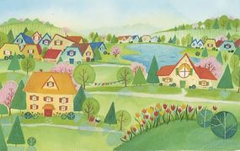
- Explore the local area. Ask them to guess how many buildings do they think are on the street, how far is it to the nearest river or how many dogs and cats live in your street. Ask for the reasons behind their answers.

TIME:
- Talk about time. Talk about the difference between morning / afternoon / evening and the different things we do during these times. Can your child make time line of what they do and when in a day?
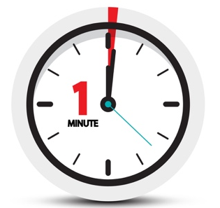
- One Minute: Have your child do a short repeatable task and ask them repeatedly do it for what they think is one minute (e.g. writing their name. Next, time them for exactly one minute doing the same repeated task. How close were they to being correct?

  - Clocks: Use clocks to show your child the hour hand and what time it shows. What happens at 8am? 12noon? 3pm? 6pm?

MONEY:
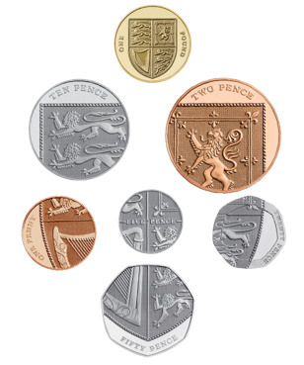
- Play the coin game. Trace around coins and colour in the shapes; match the coin to the image and talk about each one's name, shape and size.
- Coin jigsaw. Modern British each have a specific design on the reverse which, when put together make a shield. Can your child fit together the coins to see the shield?

- Play shops. You could make pretend money or use Monopoly money for your play shop, and use items around the house as shop items. Start with items costing very little – between 1p and 10p (as opposed to their actual amount), gradually increasing the amount as your child gains confidence in larger numbers and using money.
- Explore quantities by asking them to think about how many different ways they can make £1. For example how many 10p coins do you need to make £1.
- At the shops.
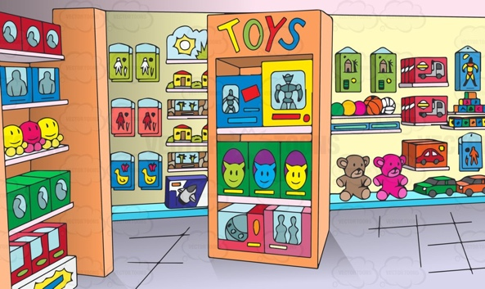
  - Ask your child to guess how much items will cost together.
  - Give them small amounts of change and ask them what they think they can buy with it.
  - Show the price labels and symbols (£ and p) on items.
  - Talk about the items you buy; which are more expensive and which are cheaper?
  - When buying, get your child to hand you the correct money and check the change with them afterwards.

https://education.gov.scot/parentzone/learning-at-home/supporting-numeracy/Introduction%20to%20supporting%20numeracy

http://www.familymathstoolkit.org.uk/6-9-year-olds/maths-and-money

https://www.parentclub.scot/topics/play-learn/counting-maths

EARLY: Tips & ideas
- Cooking. Measure ingredients and set the timer together.
- Find the same amount of different items to help your child understand what numbers mean. For example, find 3 spoons, 3 hats, or 3 socks.
- Talk about the shape and size of objects, e.g. big car, round ball, rectangular box. Ask questions like "pass me the biggest box", or "which is the smallest shoe?".
- Play with items like shells, bottle tops, beads, Lego and compare them. Try making patterns with them together.
- Put items in order. You could do this by weight, height or size. Ask your child to help you organise items around the house.
- Make patterns with objects, colouring pencils, paint or Play-Doh.
- Build structures with Duplo, Lego or boxes.

- OUT AND ABOUT: Go on a shape hunt at the park or while you're out and about. How many circles, squares, rectangles or triangles can your child find? Are they 2 dimensional or 3 dimensional? Try getting them to look for patterns.
- Dance. Create patterns by making up short dances and rhythms using your body (e.g. clap, clap, stomp, belly slap, and repeat).
- Sport. Sports are the perfect chance for your child to think about speed, scores, time and angles. Get competitive; how many goals or points can your child score? How many can you score?
AGES 6+
- Talk about time. For example, get them to work out what time you need to leave the house to get to school on time.
- Cooking. Measure ingredients and set the timer together. Get them to work out how much more food will you need if extra people are coming for dinner.
- Talk about the shape and size of objects. Look online for interesting facts, like tallest and shortest people, or biggest and smallest buildings etc.
- When you are sharing food like pizza or cake, ask your child to help you share it equally between the number of people eating.
- Collect information and create a tally chart, for example to find out the family’s favourite animal or fruit etc.
- Make patterns with objects, colouring pencils, paint or Play-Doh, and build structures with Lego or boxes.
MONEY
- Estimate. At the shops ask your child to estimate how much 3 or 4 items will cost together.
- Give them small amounts of pocket money. For example, give them 50p a week and ask them what they think they can buy with it or, if they want to save for something bigger, how long will it take to reach their goal.
- Talk about the items you buy. Ask them which are more expensive, which are cheaper, which are heavier, and which are lighter etc.
- Explore quantities by asking them to think about how many different ways they can make £1. For example how many 10p coins do you need to make £1.
- When you buy something, get your child to hand you the correct money and check the change with them afterwards.
OUTDOORS:
- Go on a shape hunt. How many circles, squares, rectangles or triangles can your child find? Are they 2D or 3D? Try getting them to look for patterns and symmetry.
- Play outside games that use counting. Hopscotch, hide and seek, What’s the Time Mr Wolf, skipping or hula hooping are a great place to start. Practise times tables by counting in multiples e.g. 4, 8, 12, 16, or 7, 14, 21, 28.
- Dance. Ask your child to create dance routines along to their favourite songs.
- Sport. Sports are the perfect chance to think about speed, scores, time and angles. Get competitive; try out different angles to score from, ask them how many star jumps can they do in a minute.
- Ask them to give you directions to local landmarks or important places. Get to work out how long each stage of the journey takes.
- Use sticks for shape challenges. Ask them how many triangles can they make with 9 sticks etc.

