cfebannernew2

Campbeltown Grammar School



S3 Curriculum

Information for Pupils and Parents

Choices and Changes

cfebannernew2

Contents

[Choices and Changes in S3 3](#_Toc123737452)

[S3 Choices Structure 4](#_Toc123737453)

[What will pupils learn in S3? 5](#_Toc123737454)

[Language and Literacy 5](#_Toc123737455)

[English 5](#_Toc123737456)

[Modern Languages 6](#_Toc123737457)

[Mathematics and Numeracy 6](#_Toc123737458)

[S3 Science Options 6](#_Toc123737459)

[Biology 7](#_Toc123737460)

[Chemistry 7](#_Toc123737461)

[Physics 8](#_Toc123737462)

[Social Subjects 8](#_Toc123737463)

[Geography 8](#_Toc123737464)

[S3 History Curriculum 9](#_Toc123737465)

[Business 10](#_Toc123737466)

[Expressive Arts 10](#_Toc123737467)

[Art 10](#_Toc123737468)

[Music 10](#_Toc123737469)

[Technologies 11](#_Toc123737470)

[Health and Food Technology 11](#_Toc123737471)

[Computing 12](#_Toc123737472)

[Technical 13](#_Toc123737473)

[Administration and IT 13](#_Toc123737474)

[Health and Wellbeing 14](#_Toc123737475)

[PSE 14](#_Toc123737476)

[Physical Education Sport & Health 14](#_Toc123737477)

[B.G.E Outdoor Education 15](#_Toc123737478)

[RME (Religious and Moral Education) 15](#_Toc123737479)

[Assessment, Reporting and Recording 17](#_Toc123737480)

[Supporting Pupils for Choices and Changes 18](#_Toc123737481)

[The Senior Phase (S4 to S6) 19](#_Toc123737482)

[Where can I get more information? 20](#_Toc123737483)

# Choices and Changes in S3

What are S1 and 2 currently learning?

At Campbeltown Grammar School our S1 and 2 pupils are currently experiencing a broad, general education (BGE) as per Curriculum for Excellence (CfE) and are working mainly through level 3 experiences and outcomes in their curriculum areas and in the *cross*-curricular themes of Literacy, Numeracy and Health and Wellbeing. All pupils have had an opportunity to participate in Interdisciplinary projects across subjects and take part in Outdoor Education.

Some pupils will have completed the coverage of level 3 outcomes by the end of S2. Others will continue these level 3 outcomes into S3 or will be starting on level 4 experiences and outcomes. Some pupils will be offered individual learning programmes according to their needs.

|  |  |
| --- | --- |
| Early Level | Includes pre-school and Primary 1 or later for some |
| Level 1 | Includes P2 to P4 but earlier or later for some |
| Level 2 | Includes P5 to P7 but earlier or later for some |
| Levels 3 & 4 | Includes S1 to S3 but earlier or later for some |

*How will the choices which pupils make now affect the options they have to make at the end of S3?*

Through discussion with parents, subject teachers, guidance teachers and through the Choices and Changes programme delivered in PSE, we hope that all pupils will choose subjects for S3 which are relevant to their interests, needs, strengths and future plans. However, it is natural and understandable that we change our minds or that our interests or strengths change too. For this reason pupils may opt for a subject in Senior Phase which they have not taken in S3.

*What will S3 pupils be doing next year and how much time will they spend on each curricular area?*

As a continuation of their broad, general education each pupil will experience eight curricular areas, the numbers of periods for each and the main aims of each are shown on page 3. Lessons are 45 minutes each and there may be double periods allocated.

There is no formal choice in English, Mathematics and Health and Wellbeing, although within the subject itself there will be opportunities for personalisation.

Pupils must do all eight curricular areas. However, for pupils with Additional Support Needs there is a responsibility to ensure that the curriculum choices are appropriate and in some cases pupils will do alternatives to the timetable shown on page 3. Please note that pupils cannot pick the same subject in two columns.

The teaching and learning of the curriculum will involve a range of methodologies which will encompass elements of traditional teaching but will also involve active learning, independent learning, the use of technologies, group work, research projects, presentations and performances, all of which aim to create challenging and enjoyable learning experiences.

cfebannernew2

# S3 Choices Structure

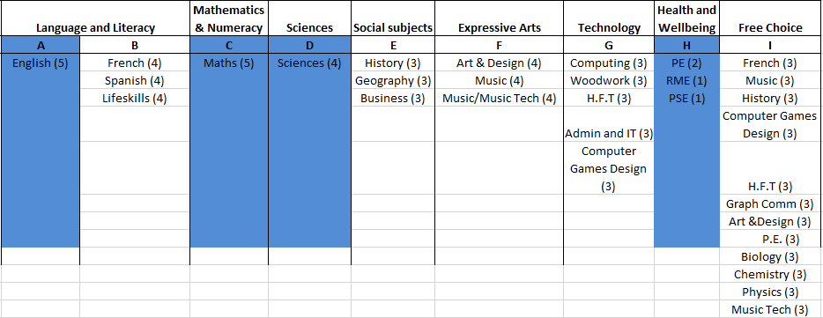

cfebannernew2

# What will pupils learn in S3?

In S3 courses will continue to be built on the Experiences and Outcomes set out for each curricular area.

The following is a broad guide to the content to be delivered in in subject/curricular area:

# Language and Literacy

# English writing_girl[1]

During S3, pupils will cover a variety of tasks which will allow them to demonstrate competency in relation to **Writing; Reading; Talk and Listening**.

Additionally, pupils will consider **Literacy** and the thinking behind a **Value Added Unit** – both areas of study that are required at National 4 level.

**Writing Skills** covered will include developing pupils’ imagination and their ability to reflect and present information on various issues in different formats. The aforementioned skills will be covered through participation in **Creative Writing**: Imaginative and/or Personal/ Reflective, and **Broadly Transactional Writing:** Discursive, Persuasive and Informative.

**Reading** covered will include **Prose, Drama, Poetry and Film** with pupils being taught the various **Skills** involved in producing **Critical Responses** across a range of these genres.

Additionally, pupils will be taught the **Skills** involved in **Reading for Understanding, Analysis and Evaluation:** learning to identify **Audience and Purpose;** to **Understand** information contained in pieces of non-fiction and to learn how **Language** functions, both in terms of **Word Choice** and **Sentence Structuring**.

**Personal Reading** (both fiction and non - fiction) will be constantly encouraged. All pupils will have three home readers to read at home over the year.

**Talk** will be an ongoing feature of the course, with pupils being encouraged to give their views duringa range of learning situations: individually; in pairs; in groups and/or in whole class feedback/discussion sessions.

**Listening activities** will be undertaken and will concentrate on how language operates in a variety of spoken contexts and **develop pupils’ skills** in terms of listening, taking notes and answering a range of questions (both orally and in Writing) on the **piece** being listened to.

# Modern Languages 14194-illustration-of-a-french-flag-pv[1] *750px-Flag_of_Spain_(1785-1873_and_1875-1931)*

Over S1 and S2, pupils have studied both French and Spanish. They now have the opportunity to opt for the language of their choice or to opt to carry on with both languages. They will have 4 periods per week of whichever language they choose to study.

Pupils will continue to develop the four language skills of reading, listening, talking and writing over the contexts of society, learning, employability and culture**.** As well as this, they will continue to learn about the lifestyle and culture of countries where their chosen language is spoken. This will allow pupils to gain an insight into different cultures and customs and to celebrate diversity in society.

ASDAN Lifeskills will be once again made available to some pupils. This programme is an alternative to Modern Languages to grow skills for learning, skills for employment and skills for life. There will be no formal tests but pupils will be asked to compile a portfolio of work which will be presented at the end of the year.

# Mathematics and Numeracy *math_symbol[1]*

Pupils will continue to work at their appropriate level. Particular focus will be on Level 4(plus) which extends into Level 5 material in preparation for SP. Topics “common” to the Nat 5 courses will be covered first including, Finance, Statistics and Volume.

Numeracy will play a pivotal role during the year with particular focus on Non Calculator skills. All pupils will have the opportunity to achieve a Numeracy Unit qualification by the end of BGE and will complete the SNSA towards the end of the session.

Problem Solving sessions will include quizzes, group challenges and various other activities.

***j0305257***

# S3 Science Options

Each of the S3 science subjects builds upon pervious learning of knowledge and skills while preparing the pupils for the senior phase. Pupils will continue to develop their inquiry and investigative skills, scientific analytical thinking skills, and skills and attributes of scientifically literate citizens. Practical activities contribute in an important way to learning within the sciences and allow pupils to further develop their skills and understanding of scientific concepts.

# Biology

Biology, the study of living organisms, plays a crucial role in our everyday existence and is an increasingly important subject in the modern world. Biology affects everyone and aims to find solutions to many of the world’s problems. Advances in technologies have made this varied subject more exciting and relevant than ever.

There are three topics in the S3 Biology course:

*Cell Biology*

Pupils will learn about cell division and its role in growth and repair, DNA, genes and chromosomes, therapeutic use of cells, properties of enzymes and use in industries, properties of microorganisms and use in industries, photosynthesis — limiting factors, factors affecting respiration, and controversial biological procedures.

*Multicellular Organisms*

Pupils will learn about sexual and asexual reproduction and their importance for survival of species, propagating and growing plants, commercial use of plants, genetic information, growth and development of different organisms, and biological actions in response to internal and external changes to maintain stable body conditions.

*Life on Earth*

Pupils will learn about how animal and plants species depend on each other, impact of population growth and natural hazards on biodiversity, nitrogen cycle, fertiliser design and environmental impact of fertilisers, adaptations for survival, and learned behaviour in response to stimuli linked to species survival.

# Chemistry

Chemistry is the study of matter at the level of atoms, molecules, ions and compounds. These substances are the building blocks of life and all of the materials that surround us. Chemists play a vital role in the production of everyday commodities. Chemistry research and development is essential for the introduction of new products. The study of chemistry is of benefit not only to those intending to pursue a career in science, but also to those intending to work in areas such as the food, health, textile or manufacturing industries. There are three topics in the S3 Chemistry course:

*Chemical Changes and Structure*

Pupils will develop scientific skills and knowledge of the chemical reactions in our world. Through practical experience pupils will investigate rates of reaction, energy changes of chemical reaction, and the reactions of acids and bases and their impact on the environment. Focusing on these reactions, pupils will work towards the concept of chemical equations. Pupils will research atomic structure and bonding related to properties of materials.

*Nature’s Chemistry*

Pupils will research the Earth’s rich supply of natural resources which are used by each and every one of us. Pupils will investigate how fossil fuels are extracted and processed for use. They will investigate: the chemistry of using fuels, their effect on the environment and the impact that renewable energy sources can have on this; plants as a source of fuels, carbohydrates and consumer products; and how chemists use plants in the development of products associated with everyday life.

*Chemistry in Society*

Pupils will focus on the chemical reactions, properties and applications of metal and alloys. The chemistry of metals in chemical cells is explored. Through research, pupils will compare and contrast the properties and applications of plastics and new materials. Pupils will investigate the use of fertilisers, the formation of elements, and the presence of background radiation, and will research the use of chemical analysis for monitoring the environment.

# Physics

Physics is the study of matter, energy and the interaction between them. This entails asking fundamental questions and trying to answer them by observing and experimenting. The answers to such questions can lead to advances in our understanding of the world around us and often result in technological improvements which enhance the lives of all. The study of physics is of benefit, not only to those intending to pursue a career in science, but also to those intending to work in areas such as the health, energy, leisure and computing industries.

There are three topics in the S3 Physics course:

*Electricity and Energy*

Pupils will learn about generation of electricity, electrical power, electromagnetism, practical electrical and electronic circuits, gas laws and the kinetic model.

*Waves and Radiation*

Pupils will learn about wave characteristics, sound, electromagnetic spectrum and nuclear radiation.

*Dynamics and Space*

Pupils will learn about speed and acceleration, relationships between forces, motion and energy, satellites and cosmology.

# Social Subjects

# Geography

4 topics will be covered:

1.  ***From Mountains to the Sea*** – glaciation, and coasts. This also includes the use of OS maps.

2. India – population and development issues.

3. C:\Users\caseye-s\AppData\Local\Microsoft\Windows\Temporary Internet Files\Content.IE5\R89DX9F8\weather-26335_640[1].png ***Advanced weather*** – air masses, station circles, synoptic charts, anticyclones and depressions, and forecasting.

4.  ***Campbeltown CBD Fieldwork Project*** – traffic and land use in the centre of Campbeltown. This is excellent preparation for the N5 Assignment or the N4 AV Unit if pupils choose Geography in the Senior Phase.

# S3 History Curriculum

In S3 there will be four topics covered:

* **Holocaust Project**



Pupils will work in small groups to investigate and create a project on the Holocaust. They will focus on the gradual persecution of Jewish people and minority groups in Nazi Germany, leading to the eventual mass murder within the concentration and extermination camps. By the end of this topic pupils will aim to explain the importance of respecting the heritage and identity of others.

* **Free at Last? Civil Rights in the USA, 1918-1968**



This topic is a study of the development of race relations in the USA during the years 1918-1968, illustrating themes of ideas, identity, and power. The key issues covered are The ‘Open Door’ policy and immigration to 1928, ‘Separate but equal’ to 1945, Civil rights campaigns to 1968 and the ghettos and black American Radicalism.

* **Changing Britain, 1760-1914**

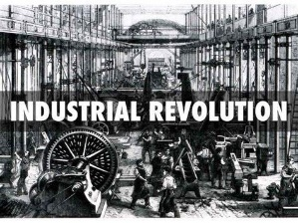This topic is a study of the reasons for and impact of industrialisation on life in Britain, focusing on the social, economic, and political developments which transformed life across Britain in the late 18th and 19th centuries. The key issues covered are Health and Housing, Industry – textile factories and coal mines, Transport – canals and railways, and pressure for democratic reform up to 1884.

* 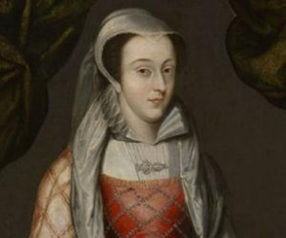**Mary Queen of Scots, and the Reformation, 1542-1587**

This topic is a study of religious and political change and conflict in 16th-century Scotland, illustrating the themes of crown, church, and authority. The key issues covered are Mary from the ‘Rough Wooing’ to becoming Queen of France to 1559, The Reformation in Scotland to 1587, Mary’s reign, 1561-1567, and Mary in England 1567-1587

All courses develop on the basic historical skills learned in S1 and S2 with more emphasis being placed on introducing and developing both National level skills and knowledge in preparation for senior phase.



# Business

In S3 pupils will be develop their ICT skills in a business context.  They will learn about enterprise and research successful businesses.  Pupils will learn about the sectors of business and economy up to Level 4. They will apply their skills to independently plan their own business and create business documentation including business cards, logos, advertisements and letters.

Students will also gain the opportunity to work as a team, developing communication skills as part of nationwide competitions such as *Design a Sub Challenge -* where pupils are given a fictitious budget to create an innovative new healthy Subway sandwich recipe and produce a marketing plan to 'pitch' to investors.  Students will also get the chance to take part in other problem solving and entrepreneurial initiatives throughout the year such as the *Tenner Challenge* where they are given a business loan of £10 and given the task of aiming to make profit within 1 month!  Within that time there are weekly competitions where pupils have to make important decisions on budgeting, planning, designing and advertising.

# Expressive Arts

# Art 120px-Art_animation[1]

Pupils will develop Art & Design skills which will prepare them for Senior Phase at the end of S3.  The course is divided broadly into two areas.

The expressive art side of the course will continue to build upon the drawing, painting and 3D skills that they have learnt in S1 &2.  They will produce expressive ideas and work towards a more finished work in a range of different mediums.  They will look at a variety of art styles throughout the year, broadening their approaches to their own practical work as they do so.

The Design side of the course will build upon the design skills that they have learnt in S1 & 2.  The pupils will develop ideas & market research through to developing a final design, primarily in graphic design projects.  They will look at a variety of design styles and techniques throughout the year, broadening their approaches to their own practical work as they do so.

# Music Music-icon-20110813[1]

Music will be split in to 3 sections:

Performing, Technology and Understanding.

Composing will be split throughout the 3 main sections of the course.  The course will be practical based with pupils working individually and in groups to achieve outcomes.  Personalisation and choice will be given in many activities and pupils will be encouraged to be more responsible for their learning and the decisions they make.

By the end of the year pupils will have improved their understanding and skills whilst gaining a wide-ranging experience of all three areas of Music.

# Technologies

# Health and Food Technology *422941,1296057418,2[1]*

This course continues to embed life skills essential to health and wellbeing, as well as giving insight into future course options in the senior phase of Practical Cake Craft, Health and Food Technology and Hospitality -Practical Cookery

Pupils will undertake a variety of food preparation and production techniques, learning the science behind ingredients and cookery methods, as well as nutrition and health information.

Throughout the course pupils will develop:

* traditional baking skills,
* food preparation skills,
* organisational skills,
* fine motor skills,
* design techniques
* time management.

Knowledge of the science of food and of the ingredients used will also be covered.

In response to the resurgence and popularity of traditional baking skills, pupils will undertake a variety of baking techniques to develop the core skills. Towards the end of the course pupils will be given the opportunity to use the knowledge and skills acquired, as they work through a set of challenges. These will include the creation of a finished cake for a specific occasion and selecting and preparing two course meals. Pupils will also have the opportunity to study for and sit the REHIS exam for food handlers which is now required to work in the food industry.

# Computing clip-art-computers-184766[1]

Course aims

* To look at aspects of the impact of technology on individuals and the environment
* To explore different elements of computing science
* To prepare you to undertake Computing Science in 4th year

Course content

Contemporary Computer Developments

* Transport and technology
* Technology the economy and the environment

Software design 1 - Scratch

* Understanding programming concepts through practical programming using the Scratch coding language

Databases

* Understanding the basics of databases through practical examples
* Understanding the function of databases in society

Website Design

* Learning about website design and using HTML to create webpages

Software Design 2 – Python

* Developing programming skills using a text based coding language

Progression

* Computing Science National 4 or 5
* NPA Computer Games Development Levels 4 or 5
* NPA PC Passport Levels 4 or 5
* NPA Web Design Level 5

# Technical fig_14[1]

Within the Technical department pupils will have the choice to specialise in Graphic Communication and Practical Woodwork.

**Graphic Communication:**  In S3 the course is designed around the “3 P’s”. This stands for Preliminary, Production and Presentation.  These are the three key areas of Graphic Communication and pupils will undertake assignments to prepare them for senior phase by the end of S3.

**Practical Woodwork**:  In S3 the course is designed around the three main areas of Woodworking: Flat Frame construction, Carcase construction and Machining and finishing.   These areas will prepare pupils for senior phase by the end of S3.

# Administration and IT

The Administration and IT course will prepare students with ICT skills for the Senior Phase and build progression up to level 4. Pupils will apply their ICT skills to independently create business documentation including business cards, logos, advertisements and letters.

Pupils will also increase their skills in spreadsheets, charts and databases, applying them to the world of work.   Pupils will continue to build on these ICT skills during the course, particularly gaining valuable word processing and desktop publishing software experience and increasing their speed and accuracy at keyboarding using Microsoft Office software.  Students will develop their skills to communicate using email and presentation software. Pupils will gain experience at fourth level in organising events as well as searching and problem solving using the Internet. Pupils will be using file management skills to upload files on to the school network to record evidence of their work. They will also gain skills in creating and managing their school email applications including to-do-lists and calendar.

Depending on numbers, Business and Admin may be combined into 1 class.

# Health and Wellbeing Health_Triangle[1]

# PSE

Skills for learning, mental, sexual and physical health, planning for choices and changes in S4, preparing for work skills and work experience.

# Physical Education Sport & Health

Pupils in S3 will have the opportunity to participate in the following activities:

**Football, Rugby, Badminton, Gymnastics, Table Tennis, Short Tennis, Social Dance, Netball, Volleyball, Basketball, Athletics and Softball.**

Participating in Physical Education in third year provides learners with the opportunity to build physical competencies, improve their knowledge and understanding of how to assess and develop practical performance and recognise the important contribution that physical activity makes to living a healthy lifestyle.

Learners will demonstrate, refine and advance their practical performance skills in a range of physical activities. The courses will provide opportunities for learners to demonstrate initiative, decision making and problem solving. Learners will work both independently and collaboratively to develop thinking and interpersonal skills. This makes Physical Education an ideal platform for developing confidence, resilience responsibility and leadership.

As in the first two years of the broad general education all pupils participate in 2 periods of Physical Education a week.

The third year curriculum is designed to maximize opportunities for personalization and choice while ensuring that pupils experience both challenge and enjoyment.



# B.G.E Outdoor Education

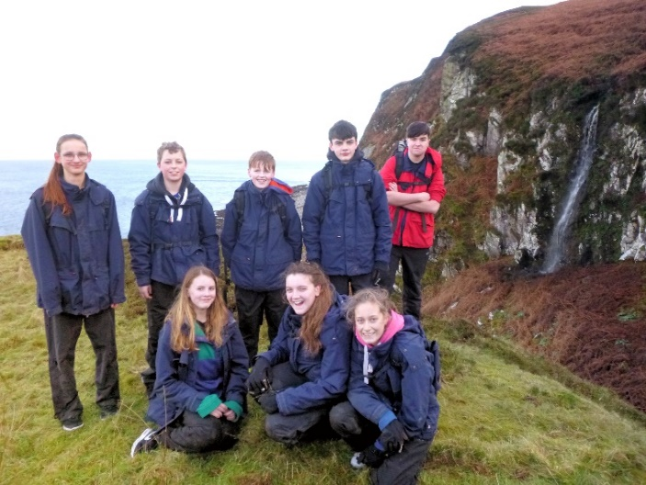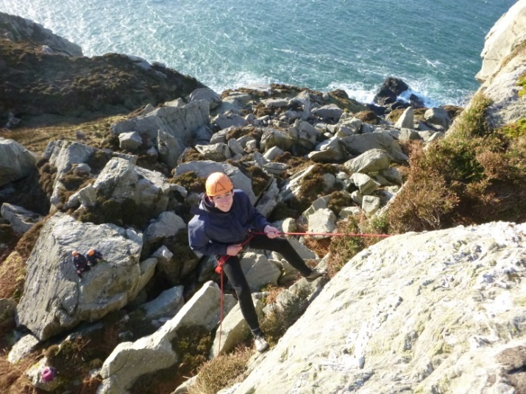Campbeltown is in a unique location, geographically isolated but surrounded by amazing natural landscapes. Outdoor Education is a unique curriculum opportunity for all S3 students aiming to fully utilise our rich local environments and engage in ‘adventure activities’ for personal development.

Gorge scrambling, mountain biking, rock climbing, hill and coastal exploring are activities which align with the natural energy and curiosity of young people. These very concrete experiences are used to teach students the deeper learning that they have the ‘tools’ for responding to challenge within them. Outdoor Education provides students with an environment of high expectations and high support so that these skills do not remain hidden and undeveloped.

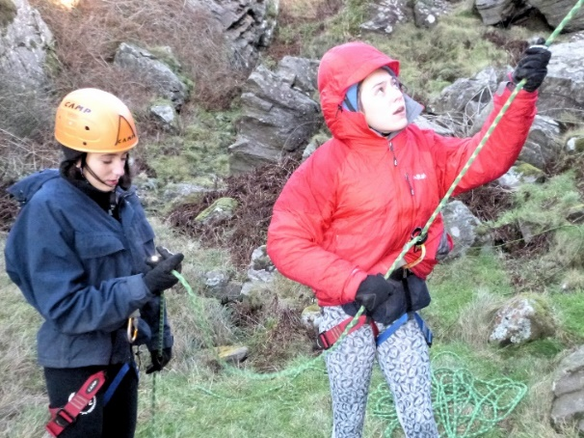

* Confidence and self-belief
* Resilience and tenacity
* Application and perseverance
* Managing risk
* Cultivating a growth mind-set
* Finding personal motivation

# RME (Religious and Moral Education)religiones-en-el-mundo[1]

**Beliefs about God**

Ultimate Questions

Life after death

Human exceptionalism?

**Global Citizenship**

Human Rights

History of Human Rights

Amnesty International letter writing activity

Refugees

Fairtrade

**Environment**

Global warming

Religious & Humanist perspectives

Sustainability

# Assessment, Reporting and Recording

*How will progress be measured?*

As currently happens, there will be a structured system for informing parents on how their children are progressing. This will include an interim as well as a Full Report issued in March prior to the Options programme.

This will continue to involve reporting and parents’ evenings and you will find the dates of these in our calendar. You can contact the school at any time to discuss your child’s progress.

*How will pupils be assessed in S3?*

There will be both formative and summative assessment based on what pupils say, write, make and do.

Assessment in all areas will involve a variety of techniques including written, oral and practical tests, projects, presentations, performances, products, teacher observations, self- and peer-assessment.

In some subject areas, pupils are assessed using National 3 and 4 units. Although pupils in S3 will not be able to be presented for these units until S4, their performance can provide a good indicator of appropriate study levels in S4.

# Supporting Pupils for Choices and Changes

*What support will be given to pupils to prepare for the new S3 curriculum?*

|  |  |
| --- | --- |
| What? | Who? |
| Information on S3 programmes and senior phase; | PSE and Subject Teachers;  4 week Choices and Changes programme. Individual interviews with Guidance Teacher.  Input from Skills Development Scotland  Argyll College Taster Sessions Exhibition |
| Review of S1-S2 progress; | Guidance and Personal Support Teachers; |
| Advice on levels S3 | Guidance and Subject Teachers |

*What support will be given to pupils when they are in S3 to prepare for their Senior Phase courses*

Pupils will be given on-going feedback on their progress throughout S3 and recommendations will be made to pupils and parents on S4 senior phase qualifications in reports and at parents’ evenings. Within PSE, there will be a Choices and Changes programme which will help pupils to make appropriate choices on the best possible pathways for them to reach a positive destination when they leave school, be it to employment, training, Further or Higher Education.

To complement the PSE programme each pupil will receive an individual pathways interview. There will be input from other agencies, such as SDS (Skills Development Scotland), Community Learning and Development and Argyll College. Under the National Learning Choices Opportunities for All (formerly16+) programme, pupils who are at risk of not achieving a positive destination when they leave school will be identified from S3.

cfebannernew2

# The Senior Phase (S4 to S6)

*What courses will pupils be able to take in the Senior Phase (S4 to S6)?*

Most pupils in S4 will take 6 subjects at either National 4 or 5 levels. Some pupils will do Nationals 1, 2 or 3 or alternative courses such as ASDAN or courses provided by Argyll College such as Skills for Work.

In S5 and 6, pupils will progress to Higher courses, Advanced Higher or further National 4 and 5 qualifications.

Nationals 1 to 4 courses are assessed internally while National 5, Higher and Advanced Higher are assessed through a mixture of internally assessed units and external examinations.

In general terms, the new Senior Phase Qualifications have the following equivalencies to previous SQA courses with which some parents might be more familiar.

|  |  |
| --- | --- |
| New National Qualifications | Previous Qualifications |
| Advanced Higher | Advanced Higher |
| Higher | Higher |
| National 5 | Credit Standard Grade/Intermediate 2 |
| National 4 | General Standard Grade/Intermediate 1 |
| National 3 | Access 3/Foundation Standard Grade |
| National 2 | Access 2 |
| National 1 | Access 1 |

cfebannernew2

# Where can I get more information?

Education Scotland Parentzone: [www.ltscotland.org.uk/parentzone/index.asp](http://www.ltscotland.org.uk/parentzone/index.asp)

Campbeltown Grammar School Website: <https://blogs.glowscotland.org.uk/ab/campbeltowngs/>

(see Senior Phase Options Booklet and Fact File on School Website)

Information on new Senior Phase Qualifications: [www.sqa.org.uk](http://www.sqa.org.uk)

Others:

<http://www.learningatschool.net/>

<https://blogs.glowscotland.org.uk/glowblogs/NPF/nationals-in-a-nutshell/>