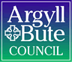

Standards and Quality Report 2019-2020

Name of school
Campbeltown Grammar School

Context of the school
Including some or all of the following:
- basic school details (roll, class composition etc.)
- school vision, value and aims;
- local contextual issues;
- factors affecting progress (e.g. staffing changes/issues).

Campbeltown Grammar School is a comprehensive non-denominational school with a school role of 358. It is located in a ‘remote small town’ on the Kintyre peninsula with a population of less than 10000. The school serves the South Kintyre area and is associated with Castlehill, Dalintober, Drumlemble, Carradale, Southend, Glenbarr, Rhunahaorine and Gigha Primary Schools.
We moved into our new building on 21 February 2018 and the Head Teacher took up the post on 23 April 2018.
Our spread across the school roll has around 50% in SIMD 6&7 with 15% in SIMD 2 and a fairly even spread between SIMD 3-5. Our FSM spread is even across S1,3,4 and 5 at around 14%, with 22% in S2 and 4% in S6. We have been allocated £23496 PEF funding for session 20/21.
Education Scotland carried out an inspection in January 2018. A Further inspection took place in October 2019 and the report released on 21/1/20 reported on the progress we have made since January 2018. This document describes our progress achieved to date. The national lockdown as a result of Covid19 has limited our progress, but our work since April 2018 has still resulted in significant improvements. Notable is the increase in National Certificates options available to learners from 5 to 6. This has led to a significant increase in the overall number of National Certificates achieved in Session 2019/20. For example, the number of candidates achieving Higher A-D increased from 97 in 2018/19 to 124 this session and the number achieving A-D at National 5 increased from 280 to 354.
The Senior Leadership Team now has three Depute Head Teachers following the acting DHT post being made permanent. This has allowed us to create more strategic remits within SLT. Staffing continues to be a concern. The HT has been working closely with the LA to address future staffing concerns, particularly in relation to teacher age demographics and the possibility of shortages in key areas.
Covid19 has had a particularly detrimental impact on Music, PE and other practical subjects. Our Brass and Pipe Bands have been unable to hold competitions and our involvement in Erasmus has been curtailed. However, we will continue to make the very best of the opportunities and facilities that are available to us within the restrictions we are currently working under.

Review of SIP | Priority 1
Take the opportunity provided by the move to the new building to revise the school vision, values and aims, involving young people, parents and staff, to provide the school and its partners with a clear sense of direction.
Progress and Impact:
In their Record of Visit, 20 January 2020, Education Scotland recognised ‘hugely significant challenges’ during the HT’s first year in post that led to little progress being achieved. However, since summer 2019, the ability of all stakeholders to work more effectively together has enabled a clearer sense of direction in the school community to be developed and shared. We have refreshed and enhanced our sense of pride in our school through working collaboratively with our stakeholders to identify what is considered to be important to Campbeltown Grammar School and we have been embedding these values and aims into our everyday working practices.

We held a very successful ‘open day’ in May 2019 which saw members of the Campbeltown community in our school. Senior pupils organised this event and we raised a significant amount of money and the community witnessed first hand how well our school is serving the needs of our young people.

The membership of our Parent Council has increased and more parents are involved in school improvement activities. We have simplified our documentation on school improvement using the Local Authority’s new template to help further encourage stakeholders’ involvement and contribution to school improvement.

Collegiate meetings have been focussed on the improvement of Learning and Teaching with reference to our shared understanding of ‘12 ingredients for an excellent lesson’.

Quality Assurance learning visits have recorded improvements in the quality of learning and teaching.

Next Steps:
All teachers will refresh their knowledge and understanding of the GTCS Standards for Registration.

All teachers will participate in working groups to secure further school improvement.

The Relationships and Ethos Committee will evaluate our approach to promoting positive behaviour among young people and relationships with staff. It will also evaluate its clarity, effectiveness and consistency with our school values.

Monthly Departmental Meetings will consider ongoing progress in the SIP and DIP and agree next steps.

Our School Improvement Plan will be shared with all stakeholders. A simplified version will be created to help engage a wide range of stakeholders,

Questionnaires will be used amongst all stakeholders to seek views on ‘how good is our school’ and to provide opportunities for sharing ideas and making a contribution to further improvement.

A digital Suggestions Box will be used to collect feedback and ideas from our school community.
https://blogs.glowscotland.org.uk/ab/campbeltowngs/suggestions

Review of SIP | Priority 2
Further develop a curriculum which is relevant to the school’s context, meets the needs of all learners and provides appropriate pathways and qualifications for all young people.
Progress and Impact:
Our new curriculum framework has provided our young people with increased opportunities to gain National Qualifications. As stated above, increasing the number of National Certificates options available to learners from 5 to 6 has led to a significant increase in the overall number of National Certificates achieved in Session 2019/20. For example, the number of candidates achieving Higher A-D increased from 97 in 2018/19 to 124 this session and the number achieving A-D at National 5 increased from 280 to 354. Detailed analysis from INSIGHT is not yet available.

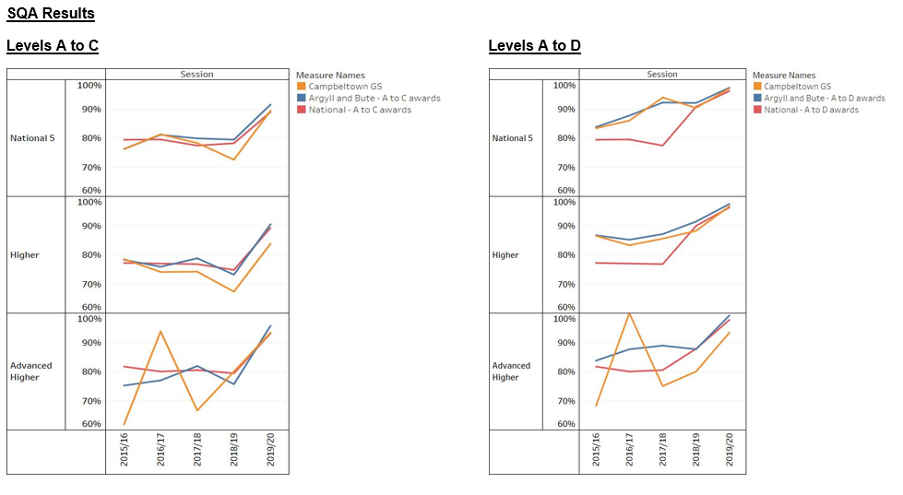

We have provided an increased range of qualifications, and progressive learner pathways in the senior phase which meet the needs of more young people. In addition to a range of Skills for Work courses provided by Argyll and Bute College, young people now also have the option to choose from a number of Foundation Apprenticeships.

We are very well supported by a range of partners in the wider community including Skills Development Scotland, Community Learning and Development, Argyll and Bute College, Kadas, Kintyre Youth Cafe and Young Carers, Calmac, Argyll and Bute Council and other employers. Young people benefit from very good opportunities to undertake work experience in a range of contexts, including an innovative high-quality internship with Springbank Distillery.

We have improved opportunities for wider personal achievement in S5 and S6 including roles as sports leaders and in volunteering. Young people can now also accredit these experiences by completing the Scottish Qualifications Authority Leadership Award and Saltire Awards.

We have made improvements to the curriculum in the BGE from S1 to S3 as well as the senior phase. Young people now have the opportunity to learn at fourth level as well as third, in the BGE, across all curricular areas. Most young people also have an improved awareness of their progress through Curriculum for Excellence levels. My World of Work ambassadors have been trained in S3 and will continue their work throughout their time in Senior Phase, to help to prepare BGE pupils for the Senior Phase.

We have provided more opportunities for young people to apply their knowledge and develop skills for life and work through the reintroduction of interdisciplinary learning in S3. This includes the Erasmus project and the Youth Philanthropy Initiative. All young people in S2 and S3 can further develop their skills for life and work through our very successful programme of outdoor education which we hope to extend again into the senior phase.

Staff in the English department have led work with all teachers to develop young people’s literacy skills. They have provided training and resources for all staff, as well as support and mentoring for staff in a few departments. For example they have provided shared success criteria to outline standards of achievement for young people and staff in writing skills at second, third and fourth level and are currently working to do the same for the skills of group talk. These have been shared with all staff to inform planning in departments. All staff have also had opportunities to moderate writing at third and fourth level to inform their understanding of standards.

Learning and Teaching

The Education Scotland ROV dated January 2020 noted some improvements to the quality of learning and teaching since the inspection visit in February 2018. They found that young people are largely well behaved and attentive during lessons, and that relationships between peers and with teachers are positive. In most classes young people were motivated and engaged in their learning. The pace of learning was positive in the majority of lessons. They said almost all teachers provide clear instructions and explanations and the majority use questioning well. Young people said to enjoy opportunities to take part in paired and group work. They noted that teachers were increasingly sharing learning intentions and success criteria, and young people could explain how this benefitted their learning.

SLT learning visits are indicating that the shorter period and improved pupil choices are leading to better engagement and increased level of pace. Well planned, quality Interdisciplinary Learning has developed understanding, relevance and pace of learning.

Next Steps:
Curriculum
We will continue to Argyll College, SDS, DYW and Argyll & Bute Council to offer Foundation Apprenticeships relevant to learner pathways and local employment opportunities. We will try to improve uptake by ensuring parents and pupils are well informed about the nature of these qualifications and certification levels. In consultation with young people, staff, parents and partners, we will continue to develop opportunities for wider achievements that engage young people and ensure that links with employers are built into progression pathways for young people into positive destinations.

We will continue to work to ensure that the curriculum meets the needs of all young people from S1 to S6 including specific groups such as those experiencing social or economic disadvantage, S4 school leavers, care experienced young people and young carers. We will work closely with our partners to plan learning pathways for identified groups of young people, and for individuals who require more flexible and personalised arrangements.

As part of our work to develop the curriculum rationale, senior and middle leaders will adopt a more strategic approach to the development of skills for life, learning and work in a progressive way, from S1 to S6. This will include applying the Careers Education Standard in learning across all curricular areas.

We will actively involve partners, parents and young people in the Curriculum Committee, for example, to take part in the evaluation of curricular change and planning for improvement.

Learning, teaching and assessment
We will continue to improve learning and teaching so that all lessons will consistently demonstrate characteristics of effective learning and teaching described in our ‘12 ingredients for an excellent lesson’. Lessons will be designed to involve fewer whole-class activities so that our learners experience more appropriate pace and challenge in their learning in all contexts. Current restrictions with Covid guidelines may reduce opportunities to do this effectively at present.

We will review course planning in the BGE and develop approaches to learning, teaching and assessment, following training provided last session. SLT will provide the support and challenge required to embed literacy across the curriculum and develop a strategic approach to developing the skills associated with numeracy and health and wellbeing across the curriculum.

We will begin to develop opportunities for young people to co-construct success criteria and be more actively involved in planning and leading learning. We will ensure that learners have opportunities to take part in peer- and self-assessment in all curricular areas to develop a clearer understanding of their progress in learning. We will work to ensure that learners’ views are sought and acted upon when teachers are planning learning.

We will continue to develop the use of digital technologies to enhance learning across the curriculum including the use of mobile devices across the curriculum.

Pupil Voice
The Pupil Council will continue to explore how they can fully develop their role and engage young people across the school in aspects of school improvement, including learning and teaching.

Review of SIP | Priority 3
Improve the quality and consistency of the school’s approaches to self-evaluation, informed by rigorous use of data and effective planning to improve outcomes for young people.
Progress and Impact:
We have implemented a calendar of self-evaluation activities which provides a common framework which can be customised in departments. This is supporting a more structured approach to self-evaluation. All teachers have received training in data analysis, particularly in relation to use of the Insight tool. As a result, teachers are developing professional discussions around the progress of young people in the senior phase which are increasingly informed by evidence.

We are beginning to make use of tracking systems in the broad general education (BGE) and consolidating our use of tracking data in the senior phase. Effective SLT and PT meetings are taking place as part of the Tracking and Monitoring Calendar. These have identified concerns and enable the implementation of successful strategies for pupil success.

We are improving the use of the data transferred from Primary for Literacy and Numeracy to ensure we utilise this information to inform the working levels of young people and build upon prior levels of attainment. This supports the analysis of young people’s progress in relation to factors which may potentially act as barriers to their learning. In the senior phase, tracking is beginning to inform our understanding of how young people progress in their learning.

Teachers have engaged positively in professional learning activities and have created opportunities to lead professional learning for colleagues, sharing good practice to help improve the overall quality within the school. Staff have been given opportunities in ICT training to improve the use of technology to enhance the quality of Learning and Teaching.

Most teachers have welcomed their involvement in learning rounds to share professional practice. A few indicate ways in which they believe their practice, and that of their colleagues, has developed as a result. SLT learning visits suggest the focus on AiFL and Active Learning has led to some improvements in learning and teaching. It has also been found that pupils are aware of the levels they are working at and have a better understanding of their learning, why they are learning and the next steps they need to take to improve. SLT learning visits will continue to be focussed on particular aspects of our ‘12 ingredients’ and will be graded to allow improvement to be measured. Examples of good practice are being collated to provide colleagues with information about who might be of most benefit to their peer learning visits.

Pupils have more opportunities for critical reflection on their learning through progress discussions between classroom teachers and pupils and through the new progressive programme of Personal Support lessons introduced as part of the new curriculum structure. A new S3 Profile class once per week will provide an opportunity for learners to record their learning in each subject area and make connections between the knowledge and skills that are being learned.

Next Steps:
We will continue to develop our analysis of tracking data to inform learner conversations, decisions about approaches to learning and teaching and appropriate next steps for young people.

We will continue to encourage the engagement of teachers in professional learning, including peer learning visits to share good practice. We will use creative ways to deal with restrictions on professional learning caused by the rural location of the school. Aspects of improvement will be addressed and clearly focused on securing improved outcomes for young people. We will continue to develop such opportunities to use self-evaluation tools, such as challenge questions from HGIOS4 and include young people and other stakeholders as appropriate.

A shared understanding among all staff and stakeholders of the school’s strengths and development needs will be articulated by senior leaders. Self-evaluation activities will focus more clearly on aspects of young people’s learning successes and achievements. This will lead to clear evidence of improved outcomes for young people and underpin shared planning with stakeholders for continuous improvement. We will continue to develop ways for all stakeholders to be effectively and appropriately engaged in school self-evaluation.

A consistent approach across the school will be developed to elicit feedback from young people to inform self-evaluation and focus on learning. This will increasingly become an established aspect of staff’s professional day to day work and lead to informed decisions about approaches to learning and teaching and next steps to ensure effective progress is being made.

We will continue to develop learner voice including the use of Student Council by providing more opportunities for pupils to feedback on their learning experiences and make meaningful contributions to Learning and Teaching throughout the school. We will continue to include and seek to increase the use of pupils and Parent Council in staff recruitment processes.

Review of SIP | Priority 4
Develop strategic leadership across the school in order to identify key improvement priorities. Senior leaders should maintain an overview of the pace of change to ensure that it is manageable and sustainable. Planning over the mid and short term should focus on a small number of priorities.
Progress and Impact:
Staff have developed more effective and positive working relationships that will enable us to take forward, with confidence, initiatives that will lead to significant school improvement. SLT will ensure that staff are supported in helping move the school forward.

We have a better understanding of the priorities we are working on in relation to improving young people’s learning experiences and outcomes. Some principal teachers (PTs) have a clear idea of the role they need to play to ensure that they fully contribute to the strategic direction of the school and support is planned to ensure all PTs recognise the importance of their role in this regard.

A few teaching staff have accepted responsibility for leading on initiatives and presenting to the whole staff during in-service days and at collegiate meetings. Examples can be found in our approach to active learning, literacy and assessment and moderation. Collegiate meetings involving all staff are more focused on the school’s priorities.

Next Steps:
There has been some improvement in strategic leadership since the previous inspection visit with some staff feeling more included and involved. Senior managers remain focused on developing strategic leadership to ensure the school achieves its full potential in improving outcomes for young people.

We have limited the number of priorities staff are asked to focus on to allow time to have fruitful discussions and take appropriate action. Improved lines of communication are being developed to support teamwork within the group of PTs to enable them to be fully involved in the strategic direction of the school. PTs will be consulted about the use of time at collegiate meetings and in-service days and this time should be used to balance whole-school activities with departmental priorities. Regular consultation with all staff ensures that the pace of change is manageable and leads to productive outcomes. Remits of the SLT have been clarified to provide stability and a clear sense of direction for all staff. The emphasis of the SLT and others is on developing positive relationships and a positive culture where the views of all stakeholders are respected and taken into account. Senior Leaders have attended Columba 1400 to help develop values based leadership. Covid19 restrictions mean further participation is currently on hold.

Good practice in other schools both within and outwith the local authority will continue to be sought and shared with opportunities for all staff to explore the benefits of this good practice.

More opportunities are being created for young people to take on leadership roles in the school and develop their leadership potential.

Review of SIP | Priority 5
Set a strategic direction to lead developments and maintain an overview of young people’s wellbeing at Campbeltown Grammar School. This should include the development and implementation of approaches to wellbeing which support young people having a shared understanding of their own progress in wellbeing.
Progress and Impact:
We have started to make use of the SEEMIS wellbeing app which has been used in other parts of the authority for several years. This can be used to access young people’s ‘Child’s Plan’. The application has been used for the past few months and is focused on young people’s progress within the wellbeing indicators. Currently this approach is used by guidance staff and senior managers. There is potential to use this approach to help young people to discuss and better understand their wellbeing needs.

Awareness of young carers has been raised with staff through the whole school tracking and monitoring spreadsheet to track and monitor their attainment and achievement creating strategies to minimise potential barriers to their learning. Young Carers and LAC learners are closely monitored with regular liaison with Lena Carter.

We implemented a timetabled approach to wellbeing which includes a single period of Personal Support each week with a tutor, which is additional to the timetabled PSHE input delivered by guidance staff and others. Personal Support has changed the role of the registration teacher into a more nurturing role. All staff are aware of their responsibilities in terms of wellbeing and child protection.

For session 2020/21, Personal Support lessons have been developed into 15 minute slots throughout the week. All Personal support teachers received two training sessions. The first, covering the role of the tutor and the second covering focussed learning conversations and recording of information on Latest Pastoral Notes. All staff have received training on using Latest Pastoral Notes including highlighting the wider achievements of our young people.

Pupils and staff are responding well to our revised positive relationship strategy. Pupils feel well supported by their guidance teacher. All staff and pupils are aware of the ‘Expectations of all’ as part of our refreshed Positive Relationship Strategy developed through the Positive Relationships Committee. This revised policy clearly links to “Right Respecting Schools” and is displayed within every classroom. Pupils are very aware of this policy and what it means for everyone.

The PSHE programme is regularly reviewed and updated with staff adapting topics in response to issues in the school and the wider community. Opportunities have been built into the PSHE programme for young people to choose between or within activities, particularly, but not exclusively, in S5 and S6.

The ‘Healthy Me’ programme was launched as an outcome from a group meeting Health and Wellbeing Partnership group. This runs at lunchtimes on Mondays and is organised on a termly basis. At least two activities are available at each of these sessions and young people can opt in as appropriate. Recent activities have included smoking cessation, cardiopulmonary resuscitation, breast cancer awareness, walking/jogging, yoga and emotional health and crafts for mindfulness. Some partner agencies are involved in the delivery of these sessions.

The Learning Support department in the new school building is particularly well appointed and situated. There are several well-resourced areas where structured learning can take place and there is direct access to the outdoor facilities. Young people have access to a garden shed, potting shed, cold frames, a range of small planting areas and, further up the path, a number of sturdy raised beds. Support for learning staff are beginning to use these areas to encourage young people to develop their horticultural skills and to gain accreditation for them. Similarly, options for accreditation in the local community, such as volunteering for ‘Shopper Aid’, are made available to young people.

Young people can be referred to the Learning Support department for a range of reasons including specific learning difficulties, issues with literacy or numeracy, communication needs and interrupted learning. The amount of time they spend in the Learning Support department varies according to their individual needs. Young people enjoy attending the Learning Centre and appreciate the calm, relaxed atmosphere which staff have created. Staff know young people and their needs well.

Overall, support for learning staff are now more included in the work of the school, although more could be done to make their work even more central to outcomes for young people.

Next Steps:
Ensure the use of the wellbeing app for all Childs’ Plans by June 2020. Guidance staff to receive refresher training on the use of the wellbeing app. Quality assurance of child’s plans will take place throughout the year – peer support will be given from authority GIRFEC advisers. This will be built into the Quality Assurance Calendar happening at least once a term.

Consultation with staff, pupils and parents to ensure that this strategy is effective. The Pupil council will be asked for feedback. The Parent council will also be asked for feedback. The Behaviour Working Group will look at the statistics of behaviour including referral numbers. This group will also highlight good practice which will be shared at collegiate meetings.

Feedback on the impact of the Personal Support Period was communicated through the Curriculum Working Group. Personal Support Teachers will meet to give their feedback during a collegiate meeting in September. Pupils are giving feedback on this through the pupil council. Pupil focus groups will be established to ensure the future direction of the curriculum on Personal Support.

A baseline survey will be carried out with year groups using PASS on GL Assessment. This will give a clear indication of how nurturing a school we currently are.

Working with partner agencies we will improve the identification of young carers to ensure effective support and intervention. The Health and Wellbeing Partnership group will help develop an agreed strategic approach to health and wellbeing. In particular, developments and initiatives around issues such as mental health will be better signposted to maximise their effectiveness.

Pupil focus groups will be established to look specifically at creating a more nurturing environment. Education Psychology will be asked for input into the creation of a whole school nurture policy.

The ASN tab within SEEMiS will be used to highlight our Young Carers and LAC Pupils to staff. Training will be provided for staff on SEEMiS and on the Progress and achievement application highlighting where this information can be accessed.

We will continue to consolidate and review our Positive Relationship Strategy and ‘Expectations of all’ to ensure consistency and safety of staff and young people. .

We will continue to review our approach to referrals to the Learning Centre and to planning for young people requiring additional support. We will develop a formal referral system for the Learning Centre and hold regular timetabled meetings between support for learning and guidance staff.

Support for learning staff will continue to work more collaboratively on making the curriculum and lessons more appropriate and accessible for a wider range of young people and their needs. Support for learning teachers will increase their potential impact on young people’s progress by being more involved with subject staff through consultation, curriculum development and cooperative teaching in classrooms.

Review of SIP | Priority 6
Improve attainment. Develop approaches to assessment, including the monitoring and tracking of young people’s progress, to ensure there is timely reliable data on the attainment of every learner.
Progress and Impact:
Almost all of our young people in S4 achieved a National Qualification in Literacy and Numeracy in August 2019.

As illustrated in Priority 2, the number of candidates achieving Higher A-D increased from 97 in 2018/19 to 124 in Session 2019/20 and the number achieving A-D at National 5 increased from 280 to 354.

Good support and training has been provided by teachers to improve assessment practice in the BGE and the validity of teacher assessment judgements in S1 to S3. This has included a useful focus on course planning, developing effective learning intentions and success criteria, implementing the learning, teaching and assessment cycle, and approaches to moderation. A few departments have adopted planning approaches which ensure that assessment is integral to their planning of learning and teaching. Teachers in all departments are now using the National Benchmarks to moderate their assessment judgements. All teaching staff have also had opportunities to moderate literacy at third and fourth level to inform their understanding of standards.

We have just introduced a system to develop a consistent approach to tracking and monitoring progress in the BGE. This will generate data which can subsequently be used to evaluate the impact of the training and support provided on the quality of teacher assessment judgments. It will also enable teachers to compare the progress of young people across curricular areas to inform their self-evaluation and planning for improvement.

Tracking and monitoring in BGE is being used in some subject departments but this information is still not being consistently used to inform next steps in learning for all young people. The new Progress and Achievement system for tracking BGE through SEEMIS has been introduced to all staff and is facilitating a whole-school overview which will robustly ensure data that will lead to more appropriate interventions, support and challenge for all learners.

All teachers are aware of the top 20%, middle 60% and lower 20% learners’ performances across all subject areas. This is allowing identification of trends, outliers and anomalies which are being addressed by SLT, PT’s, subject teachers and Personal Support Teachers. This data also provides SIMD information which can, where required, be used to target pupil equity funding interventions.

The trained QAMSO has supported staff with approaches to differentiation, assessment and moderation.

Principal Teachers meet with the Head Teacher and link deputes to discuss the raw SQA data in August. They use a template and questions provided by SLT which has ensured consistency to prepare a report which focuses on priorities for improvement for the coming year. Once Insight data is released, the link depute meets with all staff within a department and discusses their analysis of information from Insight and agrees any changes to priorities for improvement.

Parents now receive 3 reports based on tracking information as a result of feedback, the next tracking report will include more formative statements following 2 stars and a wish. Pupils complete a target booklet based on the each tracking report with a focused learning conversation with their Personal Support Teacher. At house meetings the most appropriate intervention will be agreed and monitored.

Staff have undertaken training around use of Insight on two occasions with a third training event planned for November. This training has ensured that class teachers are better informed of the information and data available from Insight. Principal Teachers are accessing their subject data and are beginning to use this to inform improvements. SLT are now more confidently able to use Insight to look at performance against the virtual comparator.

Next Steps:
We will continue to work with different areas of the curriculum to ensure more consistent improvement in achievement throughout the school. We will draw upon key features of our procedures for professional review and development to support the professional learning that will be required.

We will continue to monitor, evaluate and support approaches to assessment and moderation across the school. We will develop our use of the new SEEMIS Progress and Achievement module system to track and monitor pupil progress in the BGE. We will increase moderation activities in Literacy and Numeracy within CGS and with South Kintyre Cluster schools.

We will continue to seek out CPD opportunities for the Maths department and encourage links with other schools.

We will continue to use tracking and monitoring data in the Senior Phase to improve attainment and achievement.

We will ensure that teachers improve the quality of the evidence they use as the basis for tracking and this should lead to an improvement in the quality of estimates.

Using the success of literacy across the curriculum as a benchmark, we will work on improving numeracy.

1.1 Attainment Data
Attainment of Literacy Curriculum for Excellence levels 2016/17, 2017/18 and 2018/19
(teacher judgement – confirmed levels – 3 year trend).
*Example below- school-specific data will be provided in the summer term
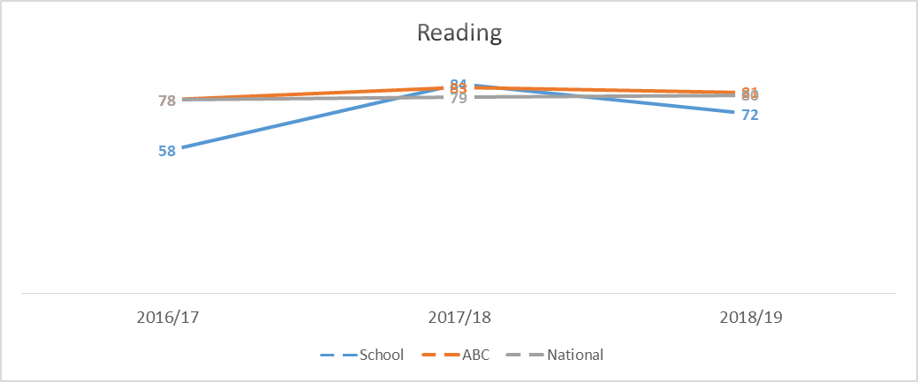?????
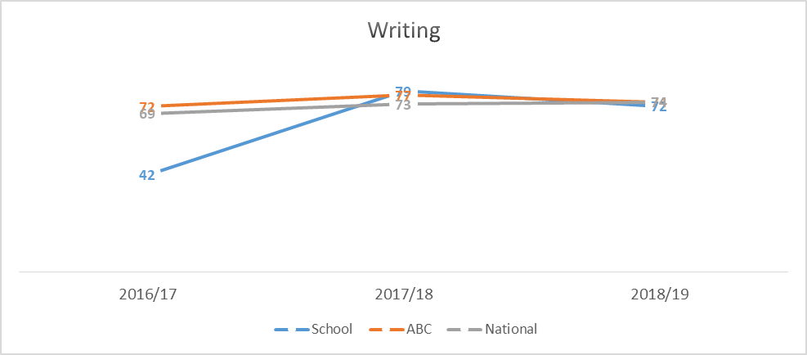
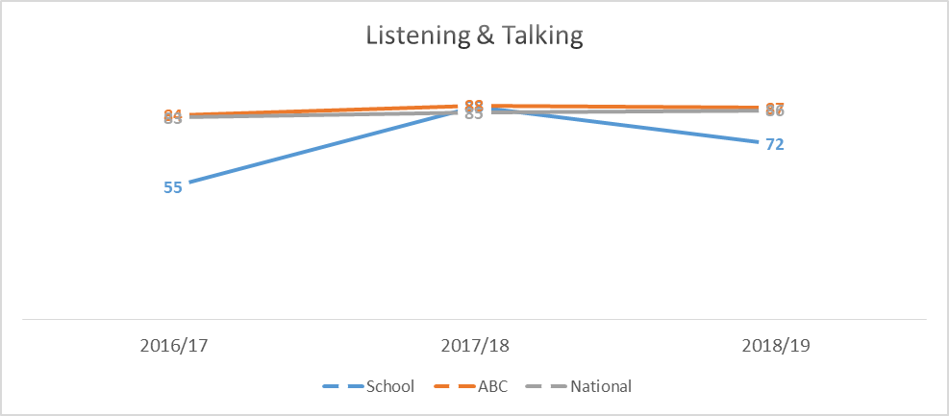

1.2 Attainment Data
Attainment of Numeracy Curriculum for Excellence levels 2016/17, 2017/18 and 2018/19
(teacher judgement – confirmed levels – 3 year trend).
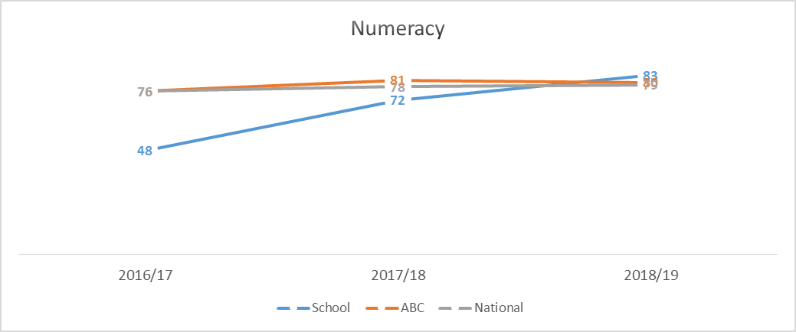

1.3 Attainment Data
School-specific data on Insight (the four Dashboard Measures)
1. Benchmarking Measure: Literacy and Numeracy

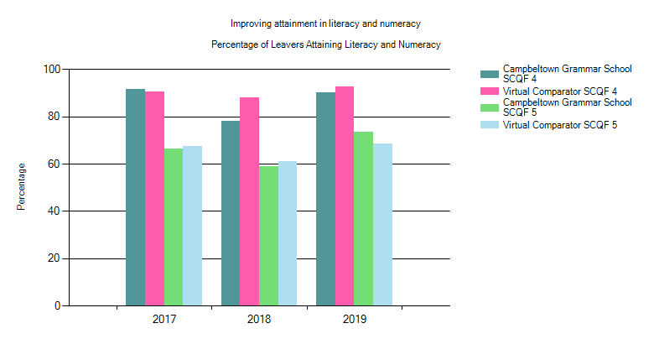
We are above the Virtual Comparator for Literacy and Numeracy for N5 and lower in N4.
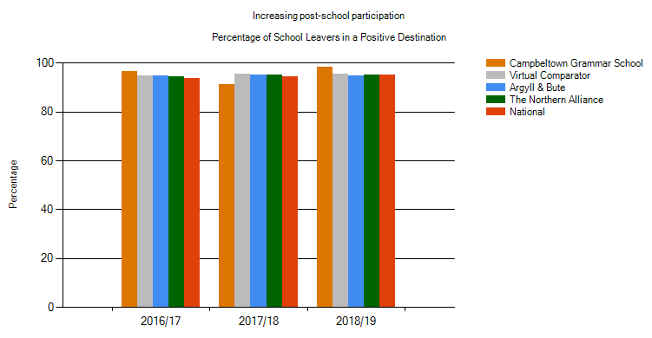
2. Benchmarking Measure: Leaver Initial Destinations
At 98.33%, we have a higher positive destination rate than all four comparators.

1.3 Attainment Data
School-specific data on Insight (the four Dashboard Measures)
3. Benchmarking Measure: Improving Attainment for All (Complementary Tariff)
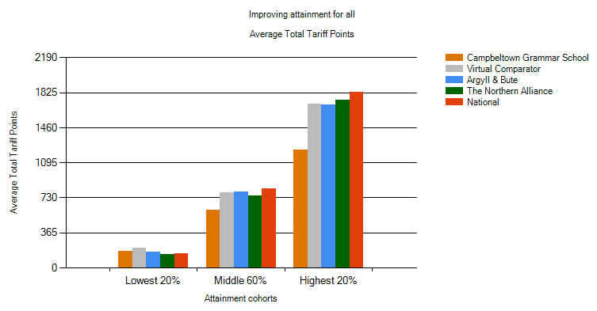

We are below the VC in the lowest 20% and well below all comparators in Middle 60% and highest 20%. The complementary tariff score takes an average of the top 5 qualifications. Our learners only had 5 and if they failed one of these, the average is much lower. With learners now potentially having 6 qualifications, our average total tariff points will increase in 2019/20.
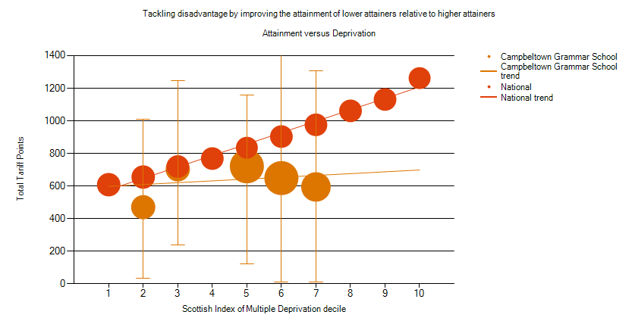
4. Benchmarking Measure: Attainment versus Deprivation (Complementary Tariff v Virtual Comparator)
Total tariff points are much lower in SIMD 2. SIMD 5-7 progressively lower as SIMD increases. Some explanation to be found in the tariff data provided above. All SIMD groups being targeted for interventions to improve attainment.

Overall quality of our learners’ wider achievements Highlights of session 2019-20
Several learners attended an award event at the Scottish Parliament to recognise our achievement of Level 1 Vision Schools Scotland in recognition of our commitment to Holocaust education, anti-racism, citizenship and support religious equality. Vision Schools Scotland is a partnership between the University of the West of Scotland and the Holocaust Educational Trust.
Two senior students completed Open University YASS courses securing success in our first year of this offer.
We had many S5 & S6 students working on wider achievement and leadership courses, completing volunteer and leadership projects in and outside of the school.

Comment on strategies that have been successful in engaging with children and young people, staff, parents and the wider community and the impact of these.
We held a very successful ‘open day’ in May 2019 which saw members of the Campbeltown community in our school. Senior pupils organised this event and we raised a significant amount of money and the community witnessed first hand how well our school is serving the needs of our young people.

The membership of our Parent Council has increased and more parents are involved in school improvement activities. We have simplified our documentation on school improvement using the Local Authority’s new template to help further encourage stakeholders’ involvement and contribution to school improvement.

Comment on progress made with the following aspects of empowerment:
- curriculum;
- improvement activities;
- parental and community engagement; and pupil participation.

https://education.gov.scot/improvement/learning-resources/an-empowered-system/?dm_i=LQE,6RTY0,WAUPY4,R37A1,1
We engaged with all stakeholders in changes to the structure of our school week and our curriculum rationale. We sought a wide range of views and used data from surveys and questionnaires to shape how we moved forward.
We have an active Junior and Senior Student Council and we have been engaging with them in the development of the SIP and in the operational aspects of school life. We have plans to develop our use of HGIOURS to help students collaborate and participate in our improvement planning.
We have had some success in encouraging parents to join improvement committees and working groups.
We work closely with our partners, particularly in health to develop courses to a wide range of our young people.
Argyll College has collaborated with us to ensure the availability of Skills for Work courses and Foundation Apprenticeships that meet the needs of our young people and community.

Comment on progress made with Pupil Equity Funding, taking account of the five key areas below:
- attendance;
- attainment;
- exclusion;
- engagement;
- participation.

Funding in session 2019/20 was focussed on Health & Well Being, Numeracy and Literacy to raise attainment of all.
The ability to use funding during lockdown to improve IT capabilities had a positive effect on engagement and participation.

Quality Indicator | How are we doing? | How do we know? (Evidence) | School Self-Evaluation (1-6)
1.1  Self-Evaluation for Self-improvement | Quality assurance calendar in place to map out opportunities for reflection, analysis and planning interventions. | Quality assurance calendar.  Learning Visit reports  Learner conversations  PRDs | 3
1.3  Leadership of Change | Staff have developed more effective and positive working relationships that will enable us to take forward, with confidence, initiatives that will lead to significant school improvement. | Stakeholder participation in school improvement working groups.  PTs taking responsibility for aspects of whole school improvement | 3
2.3  Learning, teaching and assessment | Learners in most classes are motivated and engaged in their learning. The pace of learning is positive in the majority of lessons. Almost all teachers provide clear instructions and explanations and the majority use questioning well. Learners enjoy opportunities to take part in paired and group work. Teachers were increasingly sharing learning intentions and success criteria. Learners can explain how this benefited their learning. | Education Scotland further inspection October 2019 & ROV January 2020.  Learning visits.  Learner questionnaires. | 3
3.1  Ensuring wellbeing, equality and inclusion | Learners feel well supported by their guidance teacher.  Child’s Plans are more coordinated having been placed on SEEMIS module.  Support for Learning department is more involved with subject staff across the school. | Responses to questionnaires.  Child’s plans on SEEMIS.  Department work on differentiation, departmental meetings. | 3
3.2  Raising attainment and achievement | Increasing the number of National Certificates options available to learners from 5 to 6 has led to a significant increase in the overall number of National Certificates achieved in Session 2019/20. For example, the number of candidates achieving Higher A-D increased from 97 in 2018/19 to 124 in Session 2019/20 and the number achieving A-D at National 5 increased from 280 to 354. | SQA results. | 3

