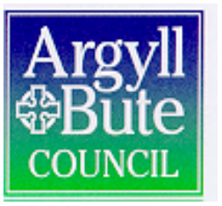
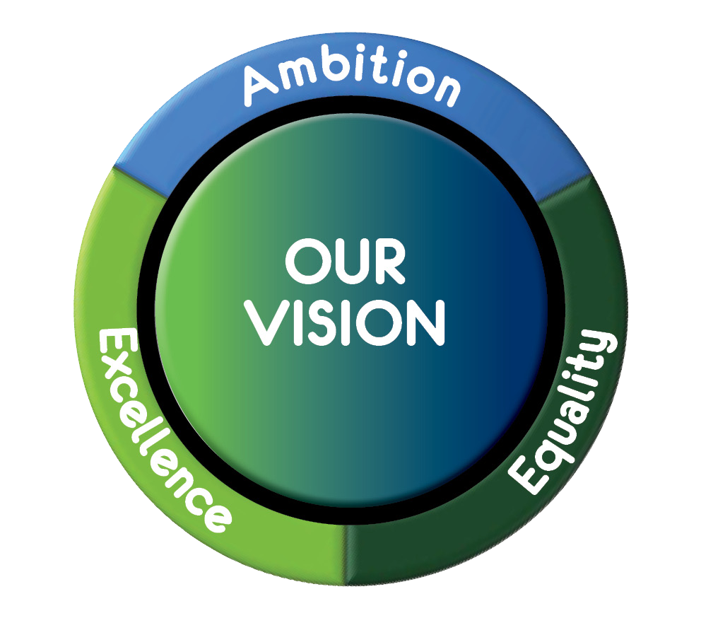
Community Services: Education
Executive Directors: Anne Paterson and Louise Conner

Head Teacher: David Fyfe Campbeltown Grammar School
Hutcheon Road, Campbeltown, Argyll, PA28 6JS
Tel: 01586 553773
Email: enquiries.campbeltown@argyll-bute.gov.uk
If phoning or calling please ask for:
Date: 11/8/20
Dear CGS Community,

Phased Return to School from 12 August 2020

Further to my letter of 6/8/20, our Parent Council has asked me to clarify some key points. I apologise in advance for the length of this letter but would urge you to take the time to read though it.

- S1 will return to school tomorrow, Wednesday 12 August starting at 9.00am and will also attend on Thursday 13 August. S1 parents and carers have received a letter with details of plans for tomorrow.
- S2 and S3 will attend on Thursday 13 August starting at 9.00am. S1, 2 and 3 will not attend school on Friday 14 August.
- Senior Phase (S4, S5 and S6) will return to school on Friday 14 August starting at 9.00am.

All year groups will return to school on Monday 17 August at 9.00am sharp and in full school uniform unless otherwise instructed. Use of hand sanitisers and strict adherence to the safety guidelines provided the previous week will be essential. Flagrant disregard for the safety of others will result in immediate contact with home. BGE will continue to use the main entrance and SP will use the car park entrance until further notice. A ‘turn left and keep left’ rule will be in place and regardless of the location of the classroom a learner is leaving, they will turn left and keep left until they reach their destination.

Pupils should not come to school if they feel unwell. The main symptoms of coronavirus (Covid-19) are a high temperature, a new continuous cough and a loss or change to their sense of smell or taste.

The School’s Risk Assessment can be found on the school website https://blogs.glowscotland.org.uk/ab/campbeltowngs/covid19. This is a working document and will continue to change in light of Scottish Government, Local Authority or school changes. Extracts from Argyll & Bute’s guidance on safe working in the workplace are provided at the foot of this letter.

Cashless Catering
All accounts should be topped up using the online facility https://www.argyll-bute.gov.uk/pay-it
If you would like reminded of your account reference please email enquiries.campbeltown@argyll-bute.gov.uk and we will get back to you as soon as possible. We are aware that some new S1 online accounts have not been activated yet and online top ups may not be available. We are also aware that this applies to some children in other year groups. If you have experienced any difficulty, please ensure your child brings their card along with cash where there will be an opportunity to safely top up the account under the supervision of staff. We hope this online issue will be resolved as soon as possible. In the interests of safety, all pupils will require their cashless cards and online top up after this interim period.

Music Tuition
Currently, no woodwind or brass instruments or bagpipes can be played and no singing can take place. This presents obvious challenges for our Music teachers and instructors. Music lessons will continue, but the focus initially will have to be theoretic rather than practice. Face to face tuition with music instructors will not begin until 24 August when a blended model of delivery may be possible. No instruments at all should be brought into school until further notice. However, an exception is an electronic chanter which can be brought into school. A letter from Katherine Wilkie is in Appendix 2 of this letter for your information.

Uniform and equipment
All pupils should attend school as normal in school uniform unless they have PE. Our current preference is to have pupils coming to school in PE kit on the days they have PE. We will keep this under review and hope that restrictions on the use of indoor PE spaces and changing facilities are eased as soon as possible. There is no need to wash any item of clothing, including school uniform, more than you would normally. Mr McQuaker’s letter is in Appendix 2 of this letter for your information.

Pupils are permitted to bring their own bags and equipment. These bags should be kept under their own seats when in class and should not be passed to anyone else. Similarly, anything in the bags should only be handled by the owner. Any food boxes or water bottles within the bags should be cleaned at home, every night. Nothing should be shared. It is essential that pupils bring their own learning equipment, pencil, pen etc to school.

All pupils should bring a face covering to school each day. They may need this for travelling; for leaving school and going out into the community before returning to school; for taking part in Home Economics for example. A small number of disposable masks will be available for pupils who have forgotten to bring their own.

Travel to and from school
Pupils are to be encouraged to walk or cycle to school wherever possible.
If parents/carers do have to drive their children to school, they should be dropped off at a safe place and a safe distance from school. This will allow the pupils to spread out as they approach the school and avoid gatherings.
Parents/carers are not permitted to drop off children in the car park unless there is a medical need and agreement with the school is made prior to arrival.
Parents/carers are advised not to car share.

BUSES/CARS/TAXIS
- Follow the guidance on display at main bus stops.
- Drivers, pupil escorts and all passengers, including school pupils, are required to wear suitable face coverings. Exemptions include children under five years of age and people who have a health condition or disability. Individual discretion should be applied in considering the use of face coverings for children with breathing difficulties and disabled children who would struggle to wear a face covering. A small number of disposable masks will be available on vehicles for pupils who have forgotten to bring their own.
- Mounted hand sanitisers will be provided and should be applied by all staff and pupils when entering the vehicle.
- Vehicles should be kept well ventilated.
- An enhanced cleaning schedule will be put in place to ensure that frequent contact points, eg door handles, are thoroughly cleaned and disinfected after each journey
- If someone displays the symptoms of Covid-19, lives with someone displaying symptoms of Covid-19 or is a confirmed case, the affected transport will be subject to an enhanced clean.
- The Scottish Government has advised that dedicated school transport services should be regarded as an extension of the school estate. This means physical distancing between pupils is not necessary as long as infection rates remain low in Scotland. Due to the confined space within school transport vehicles, drivers and pupil escorts will be required to wear face masks and shields they have provided with. All children and young people will be responsible for providing their own face coverings.
- All pupils should maintain a one metre social distance from all fare paying passengers on public bus services.
- School pupils will be discouraged from singing and shouting whilst on board vehicles to reduce the possible spread of virus transmission.
- Appropriate signage will be on display in each vehicle.
- Wipes and disposable face masks will should be placed in bins or waste bags as soon as possible after use.

Our Parent Council also raised questions about social distancing of pupils and hopefully the following advice from Argyll & Bute’s guidance on safe working in the workplace will help answer any questions.

Understanding the risk
The novel coronavirus SARS-CoV-2, which causes the disease COVID-19, is spread by two principal routes.

- Close contact with a person shedding virus particles leading to droplet inhalation, or
- Touching surfaces contaminated with virus particles and subsequently transferring those viruses to the eyes, nose or mouth.

A close contact can be defined as someone living in the same household, someone who had direct or physical contact with an infected person, or someone who has remained within two metres of the infected person for longer than 15 minutes. People who have simply passed an infected person in the school corridors, street or in an enclosed place are at very low risk.

How will we control the risk?
- A thorough approach to cleaning will be implemented to prevent the spread of the virus, sanitation measures focusing on enhanced cleaning routines for “touch points” means that there is less opportunity for virus particles to spread from hand to hand.
- Hand gel and wipes have been placed at the front door, in every classroom, and across a number of wider areas across the school.
- Measures are in place to allow pupils and staff time to clean their hands with soap, running water or sanitiser, when they arrive at school, return from breaks, changing rooms/areas and before and after eating.
- Good respiratory hygiene must be practiced. Children, young people and staff will be encouraged to catch coughs/sneezes with tissues or elbow, avoid touching their faces and use bins that are emptied regularly for tissue waste.
- Windows and doors will be kept open to aid ventilation wherever practical. This will also help to reduce contact with door handles.
- Children are not required to wear masks in school unless consistently facing each other for more than 15 minutes. For example, masks will be necessary in Food Technology classes because the ovens face each other. (Pupils may wear appropriate masks at any time should they wish. Please ensure your child’s mask is a plain colour with no graphics. Your child’s mask will be confiscated and replaced with a plain one if this instruction is disregarded).

Test and Protect
This scheme will be operational from Day 1 of schools re-opening. It is operated by Public
Health Scotland (PHS), not the school, and will activate wherever a case is reported. Two recorded instances of infection within a school would be classed as an outbreak and lead the involvement of a multi-agency incident management team. This, in turn, may lead to local school closures, although that would be a decision for the incident team rather than school management.

We will have an identified room or area which is designated for anyone showing symptoms until they can be picked up. We will have PPE available for pupils and staff.

The use of PPE
PPE will not normally be required or necessary, however, there are already set risk assessment processes for where the need for PPE has been identified such as personal care, where staff come into contact with blood and body fluids or lift children and young people. In these cases PPE will be provided by the school.

The position on face coverings in schools is:
- Face coverings should not be required for most children (other than those clinically
advised to wear one)
- Where adults cannot keep 2 metre distance and are interacting face-to-face for a sustained period (15 mins or more), face coverings should be worn.
- Anyone (whether child, young person or adult) wishing to wear a face covering in school will be allowed to do so - remember plain colour with no graphics.
- The impact of wearing a face covering for learners with additional support needs including any level of hearing loss, or for learners who are acquiring English and rely on visual cues, will be carefully considered and in these cases, clear masks and/or visors will be used as a shield, rather than a face mask that hides the mouth.

There is no routine need for PPE (masks, gloves and aprons) although a supply should be available in case anyone becomes unwell. Wearing aprons and gloves is not advised, practicing good hand hygiene is the recommended way to protect against infection. It is also advisable that long hair is tied up.

Communication
Parents are not permitted in school unless to collect a child following an emergency; or following agreement by management necessitated by there being no other option.

We have gained a great deal of experience using online communication since the Lockdown began in March. This method of communication will continue.

Initial contact should ideally be through email, rather than telephone or in person.
Unless it is urgent, please email us your question or provide any information required by email.

All important letters and documents are emailed to parents/carers. We often follow these up with information on social media https://www.facebook.com/campbeltowngrammarschool and

There are only two paper-based returns that we need from parents each year: the annual data check and the media consent form. These will issued to all pupils on Monday 17th August and should be returned to school completed and signed by Friday 28th August at the very latest.
Everything else, should wherever possible, be done by email.

Any discussions about pupils will be held over the phone or using Google Meet where appropriate.

School meetings involving a number of parties will be held using Google Meet and not in person. Parents/carers will be given all support necessary to ensure our communication with you serves the needs of our children and families.

Thank you and well done for reaching the end of this letter. I appreciate you may still have questions, so please do not hesitate to make contact if necessary contact@campbeltowngrammar.com. As advised earlier, you may find this website to be a useful source of further information. https://www.parentclub.scot/articles/faqs-on-scottish-schools-reopening
Yours faithfully,
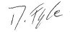
Appendix 1
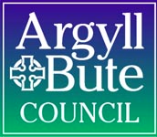

Argyll and Bute Instrumental Service
Information for Schools 11/08/2020
Moving towards Delivery
Argyll and Bute Instrumental Service part of the national HITS (Heads of Instrumental Services) Scotland group working to find solutions to the many challenges present.
During the first two weeks music instructors will be working together, contacting schools and families to enable the restart of the instrumental lessons.
The pertinent paragraphs from the Scottish Government guidelines that apply to instrumental teaching are as follows:
65. Movement between schools (e.g. of temporary/supply/peripatetic staff etc) should be kept to a minimum, until further notice.
129. Scientific and medical advice around how activities such as singing, talking at volume e.g. in theatre performance, or playing wind/brass musical instruments can be managed safely is still being developed. These activities should be avoided during the initial return to schools.
The service priorities are as follows
- SQA pupils
- Highly engaged pupils
- Re-engaging with pupils did not participate in music lessons during lockdown
Method
Instructors should be delivering from home or school.
At present the delivery method will be a blend between ‘online’ and ‘live online.’
The reasons for ‘non-live’ lessons during school time are:
- Schools are minimising movement for all
- It is not possible to teach an instrument in a class with other pupils present
- An instrumental pupil would be required to bring in an instrument to school – bringing equipment from home is being discouraged
- IT availability in school
This list is not exhaustive.
Online learning would be a piece of work/ video posted for groups of pupils, with direction for individuals groups. Feedback would be an essential part of this – pupils can post videos directly to the instructor. The pupil videos will only be accessible to the instructor.
Live online would be the preferable method to deliver to SQA pupils.
Live online would be teaching live through Google Meet/ Google Classroom – all restrictions on live teaching have been lifted.
Other points
- Schools will be asked to help reconnecting instructors with pupils who have become disengaged with their music lessons.
- There will be no ‘new starts’ yet.
- The service will inform parents directly of developments.
The aim is for tuition to start w/c 24th August 2020.
Further information regarding the service will be delivered as appropriate.

Kathryn Wilkie
Education Officer
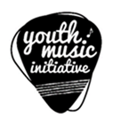
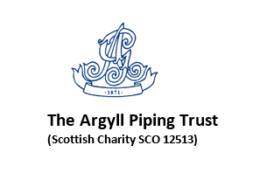
Appendix 2
Covid-19: Return to educational establishments
Physical Education GUIDELINES August 2020

Physical Education – Campbeltown Grammar School
The outdoors can provide extra space for social distancing between consistent groups of learners and help to decrease the risk of transmission. In line with guidelines issued from Education Scotland under current circumstances, physical education should take place outdoors. A review of the safety of indoor facilities will take place in due course.
In Campbeltown Grammar
- On PE days pupils should attend school in clothing that is appropriate for physical education and the weather conditions to eliminate the use of changing rooms.
- Focus will be on activities that minimise the use of equipment. Where equipment is used PE staff will ensure safe, healthy equipment management avoiding sharing.
- On arrival pupils will be assigned their own learning space where they will be able to change into/out of jackets and outdoor clothing and safely store personal belongings, for example schoolbag.
- Access to hand sanitiser stations will be available at entry/exit points, to allow all learners to sanitise their hands as they enter/leave the building when participating in physical education.
We would encourage all pupils to bring suitable outdoor waterproofs for PE lessons, a change of socks and a small towel would also be useful. A roll-on deodorant may be used.
We look forward to welcoming our pupils back to PE in CGS as they re-connect, and adapt to their return to school.
Should you require any further information please do not hesitate to contact myself at the school.

Yours sincerely,

Mr S. McQuaker
Principal Teacher of Physical Education
Campbeltown Grammar School

